Portfolio
Name: Khaled Abdelmajeed
Instructor name: Mandy Vial
Class: CUL121
Table of Content
Week 1……………………………….……………….….. 3
Week 2……………………………..………………….…..5
Week 3………………………………………………….....7
Week 4…………………………………………………….9
Week 5……………………………………………………11
Week 6……………………………………………………13
Week 7……………………………………………………15
Week 8……………………………………………………18
Week 9……………………………………………………20
Summary………………………………………………….23

Streusel Topping:
Combine all dry ingredients, cut the butter until the mixture is crumbly
Then sprinkle on top of the muffins before baking.

Blueberry Muffin Method:
Stir all dry ingredients together
Whisk eggs in a separate bowl until smooth, then add buttermilk, oil vanilla and lemon zest
Fold liquid into dry and do not over mix, it should be lumpy
Dredge frozen blueberries in a small amount of flour and gently fold into batter.
Portion into greased muffin tins or paper
Bake muffins on oven at 375F for 25-30 minutes until golden brown
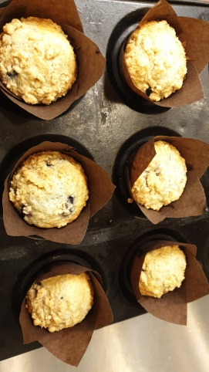

Peanut Butter Sandies: creaming method
Sift together the flour, baking soda, and baking powder to remove impurities and set aside
Cream the butter and add sugar and continue creaming, then gradually add the eggs, and add the peanut butter and salt.
Then add the dry ingredients to the butter, then add the peanut butter and salt
Add the dry ingredients to the butter mixture and mix to make a firm dough
Scoop the dough in a same size and press them using a fork press crisscross markings on the surface of each cookie
Bake at 400F until golden brown approximately 10-12 minutes

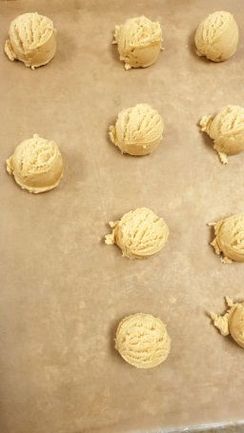

Soft Yeast Dinner Rolls:
Pour the flour on the table and make a well in the middle and add the ingredients dry alone and liquids alone
Start mixing them and slowly take some of the flour and keep going until all flour is mixed and well incorporated
Start rolling them or kneading to produce gluten and creating a springy and elastic dough
Cover and place in a warm place until size is almost doubled
Then push the dough using your fingers and shape it again and place it in a warm place for 10 minutes, until doubled
Then weight them and divide them each one about 40 grams
Bake them in the oven for 12-15 minutes at 400 F
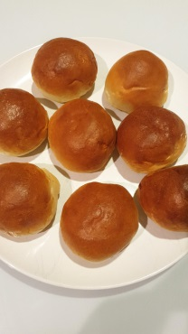

Chef critiques and recommendations week 1
Blueberry Muffin: was really good
Peanut Butter Sandies: size portion was good but I left to much in the oven and it was brown.
Soft Yeast Dinner Rolls: was really good and colour was good but my yield was low.

Focaccia:
Pour the flour on the table and make a well in the middle and add the ingredients dry alone and liquids alone.
Start mixing them and slowly take some of the flour and keep going until all flour is mixed and well incorporated.
Start rolling them or kneading to produce gluten and creating a springy and elastic dough
Put the dough in a bowl with oil.
Cover and out it in a warm place until size is almost doubled
Then press it again and turn it to the other side and again put it in a warm place until it is doubled.
Then put it in a tray and punch down the dough to spread it out and sprinkle rosemary on top and add the cherry tomatoes
Bake in the oven at 400 F for approximately 20 minutes.

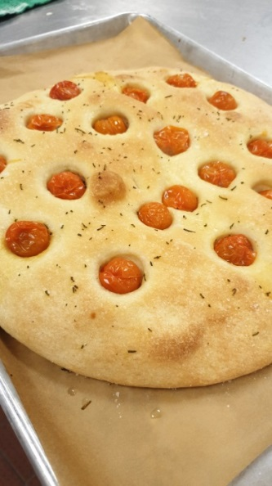

Chocolate Chunk Cookies: Creaming Method
Cream the butter and the sugars in the mixer with the paddle attachment.
Add the eggs to the creamed mixture and then, add the vanilla.
Stir the salt, flour and baking soda together and add to the creamed mixture.
Stir in the pecans or walnuts and chocolate chips
Portion the dough using a scoop onto a parchment paper 3500F until the cookies are golden brown and cooked through, approximately 10 to 12 minutes.

Apple Pie:
Cut the butter into medium dice Sift the flour onto a work surface or into a large bowl.
Cut the butter into the flour mixture until the desired consistency (flaky or mealy) is reached Combine the buttermilk or water, salt, sugar and vanilla in a bowl with a whisk.

Gradually add the buttermilk to the flour mixture. Mix gently until the dough holds together. Do not over mix or add too much liquid. Cover the dough with plastic wrap and chill thoroughly before using.

When ready to use, divide the dough in half and roll out the chilled dough on a lightly floured surface to a thickness of 1/8inch to 1/4 inch Line a pie or tart pan with the dough. Then add the apple mixture

Brush the side of the pie with egg wash so you can stick the other pie dough on top

Spread the other half and cover the pie make sure all the apple are covered

Bake in the oven for 45 minutes.
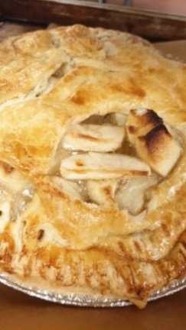

Chef critiques and recommendations week 2

Focaccia: was really good, also had a nice colour
Chocolate Chunk Cookies: was nice I had no negative comments
Pie Dough: was fine but I had some difficulties rolling them out because I under mixed it, and of course it is better than over mixing it.

Conchas Topping:
Combine all ingredients together until a dough if formed and place in the fridge to chill
Once chill spread it and cut round pieces
And top it on the soft yeast dinner rolls

Soft Yeast Dinner Rolls:
Pour the flour on the table and make a well in the middle and add the ingredients dry alone and liquids alone
Start mixing them and slowly take some of the flour and keep going until all flour is mixed and well incorporated
Start rolling them or kneading to produce gluten and creating a springy and elastic dough
Cover and place in a warm place until size is almost doubled
Then push the dough using your fingers and shape it again and place it in a warm place for 10 minutes, until doubled
Then weight them and divide them each one about 40 grams and Then top the bun with the conchas topping
Bake them in the oven for 12-15 minutes at 400 F
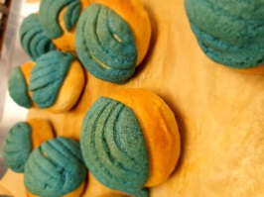

Banana Bread:
Cream the butter and then add the sugar in a mixer
Then add the egg, then mash the banana and add to the mixture.
Sift the flours with the baking powder, baking soda, salt and cinnamon. Add to the banana mixture, alternating with the buttermilk. Stir in the walnuts.
Add the mixture to the loaf pan and bake at 375 until light brown, approximately 25 to 30 minutes.

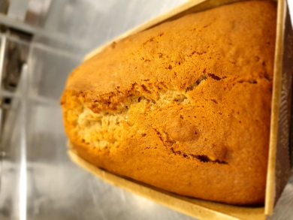

Brownies:

Melt the butter and chocolate over a double boiler to 120F (49C). Hold the chocolate at this temperature.
beat the eggs and sugar in the mixer with the paddle attachment on medium speed for 10 minutes.
Add the salt and extracts.
Then add the melted chocolate, blending until well combined.
Add the flour and mix until combined. Fold in the nuts.
Spread the mixture evenly onto a paper-lined half-sheet pan. Bake at 325F or until the center is set, approximately 40 minutes.
Cool completely before cutting.

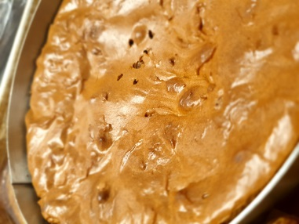

Chef critiques and recommendations week 3
Soft yeasr dinner roll: well rolled and good colour
Conchas topping: was really nice however was little small for the size of the bun
Banana Bread: was perfect no negative comments.
Brownies: was really good and I did a great job

Short bread:
Blend the butter and powdered sugar in a mixing bowl without creaming. Stir in the vanilla and salt, mixing thoroughly. Add the flour and mix until just combined.
Roll the dough in equal thickness and wrap in plastic. Freeze until hard.
Remove from the freezer and unwrap, then cut into round all with equal portions and brush each disk with egg wash.
]Bake at 375F until pale golden brown, approximately 15 to 20 minutes.

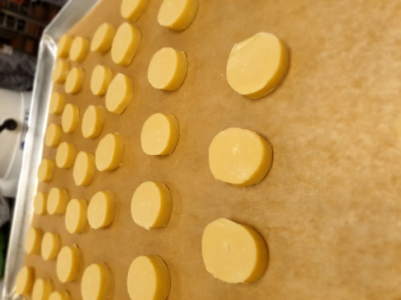

Whole wheat bread:
Pour the flour on the table and make a hole in the middle and add the ingredients dry alone and liquids alone
Start mixing them and slowly take some of the flour and keep going until all flour is mixed and well incorporated
Start rolling them or kneading to produce gluten and creating a springy and elastic dough
Cover and place in a warm place until size is almost doubled
Then push the dough using your fingers and shape it again and place it in a warm place for 10 minutes, until doubled
Then roll the bread into rectangle by folding the dough into the half from both sides.
Bake them in the oven for about 30 minutes at 375 F
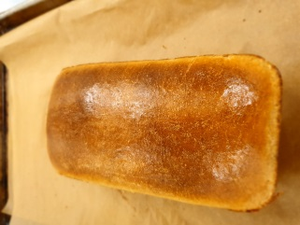
Chocolate Cherry Scones:
Cut the butter into 1/4 inch cubes.
Whisk together the sugar, buttermilk, sour cream, salt and vanilla in a bowl until smooth.
Put the flour and baking powder. Place the butter on top and mix them using your hand just until the flour and the butter are combined.
Add the buttermilk mixture to the dry ingredients and mix very briefly, until just combined. Mix in the cherries and chocolate until just combined.
Place the dough in a ring and cut them into 8 pieces
Bake at 375°F until light golden brown, approximately 18 to 24 minutes.

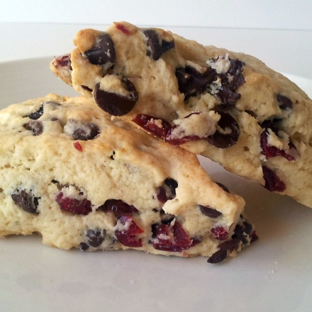

Chef critiques and recommendations week 4
Whole Wheat Bread: looked correct, proper technique WW bread-Nicely rolled
Short Bread: Cookies-baked well, made correctly
Chocolate cherry scones: Scones-sell able

Baguette:
Prepare the Old Dough and allow it to ferment. Which we already had
Mix the flour salt and yeast together with water until dough is almost made then add in the old dough and knead until forms a gluten window then put it in the proofer until it doubles in size.
Then push the dough using your fingers to remove the gas and shape them again and place it for about 10 minutes cover and bench rest it.
Cut the dough in half and shape them in square and start folding them and roll them to about 50cm long.
Place the rolled dough seam side up onto a canvas couche lightly dusted with flour. Proof until the loaves increase 55 to 65 percent in volume, approximately 30 to 45 minutes.
Remove the proofed loaves from the proof box and let the bread’s surface dry for 5 minutes. Use the canvas to roll the bread onto sheet pans. Score 5 diagonal cuts in each piece of dough.
Bake at 450°F (230°C), with steam injected into the oven during the first few minutes of baking,
until golden brown, approximately 20 to 22 minutes

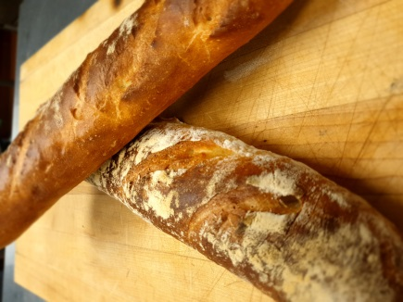

Pie Dough:
Cut the butter into medium dice Sift the flour onto a work surface or into a large bowl.
Cut the butter into the flour mixture until the desired consistency mealy is reached
Add the water, salt, sugar and vanilla in a bowl with a whisk. Add the water to the flour mixture. Mix gently until they hold together. Do not over mix
Cover the dough with plastic wrap and chill thoroughly before using.
When ready to use, divide the dough in half and roll out the chilled dough on a lightly floured surface to a Line a pie or tart pan with the dough.
Pecan Filling:
Whisk together the eggs, brown sugar and melted butter. Add the vanilla and salt. Whisk in the syrups until well combined.
Shop some pecans and add them to the syrup mixture and whisk them together.
Pour the mixture in the pie shell and cover it with pecan pieces and bake at 325°F until the center of the pie have set, approximately 35 to 40 minutes.

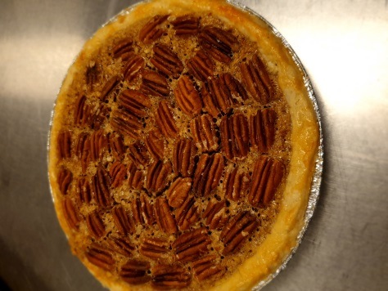

Chocolate Spritz Cookies: Creaming Method
Cream the butter and sugar until light and fluffy. Add the salt, vanilla extract and egg,
Then add the flour, beating until just blended. The dough should be firm
Put the dough in a piping bag fitted with a large star tip, pipe them in a cooking sheet.
Then Pipe jam in the middle, and bake at 350 F until lightly browned edges approximately 10 minutes

Chef critiques and recommendations week 5
Baguette: Good technique, well made Cuts varied, this comes with practice, well baked
Pie Dough: well made and rolled out and correct technique.
Pecan filling: -sell able pie
Chocolate Spritz Cookies: piping hard dough is not easy; this makes the sizes varied sometimes. Jam in the center

Raisin Bread:
Pour the flour on the table and make a hole in the middle and add the ingredients dry alone and liquids alone
Start mixing them and slowly take some of the flour and keep going until all flour is mixed and well incorporated
Start rolling them or kneading to produce gluten and creating a springy and elastic dough
Cover and place in a warm place until size is almost doubled
Then push the dough using your fingers and shape it again and place it in a warm place for 10 minutes, until doubled
Roll the dough into a rectangle measuring 10 inches by 6 inches, Sprinkle each piece of dough with Cinnamon Sugar. Roll up tightly and place the dough, seam side down, into buttered or paper-lined loaf pans.
Then roll the bread into rectangle by folding the dough into the half from both sides.
Bake them in the oven for about 30 minutes at 375 F
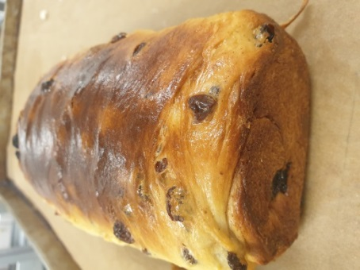
Pie Dough:
Cut the butter into medium dice Sift the flour onto a work surface or into a large bowl.
Cut the butter into the flour mixture until the desired consistency mealy is reached
Add the water, salt, sugar and vanilla in a bowl with a whisk. Add the water to the flour mixture. Mix gently until they hold together. Do not over mix
Cover the dough with plastic wrap and chill thoroughly before using.
When ready to use, divide the dough in half and roll out the chilled dough on a lightly floured surface to a Line a pie or tart pan with the dough.
Chocolate Cream Pie:
In a heavy saucepan, dissolve (70 grams) of the brown sugar in the milk. Add the cocoa powder and bring to a boil. Meanwhile, whisk the egg yolks, the remaining sugar and cornstarch until smooth.
Temper the egg mixture with approximately one-fourth of the boiling milk. Stir the warmed egg mixture back into the remaining milk and return to a boil, whisking constantly.
Whisking constantly and vigorously, allow the cream to boil until thick, approximately 2 minutes. Remove from the heat and stir in the chocolate, butter and vanilla. Stir until the ingredients are melted and incorporated.
Pour the cream through a sieve into the pie shells and place in a refrigerator.
Top the pies with Crème Chantilly once the filling is very cold. Decorate the pies with chocolate shavings.

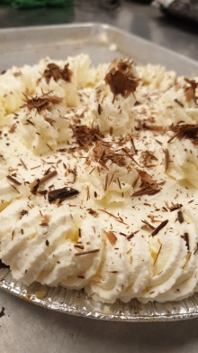
Oatmeal cookies: Creaming Method
Sift together the flour, baking soda and cinnamon.
Cream the butter until light and fluffy. Add the sugars and continue creaming until the mixture is lightened. Add the eggs.
Then add the orange juice concentrate, vanilla extract and salt.
Fold in the flour mixture and the raisins. Portion the dough onto paper-lined sheet pans.
Bake at 375F until golden, approximately 10 to 12 minutes.

Chef critiques and recommendations week 6
Raisin Bread: was a little sticky, be really sure that water and flour are scaled correctly, came together nicely
Pie Dough: looked correct
Chocolate cream filling: Tip was too small for piping, next time use a bigger tip, pie looked good
Oatmeal cookies: sell able cookies

Multigrain Sourdough
Combine the cracked wheat and hot until it is cooked and cooled
Add the butter, molasses, honey, salt and milk powder. Set aside to cool.
Pour the flour on the table and make a hole in the middle and add the ingredients dry alone and liquids alone
Start mixing them and slowly take some of the flour and keep going until all flour is mixed and well incorporated
Start rolling them or kneading to produce gluten and creating a springy and elastic dough
Then add the flax seed and sunflower seed knead until they are mixed.
Cover and place in a warm place until size is almost doubled
Then push the dough using your fingers and shape it again and place it in a warm place for 10 minutes, until doubled.
Then place it in a bread box to shape it and leave it in the proofer.Take it out when it is 70% fermented and score it.
Bake it in the oven for 3o minutes.
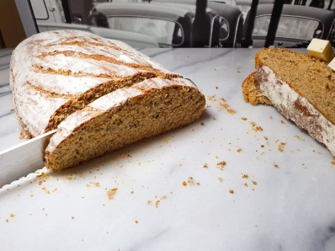
Pecan Sticky Buns:
Pour the flour on the table and make a hole in the middle and add the ingredients dry alone and liquids alone
Start mixing them and slowly take some of the flour and keep going until all flour is mixed and well incorporated
Start rolling them or kneading to produce gluten and creating a springy and elastic dough
Then place the dough in the mixer and mix it while adding the butter pieces slowly until incorporated.
Cover and ferment until doubled in size
Punch down the dough and bench rest 10 minutes. Roll out the dough into a rectangle measuring 12*18 inches and approximately 1/4 inch thick. Brush with the melted butter and top evenly with the filling mixture.
roll up the dough. Cut into slices about 2 inch thick. Place a slice in the ring sticked to each other.
Proof the buns and bake for 1 hour or until golden brown.
Flip them on a parchment paper a let it cool.
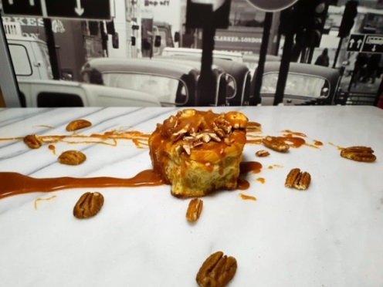

Cranberry Sour Scone:
Cut the butter into 1/4 inch cubes.
Whisk together the sugar, buttermilk, sour cream, salt and vanilla in a bowl until smooth.
Put the flour and baking powder. Place the butter on top and mix them using your hand just until the flour and the butter are combined.
Add the buttermilk mixture to the dry ingredients and mix very briefly, until just combined. Mix in the cranberry until just combined.
Place the dough in a ring and cut them into 8 pieces
Bake at 375°F until light golden brown, approximately 18 to 24 minutes.

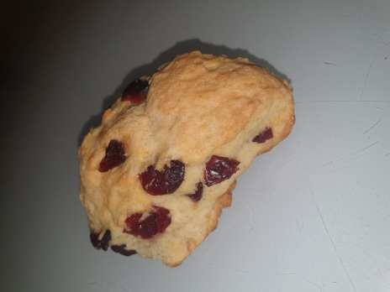

Chef critiques and recommendations week 7
Multigrain Sourdough: correct technique , baked and scored nicely
Pecan Sticky Buns: dough was hard, rolled and baked correctly
Scones: sellable

Focaccia:
Pour the flour on the table and make a hole in the middle and add the ingredients dry alone and liquids alone
Start mixing them and slowly take some of the flour and keep going until all flour is mixed and well incorporated
Start rolling them or kneading to produce gluten and creating a springy and elastic dough
Put the dough in a oily bowl
Cover and out it in a warm plac`e until size is almost doubled
Then press it again and turn it to the other side and again put it in a warm place until it is doubled
Then put it in a tray and punch down the dough to spread it out
Sprinkle rosemary on top and add the cherry tomatoes
Bake in the oven at 400 F for approximately 20 minutes.

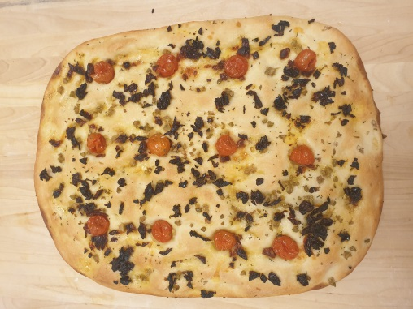

Raspberry Muffin: Muffin Method
Stir all dry ingredients together
Whisk eggs in a separate bowl until smooth, then add buttermilk, oil vanilla and lemon zest
Fold liquid into dry and do not over mix, it should be lumpy
Dredge frozen blueberries in a small amount of flour and gently fold into batter.
Portion into greased muffin tins or paper
Bake muffins on oven at 375F for 25-30 minutes until golden brown
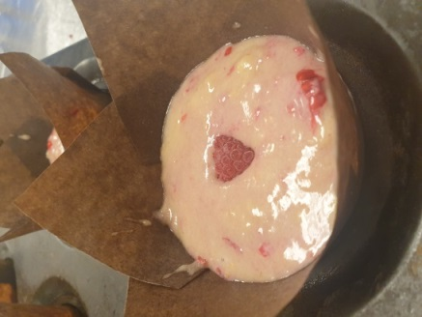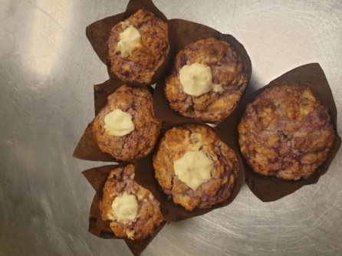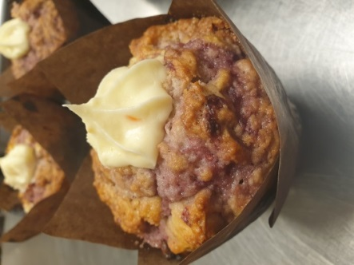

Savory Greek Scones:
Stir the flour, baking powder and salt together.
Then cut the butter and feta into the flour until it resembles coarse meal. Stir in the olives and dill.
Combine the egg, yogurt and buttermilk, then stir the liquid mixture into the dry ingredients.
Place the dough in a ring and cut them into 8 pieces.
Then brush with egg wash and bake at 425˚F until golden brown, approximately 25 to 30 minutes.
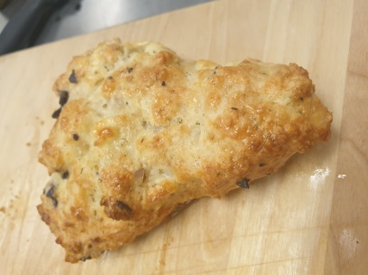
Chef critiques and recommendations week 8
Dough- correct technique
Focaccia- a little too thin, well baked and well topped
Muffins- different recipe, nice rise, correct technique
Scones- correct technique, well baked

Morning Glory Muffin: Muffin Method
Sift the dry ingredients together and set aside.
Combine the carrots, raisins, pecans, coconut and apple. Whisk together the eggs, oil and vanilla.
Toss the carrot mixture into the dry ingredients. Then add the liquid ingredients, stirring just until combined.
Portion into well-greased large muffin cups and bake at 350F approximately 25 minutes.

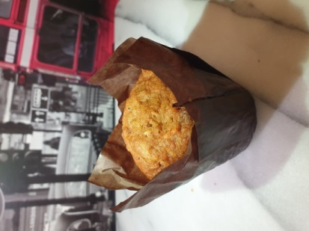

Broiche Braid:
Make a well in the middle with the dry ingredients and then add everything and start mixing until combine. Then add the old dough and start kneading until the dough is smooth and reaches the gluten window.
Then add pieces of the butter and keep kneading, the dough will become wet and soft and it will come back together again.
Place the dough in the fridge to cool.
Then divide the dough into 3 equal pieces and roll them out to be 18 inch long and braid them together.
Proof them until the volume is increased by 70%, then egg wash them and bake at 375F for 20 minutes
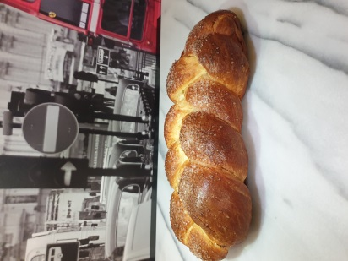

Chocolate Bread:
Make a well in the middle with the dry ingredients and then add everything and start mixing until combine. Then knead the dough until smooth and reaches the gluten window. Add the inclusions and knead to incorporate. Proof the dough until doubled and then degas and round the dough and bench rest for 10 minutes. Shape in and place in pan and proof to double volume. Score the bread and bake in the oven with steam injected.

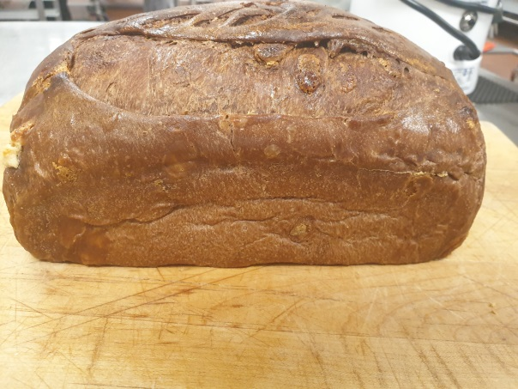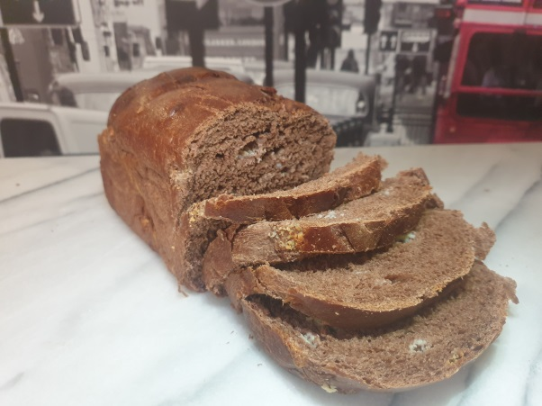

Chef critiques and recommendations week 9
brioche dough: When working with an enriched dough you must use the flip and fold technique. It assists the gluten strands to attach again. Try not to press and pull the dough as it will tear the gluten in this stage.
brioche bread-: correct braid, egg wash and topped well
chocolate dough-: when mixing by hand if the dough becomes sticky flip and fold the dough until you can roll back and forth again. It’s the correct technique for bread making
chocolate bread- good surface tension, well baked.
Muffins: correct method, good bake

Summary

I learned a lot in this course working with breads every week was a new experience I never thought I would do or even enjoy doing it. I got to experience the kneading by hand with different kind of dough and if I am making an enriched dough once adding the butter it will break and come back again when kneading, I once did I brioche at home and when I added the butter it fell apart and I thought it was ruined and I actually gave up and threw it but taking this course made me know that how it is supposed to be when working with enriched dough. I really liked this course that I even bake my own bread at home and rarely when I buy bread from the stores. I learned many kinds of muffins and scones.
Difficulties that I had was not much in this course but maybe little bit with the bread sometimes it sticky and wet and I am not sure if that how it should be and when should I add little but of flour , cause some dough has a lot moisture than other so this sometimes confuses me.
The thing I would not forgot is the bread all kind of breads especially the Brioche I really liked it is so satisfying when working with a dough that hard and takes time to make it and the end result would be so nice I feel I accomplished something that is not easy and fast to make.
I took away many things in this course but of course the most important is the making of bread as I said I stopped buying bread now. When I cook hamburgers I make my own hamburger bun which gives a totally different taste to me knowing that the bread is freshly made by me.

