Angie De La Hoz
Ashley Belo
Veronica Scalia
Stefanie Becker
571-KRM-03 - Introduction to Fashion Marketing

PROJECT #1
ANALYSIS OF TIFFANY & CO.

Presented to Mr. Eric Martineau

March 21st
2017
INTRODUCTION
Tiffany & Co. is an american luxury specialized jewler retailer (with 93% of their net sales based on jewelry) and also sells timepieces, leathergoods, stationary, sterling silverware, china, crystal, fragrances and acessories. Founded in 18th of September 1837 by Charles Lewis Tiffany and John B. Young, the company started as a stationary and fancy goods emporium in New York. It was one of the first stores to have non-negotiable prices. Following its foundation, the company created the “Blue Box” as a symbol that represents the brand’s name. Nowadays, Tiffany & Co is an international reference in the luxury and jewelry market and it’s worth almost 3 billion dollars, with 220 retail stores in many countries around the world. The retailer’s market share compared to its competitors is 13%, showing a strong and stable presence in the market.
The company’s mission statement is “To be the world’s most respected and successful designer, manufacturer and retailer of the finest jewelry” and its objective is to manage an ethical business that is also sustainable. Tiffany & Co’s mission statement is represented through the protection of interests of the stockholders by making professional and responsible decisions to show their commitment. In addition, the company works directly with their employees, supply chain and local communities to guarantee a reduced environmental impact and build up Tiffany’s social impact. Also, they seek the satisfaction of their customers by designing beautiful enduring products that will be admired for generations, transmitting their loyalty with their clients, oriented customer service and quality of their products guaranteeing the “Tiffany’s Experience”. Tiffany & Co has a Strategic Business Unit known as The Foundation which is in charge of the sustainable aspect of their business with missions such as responsible mining and coral conservation. Their mission statement is “Tiffany & Co Foundation seeks to preserve the world’s most treasured landscapes and seascapes.”.

SWOT ANALYSIS
- Strenghts
Highly Profitable – with a market share of 13% due to its pricing power, Tiffany & Co. is able to charge higher prices for their consumers. Investments in technology accelerated the company’s productivity, along with expensive rents and occupancy costs, justifying their higher price tags. More implements of silver in their products as well as fashion-oriented collections is bringing more profit to the company.
Strong Local Presence – Tiffany & Co. has their retail stores relocated in areas of intense human traffic and their stores are also larger than the ones from its competitor Pandora. Tiffany’s first store in Singapore was opened in 1991 and has built a strong presence since almost every Singaporean knows about the brand. Nowadays, Tiffany & Co. is an international known brand.

- Weaknesses
Seasonality – The biggest part of the company’s sales(30-35%) is generated only in the month of January. As a retailer, it is important for them to have strong sales in the holidays and that brings disproportional results for the company.
Limited design range – While in the U.S Tiffany & Co. has a large diversity of designs for the products, in Singapore they only rely on sterling silver jewelry and it should not be like that, once they are missing sales compared to the other stores that have a large diversity of products and limited editions.

- Opportunities
International Expansion – many stores started to open in emerging countries once a large portion of the population is leaving the poverty into the middle class
Singapore, A luxury retail hub – Singapore is now the top destination for Chinese tourists to buy luxurious garments and jewelry. Besides targeting the Singaporeans customers, the company can expect tourists to be part of the market segment for luxury goods as Singapore transforms into a luxury retail hub.

- Threats
Slow Growth of the Economy – even though the U.S economy is stable, Europe and also Japan are going through a recession in their economy and also China affecting the customer’s purchase and the company’s sales for a while.
Growth of Imitation Products – a large amount of Ebay sellers are selling imitation of Tiffany’s products. However, due to its large number of sellers, the company finds difficult to

THE CONSUMER DECISION MAKING PROCESS AT TIFFANY'S

The consumer decision making process at Tiffany's is very specific and can take some time due to it being a very expensive purchase. When it comes to a customers first purchase with the company they always prefer to know what they are purchasing and want to be aware of the specific gems and diamonds they are engaging in, when shopping at Tiffany's the consumer will often go with the intention of following through with they're purchase due to a meaningful event in life such as an engagement or an anniversary and it requires a responsible and right decision to make. Although a regular customer whom is accustomed to the company would base there decisions in regards to the purchase differently they have built trust and a solid foundation there for the process of decision making is quicker. Tiffany & Co. is a company that signifies prestige and elegance there for customers who decide to purchase with them are seeking an image of high class and want a sense of luxury.

SEGMENTATION/TARGETING
People buy Tiffany's product basing their purchasing decisions on motives and lifestyle. Tiffany's main market target is women, who buy and receive as gifts these beautiful jewelry. So, even though men are involved in the purchasing of Tiffany's products, women remain to be the main influencers. With its various design collections and price range, the company meets wants and needs of consumers of different age and income. Tiffany services generations X, Y and baby boomers. While generation X, who are working women, earn enough money to pay for high-quality goods, baby boomers buy the luxurious items even despite insufficient funds. But, generation Y consumes the product because they enjoy to follow the celebrity trends. These women love to treat themselves to luxurious things, follow fashion and adhere to aspirational brands. The Company makes special collections, this special collections targets women who celebrate he uniqueness and social status in terms of wealth and power.
Despite the fact that originally Tiffany's jewelry were created for high-class women, now its product becomes more affordable as the company always looks for the way to expand its market. Now even lower income women can buy Tiffany's product because of the addition of collections such as made from sterling silver. For example, they have business gifts for consumers that want to purchase a gift for business partners; a wide range of functional products in different prices are offered for different occasions in business, these gives flexibility and ease in choice making to customers of this segment.
Since Tiffany & Co. is a specialty company that sells mainly jewelry, customers turn to its product for celebration of some significant events such as engagement, wedding , anniversary or birthday. In this case, this kind of purchase may include people of different family life cycles such as young single, young married with/without children, middle-aged married with/without children etc. The spouses, partners, family members and anyone else in the circle of friends of the main market are a secondary target, they are the secondary buyers of Tiffany & Co.
UNIQUE SELLING PROPOSITION
Tiffany & Co. has two main targets; the gift-givers and gift-receivers are mainly targeted when a special occasion occur. And also affluent self-buyers aged 20 to 35 are those who generally pamper themselves with mid-range luxury goods. A comparison between Tiffany & Co. and its competitors can be done to
Blue line:
The targets of this company are men and they shoe their brand with television and internet.in internet the website provides pictures and useful information to help men easily find what they want. Blue Nile is that it offers personalized services even without a physical store. On the website, several features such as toll-free call assistance, emailing, and live-chatting is made available to the customer and also they help the customer, they have a good way to pay the customers choose to pay 6 months later.
Pandora :
Pandora offers women across the world a universe of high quality, hand-finished, modern and genuine jewelry products at affordable prices, they are inspiring women to express their individuality.
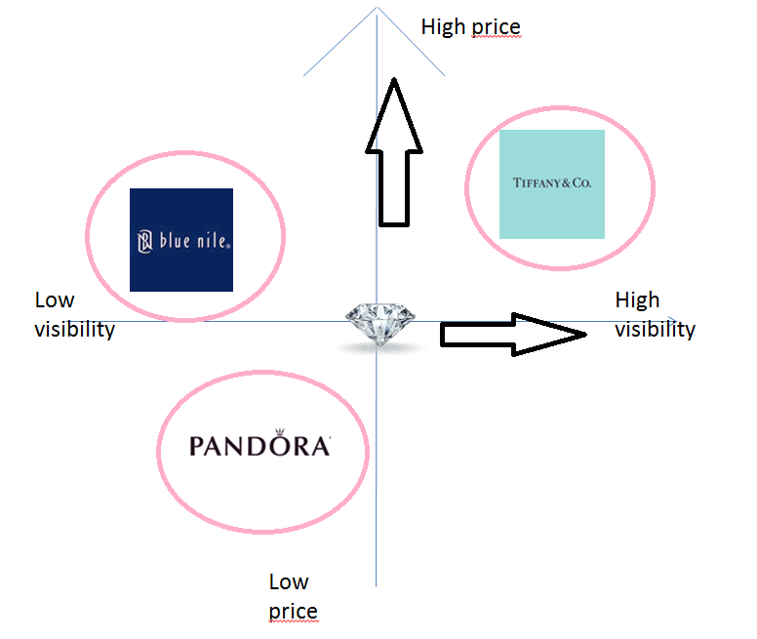

THE COMPANY VALUE PROPOSITION

Emotional benefits: Luxury, feeling of success, social approval.
Distinctive benefits: High purity in each diamond, quality and design.
Physical Attributes: Exclusive and unique, high class, jewelry and feminine.

BIBLIOGRAPHY
https://pt.slideshare.net/VisoudaKounlavong/tiffany-co-market-analysis
https://issuu.com/mayaalexandria/docs/marketing_plan1
http://investor.tiffany.com/annuals.cfm
http://investor.tiffany.com/
http://marketrealist.com/2015/12/weighing-tiffanys-debt-burden-leverage/

