The Final Term Project
The Restaurant/Menu Project
PART II
Feddy Halabi Troisi
06 of September 2019
MANAGEMENT BY MENU
Instructor Mohsen Saberi
section 10001
Student ID 1840036

Standard Operating Procedures
Employee Health and Personal Hygiene
Policy: All foodservice employees will communicate health concerns and maintain good personal hygiene practices to safety of food.
Procedure for all kitchen employees:
Grooming standard:
- Arrive at work clean with clean hair, clean clothing, teeth brushed, bathed and daily use of deodorant.
- Maintain short, clean, and polish-free fingernails.
- Wash hands (including under fingernails) and up to forearms vigorously and thoroughly with soap and warm water for a period of 20 seconds, following Handwashing SOP:
  - When entering the facility before work begins.
  - Immediately before preparing food or handling equipment.
  - As often as necessary during food preparation when contamination occurs.
  - Before putting on gloves to start a task that involves working with food.
  - In the restroom after toilet use and when you return to your work station.
  - When switching between working with raw foods and ready-to-eat or cooked foods.
  - After touching face, nose, hair, or any other body part, and after sneezing or coughing.
  - After cleaning duties.
  - Between each task performed and before wearing disposable gloves.
  - After smoking, eating, or drinking.
  - Any other time an unsanitary task has been performed – i.e. taking out garbage, handling cleaning chemicals, wiping tables, picking up a dropped food item, etc.
- Wash hands only in hand sinks designated for that purpose.
- Dry hands with single use towels or forced air dryer. Turn off faucets using a paper towel, in order to prevent recontamination of clean hands.
Fingernails
- Fingernails should be trimmed, filed, and maintained so edges and surfaces are cleanable and not rough.
Proper Attire:
- Wear appropriate clothing – clean uniform with sleeves and clean non-skid close-toed work shoes that are comfortable for standing and working on floors that can be slippery.
- Wear apron on site:
  - Do not wear apron to and from work.
  - Take off apron before using the restroom.
  - Remove apron when leaving the foodservice area.
  - Change apron if it becomes soiled or stained.
- Follow Glove Use SOP.
- Only gloves approved for foodservices should be used.
- Wear provided, disposable gloves to cover any cuts, sores, rashes, or lesions.
- Wear gloves when handling ready-to-eat foods that will not be heated-treated.
- Change disposable gloves between tasks or every four hours if uninterrupted work on continuous task has occured. Wash hands before donning and after discarding gloves. Do not blow into gloves, roll gloves, or wash and reuse gloves.
Hair Restraints and Jewelry:
    - Wear a hair net or bonnet in any food production area so that all hair is completely covered.
    - Keep beards and mustaches neat and trimmed.
    - Do not wear false eyelashes.
    - Refrain from wearing jewelry to prevent physical and microbial contamination of foods.
  - Only a plain wedding band.
  - No necklaces, bracelets, or dangling jewelry are permitted.
  - No earrings or piercings that can be removed are permitted.
Illness:
- Report any flu-like symptoms, diarrhea, jaundice, sore throat with fever, uncovered open wounds with fluid, boils, and/or vomiting to the unit supervisor. Employees with these symptoms will be sent home with the exception of symptoms from a noninfectious condition.
- Instances of illness or recent exposure to Norovirus, Hepatitis A, Nontyphodial Salmonella, Salmonella Typhi, Shigella, or Shiga Toxin-producing Escherichia Coli must be reported to the unit supervisor. Exclude the foodservice employee if diagnosed with an infection from Norovirus, Hepatitis A, Nontyphodial Salmonella, Salmonella Typhi, Shigella, or Shiga Toxin-producing Escherichia Coli.
Cuts, Abrasions, and Burns:
- Bandage any cut, abrasion, or burn that has broken the skin.
- Cover bandages on hands with gloves and finger cots, and change as appropriate.
- Inform unit supervisor of all wounds.
Smoking, eating, and gum chewing:
- Smoke, eat and chew gum only in designated areas.
- A closed beverage container with a straw or a sip-lid top may be used in the production area if the container is handled to prevent contamination of 1) the employee’s hands, 2) the container, and 3) exposed food, clean equipment, utensils, linens, and unwrapped single-service and single-use articles.
- Refrain from chewing gum or eating candy during work.
- Follow approved tasting procedures such as two-spoon technique.

Safety Production
Sanitation Plan

Part 1: List of Cleaning and Sanitizing Agents

Name of cleaning agent | Mixing Instructions | Used for Cleaning
Dishwashing detergent  “Foraggio” | 10% of the product means that every liter of water (equal to 1000 milliliters) it is necessary to add 100 ml. of detergent | Used to sanitize:  - All
AXA Cooking Surfaces  “Defir” | Spray the product directly on the surface to be treated, which must be at a temperature of 60°C | Used to sanitize:  - cooking surfaces

Part 2: Cleaning and Sanitizing Requirements

Name of cleaning agent | Mixing Instructions | Used for Sanitizing
100 ppm Bleach  Solution | - 2 ml (1/2 tsp) of household bleach added to 1 litre of water mixed in a spray bottle  - Verify concentration with a test strip.  - Make solution fresh daily. | Used to sanitize:  - All

Part 3: List of Pesticides

Name of pesticide | Used for | Storage
Fly Bait | - Bait is applied to garbage area monthly.  - Bait is applied according to the manufacturer’s directions on the package. | - in original container with lid on  - Do not transfer to another container  - Product kept in designated area in basement

General Cleaning Schedule Template

ITEM | FREQUENCY OF CLEANING |  |  |  |  | METHOD OF CLEANING | WHO
 | After Use | Every Shift | Daily | Weekly | Other
Refrigerator |  |  |  | √ |  | First wash with soap and water and then disinfect with a sanitary product | Handlers
Freezer |  |  |  | √ |  | First wash with soap and water and then disinfect with a sanitary product | Handlers
Pots | √ |  |  |  |  | Rinse, scrape or soak  Wash with “Dishwashing detergent” 43°C  Rinse warm  Sanitize 49°C | Handlers
Plates | √ |  |  |  |  | Rinse, scrape or soak  Wash with “Dishwashing detergent” 43°C  Rinse warm  Sanitize 49°C | Handlers
Forks | √ |  |  |  |  | Rinse, scrape or soak  Wash with “Dishwashing detergent” 43°C  Rinse warm  Sanitize 49°C | Handlers
Tools | √ |  |  |  |  | Rinse, scrape or soak  Wash with “Dishwashing detergent” 43°C  Rinse warm  Sanitize 49°C | Handlers
Cooking surfaces | √ |  |  |  |  | Spray the product directly on the surface to be treated, which must be at a temperature of 60 ° | Handlers
Microwave | √ |  |  |  |  | First wash with soap and water and then disinfect with a sanitary product | Handlers
All Prep. Station | √ |  |  |  |  | First wash with soap and water and then disinfect with a sanitary product | Handlers

Equipment Cleaning Schedule Template
Complette for each item of eqipment:
Equipment to be cleaned | Cooker hood
Location of Equipment | Kitchen
Cleaning agents to be used | AXA Cooking Surfaces - “Defir”
Cleaning frequency | Weekly
Cleaning Method | Spray the product directly on the surface to be treated, which must be at a temperature of 60 ° C

Food Safety Plan
A Food Safety Plan, also often referred to as a HACCP Plan (Hazard Analysis Critical Control Point) is a set of written procedures that will help to eliminate, prevent or reduce food safety hazards that may cause your customer to become ill or injured.
Below is an example of a food safety plan for a specific recipe: "Spaghetti alla Vongole".
In the example there are also examples of standard corrections to be performed in exceptional cases, such as lowering or raising the temperature of refrigerators and / or freezers.
Procedure required for each menu item.

EXAMPLE - Recipe with FOOD SAFETY PLAN
Spaghetti with clams (Spaghetti alle vongole)
 | Ingredients (doses for 4 people) | Weights and Measures
 | Spaghetti | 320 g.
 | Clams | 1 kg.
 | Garlic | 1 clove
 | Parsley | 1 bunch
 | Extra virgin olive oil | as needed
 | Black pepper | as needed
 | Salt | as needed
PREAPARING
- To prepare spaghetti with clams, start by cleaning them. First make sure there are no broken or empty shells, they will be discarded. Then beat them against the sink, or possibly on a cutting board. This operation is important to verify that there is no sand inside: the healthy bivalves will remain closed, while those full of sand will open instead. Then place the clams in a colander resting on a bowl and rinse them. Place the colander in a bowl and add plenty of coarse salt, you will have to recreate a kind of sea water. Soak the clams for 1 hour. After this time the clams will have purged any sand residues.
COOKING
- Heat a little oil in a pan. Then add a clove of garlic and, as this is flavored, drain the clams well, rinse them and dip them in the hot pan. Cover up with the lid and cook for a few minutes on high heat. The clams will open with heat, then shake the pan from time to time until they are completely open. As soon as they are all open, immediately turn off the flame, otherwise the clams will cook too much. Collect the juice by draining the bivalves and do not forget to discard the garlic.
- Meanwhile cook the spaghetti in plenty of boiling salted water and drain halfway through cooking.
- Then pour the sauce into a pan, add the spaghetti and continue cooking using a little cooking water. In this way you will re-cook the pasta. When cooked, add the clams and the chopped parsley.
SERVING AND HOLDING
- It is advisable to eat spaghetti with freshly made clams, or
- can keep them in the fridge for a day at most, sealed with an airtight container.
COOLING
- If the clams are not eaten immediately, store them in the refrigerator, for 2 days, in a large bowl filled with cold water or wrapped in a damp cloth.
HEATING
- in a pan heat a little extra virgin olive oil and put the spaghetti and clams, previously looked at in the refrigerator.

EXAMPLE - Recipe with FOOD SAFETY PLAN
(Critical Steps and detailed information on how to control the hazard)
 |  | Ingredients (doses for 4 people) | Weights and Measures
 |  | Spaghetti | 320 g.
 |  | Clams | 1 kg.
 |  | Garlic | 1 clove
 |  | Parsley | 1 bunch
 |  | Extra virgin olive oil | as needed
 |  | Black pepper | as needed
 |  | Salt | as needed
 | PREAPARING
Critical Steps | - To prepare spaghetti with clams, start by cleaning them. First make sure there are no broken or empty shells, they will be discarded. (PHISICAL CONTROL). Then beat them against the sink, or possibly on a cutting board. This operation is important to verify that there is no sand inside: the healthy bivalves will remain closed, while those full of sand will open instead (PHISICAL CONTROL). Then place the clams in a colander resting on a bowl and rinse them. (RUNNING WATER). Place the colander in a bowl and add plenty of coarse salt, you will have to recreate a kind of sea water. Soak the clams for 2 hour (TEMPERATURE CONTROL - BELOW 4° C). After this time the clams will have purged any sand residues.
 | COOKING
Critical Steps | - Heat a little oil in a pan. Then add a clove of garlic and, as this is flavored, drain the clams well, rinse them and dip them in the hot pan. Cover up with the lid and cook for a few minutes on high heat. (CONTINUE HEATING CLAMS STEW UNTIL 63° C or 145° F OR HOTTER IS REACHED FOR AT LEAST 15 SECONDS). The clams will open with heat, then shake the pan from time to time until they are completely open. As soon as they are all open, immediately turn off the flame, otherwise the clams will cook too much. Collect the juice by draining the bivalves and do not forget to discard the garlic.
 | - Meanwhile cook the spaghetti in plenty of boiling salted water and drain halfway through cooking (TEMPERATURE CONTROL 100° C or 200° F).
 | - Then pour the sauce into a pan, add the spaghetti and continue cooking using a little cooking water. In this way you will re-cook the pasta. When cooked, add the clams and the chopped parsley.
 | SERVING AND HOLDING
 | - Serve immediately or
Critical Steps | - HOLD SPAGHETTI WITH CLAMS AT 60° C (140° F) OR HOTTER IN HOT HOLD UNIT, AND COVER IF POSSIBLE. DO NOT MIX NEW PRODUCT WITH OLD. The product that will not be consumed during the service will be discarded. Only the clams that have not been mixed with spaghetti will be preserved.
 | COOLING
Critical Steps | - The clams store in the refrigerator, for 2 days, in a large bowl filled with cold water or wrapped in a damp cloth. (STORE AT A PRODUCT TEMPERATURE OF 4°C OR 40°F, OR COLDER IN THE COOLER. COVER)
 | REHEATING
Critical Steps | - REHEAT CLAMS TO A PRODUCT TEMPERATURE OF 74°C or 165°F OR HOTTER FOR AT LEAST 15 SECONDS WITHIN 2 HOURS - ONE TIME ONLY.

Flow Chart Food Safety Plans
EXAMPLE
Spaghetti with clams
Ingredients
Refrigeration | Vegetables | Dry Ingredients
Clams | Garlic | Spaghetti
 | Parsley | Extra Virgin Olive oil
 |  | Black Pepper
 |  | Salt

Store in refrigerator at | Store in refrigerator at | Store in
From 0°C (32°F) | 4°C (40°F) | Dry storage
To -1°C (30°F)

Preparation

clean clams - cut parsley and garlic - put to warm water

COOKING
Cook the clams until they open completely

(reaching a safe temperature of 63 ° C (145 ° F) for at leasr 15 seconds).
Cook the spaghetti in plenty of boiling salted water

Food Preparation with No Cook Step

EXAMPLE

Menu Items (list):
Spaghetti, Clams, Garlic, Parsley, Extra virgin olive oil, Black pepper, Salt

Preparation Steps | Is Preparation Step a Critical Step (yes/no) | Critical Limits  (Food Safety Standards) | Check for  Critical Limit | Corrective Actions
Receive Food
Spaghetti | NO | NO | √ | Return unsuitable food to the supplier
Clams | YES | √ | √
Garlic | NO | √ | √
Parsley | NO | √ | √
Extra virgin olive oil | NO | √ | √
Black pepper | NO | √ | √
Salt | NO | √ | √
Cold Holding
Clams | YES | √ | √ | If there is a problem, return the product to the supplier
Preparation
Clams | YES | √ | √

Spaghetti with clams Chart Style Food Safety Plan
EXAMPLE
Flowchart | Potential Hazard | CCP | Critical Limits | Monitoring Steps | Corrective Actions
Receiving  ⇓  Refrigeration  ⇓  Preparing  ⇓  Cooking  ⇓  Holding  ⇓  Cooling  ⇓  Reheating | Contamination; Growth of pathogens | No | PHFs must be below 4°C (40°F). | Check temperature  Visual inspection. | Reject load if above 4°C  (40°F), or if contamination is seen.
 | Growth of pathogens | No | Maintain below 4°C (40°F). | Check food and air temperature every 4 hours. | Lower the cooler temperature setting.
 | Contamination | No | Use of clean utensils. | Ensure all utensils and mixing pots are clean before use. | Inform dishwasher if any utensils/ pots are not clean.
 | Pathogen  survival | Yes | Heat to 63°C (145°F) or hotter and hold  for at least 15 seconds | Check clam’s temperature (sanitized thermometer) before serving/ holding. | Continue heating until 74°C (165°F) or hotter for  15 seconds.
 | Growth of pathogens | Yes | Minimum temperature of 60°C (140°F) | Check clam’s temperature in hot hold unit every 2 hours (sanitized thermometer). | Reheat to  74°C (165°F) if clams is less than 60°C (140°F) for 2 hours or less. If more than 2 hours, discard.
 | Growth of pathogens | Yes | 60°C (140°F) to 20°C (70°F) within 2 hours AND then 20°C  (70°F) to 4°C (40°F) within 4 hours | Check temperature (sanitized thermometer) of cooling clams. | Discard if time/ temperature standards not met.
 | Pathogen  survival | Yes | Heat to 74°C (165°F) or hotter and hold for at least 15 seconds. Heating must be done within 2 hours | Check temperature (sanitized thermometer) of heating clams every hour. | Discard if time/ temperature standards not met.

Temperature Monitoring Log (Multiple Units)

EXAMPLE
For: Clams

Monitoring:  Required temperatures are as follows:  - coolers: at or below 4°C  - freezers: at or below 18°C  - reheat/cook: above 74°C or as per food safety plan  - hot holding: above 60°C | Corrective Action:  Apply following action as appropriate:  - Adjust temperature setting  - Have unit serviced  - Move food to alternate storage unit  - Discard food held above 4°C for more than 2 hours
DATE |  | Temperature Reading |  | Corrective Action  Taken | Checked By
Month | Day
XX | XX | Am | pm
 |  | 2°C | 3,5°C |  | Handlers
XX | XX | Am | pm
 |  | 3,8°C | 5,5°C | Have unit serviced  Move food to alternate storage unit  Discard food held above 4°C for more than 2 hours | Handlers

Daily Temperature Log
EXAMPLE
Date: ____________________________
 | A.M. | Mid Day | P.M. | Corrective Action
Line Coolers
 | 2°C | 3°C | 3,5°C
Cooking
 |  | 63°C | 63°C
Reheating
 |  | 74°C | 74°C
Hot Holding
 |  | 60°C | 60°C

Daily Temperature Log
Date: ____________________________
 | A.M. | Mid Day | P.M. | Corrective Action
Line Coolers
 | 3,8°C | 5°C | 5,5°C | Have unit serviced  Move food to alternate storage unit
 |  |  |  | Discard food held above 4°C for more than 2 hours
Cooking
 |  | 63°C | 63°C
Reheating
 |  | 74°C | 74°C
Hot Holding
 |  | 60°C | 60°C

Exhibit n. 1 Selling Pricing
- Babà al Rum 301 calories per serving
INGREDIENTS FOR 25 BABÀ FROM ABOUT 50/55 G
https://ricette.giallozafferano.it/Baba-al-rhum.html
Eggs 600 g | $ 3.19 | 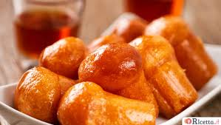
Manitoba flour 600 g | $ 1.31
Sugar 630 g | $ 0.78
Salt 10 g | -
Butter 200 g | $ 2.13
Fresh brewer's yeast 25 g | $ 0.96
Rum 300 g | $ 3.07
Tot for 25 pieces | $ 11.44
Babà al Rum | AP | YIELD | EP | FOOD % | Selling Price
3 units per dish (11.44/25 x 3) = | $ 1.37 | 100 % | $ 1.37 | 228 % | $ 6.00
- Potatoes & Peppers 430 calories per serving
INGREDIENTS - Doses for: 4 people
By https://ricette.giallozafferano.it/Patate-e-peperoni.html
Potatoes 800 g | $ 2.17 | 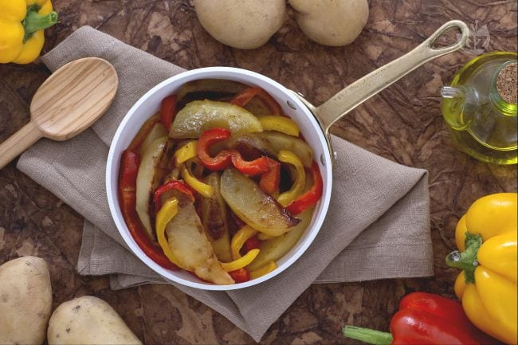
Extra virgin olive oil 140 ml | $ 1.39
Salt 10 g | -
Yellow peppers 300 g | $ 2.63
Red peppers 300 g | $ 2.63
Tot for 4 people | $ 8.82
Potatoes & Peppers | AP | YIELD | EP | FOOD % | Selling Price
Individual Portion (8.82/4) = | $ 2.20 | 61 % | $3.60 | 60 % | $ 6.00
- Meatloaf & Stuffed Heart & Vegetables Saute' 826 calories per serving
INGREDIENTS - Doses for: 4 people
By https://cucina.fanpage.it/polpettone-con-cuore-ripieno-di-mozzarella/
By https://www.centercutcook.com/sauteed-vegetables/
Ground beef 500 gr | $ 5.70 | 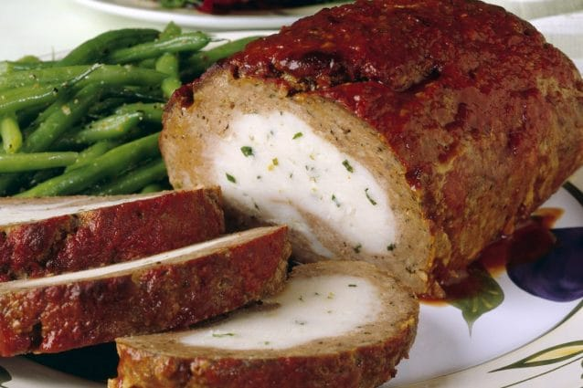
Mozzarella 400 gr | $ 6.30
Eggs 1 | $ 0.26
White bread 4 slices | $ 0.66
Milk 100 ml | $ 0.24
Parmesan 50 gr | $ 1.99
Salt as needed | $ 0.25
Pepper as needed | $ 0.25
Garlic as needed | $ 0.25
Chopped parsley as needed | $ 0.25
Extra virgin olive oil 15 ml | $ 0.15
1/2 head of cauliflower | $ 2.49
4 broccoli wreath | $ 1.24
3 carrots | $ 1.08
Tot for 4 people | $ 21.11
Meatloaf & Stuffed Heart & vegetables | AP | YIELD | EP | FOOD % | Selling Price
Individual Portion (21.11/4) = | $ 5.27 | 85 % | $ 6.20 | 34 % | $ 18.00
- Spaghetti Aglio Olio & Peperoncino 462 calories per serving
INGREDIENTS - Doses for: 4 people
By https://www.lacucinaitaliana.it/ricetta/primi/spaghetti-aglio-olio-e-peperoncino/
Spaghetti 454 g | $ 1.88 | 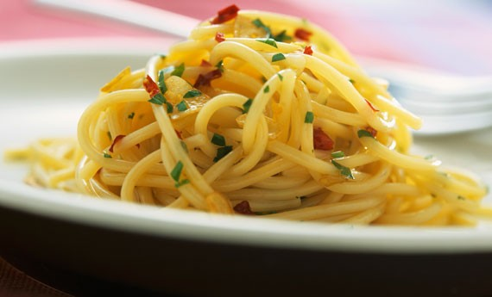
Cloves Garlic 3 | $ 0.25
Salt 10 g | -
fresh chilli 3 | $ 0.86
Extra virgin olive oil 150 g | $ 1.57
Tot for 4 people | $ 4.56
Spaghetti Aglio Olio & Peperoncino | AP | YIELD | EP | FOOD % | Selling Price
Individual Portion (4.56/4) = | $ 1.14 | 100 % | $ 1.14 | 10 % | $ 11.00
- Mediterranean Aubergine Rolls 123 calories per serving
INGREDIENTS - Doses for: 4 people
By https://ricette.giallozafferano.it/Involtini-di-melanzane-alla-mediterranea.html
Long aubergines (8 slices) 240 g | $ 0.88 | 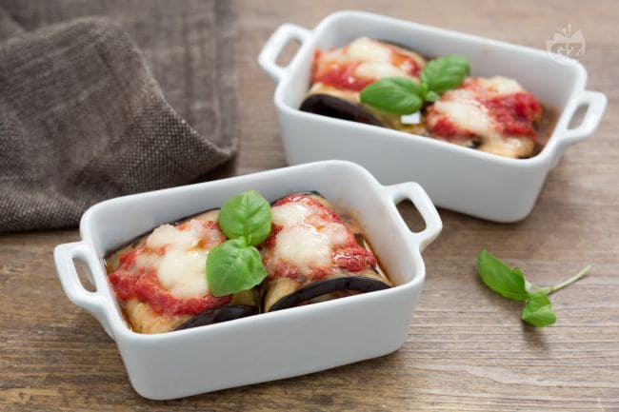
Mozzarella 200 g | $ 3.70
Tomato sauce 400 ml | $ 1.08
Pitted olives 30 g | $ 0.38
Basil 8 leaves | $ 0.16
Garlic 2 clove | $ 0.07
Extra virgin olive oil 4 tbsp | $ 0.60
Salt as need | $ 0.25
Black pepper as need | $ 0.25
Tot for 4 people | $ 7.37
Mediterranean Aubergine Rolls | AP | YIELD | EP | FOOD % | Selling Price
Individual Portion (7.37/4) = | $ 1.84 | 95 % | $ 1.93 | 38 % | $ 5.00
- Onion Soup Au Gratin 848 calories per serving
INGREDIENTS - Doses for: 4 people
By https://ricette.giallozafferano.it/Zuppa-di-cipolle-gratinata.html
Golden onions 500 g | $ 1.85 | 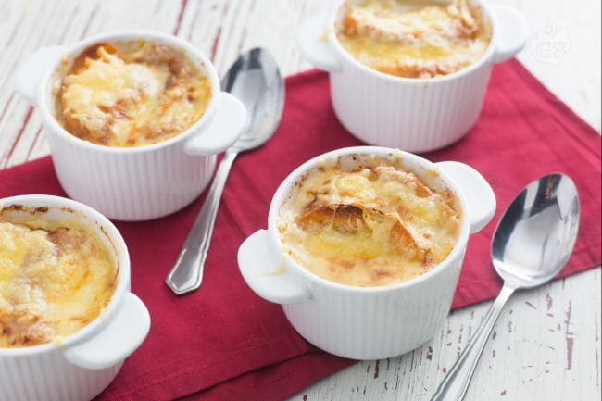
Beef broth about 1 L | $ 1.10
Butter 50 g | $ 0.43
Extra virgin olive oil 30 g | $ 0.36
Semolina flour 00 20 g | $ 0.08
Sugar 5 g | $ 0.01
Black pepper as need | $ 0.25
Salt as need | $ 0.25
8 slices baguette | $ 1.32
Emmental cheese 100 g | $ 2.50
Tot for 4 people | $ 8.15
Onion Soup Au Gratin | AP | YIELD | EP | FOOD % | Selling Price
Individual Portion (8.15/4) = | $ 2.03 | 90 % | $ 2.25 | 37 % | $ 6.00
- Spaghetti Amatriciana 721 calories per serving
INGREDIENTS - Doses for: 4 people
By https://ricette.giallozafferano.it/Spaghetti-all-Amatriciana.html
Spaghetti 454 g | $ 1.88 | 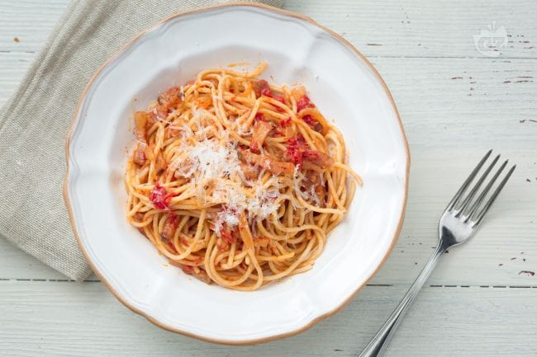
Peeled tomatoes 1 tin of 796 g | $ 1.38
Pancetta 150 g | $ 5.98
Grated Pecorino Romano 75 g | $ 2.99
Salt as need | $ 0.25
Extra virgin olive oil as needed | $ 0.36
Fresh chilli 1 | $ 0.29
White wine 50 ml | $ 0.66
Tot for 4 people | $ 13.79
Spaghetti Amatriciana | AP | YIELD | EP | FOOD % | Selling Price
Individual Portion (13.79/4) = | $ 3.44 | 100 % | $ 3.44 | 24 % | $ 14.00
- Pasta with Peppers Cream 397 calories per serving
INGREDIENTS - Doses for: 4 people
By https://ricette.giallozafferano.it/Pasta-con-crema-di-peperoni.html
Penne Rigate 454 g | $ 1.88 | 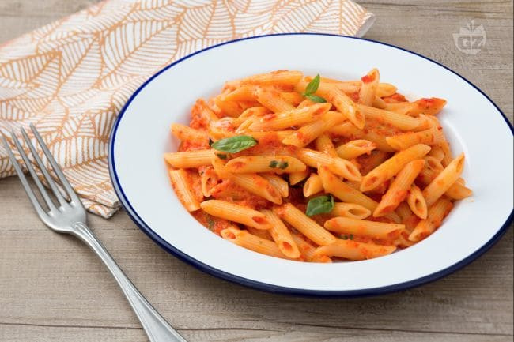
Red peppers 400 g | $ 3.50
Grape Tomatoes 250 g | $ 5.12
Garlic 1 clove | $ 0.04
Basil as need | $ 0.08
Extra virgin olive oil as need | $ 0.36
Salt up as need | $ 0.25
Black pepper as need | $ 0.25
Tot for 4 people | $ 11.48
Pasta with Peppers Cream | AP | YIELD | EP | FOOD % | Selling Price
Individual Portion (11.48/4) = | $ 2.87 | 85 % | $ 3.37 | 21 % | $ 16.00
Sources of research used for recipes and calculation of the calories of each dish:
Recipes:
https://ricette.giallozafferano.it/
https://www.buonissimo.it/lericette/
https://cucina.fanpage.it/
https://ricetta.it/
“Voglia di cucinare L’Enciclopedia della Cucina”. Giunti Demetra 1 October 2008 edition
https://www.bbcgoodfood.com/recipes/
https://www.elephantasticvegan.com/
https://www.centercutcook.com/
https://ricette.donnamoderna.com/
https://primiveloci.it/
https://thefoodellers.com/it/
https://www.lacucinaitaliana.it/ricetta/
Calories:
https://www.fatsecret.com/calories-nutrition/generic/
https://www.fatsecret.it/calorie-nutrizione/
Exhibit n. 2 Labor Costs And Indiret Costs
INDIRECT COSTS: | MY FIXED COSTS FOR THE MONTH
ADVERTISING/MARKETING COSTS
Advertising costs only for menu printing. A menu costs between 25/30 dollars. Calculation of 50 menus. | $ 1,000.00
CHEF
Based on the hourly value of the Chefs, calculating an average of 10 hours a day. The result is $ 20.00 x 10 = $ 200.00 per day for 6 days of weekly work for a total of $ 1.200.00 dollars per week x 4 weeks of the salary month of about $ 4.800.00. | $ 4,800.00
LABOR COSTS
(The average pay for a Waiter/Waitress is $10.29 per hour)
Based on the hourly value of the waiters calculating 8 hours a day for 4 full-time waiters, and 2 (4 hours a day) for 2 part-time waiters. The result is $ 82.32 / 8 hours per day for 6 days of weekly work for a total of $ 493.92 / week x 4 weeks of the month from a salary of around $ 1.975,68 rolled up to $ 2,000.00 / month each.  Part-time the result is $ 41.16 / 4 hr. per day for 6 days of weekly work for a total of $ 246.96 / week x 4 weeks of the month from a salary of around $ 987.84 rolled up to $ 1,000.00 / month each. | $ 10,000.00
(Average rate for a cook, restaurant in Vancouver, British Columbia is $ 14.38 per hour)  Based on the hourly value of the cook calculating an average of 8 hours / day for 4 full-time cooks. That translates to $ 115.04 / day for 6 days of weekly work from a total of $ 690.24 / week x 4 weeks of the month Salary of around $ 2,760.96 rounded to $ 2,800.00 / month each.  (The average rate for an assistant cook, restaurant in Vancouver, British Columbia is $ 12.42 per hour)  Based on the hourly value of line cooks, calculating an average of 4 hours / day for 2 part-time cooks. That translates to $ 49.68 / day for 6 days of weekly work from a total of $ 298.08 / week x 4 weeks of the month Salary of around $ 1,192.32 rounded to $ 1,200.00 / month each. | $ 13,600.00
MORTGAGE INTEREST OR RENT for Month | $ 13,000.00
SUPPLIES:
CLEANING SUPPLIES | $ 1,000.00
COOKING & KITCHEN SUPPLIES | $ 2,000.00
SERVICES & UTILITIES:
INTERNET/TELEPHONE/CABLE | $ 500.00
HEAT, GAS, ELECTRICITY, AND A/C | $ 1,000.00
PROFESSIONAL CLEANING/WINDOW WASHING | $ 2,000.00
FEES, FINES & TAXES:
TOTAL TAXES | $ 4,300.00
TOTAL INDIRECT COSTS | $ 53,200.00

All or Actual Cost Princing
As briefly mentioned in the section "Costs and prices" on page 08, using this method the costs are divided into units of food cost, labor and operations costs. For each item you have a dollar value, the desired food and labor costs. A desired percentage of profit is also established. The formula is the cost of food plus the cost of labor plus the operating cost plus the percentage of the established profit is 100% (or selling price). In this case, you must use actual costs, not percentages based on sales or sales price.
Based on the above:
The indirect monthly costs (including employees) are $ 53,200.00 per month.
Restaurant capacity 100 seats.
A forecast of 2 shifts, one for lunch and one for dinner, omitting the proceeds (between lunch and dinner) of the Happy Hour, from an average of 200 people / day.
Average cost / person $ 25.00 x 200 = $ 5,000.00 / day x 26 / days = $ 130,000.00
$ 130,000.00 - Incidence of 30% of food costs (A.P.) = $ 91,000.00
$ 91,000.00 - $ 53,200.00 of indirect monthly costs = $ 37,800.00
On this value we calculate 10% of the unquantified expenses =
$ 37,800.00 - 10% = $ 34,020.00
Expected monthly profit of $ 34,000.00.

References:
Web.
<https://www.glassdoor.ca/Salaries/vancouver-waiter-salary-SRCH_IL.0,9_IM972_KO10,16.htm>

Web.
<https://www.payscale.com/research/US/Job=Assistant_Cook/Hourly_Rate>

By from BibLus BIM – ACCA software. Date March 25, 2019. Web
<http://bim.acca.it/progetto-di-un-ristorante/>

By from BibLus BIM – ACCA software. Date March 25, 2019. Web
<http://bim.acca.it/progetto-di-una-cucina-per-ristorante/>

Trapletti Pittori Sagl. Date Agosto 19, 2019. Web
<http://www.traplettipittori.ch/pareti-dei-ristoranti/>

By Emma Liem Beckett. Date January 07, 2019
<https://www.restaurantdive.com/news/6-restaurant-trends-that-could-turn-tables-in-2019-1/545323/>

By Sean P. Thomas. Date June 5, 2019
<http://www.ladowntownnews.com/news/competition-and-concern-in-downtown-s-restaurant-market/article_ffec0538-8655-11e9-a8c1-332ff50a479c.html>

“HealthGuard”. Training And Education Services NSF.789 N. Dixboro Road, Ann Arbor, Michigan, USA. Version 7.1 print

Giallo Zafferano. “Ricette”. Apr 07, 2019. Web
<https://ricette.giallozafferano.it/Spaghetti-alle-vongole.html>

Interior Health. “Food safety plan”. August 2014. Web
<https://www.interiorhealth.ca/YourEnvironment/FoodSafety/Documents/Writing%20a%20Food%20Safety%20Plan.pdf>

Foraggio S.r.l. “Use and dosage of professional cleaning products”. 2016 Web
<https://www.foraggiosrl.it/uso-e-dosaggio-dei-4-prodotti-per-la-pulizia-professionale/>

Defir S.r.l. “Cleaner for ovens, grills and cooking plates”. 2016 Web
<https://www.defir.it/prodotto/axa-forni-sgrassante-superfici-cucina/>

Web
<https://www.payscale.com/research/CA/Job=Line_Cook/Hourly_Rate/5628c585/Vancouver-BC>

Iowa State University. “Standard Operating Procedures”. March 5, 2018 Web
<https://www.extension.iastate.edu/foodsafety/SOP-restaurant>

