Game Design Document

by Matthew Fong

Table of Contents
Genre & Platform 5
Essence Statement 5
Style & Tone 5
Design Pillars 5
Gameplay 5
Key Features 6
Time frame to build 6
Team Required 6
Market 6
Uniqueness 6
Platform 7
Engine 7
Camera 7
Game World 7
Story Synopsis 7
Additional Story Features 8
Gameplay 9
Structure 9
Abilities for Rue 10
Abilities for Player 10
Enemies/Abilities 12
Core Mechanics 12
Secondary Mechanics 12
AI Behaviours 12
Cinematics 13
Feature Brief 17
Rue 17
Abilities 17
Combat 17
Progression Systems 17
Assets 18
Items 18
Clothing/Armour 19
Special Earrings 19
Special Rings 19
Consumables 20
Blueprints 20
Weapons 20
Swords: 20
Bows/Crossbows 20
Enemies 25
Bosses 25
Mobs 26
Powers and Abilities 26
Abilities for Rue 26
Melee 26
Ranged 27
Level Design 27
UI/UX 27
In-Game UI 28
Menus 29
Controls & feedback 30
Art: 31
Sound: 32
Software: 32

Genre & Platform
PC – Steam

Essence Statement:
Rue is a 2D Action Adventure Platformer that puts an emphasis on recovering memories with the help of your dog companion Rue. Throughout the game you will defeat enemies that have fragments of your memory that you must recover. Discover your past and find out what is going on in this mysterious world.

Style & Tone
The game will feel like MapleStory, the whole aesthetic will be similar to a cartoon outlined type of drawings. The tone of the game will be of a bright setting but during sequences where you discover your past, it will have a black and white aesthetic with darker tones.

Design Pillars
- Exploration
- Combat
- Puzzle Solving
- Story

Gameplay
The goal of the game is to give players an experience of loss, I hope to achieve this by incorporating story elements that further this feeling. These story elements will include the main character losing his companion Rue at the end of the game, he loses her/him by recovering all of his lost memories. The companion is a vital part of the character’s personality and thoughts as Rue is just his imagination and not an actual living entity in the world. The reason that the character has a close affinity to Rue is that Rue was a stray dog in the main characters’ past that would always provide comfort and affection but would later pass away due to an illness.

The mechanics of the game have combat similar to that of MapleStory and Hollow Knight, Upgrades and Abilities can be unlocked via collecting experience. Weapons and Items can be found via loot drops from enemies and puzzles in the game include the player able to access areas with the help of Rue, and Unblock me like puzzles for unlocking doors and keypads.

Key Features
- Your Ai follower Rue will be your companion throughout the game.
- Art Style in the form of Outlined Cartoons.
- Combat will feature different weapons and clothing items that give buffs and debuffs to the player.
- Ability to command Rue to solve puzzles and access areas.

Time frame to build
- 6-9 months

Team Required
- Artists
- Programmers

Market
The game will be marketed towards fans of MapleStory and people who love Action-Adventure games with a story. Players will find that by playing my game, they will connect to something that they’ve lost or felt like they’ve lost something.

Uniqueness
My game is different because it utilizes a companion that is able to complete levels and that is vital to gameplay. Rue will help players in combat as well as serving as an extra tool used for combat.

Platform
- PC - Steam,
- In the future, a port to the Nintendo Switch and PS4

Engine
The game will be made in Unity using C#.

Camera
- 2D
- Side-Scrolling

Game World
The setting of the game will take place on an island in the Sky. The reason for this is because I want the game to have a fantasy element to it. The backstory for this island is that the government wanted to make an experimental location where no one would be able to access thus creating the first-ever floating Island that is home to various experiments and creatures.
Characters in the game consist of the main character who’s canon name is Ushi but the name can be picked by the player. Rue who is your companion and ai follower throughout your journey. Other NPCs in the game (including bosses and creatures that drop loot and experience).
Together with your dog Companion Rue, you journey towards an open world in which you can tackle any boss you’d like first. Amongst the bosses are the Limbo, an organization that is based upon the ideas of the seven deadly sins. Travelling to different parts will lead you to levels that have a theme associated with one of the deadly sins in that area. Defeating one of them will give you a memory fragment plus an item that they hold dear.

Story Synopsis
You wake up on a mysterious floating island with no recollection of your past and how you got to this island. A dog comes up to you and starts talking to you, the dog’s name is Rue. Rue gives you a rundown of how everything on the island works, it’s backstory and serves as a tutorial for the player at the beginning. Thereafter, the journey begins in which you must recover all 7 fragments of your memory in order to find out your purpose and past.
Adventuring leads you to fight each deadly sin and by defeating them, gives you a fragment of a memory, this memory fragment is disoriented and warped with each collection, adding to the overall mystery aspect and not providing a solid resolution until the player has gathered all their memory fragments. The memory in which the player will come to is from a story, the backstory for the memory is that you were forced as a young child to work as a slave for a Lord of a land. The world in which you were a slave is before the building of the floating city, in this world, you are not allowed to run outside the Walls protecting the city because there is an infection outside that turns humans into horrible creatures. (For someone to be infected they must inherit a seven deadly within their soul, you are an exception as you have Rue who is a pure being not given any innate sin.) Anybody that does try to get out will be killed on sight.
One day after receiving abuse from your Lord and then subsequently being kicked out, you decide to go steal some food to survive for the night and while stealing food from a vendor, you go into an alleyway, there you see a starving dog. You give the dog some of the food you stole and in return, the dog shows you a distant land through a hole in the wall that shows freedom and life safe from any infection. You devise a plan to break out of the confines of the walls and your slave owner, you breakout by going through a small tunnel that Rue has been digging at since before you met. After going through the small tunnel, you make it to the outside of the walls, finally, you taste freedom but not for long. A guard from a watchtower sees you and says to shoot you on sight, you run as fast as you can slowly reaching what appears to be a bunker, you make it but soon find that Rue has sustained injuries, unable to stop any sort of bleedings, Rue passes away in your arms, after this some mysterious guards come to you and restrain you, separating you from Rue and yourself and then knocking you out. The guards then take you to an experimental chamber and from then on teleport you to where the story starts, the floating city.
The memories play a distortion of when Rue dies, the guards and the escape. When the player collects all their memories and the memory plays, Rue who has actually been a hallucination the whole time disappears with a smile saying “you’re free now”. The game ends with a view of the distant land that you and Rue saw past the walls.

Additional Story Features
If you step outside of the walls you are forced to do one of the seven deadly sins which in turn transforms you into a monster
The floating city in this is made by the higher-ups to get away from the infection.
Slaves were used to building this floating city, Rue points towards the floating city as a paradise free from anything.
The floating city is a lie and is actually overrun with the infected, the people who forced the slaves to make this floating city are infected.
Because Rue is a pure being, they can grant the player protection from the curses and infections that roam the world and this is why the player is immune to all corruption.

Gameplay

Structure
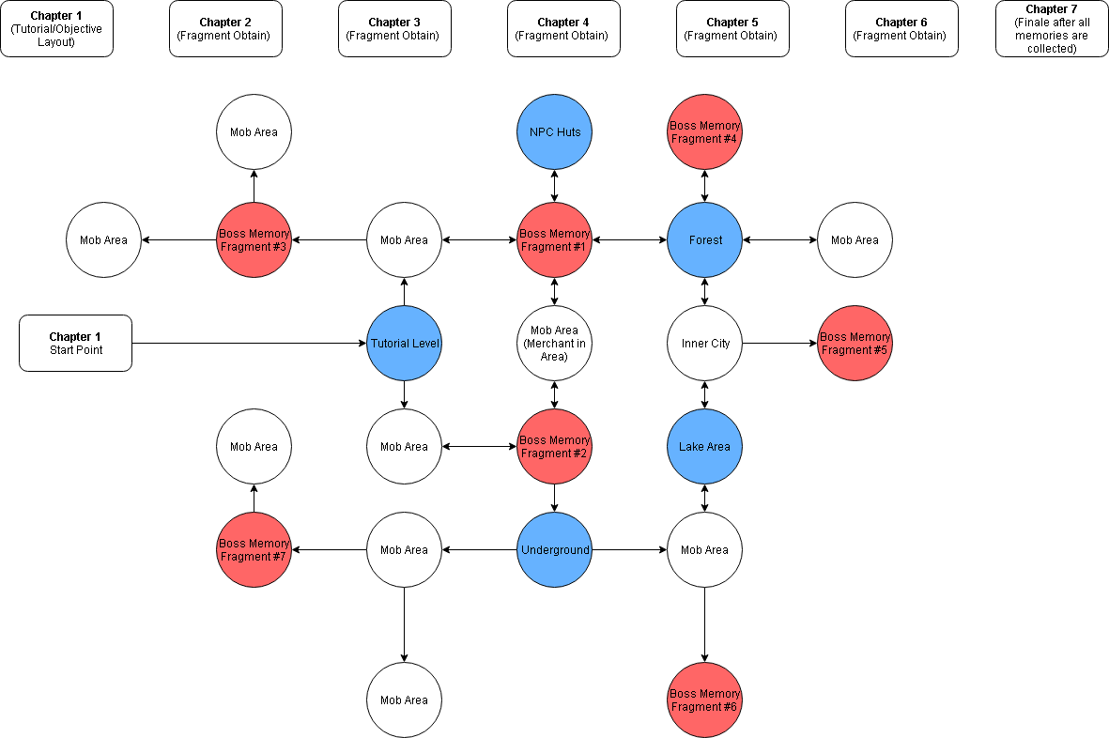
  - The game will have 7 Chapters in total spanning across different regions and areas within the game. These areas are in a similar vein to a Metroidvania style game such as Hollow Knight.

  - Chapters are broken down into how many fragments you have obtained.
  - Abilities within the game can be unlocked after levelling up, players will be shown on their screen two abilities, one for Range and one for Melee. These abilities are broken up into tiers based on how much damage they deal. Players can only choose one of these abilities per tier.

Abilities for Rue (Starting Health is 100)
    - Basic Attack (5 Attack then progresses x 1.50 each level)
    - Tornado Tail (10 Attack) Cooldown 3 sec
    - Quick Attack (8 Attack) Cooldown 2 sec
    - Howl (Stuns enemies for 5 Sec) Cooldown 6 Sec
    - Double Cross (15 Attack) Cooldown 6 Sec
    - Crunch (50 Attack) Cooldown 10 Sec

Abilities for Player (Starting Health is 100)
Melee:
    - Basic Attack (5 Attack)
    - Smash (20 Attack) Cooldown 1.5 sec
    - Rush (30 Attack) Cooldown 2 Sec
    - Grave Strike (45 Attack) Cooldown 3 Sec
    - Warp Strike (60 Attack) Cooldown 6 Sec
    - Life Strike (70 Attack) Cooldown 10 Sec
    - Sundering Blow (140 Attack) Cooldown 30 sec
    - Earth Split (Melee 1000 Attack) Cooldown 120 Sec

Ranged:
    - Basic Attack (3 Attack)
    - Fire Shot (6 Attack) Cooldown 1.5 sec
    - Lightning Shot (12 Attack) Cooldown 2 Sec
    - A barrage of Arrows (30 Attack) Cooldown 3 sec
    - Release (50 Attack) Cooldown 10 sec
    - Snapshot (200 Attack) Cooldown 10 sec
    - Searing Shot (1000 Attack) Cooldown 120 sec

Character | Ability | Range or Melee | Damage (x 5% per level) | Cooldown | Effect
Rue | Basic Attack | Melee | 5 Attack | 0 sec | A basic attack
Rue | Tornado Tail | Melee | 10 Damage | 3 sec | Rue summons a vortex of wind
Rue | Quick Attack | Melee | 8 Damage | 2 sec | Rue dashes Quickly
Rue | Howl | Range | 0 | 6 sec | Rue stuns enemies within range
Rue | Double Cross | Melee | 15 Damage | 6 sec | Rue Slashes the enemy from side to side
Rue | Crunch | Melee | 50 Damage | 10 sec | Rue bites the enemy
MC | Basic Attack | Range | 5 Attack | 0 sec | A basic attack
MC | Fire Shot | Range | 6 Damage | 0.5 Sec | Sends of a fiery arrow
MC | Lightning Shot | Range | 12 Attack | 1 Sec | A lightning shot
MC | Barrage of Arrows | Range | 30 Attack | 2 Sec | Multiple arrows are fired off at once
MC | Release | Range | 50 Attack | 5 Sec | A powerful charged shot
MC | Snapshot | Range | 200 Attack | 7 Sec | A quick flash like shot
MC | Searing Shot | Range | 1000 Attack | 120 Sec | A shot that pierces the heavens
MC | Basic Attack | Melee | 5 Attack | 0 Sec | A Basic Attack
MC | Smash | Melee | 20 Attack | 1.5 Sec | Smashes the ground with brute force
MC | Rush | Melee | 30 Attack | 2 Sec | A quick attack that sends the player forward towards the target
MC | Grave Strike | Melee | 40 Attack | 3 Sec | Sends enemies enemies towards the air and then finishing them off on the ground
MC | Warp Strike | Melee | 60 Attack | 6 Sec | Warps the player towards the target
MC | Life Strike | Melee | 70 Attack | 10 Sec | Heals the player
MC | Sundering Blow | Melee | 140 Attack | 30 Sec | A powerful attack with no effect
MC | Earth Split | Melee | 1000 Attack | 120 Sec | Smashes the ground in two for a powerful attack

Enemies/Abilities
  - Wrath Mobs:
    - Distorted Sword users that deal damage close quarters
  - Envy Mobs:
    - Enemies that look like you, attacks using elemental abilities.
  - Sloth Mobs:
    - Big enemies that deal massive damage when the player gets near their close range of attacks.
  - Gluttony Mobs:
    - Big Enemies that move slowly, deals damage by sending out waves of range attacks.
  - Greed Mobs:
    - Invisible enemies that attack the player by surprise. Deals damage by using a close-quarter knife and range attacks.
  - Pride Mobs:
    - Enemies that use rapiers and spells to deal damage to the player, really high level.
  - Lust Mobs:
    - Enemies that use elemental abilities and status effects to stun the player.
  - When levelling up, it gives you an option to choose from 2 abilities.

Core Mechanics
  - Experience Points System
  - Mana points, Health Points and how much health is regenerated per sec
  - Defence mitigates the amount of damage the user is to receive.
  - Combat system with combos utilized with different abilities.
  - Command Rue with a button.

Secondary Mechanics
  - Pick up loot from enemies that you’ve killed
  - Gain Exp from killed enemies
  - Level up when gaining enough exp

AI Behaviours:
  - When the player presses a button, it sends Rue to the front or back of the player making protecting the player from behind or in front.
  - Pressing the button for Rue’s ability sends them to use the ability wherever the player is facing.
  - Enemies will attack on sight or when the player gets too close.
  - There will be about 3 animations each for every enemy in the game (Idle, Fighting, Hurt), not including bosses.

Cinematics

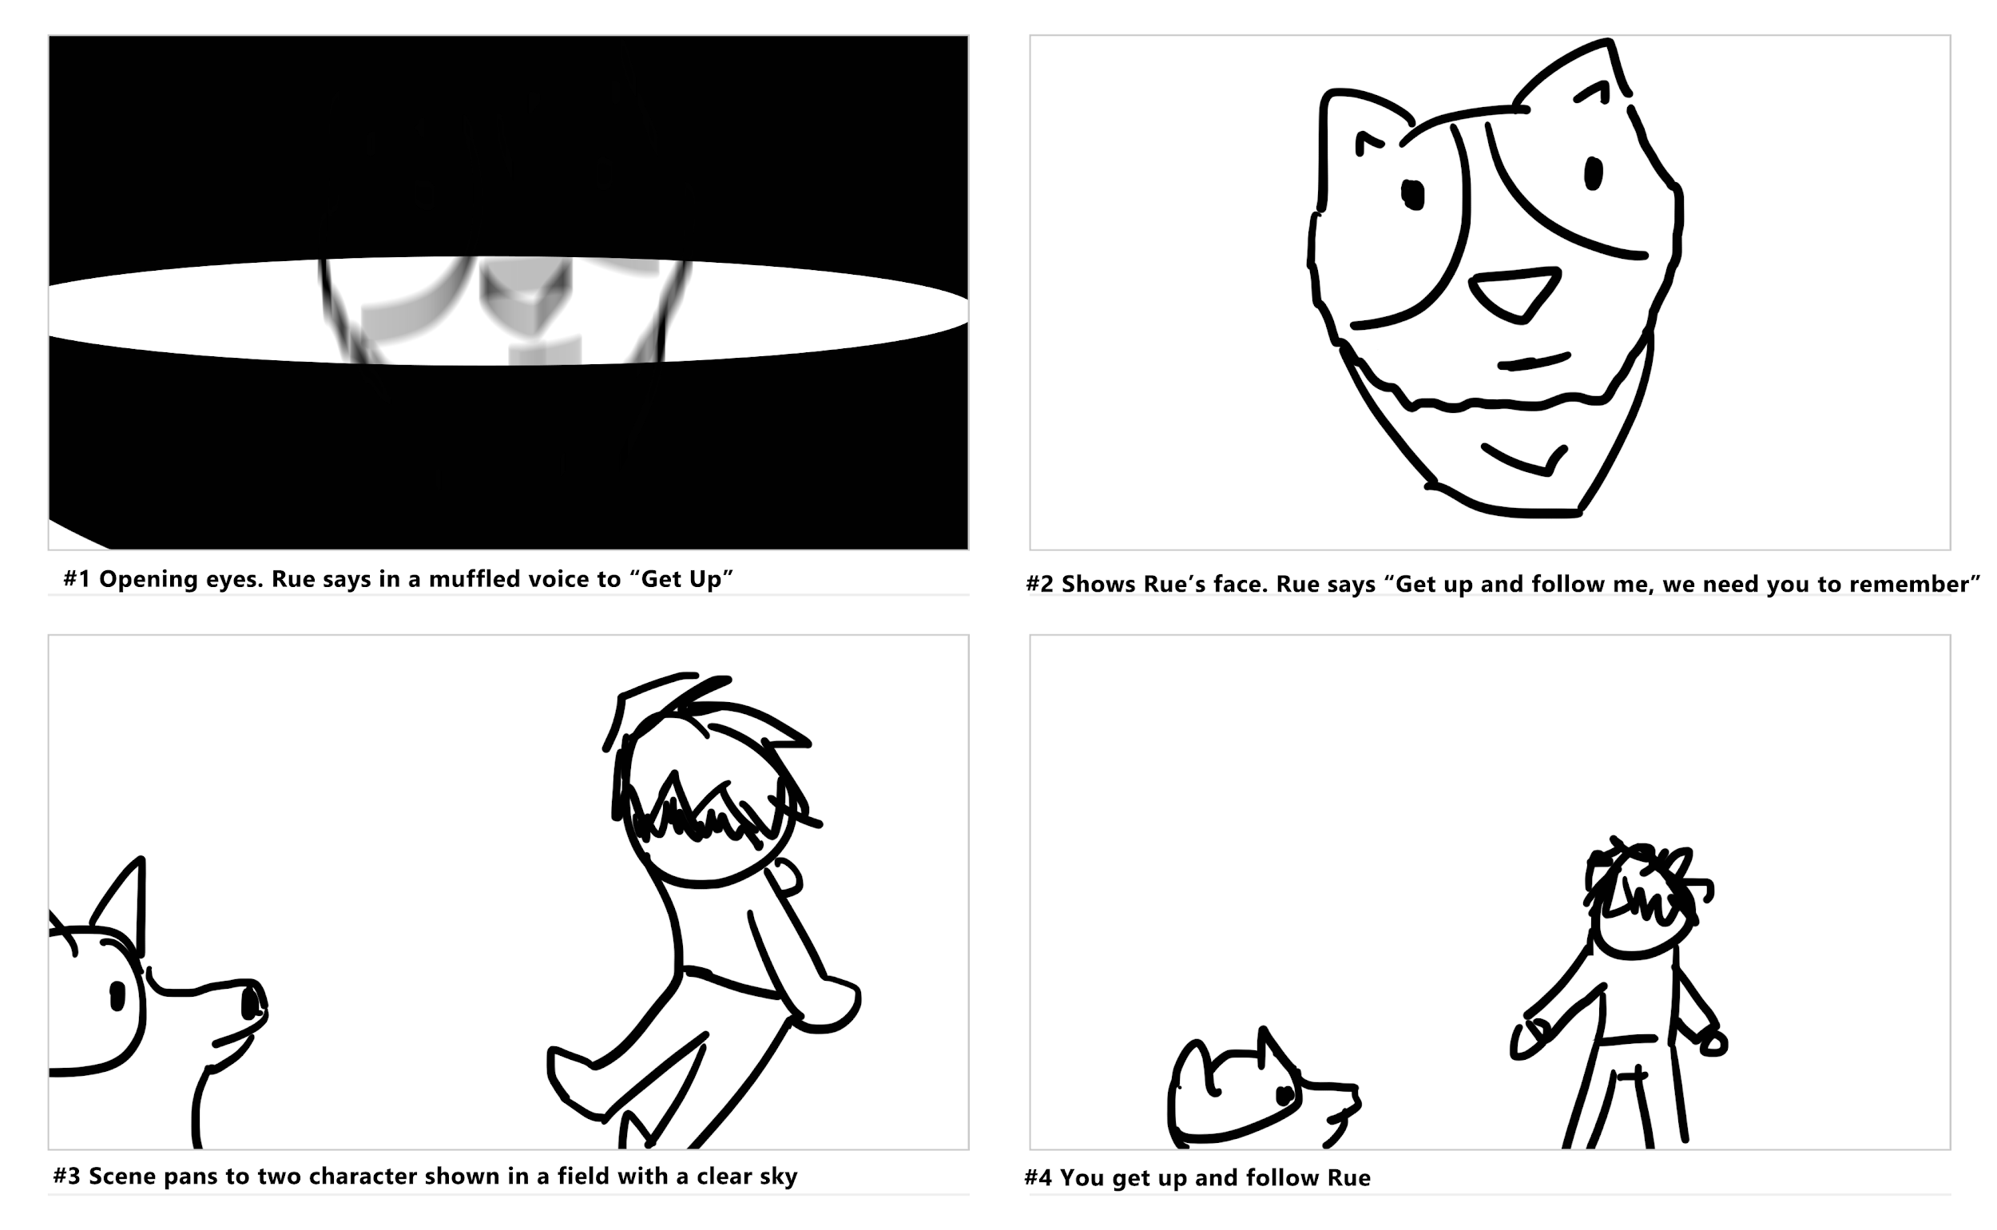

There will be two cinematics, one for the intro of the game and one for the memories that are played throughout the game. The first cinematic on top shows the player waking up and being introduced to Rue and thus leading the player to follow Rue.

The second cinematic details the various memories the player will encounter, these will not be played in the exact order as shown due to each boss having different fragments of the memory. Collecting the fragments of memories will show a distorted version of the cinematic. When the player has collected all the fragments, the true full memory will be played out as detailed below.
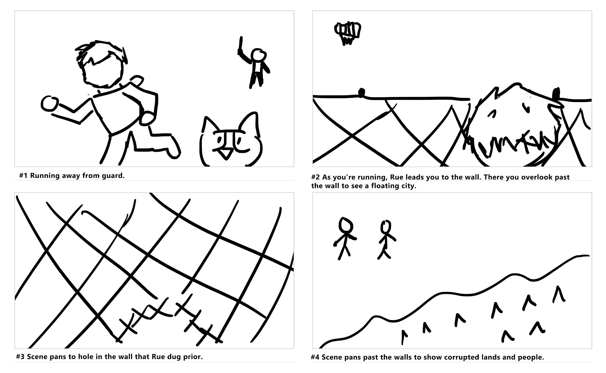
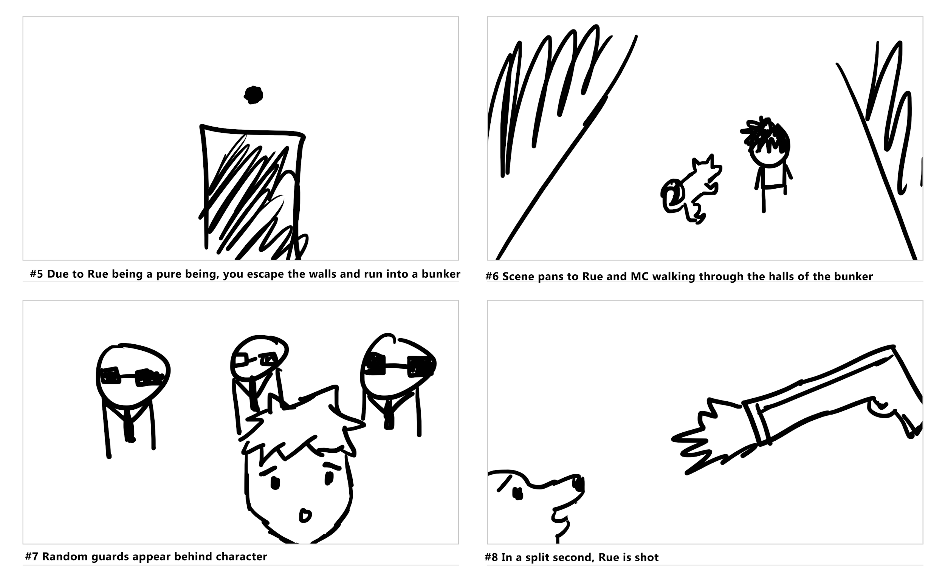
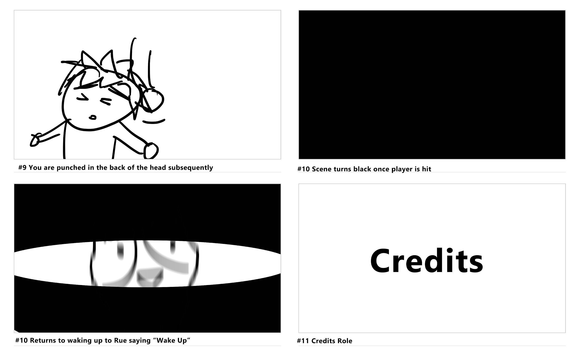

Feature Brief

Rue
Your Ai follower Rue will be your companion throughout the game. You have the ability to command Rue to the front or back to block damage from behind or in front.

Abilities
Abilities deal different types of damage and cause status effects that affect enemies. Rue’s abilities and the player’s abilities are different in attack damage and cooldowns.

Combat
Combat will feature different weapons and clothing items that give buffs and debuffs to the player. The player will be able to do a basic attack that increases in damage with each level the player goes up.
Player Basic Attack Damage | Rue Basic Attack Damage | Level
3 | 5 | 1
4.5 | 7.5 | 2
6.75 | 10.875 | 3
10.125 | 16.312 | 4
15.187 | 24.468 | 5
3,037.40 | 4,893.60 | 100

Progression Systems
The progression in my game comes from the levelling up system and the progression of the story. When you start the game you will be level 1 with no items, as the game progresses you will be significantly stronger as you defeat enemies and bosses. Bosses will be harder to beat as they have a very high level as compared to the mobs you will be facing before them, the reason for making the bosses level much higher is because it halts the player from feeling too overpowered all the time and allows for difficulty spikes in their gameplay. This type of progression can be found in a lot of 2D RPGs, MapleStory does this the same way in which a lot of the classes start off at level 1 and then progressively get stronger as you play with spikes of difficulty in between.
This progression table shows what level the bosses you encounter will be plus the minimum level required to beat them. The table from the feature brief is helpful in showing what’s to be expected of boss time completion and how much damage is dealt with.

Boss Name | Boss Level | Boss Health | Minimum Player Level Required
Gekido | 20 | 5,000 | 18
Donyoku | 30 | 15,000 | 28
Shitto | 40 | 75,000 | 38
Taida | 50 | 200,000 | 48
Boushoku | 60 | 500,000 | 58
Kouman | 70 | 1,500,000 | 68
Nikuyoku | 80 | 5,000,000 | 78

Assets

Items
Items in the game will be broken down into different categories, Clothing/Armour, Special Earrings, Special Rings, Consumables, Blueprints, Weapons. Each of these items will have stats associated that will add or decrease points to the character's overall stats.

The Attributes in the game consists of Health, Mana, Regen, Defense and Attack. Clothing/Armour will give the player bonuses to their Regen and Defense. Special Earrings give bonuses to Health, Regen and Mana, Rings gives bonuses to Attack and Defense, Consumables can be used as quick items to gain health or apply buffs, Blueprints are collectible items that can be used to craft new and unique armour. And Various weapons in the game can give the player an increased amount of Attack Damage.

Clothing/Armour
  - Bronze Plated Hoodie: +10 Defense
  - Iron Plated Hoodie: +20 Defense
  - Hooded Vest +30 Defense
  - Angelic Hoodie: +50 Regen
  - Armoured Cloak: +20 Regen + 50 Defense
  - Wrath Armour: +120 Defense
  - Sloth Coat: +50 Regen
  - Chestplate of Memories: +5 Regen +100 Defense
  - Chestplate of timeless nightmares:+10 Regen +200 defense

Special Earrings
  - Feather Earrings: +20 mana
  - Steel Earrings: +50 Health
  - Fuzzy Earrings: +40 Health, +30 Mana
  - Double Ring Earrings: +20 Regen, +20 Health
  - Earrings of Divine Dreams: +100 Mana
  - Protection Earrings: +100 Health
  - Earrings of Blind Memories: +100 Regen
  - HolyEarrings: +60 Mana, +40 Regen
  - Frenzied Earrings: +40 Mana, +20 Regen
  - Greedy Earrings: +50 Health, +50 Regen, +50 Mana

Special Rings
  - Iron Ring: +10 Defense
  - Enchanted Ring: +10 Attack
  - Barbaric Ring: +30 Attack
  - Padded Ring: +30 Defense
  - Dark Void Ring: +60 Attack
  - Shielded Ring: +60 Defense
  - Failsafe Ring: +10 Defense, +10 Attack
  - Invisible Ring: +20 Defense, +20 Attack
  - Envious Ring: +30 Defense +50 Attack

Consumables
  - Glutinous fruit: Unlimited uses, heals ¼ of HP, Cooldown: 60 Sec
  - Ominous Fruit: +35 Health
  - Tasty Mushroom: +10 Health
  - Sour Fruit: +20 Health
  - Roasted Chicken: +50 Health
  - Mysterious Mushroom: Grants the player a random permanent boon of either +5 Attack, +5 Defense or +5 Regen.
  - Charred Skewer: +15 Health
  - Frozen Pendant: Summons an Ice Monster to aid in battle. Discarded when consumed.
  - Foresight fruit: Slows down time for 15 Seconds. Discarded when consumed.
  - Strength Potion: Grants the player +200 Attack for 10 Seconds.

Blueprints
  - Rue Hoodie: gives the player a hoodie that looks like Rue +35 Defense
  - Skybound Blade: a blade forged on the tallest mountain of the City. +200 Attack
  - Rue Armour: Costume Armour for Rue.
  - Flying Sphere: Grants the ability to fly for 10 seconds.

Weapons

Swords:
  - Iron Sword: +5 Attack
  - Chain Sword: +10 Attack
  - Frenzied Sword: +20 Attack
  - Ominous Scimitar: +30 Attack
  - Sword of the lion: +50 Attack
  - Volcanic Rapier: +70 Attack
  - Lightbringer: +85 Attack
  - Prideful Blade: +100 Attack
  - Soulless Memory: +120 Attack

Bows/Crossbows:
- Wooden Bow: +5 Attack
- Hardwood Recurve Bow: +10 Attack
- Hardwood Spear Gun: +30 Attack
- Maple LongBow: +40 Attack
- Longbow of Mystery: +60 Attack
- Ebon Compound Bow: +75 Attack
- Forgotten Gun: +90 Attack
- Bullseye: +110 AttackItem Chart:
Item | Type | Attack | Defence | Special Status
Bronze Plated Hoodie | Clothing/Armour | 0 | +10 Defense | None
Iron Plated Hoodie | Clothing/Armour | 0 | +20 Defense | None
Hooded Vest | Clothing/Armour | 0 | +30 Defense | None
Angelic Hoodie | Clothing/Armour | 0 | 0 | +50 Regen
Armoured Cloak | Clothing/Armour | 0 | +50 Defense | +20 Regen
Sloth Cloat | Clothing/Armour | 0 | +120 Defense | None
Chestplate of Memories | Clothing/Armour | 0 | +100 Defense | +5 Regen
Chestplate of timeless nightmares | Clothing/Armour | 0 | +200 Defense | +10 Regen
Feather Earrings | Special Earrings | 0 | 0 | +20 Mana
Steel Earrings | Special Earrings | 0 | 0 | +50 Health
Fuzzy Earrings | Special Earrings | 0 | 0 | +40 Health. +30 Mana
Double Ring Earrings | Special Earrings | 0 | 0 | +20 Regen, +20 Health
Earrings of Divine Dreams | Special Earrings | 0 | 0 | +100 Mana
Protection Earrings | Special Earrings | 0 | 0 | +100 Health
Earrings of Blind Memories | Special Earrings | 0 | 0 | +100 Regen
Holy Earrings | Special Earrings | 0 | 0 | +60 Mana, +40 Regen
Frenzied Earrings | Special Earrings | 0 | 0 | +40 Mana, +20 Regen
Greedy Earrings | Special Earrings | 0 | 0 | +50 Health, +50 Regen, +50 Mana
Iron Ring | Special Ring | 0 | +10 Defense | None
Enchanted Ring | Special Ring | +10 Attack | 0 | None
Barbaric Ring | Special Ring | +30 Attack | 0 | None
Padded Ring | Special Ring | 0 | +30 Defense | None
Dark Void Ring | Special Ring | +60 Attack | 0 | None
Shielded Ring | Special Ring | 0 | +60 Defense | None
Failsafe Ring | Special Ring | +10 Attack | +10 Defense | None
Invisible Ring | Special Ring | +20 Attack | +20 Defense | None
Envious Ring | Special Ring | +30 Attack | +30 Defense | None
Glutinous Fruit | Consumables | 0 | 0 | Unlimited uses heals ¼ of HP, Cooldown: 60 Sec
Ominous Fruit | Consumables | 0 | 0 | +35 Health
Tasty Mushrooms | Consumables | 0 | 0 | +10 Health
Sour Fruit | Consumables | 0 | 0 | +20 Health
Roasted Chicken | Consumables | 0 | 0 | +50 Health
Mysterious Mushroom | Consumables | 0 | 0 | Grants the player a random permanent boon of either +5 Attack, +5 Defence or +5 Regen.
Charred Skewer | Consumables | 0 | 0 | +15 Health
Frozen Pendant | Consumables | 0 | 0 | Summons an Ice Monster to aid in battle. Discarded when consumed.
Foresight Fruit | Consumables | 0 | 0 | Slows down time for 15 Seconds. Discarded when consumed.
Strength Potion | Consumables | 0 | 0 | Grants the player +200 Attack for 10 Seconds.
Rue Hoodie | Blueprints | 0 | +35 Defense | gives the player a hoodie that looks like Rue.
SkyBound Blade | Blueprints | +200 Attack | 0 | a blade forged on the tallest mountain in the City.
Rue Armour | Blueprints | 0 | 0 | Costume Armour for Rue.
Flying Sphere | Blueprints | 0 | 0 | Grants the ability to fly for 10 seconds.
Iron Sword | Swords | +5 Attack | 0 | None
Chain Sword | Swords | +10 Attack | 0 | None
Frenzied Sword | Swords | +20 Attack | 0 | None
Ominous Scimitar | Swords | +30 Attack | 0 | None
Sword of the Lion | Swords | +50 Attack | 0 | None
Volcanic Rapier | Swords | +70 Attack | 0 | None
Lightbringer | Swords | +85 Attack | 0 | None
Prideful Blade | Swords | +100 Attack | 0 | None
Soulless Memory | Swords | +120 Attack | 0 | None
Wooden Bow | Bows/Crossbows | +5 Attack | 0 | None
Hardwood Recurve Bow | Bows/Crossbows | +10 Attack | 0 | None
Hardwood Spear Gun | Bows/Crossbows | +30 Attack | 0 | None
Maple LongBow | Bows/Crossbows | +40 Attack | 0 | None
Longbow of Mystery | Bows/Crossbows | +60 Attack | 0 | None
Ebon Compound Bow | Bows/Crossbows | +75 Attack | 0 | None
Forgotten Gun | Bows/Crossbows | +90 Attack | 0 | None
Bullseye | Bows/Crossbows | +110 Attack | 0 | None

Enemies

Bosses:

(Gekido) - Wrath
  - Close ranged attacks deal damage with a sword.
  - Large Enemy 2x bigger than the player
  - Can Jump in the air to do an AoE attack
  - Medium Movement, Medium Attack Speed, Medium Damage

(Donyoku) - Greed
  - Close ranged attacks deal damage with two daggers
  - Same Size as player
  - It can harden as protecting himself with silver or gold.
  - Fast Movement, Fast Attack Speed, Low damage

(Shitto) - Envy
  - Long Ranged Attacks, deals damage with a bow and arrow
  - Same Size as player
  - Can make multiples clones of itself
  - Fast Movement, Medium Attack Speed, Medium Damage

(Taida) - Sloth
  - Short Ranged Attacks, deals damage with two pillars
  - 5x Bigger than the Player
  - It can make shockwaves on the ground that bring down debris from the sky.
  - Slow movement, Slow Attack Speed, High Damage

(Boushoku) - Gluttony
  - Short Ranged Attacks, deals damage with a large Bone
  - 3x Bigger than the player
  - Can eat to regain health every 30 seconds
  - Slow movement, Medium Attack Speed, High Damage

(Kouman) - Pride:
  - Long Ranged Attacks, deals damage with tendrils
  - Smaller than the player like a child
  - Can cover the screen in darkness to blind the player
  - Medium Movement, Slow Attack Speed, High Damage

(Nikuyoku) - Lust
  - Long Ranged Attacks, deals damage with poisonous gas
  - Same size as the player
  - Can deploy poison gas pockets and if the player steps in one, they will lose health over the time with their regeneration being halted for 10 seconds
  - Medium Movement, Medium Attack Speed, Low Damage

Mobs:
- Wrath Mobs:
  - Distorted Sword users that deal damage close quarters
- Envy Mobs:
  - Enemies that look like you, attacks using elemental abilities.
- Sloth Mobs:
  - Big enemies that deal massive damage when the player gets near their close range of attacks.
- Gluttony Mobs:
  - Big Enemies that move slowly, deals damage by sending out waves of range attacks.
- Greed Mobs:
  - Invisible enemies that attack the player by surprise. Deals damage by using a close-quarter knife and range attacks.
- Pride Mobs:
  - Enemies that use rapiers and spells to deal damage to the player, really high level.
- Lust Mobs:
  - Enemies that use elemental abilities and status effects to stun the player.

Powers and Abilities

Abilities for Rue
- Basic Attack (5 Attack then progresses x 1.50 each level)
- Tornado Tail (10 Attack) Cooldown 3 sec
- Quick Attack (8 Attack) Cooldown 2 sec
- Howl (Stuns enemies for 5 Sec) Cooldown 6 Sec
- Double Cross (15 Attack) Cooldown 6 Sec
- Crunch (50 Attack) Cooldown 10 Sec
- Abilities for Player (Starting Health is 100)

Melee
- Basic Attack (Melee) 5 Damage
- Smash (Melee) 20 AttackCooldown 5 sec
- Rush (Melee) 30 AttackCooldown 7 Sec
- Grave Strike
- Earth Split (Melee 200 AttackCooldown 120 Sec

Ranged
- Basic Attack (2 Attack)
- Fire Shot (6 Attack) Cooldown 1.5 sec
- Lightning Shot (8 Attack) Cooldown 2 Sec
- Barrage of Arrows (12 Attack) Cooldown 3 sec
- Release (25 Attack) Cooldown 10 sec
- Searing Shot (100 Attack) Cooldown 60 sec

Level Design
The levels in Rue will consist of levels containing themes and aesthetics that encompasses one of the seven deadly sins. The reason for this is because each of these sins links closely with a memory from our main protagonists.
For example, The terrain for Greed will have visuals such as gold and throne and other such things that encompass that deadly sin.
Among other things, the level design for lust will not in the stereotypical way of sexual themes rather it will be more metaphorical in its visuals. This could be in the form of power, a throne or something of such that humans desire for.

UI/UX
The UI will have a mist like aesthetic to symbolize a lost memory. All of the battle information such as the Health and Mana will be displayed on the top left while the abilities will be displayed on the bottom right with cooldowns and indicators. Level and Experience Points will be displayed on the bottom left. The icon beside the HP and MP represents Rue’s health, if Rue takes damage, clouds will keep rising until it fills all of Rue’s Icon.

In Game UI
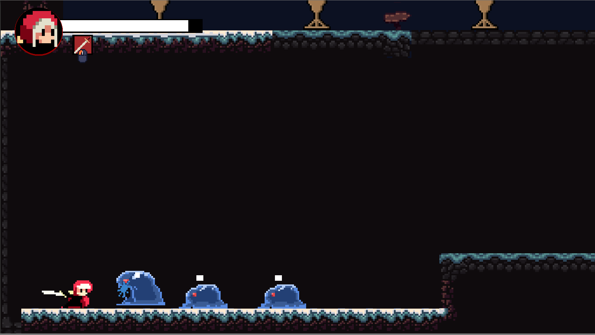

Early in game UI concept

The Inventory system shows all the items you’ve collected from enemies dropped and by selecting an item you can read it’s information via the Item Info Menu. Along the journey you may find a merchant that can sell you items used throughout your adventure.

Menus

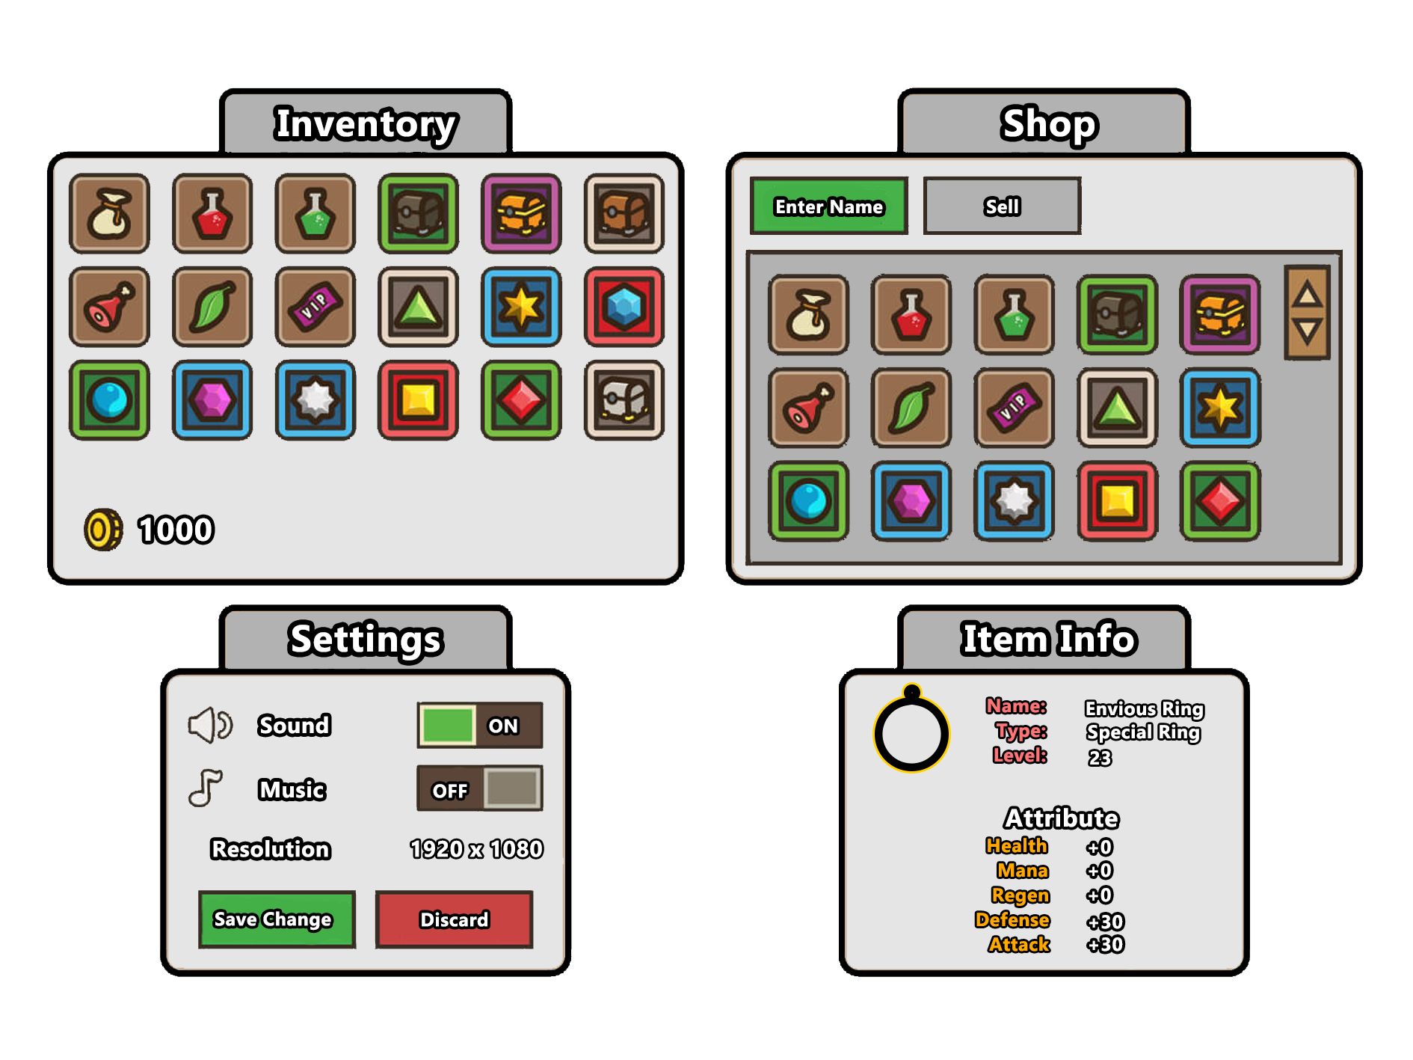

Controls & feedback:
Basic Controls (Controls are Remappable via options menu)

Keyboard
- WASD: Movement
- Escape: Open settings
- I: Open Inventory
- Q: Consumable/Quick Item
- Spacebar: Jump
- LMB: Basic Attack
- K: Ability 1
- H: Ability 2
- J: Ability 3
- R: Rue’s Ability
- Right Mouse Button: Command Rue
- Mouse: Move Camera

PS4 Controller
- Left Thumbstick: Movement
- Options: Open settings
- Touchpad: Open Inventory
- X: Jump
- R1: Basic attack
- R2: Rue’s Ability
- Square: Ability 1
- Triangle: Ability 2
- Circle: Ability 3
- Right Thumbstick: Move Camera
- L1/L2: Command Rue

Feedback within the game can be felt through the Rumble feature of the PS4 Controller and visual effects when the player is attacking or using abilities. When the player attacks with abilities it will be accompanied by an effect detailed in the ability chart, this applies to Rue’s abilities as well.

I want the player to feel satisfied with every attack and so by making each command in the game instantaneous and responsive, it can make the difference in player experience and enjoyment of the game. I also want the player to feel free to customize their controls just like in Maplestory, in MapleStory, there were two options mapped out for the keyboard. These two options made a difference in how the game was played and felt by veterans and new players.

Art:
The art of the game will be using pixel art.
Early Concepts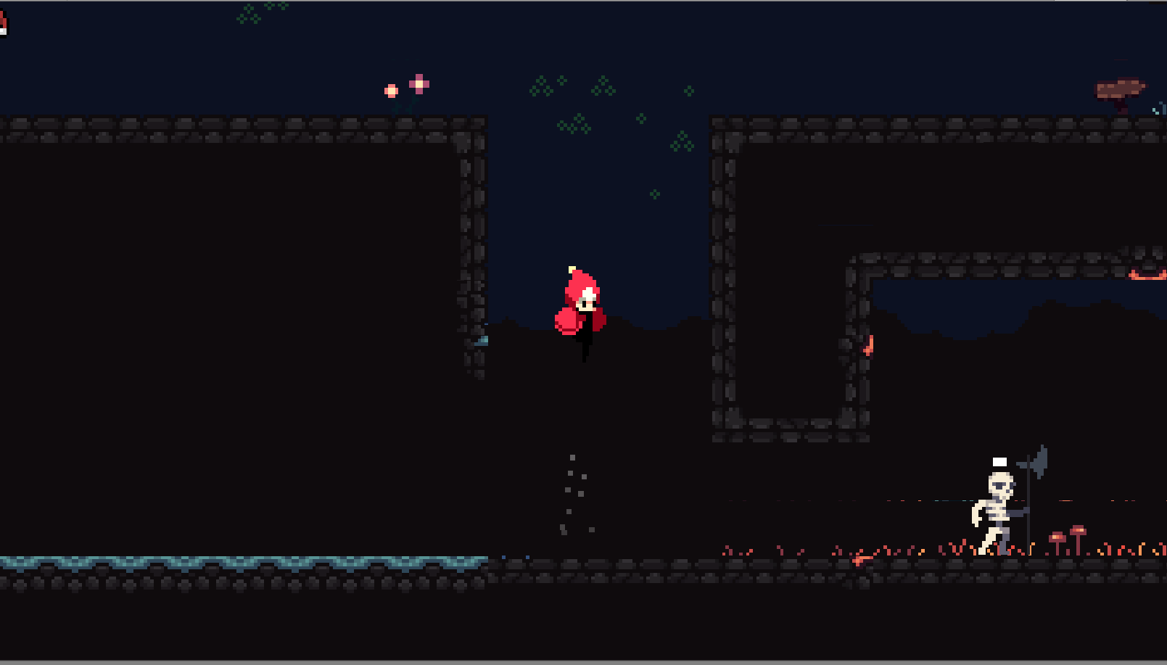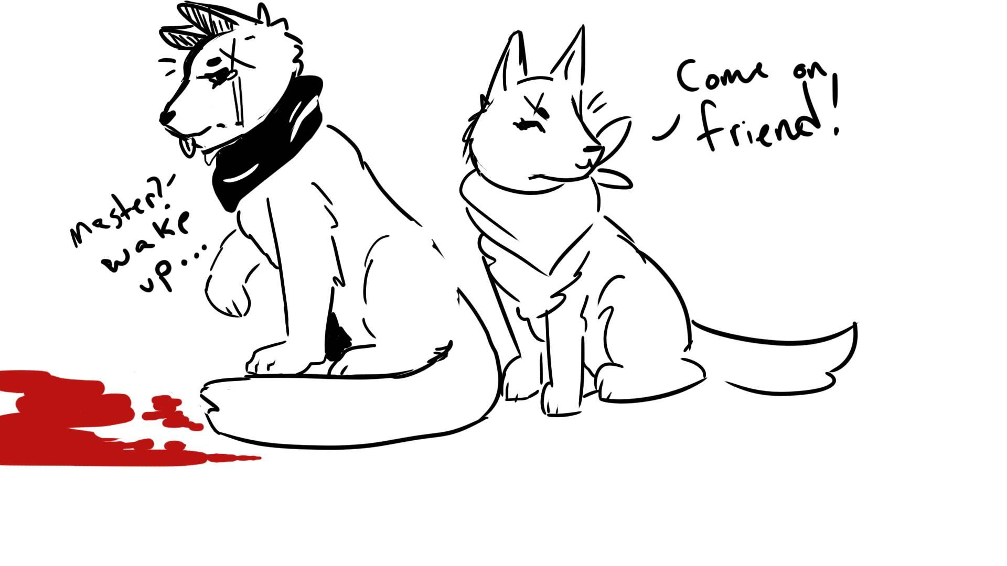

Sound:

Software:
- FMOD
- ProTools

Main Menu Soundtrack will be influenced by a Melodic piano coupled with a Sad tone setting the overall tone and story of the game.

The different Boss battles have heavy synth sounds with lots of varied soundtracks that coincide with a seven deadly sins and the area it is in.

Sound effects and Music will be done by a freelance artist by the name Sxulace.

Main Menu Music: https://drive.google.com/open?id=1nlVbQGXOL-DwB-aDGU6FIQYzB4IKQvMA

