Portfolio
Name: Khaled Abdelmajeed
Instructor name: Mandy Vial
Class: CUL122

Table of Content
Week 1……………………………….………………….. 3
Week 2……………………………..……………………..6
Week 3…………………………………………………..10
Week 4…………………………………………………..11
Week 5…………………………………………………..14
Week 6…………………………………………………..16
Week 7…………………………………………………..21
Week 8…………………………………………………..24
Week 9…………………………………………………..28
Week 10…..……………………………………………..32
Summary………………………………………………..33

Pastry Portfolio

Tuile Batter:
- Tuile batter is a type of cookies made by creaming butter and sugar with a paddle, and gradually add egg whites and then add flour until incorporated.
- Use a Silpat and spread the batter into desired shapes on your silpat.
- Bake 400F until edges are brown, 5-6 minutes.
- When shaping the cookies it must be hot so once its out of the oven quickly start shaping them, if it is cooled down reheat for 2 minutes and start shaping them again
- see the pictures bellow for Tuile cookie shapes
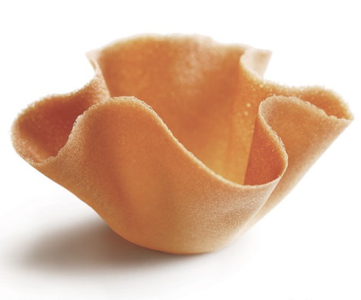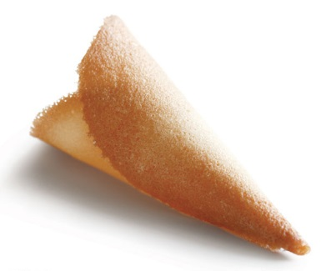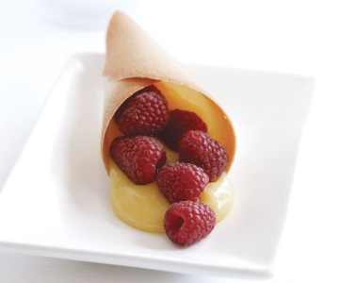
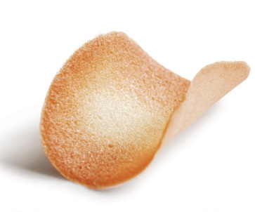

Panna Cotta
- Heat milk and sugar until boil
- In the meantime dissolve gelatin sheets in cold water
- Once milk has reached 180F remove from heat and add the Gelatine sheets until it dissolves.
- Once the mixture cools down to 120F slowly whisk the heavy cream and extract.
- Pour into 4 oz Ramekins, filling just below the rim, cover and refrigerate until completely set for approximately 6-8 hours.

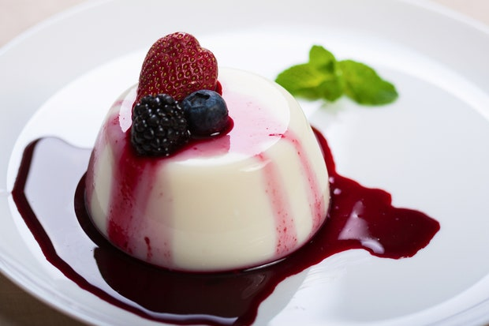

Pastry Cream
- Bring milk and vanilla beans and sugar to a boil
- Whisk egg yolks in a bowl with sugar and cornstarch, whisk to combine
- Once the milk is boiled temper the yolk mixture by adding ¼ of the milk whisk and then return to the pot and bring back to boil.
- Continue whisking vigorously, until cream boils for 2 minutes.
- Remove from heat and strain.
- Add the butter and mix until melted and incorporated. Do not over mix or it will split and the product loses the shine.
- Cover with plastic wrap and chill.

Pate Sucree
- We use creaming method which is we cream the fat and the sugar together.
- Then add the eggs to the creamed mixture until smooth and no lumps.
- On a slow speed add the flour slowly and mix until incorporated.
- Wrap the dough and place in the fridge until cold this will make it easier to work with
- Bake in oven for 10-15 minutes at 350F
Frangipane:
- Blend almond paste and sugar on low speed in a mixer until there is no lumps
- Add the butter gradually in small amounts until incorporated
- Add eggs slowly, when incorporated mix on medium speed for 5 minutes or until light and airy. Stir in the vanilla and flour blending until mixture is smooth and pipe able.

Choux paste:
- Bring water, milk, butter and salt to a boil
- Add bread flour all at once and stir vigorously until flour forms a film on the bottom of the pot.
- Transfer to mixer and mix on medium speed with a paddle until to cools down and there is no more steam.
- Slowly add eggs until paste is correct consistency

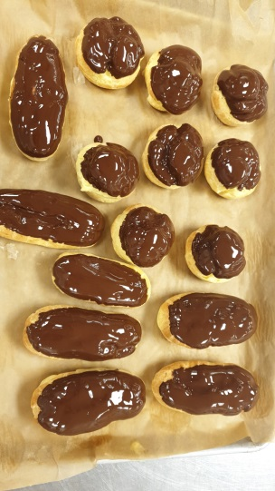

Chef critiques and recommendations week1

Tuile Cookies: I did not have the time to make them in class, however I made them at home and it was really good.
Panna Cotta: Was really good
Pastry Cream: Was good however I should have covered it properly so it doesn’t form a film on top.
Pate Sucree: Well made, rolled thin in areas
Frangipane: I did not get the chance to make them
Choux: Was really good dipped well in the chocolate but was little bit undercooked

Swiss Meringue:
Heat sugar and egg whites over a bain marie until it reached 100F.
Then using mixer whisk the mixture until the peaks are stiff and add them into a piping bag.
Lemon sabayon:
- Over bain marie, whisk lemon juice, lemon zest, sugar and eggs until it is thickened and coats the back of the spoon, make sure to keep whisking the eggs or it will be cooked.
- Take pan off heat and whisk in melted butter
- Pour mixture into prepared shell (Pate Sucree)
- And bake for 3-5 minutes and let it cool
- Then pipe the meringue and spread it on top
- Then with a spatula divide the tart into 8 pieces and pipe the meringue either inside out or outside in using a star piping
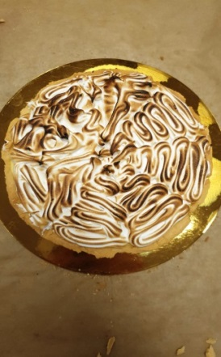
Mango Sorbet:
- Whisk together pectin and sugar, place them in a bowl with water and glucose syrup whisk until well combined
- Bring the syrup to boil for 1 minutes
- Remove from heat and let it cool completely then add the mango puree with lemon juice.
- Pour them into the ice cream machine
- Remove sorbet from the machine after 20-30 minutes and place it in the freezer.
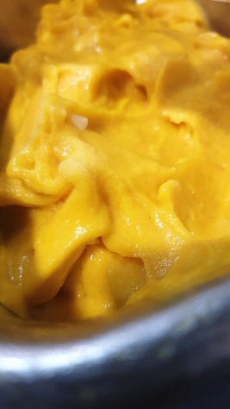

Pastry Cream
- Bring milk and vanilla beans and sugar to a boil
- Whisk egg yolks in a bowl with sugar and cornstarch, whisk to combine
- Once the milk is boiled temper the yolk mixture by adding ¼ of the milk whisk and then return to the pot and bring back to boil.
- Continue whisking vigorously, until cream boils for 2 minutes.
- Remove from heat and strain.
- Add the butter and mix until melted and incorporated. Do not over mix or it will split and the product loses the shine.
- Cover with plastic wrap and chill.
Fresh Fruit Flan:
- Make a Pate Sucree and full the shell with Pastry Cream
- Then add the fruits on top of the Pastry Cream and decorate them as you wish.
- Brush the fruit with Apricot Jam to seal it and give the tart a shine , also to make it stay fresh more.
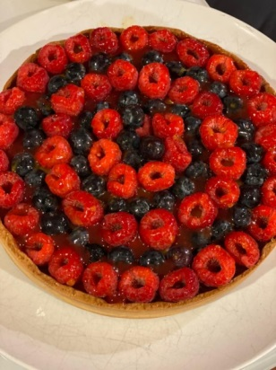

Caramel Brulee:
- Heat the milk, cream and vanilla bean in a medium saucepan over medium-high heat until bubbles appear along the sides of the pan
- .whisk sugar into the egg yolks
- When the cream is hot, slowly pour it into the yolk mixture. Whisk until well combined.
- Strain the mixture through a fine sieve into a pitcher or large measuring cup. Scrape the vanilla bean and stir the seeds into the custard
Preheat the oven to 325°F (160°C). Pour the custard into the ramekins. Set the pan of ramekins inside the preheated oven, and then carefully pour enough water into the pan to come two-thirds of the way up
the sides of the ramekins. Bake until just set, approximately 45 to 50 minutes. The custard should be set, not soupy, with only a small area of jiggle in the center.

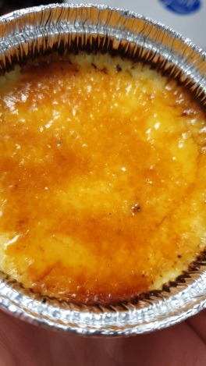

Chef critiques and recommendations week 2

Swiss Meringue:
Swiss Meringue was grey in appearance due to the whisk and mixer rubbing. Therefore not glossy.
Lemon sabayon:
- well piped, good colour
Fresh Fruit Flan:
nice design, and well glazed.
Caramel Brulee:
colour varied, no raw sugar, good job.

Chocolate Patee Sucree:
Cream the butter until light. Add in the sugar, then salt and vanilla.
Add the eggs, and mix until incorporated.
Then add the almond flour, and sift the pastry flour and cocoa powder. Add it to the butter mixture. Blend on low speed until just combined. Do not over mix. Then Chill the dough until firm in the fridge
When ready to use, roll out the dough, bake blind and bake at 350°F for 10 minutes then remove the weights and bake until golden brown
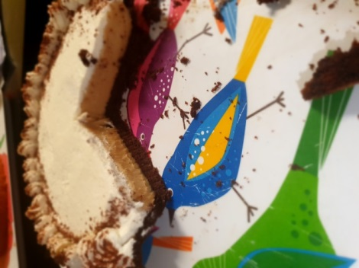

Toffee Caramel Flan:
Combine the sugar with water in a small heavy saucepan; bring to a boil. Cook until the sugar reaches a deep golden brown. Immediately pour approximately 2 tablespoons or just the bottom of the ramekins, arrange the ramekins in a hotel pan and set aside.
Combine the milk, cream, cinnamon sticks and vanilla bean in a large saucepan. Bring just to a boil, cover and remove from the heat. Allow this mixture to steep approximately 30 minutes.
Whisk the eggs, egg yolks, brown sugar, molasses and amaretto together in a large bowl.
Uncover the milk mixture and return it to the stove top. Bring just to a boil. Temper the egg-and sugar mixture with hot milk. Whisk in the remaining hot milk. strain the custard through a fine mesh strainer. Pour into the caramel-lined ramekins, filling to just below the rim.
Then pour enough warm water into the hotel pan to reach halfway up the sides of the ramekins. Bake at
325°F approximately 30 to 40 minutes or until the custards are almost set and soft in the center.
Completely chill the baked custards before serving. To unmold, place the ramekins in warm water for 30 seconds and flip it on a plate, and garnish with a fresh fruit.
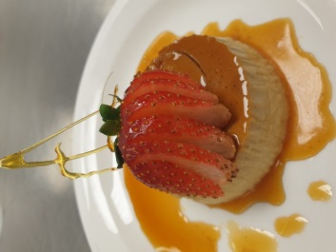

Chocolte Patee Sucree:
Chocolate pate Sucre made correctly, rolled out well
Toffee Caramel Flan:
Correct colour, and appeared smooth
Ice Cream Base:
Smooth and well made

Peanut Pie filling:
Custard base came off the stove a little thick but when combined with the whip corrected. Whipped topping, Cream was flat, looked well, border was a little thin. Piping is all about hand pressure. Try to keep consistent hand pressure

Chantilly Cream:
Place the cream in a mixing bowl. Whisk the cream until slightly thickened.
Add the sugar and vanilla and continue whisking to the desired consistency. The cream should be smooth and light, Do not over whip.
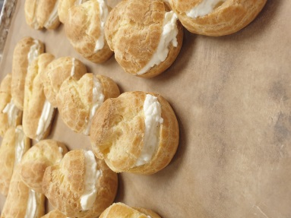

Pate Sucree
- We use creaming method which is we cream the fat and the sugar together.
- Then add the eggs to the creamed mixture until smooth and no lumps.
- On a slow speed add the flour slowly and mix until incorporated.
- Wrap the dough and place in the fridge until cold this will make it easier to work with
- Bake in oven for 10-15 minutes at 350F

Lemon sabayon:
- Over bain marie, whisk lemon juice, lemon zest, sugar and eggs until it is thickened and coats the back of the spoon, make sure to keep whisking the eggs or it will be cooked.
- Take pan off heat and whisk in melted butter
- Pour mixture into prepared shell (Pate Sucree)
- And bake for 3-5 minutes and let it cool
- Then pipe the meringue and spread it on top
- Then with a spatula divide the tart into 8 pieces and pipe the meringue either inside out or outside in using a star piping

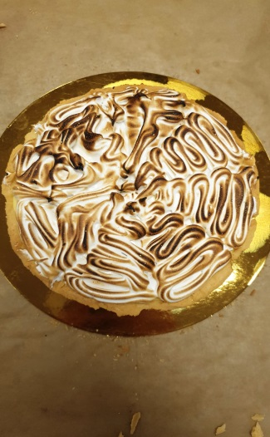
Choux –Paris-Brest:
- Bring water, milk, butter and salt to a boil
- Add bread flour all at once and stir vigorously until flour forms a film on the bottom of the pot.
- Transfer to mixer and mix on medium speed with a paddle until to cools down and there is no more steam.
- Slowly add eggs until paste is correct consistency
- Add them to the piping bag
- Start piping on a 8 inch circle then another circle inside and another circle on top between both of them.
- Bake in the oven 400F approximately 25 minutes.

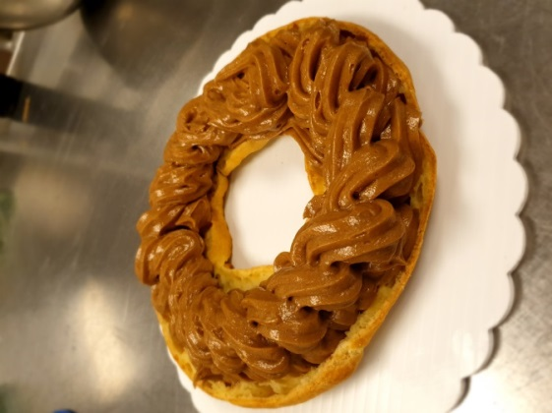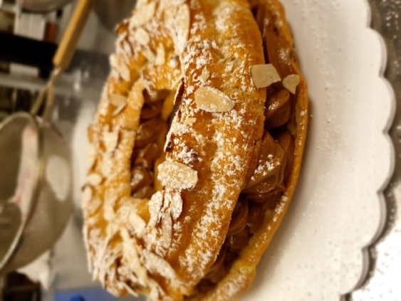

Chef critiques and recommendations week 4

Pate Sucre: a little dark, edges uneven correct thickness
Choux: piped thin but I corrected and repiped the paris-brest. Second attempt looked much better
Lemon Sabayon: Set nicely
Pastry cream/paris brest cream- PC very smooth, correctly cooled. PB cream perfect

Pate Sucre:
- We use creaming method which is we cream the fat and the sugar together.
- Then add the eggs to the creamed mixture until smooth and no lumps.
- On a slow speed add the flour slowly and mix until incorporated.
- Wrap the dough and place in the fridge until cold this will make it easier to work with
- Bake in oven for 10-15 minutes at 350F

Swiss Meringue:
Heat sugar and egg whites over a bain marie until it reached 100F.
Then using mixer whisk the mixture until the peaks are stiff.

Lemon Sabayon:
- : Over bain-marie, whisk lemon juice, lemon zest, sugar and eggs until it is thickened and coats the back of the spoon, make sure to keep whisking the eggs or it will be cooked.
- Take pan off heat and whisk in melted butter
- Pour mixture into prepared shell (Pate Sucree)
- And bake for 3-5 minutes and let it cool
- Then pipe the meringue and spread it on top
- Then with a spatula divide the tart into 8 pieces and pipe the meringue either inside out or outside in using a star piping

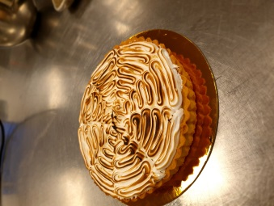

Pastry Cream:
- Bring milk and vanilla beans and sugar to a boil
- Whisk egg yolks in a bowl with sugar and cornstarch, whisk to combine
- Once the milk is boiled temper the yolk mixture by adding ¼ of the milk whisk and then return to the pot and bring back to boil.
- Continue whisking vigorously, until cream boils for 2 minutes.
- Remove from heat and strain.
- Add the butter and mix until melted and incorporated. Do not over mix or it will split and the product loses the shine.
- Cover with plastic wrap and chill.

Choux :
- Bring water, milk, butter and salt to a boil
- Add bread flour all at once and stir vigorously until flour forms a film on the bottom of the pot.
- Transfer to mixer and mix on medium speed with a paddle until to cools down and there is no more steam.
- Slowly add eggs until paste is correct consistency
- Add them to the piping bag
- Start piping on a 8 inch circle then another circle inside and another circle on top between both of them.
- Bake in the oven 400F approximately 25 minutes.

Panna Cotta
- Heat milk and sugar until boil
- In the meantime dissolve gelatin sheets in cold water
- Once milk has reached 180F remove from heat and add the Gelatine sheets until it dissolves.
- Once the mixture cools down to 120F slowly whisk the heavy cream and extract.
- Pour into 4 oz Ramekins, filling just below the rim, cover and refrigerate until completely set for approximately 6-8 hours.

Chef critiques and recommendations week 5
Pate Sucre: was good
Choux: sellable
Panna Cotta- nice
Lemon Sabayon: Set nicely
Pastry cream very smooth, correctly cooled.

Italian Buttercream:

Place the egg whites in a mixer bowl. 270 grams of the sugar nearby
Place 540 grams of the sugar in a heavy saucepan with enough water to moisten. Bring to a boil over high heat.
As the sugar syrup’s temperature approaches the soft ball stage (240°F/116°C), begin whipping the egg whites. Watch the sugar closely so that the temperature does not exceed 240°F (116°C).
When soft peaks form in the egg whites, gradually add 270 grams of sugar to them. Reduce the mixer speed to medium and continue whipping the egg whites to stiff peaks.
When the sugar syrup reaches the soft ball stage, immediately pour it into the whites while the mixer is running. Pour the syrup in a steady stream between the side of the bowl and the beater. Continue beating at medium speed until the egg whites are completely cool.
Gradually add the softened butter to the Italian meringue butter without stopping and mix well until all butter are incorporated.

White Genoise with Italian Butter cream:
Whisk the eggs and sugar together in a large mixer bowl. Place the bowl over a bain marie and whisk the mixture continuously to warm the eggs to approximately 105°F–113°F (40°C–45°C).

When the eggs are warm, remove the bowl from the bain marie and add it to the mixer. Whip the egg-and-sugar mixture at medium speed until the mixture is cool and forms thick ribbons, approximately 12 to 15 minutes.
Remove approximately one-eighth of the batter. Place it in a small bowl and mix it with the melted butter and vanilla extract.
Fold the flour into the remaining genoise batter. Then fold in the reserved butter-genoise mixture.
Spread the batter immediately onto a paper-lined sheet pan. Bake at 425°F (220°C) until light brown and springy to the touch, approximately 20 minutes.
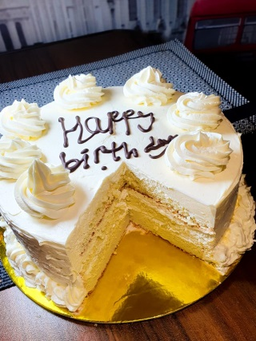

Simple Chocolate Butter Cream:

In the bowl of a mixer fitted with the paddle attachment, cream the butter until light and fluffy.
Beat in the egg. Gradually add the sugar.
Dissolve 30 g of cocoa powder in 60 ml of cold water and add it to the mixture
Add the vanilla and continue beating until the icing is smooth and light.

Chocolate Genoise with Simple Chocolate Butter Cream:
Whisk the eggs and sugar together in a large mixer bowl. Place the bowl over a bain marie and
whisk the mixture continuously to warm the eggs to approximately 105°F–113°F (40°C–45°C).
When the eggs are warm, remove the bowl from the bain marie and add it to the mixer. Whip the egg-and-sugar mixture at medium speed until the mixture is cool and forms thick ribbons, approximately 12 to 15 minutes.
Remove approximately one-eighth of the batter. Place it in a small bowl and mix it with the melted butter and vanilla extract.
Fold the flour into the remaining genoise batter replace 60g of cocoa powder with the flour. Then fold in the reserved butter-genoise mixture.
Spread the batter immediately onto a paper-lined sheet pan. Bake at 425°F (220°C) until light brown and springy to the touch, approximately 20 minutes.

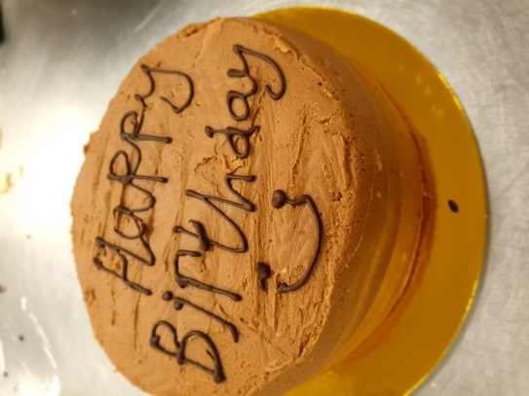

Croissants with cheese:

Pour the flour on the table and make a hole in the middle and add the ingredients dry alone and liquids alone
Warm the milk to approximately 90F .
Start mixing them and slowly take some of the flour and keep going until all flour is mixed and well incorporated
Start rolling them or kneading to produce gluten and creating a springy and elastic dough
Place the dough in a large floured bowl, cover and let rise until doubled in size, approximately
Prepare the butter while the dough is rising. Place the butter in an even layer between a parchment paper and roll into a flat rectangle, approximately (20cm)*(27.5cm) and chill.
After the dough has risen, punch it down. Roll out the dough into a large rectangle, approximately (1.2cm) thick and large enough to enclose the rectangle of butter. Place the unwrapped butter in the center of the dough and fold the dough around the butter, enclosing it completely.
Roll out the block of dough in the direction of the fold into a long rectangle, approximately 1 inch
Fold the dough in thirds, a single book fold. This completes the first turn.
Wrap the dough in plastic and chill.
Repeat the rolling and folding process two more times, chilling the dough between each turn.
When finished, wrap the dough well and chill it overnight before shaping and baking.
To shape the dough into croissant rolls, spread the dough 20inch by 8 inch and mark it from the half and each rectangle 4 inch and start cutting them into triangles.
Starting with the large end, roll each triangle into a crescent , you can add cheese. Then place on paper-lined sheet pans.
Brush lightly with egg wash. Proof until doubled, but do not allow the dough to become so warm that the butter melts.
Bake at 375F until golden brown, approximately 12 to 15 minutes.

Chef critiques and recommendations week 6

Choc buttercream- thick added milk to thin, very hard to work with
Italian buttercream- beautiful colour, nice to work with
Choc cake- Sponge was cut uneven, layers not level or even
Whit cake- Better sponge cuts, nicer layers, more even
Croissants- Prefect layers, , nicely folded and baked good

White Genoise:

Whisk the eggs and sugar together in a large mixer bowl. Place the bowl over a bain marie and whisk the mixture continuously to warm the eggs to approximately 105°F–113°F (40°C–45°C).
When the eggs are warm, remove the bowl from the bain marie and add it to the mixer. Whip the egg-and-sugar mixture at medium speed until the mixture is cool and forms thick ribbons, approximately 12 to 15 minutes.
Remove approximately one-eighth of the batter. Place it in a small bowl and mix it with the melted butter and vanilla extract.
Fold the flour into the remaining genoise batter. Then fold in the reserved butter-genoise mixture.
Spread the batter immediately onto a paper-lined sheet pan. Bake at 425°F (220°C) until light brown and springy to the touch, approximately 20 minutes.

Chocolate Genoise:
Whisk the eggs and sugar together in a large mixer bowl. Place the bowl over a bain marie and
whisk the mixture continuously to warm the eggs to approximately 105°F–113°F (40°C–45°C).
When the eggs are warm, remove the bowl from the bain marie and add it to the mixer. Whip the egg-and-sugar mixture at medium speed until the mixture is cool and forms thick ribbons, approximately 12 to 15 minutes.
Remove approximately one-eighth of the batter. Place it in a small bowl and mix it with the melted butter and vanilla extract.
Fold the flour into the remaining genoise batter replace 60g of cocoa powder with the flour. Then fold in the reserved butter-genoise mixture.
Spread the batter immediately onto a paper-lined sheet pan. Bake at 425°F (220°C) until light brown and springy to the touch, approximately 20 minutes.

Cream Chantilly:
Whisk the cream until slightly thickened. Then add the sugar and vanilla and continue whisking until thickened enough that it will stay on the cake.

Italian Buttercream:
Place the egg whites in a mixer bowl. 270 grams of the sugar nearby
Place 540 grams of the sugar in a heavy saucepan with enough water to moisten. Bring to a boil over high heat.

As the sugar syrup’s temperature approaches the soft ball stage 240°F, begin whipping the egg whites. Watch the sugar closely so that the temperature does not exceed 240°F

When soft peaks form in the egg whites, gradually add 270 grams of sugar to them. Reduce the mixer speed to medium and continue whipping the egg whites to stiff peaks.

When the sugar syrup reaches the soft ball stage, immediately pour it into the whites while the mixer is running. Pour the syrup in a steady stream between the side of the bowl and the beater. Continue beating at medium speed until the egg whites are completely cool.
Gradually add the softened butter to the Italian meringue butter without stopping and mix well until all butter are incorporated.

Tuxedo cake: (white and chocolate genoise layers)
Tuxedo cake has three layers I did 2 white genoise and 1 chocolate genoise and all cakes are soaked with simple syrup. Between each layer we spread out Italian butter cream.

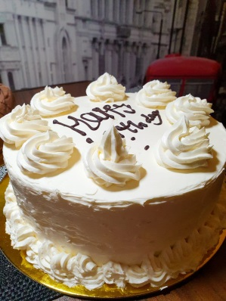

Black forest Cake:
Blackforest Cake is also a three layer cake of chocolate genoise between each layer there is cherry filling and cream Chantilly and the top layer is only cover with cream.

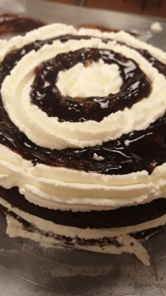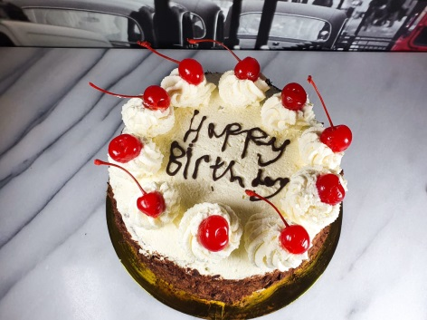

Chef critiques and recommendations week 7
Choc Genoise- short: Your egg foam looked stable, therefore this is probably due to over folding
Chantilly- nicely made
Completed Blackforest- rosettes are better but still rough looking, cake appeared a little unstable, it will be better after its in the fridge
Italian Butter cream- very nice, be sure that it is smooth and if it is airy, to go back in the mixer until smooth.. this will make it easier for you to use and a nicer final cake
Completed Tuxedo Cake- nice cake, rosettes are the best you could manage today, practice that round wrist movement and you will be able to get them double high

New York Cheesecake:
Wrap the bottom of two 8-inchround springform pans with foil, or just place a pot with water under the sheet pan.
Combine the graham cracker crumbs with the melted butter. Press the mixture into the bottom of the ring . Bake for 12 to 15 minutes at 375°F until the crust is dry to the touch. Set aside.
Blend the cream cheese and sugar on low speed in the bowl of a mixer fitted with the paddle attachment until no lumps remain. Scrape down the bowl often.
Add the eggs one at a time, waiting for each egg to be fully incorporated before adding more. Scrape down the bowl and paddle after each addition.
Add the flour and mix until combined. Add the remaining ingredients and mix to blend.
Add the cheesecake batter in the ring or pam. Wrap the bottom and sides of each pan in several layers of aluminum foil and place them in a hotel pan.
Preheat the oven to 300°F. Place the batter-filled pans in a hotel pan and set the hotel pan in the preheated oven. Pour enough warm water into the hotel pan to come halfway up the sides of the pans. Bake until the batter is set and no longer trembles, approximately 75 to 90 minutes.
Cool the cakes on a wire rack in their pans, then refrigerate overnight. Remove the cakes from the pans. Portion the chilled cheesecakes. Serve garnished with raspberry sauce and chocolate, if desired.
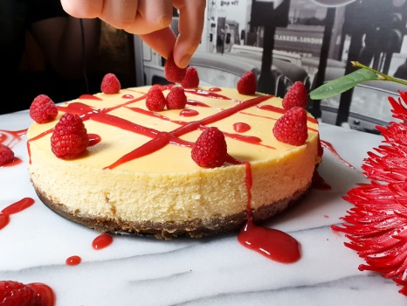

Lady fingers:
Sift the flour and cornstarch together. Set aside.
Whip the egg yolks and vanilla together in the mixer fitted with the whip attachment until the mixture is thick and creamy.
Simultaneously in the bowl of a second mixer fitted with the whip attachment, whip the egg whites and granulated sugar until the mixture holds stiff peaks.
Using a balloon whisk, gently stir the egg whites to restore a smooth appearance. Add the whipped yolks all at once into the egg whites. Gently fold the two together using a rubber spatula or a balloon whisk until the mixture is streaked in appearance and is not completely combined. Gently fold in the flour, taking care not to deflate the batter.
Place the batter into a pastry bag fitted with a medium plain tip. Pipe 4-inch- (10-centimeter-) long cookies onto paper-lined sheet pans.
Sprinkle the surface of the piped batter with powdered sugar. Let it sit for a few minutes until the powdered sugar dissolves. Sprinkle a second time with more powdered sugar.
Bake at 410°F

Bavarian Cream:
Heavy cream, whipped to soft peaks 370 ml
To prepare a custard sauce, combine the milk, cream, (22.5 grams) of the sugar and the vanilla bean in a heavy saucepan. Bring to a boil.
Whisk the egg yolks and remaining (45 grams) of sugar together to the ribbon stage. Temper the yolk mixture with one-quarter of the heated milk, whisking constantly.
Pour the yolk mixture into the saucepan with the rest of the milk. Stir constantly with a rubber spatula until the custard reaches 185°F (85°C).
Remove from the heat and pour through a fine mesh strainer into a clean bowl.
Add the softened sheet gelatin to the hot custard. Chill until thick in an ice bath, stirring regularly to prevent lumps from forming, until the custard reaches 75°F (24°C) or slightly cooler. Fold in the whipped cream.
Pour the Bavarian Cream immediately into serving dishes or a mold.

Cream Chantilly:
Whisk the cream until slightly thickened. Then add the sugar and vanilla and continue whisking until thickened enough that it will stay on the cake.

Raspberry Mousse (Filling):

Fold in the cream Chantilly and Bavarian cream then add to them 100 grams of raspberry puree and mix until well incorporated.

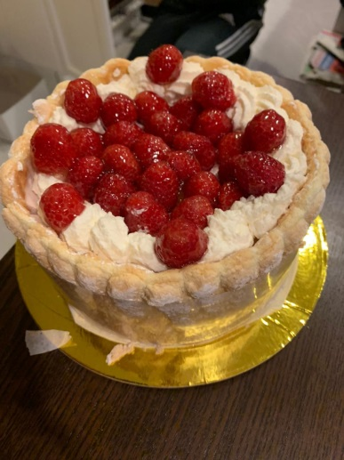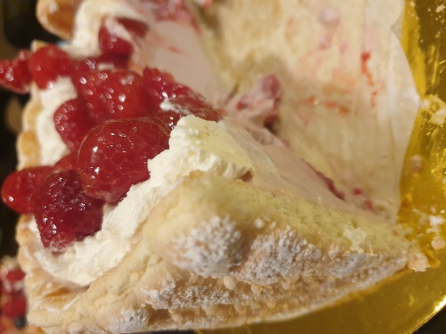

Danish Dough:

Pour the flour on the table and make a well in the middle and add the ingredients dry alone and liquids alone
Start mixing them and slowly take some of the flour and keep going until all flour is mixed and well incorporated
Start rolling them or kneading to produce gluten and creating a springy and elastic dough
Place the dough in a large floured bowl, cover and place in the fridge to cool
Prepare the butter while the dough is cooling. Place the butter in an even layer between a parchment paper and roll into a flat rectangle, approximately (20cm)*(27.5cm) and chill.
After the dough has cooled. Roll out the dough into a large rectangle, approximately (1.2cm) thick and large enough to enclose the rectangle of butter. Place the unwrapped butter in the center of the dough and fold the dough around the butter, enclosing it completely.
Roll out the block of dough in the direction of the fold into a long rectangle, approximately 1 inch
Fold the dough in thirds, a single book fold. This completes the first turn.
Wrap the dough in plastic and chill.
Repeat the rolling and folding process two more times, chilling the dough between each turn.
When finished, wrap the dough well and chill it overnight before shaping and baking.
Then Spread again the dough make rectangle shape and cut ut 4 by 4 inch and start shaping the dough
Proof it then add the filling and brush it with egg yolks and bake for 10 minutes or until golden brown.

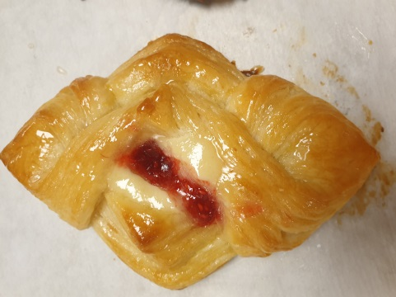

Cream Cheese filling:

In the bowl of a mixer fitted with the paddle attachment, blend the cream cheese and sugar on low speed until smooth. Scrape down the bowl and gradually add the eggs, scraping the bowl between each addition.
Stir in the vanilla and lemon zest. Fold in the flour.
Fill pastries with this mixture before baking.
Coconut cream filling:
In the bowl of a mixer fitted with the paddle attachment, cream the butter and sugar until
smooth. Scrape down the bowl. Add the remaining ingredients on low speed and mix until well combined.
Fill pastries with this mixture before baking.

Chef critiques and recommendations week 8
Danish Dough: 3 folds complete
lady fingers: piping will get better with practice, be sure to have your hand in the correct position
cheesecake: base and filling- correct base, filling was smooth, no cracks
2 fillings for Danish: completed

Chocolate Mousse: Filling for Jaconde
Melt the chocolate and butter in a double boiler over low heat. Stir until no lumps remain.
Allow the mixture to cool slightly to 120°F, then whisk in the egg yolks, a small amount at a time.
Beat the egg whites until soft peaks form. Slowly beat in the sugar and continue beating until stiff peaks form. Fold the whipped egg whites into the chocolate mixture.
Whip the cream to soft peaks. Allow the mousse to cool to 95°F (35°C), then fold in the whipped cream. Make sure no streaks of egg white or cream remain.
The mousse may be used as a cake or pastry filling.

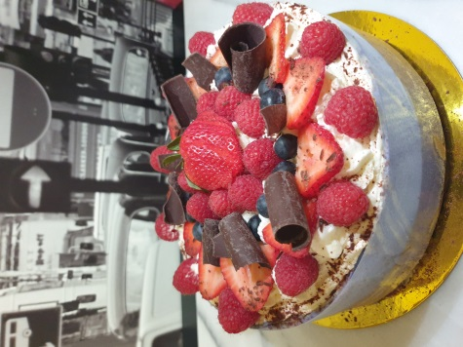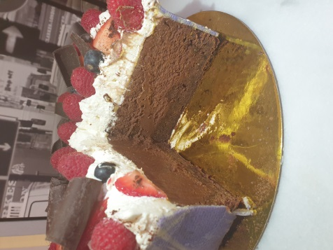

Italian Buttercream:
Place the egg whites in a mixer bowl. 270 grams of the sugar nearby
Place 540 grams of the sugar in a heavy saucepan with enough water to moisten. Bring to a boil over high heat.
As the sugar syrup’s temperature approaches the soft ball stage (240°F/116°C), begin whipping the egg whites. Watch the sugar closely so that the temperature does not exceed 240°F (116°C).

When soft peaks form in the egg whites, gradually add 270 grams of sugar to them. Reduce the mixer speed to medium and continue whipping the egg whites to stiff peaks.
When the sugar syrup reaches the soft ball stage, immediately pour it into the whites while the mixer is running. Pour the syrup in a steady stream between the side of the bowl and the beater. Continue beating at medium speed until the egg whites are completely cool.
Gradually add the softened butter to the Italian meringue butter without stopping and mix well until all butter are incorporated.

White Genoise:
Whisk the eggs and sugar together in a large mixer bowl. Place the bowl over a bain marie and whisk the mixture continuously to warm the eggs to approximately 105°F–113°F (40°C–45°C).
When the eggs are warm, remove the bowl from the bain marie and add it to the mixer. Whip the egg-and-sugar mixture at medium speed until the mixture is cool and forms thick ribbons, approximately 12 to 15 minutes.
Remove approximately one-eighth of the batter. Place it in a small bowl and mix it with the melted butter and vanilla extract.
Fold the flour into the remaining genoise batter. Then fold in the reserved butter-genoise mixture.
Spread the batter immediately onto a paper-lined sheet pan. Bake at 425°F (220°C) until light brown and springy to the touch, approximately 20 minutes.

Croissants:
Pour the flour on the table and make a well in the middle and add the ingredients dry alone and liquids alone
Warm the milk to approximately 90F .
Start mixing them and slowly take some of the flour and keep going until all flour is mixed and well incorporated
Start rolling them or kneading to produce gluten and creating a springy and elastic dough
Place the dough in a large floured bowl, cover and let rise until doubled in size, approximately
Prepare the butter while the dough is rising. Place the butter in an even layer between a parchment paper and roll into a flat rectangle, approximately (20cm)*(27.5cm) and chill.
After the dough has risen, punch it down. Roll out the dough into a large rectangle, approximately (1.2cm) thick and large enough to enclose the rectangle of butter. Place the unwrapped butter in the center of the dough and fold the dough around the butter, enclosing it completely.
Roll out the block of dough in the direction of the fold into a long rectangle, approximately 1 inch
Fold the dough in thirds, a single book fold. This completes the first turn.
Wrap the dough in plastic and chill.
Repeat the rolling and folding process two more times, chilling the dough between each turn.
When finished, wrap the dough well and chill it overnight before shaping and baking.
To shape the dough into croissant rolls, spread the dough 20inch by 8 inch and mark it from the half and each rectangle 4 inch and start cutting them into triangles.
Starting with the large end, roll each triangle into a crescent , you can add cheese. Then place on paper-lined sheet pans.
Brush lightly with egg wash. Proof until doubled, but do not allow the dough to become so warm that the butter melts.
Bake at 375F until golden brown, approximately 12 to 15 minutes.

Chef critiques and recommendations week 9
croissants- when shaping be sure to use even pressure and not to pull too hard. Relax the dough in this step.
Cake- buttercream was a little thick- this means it will be harder to work with. Usually the butter is too cold at this stage. There is a fine balance, if you whip it a little longer it will be easier to use.
Choc mousse cake- Whip cream was the correct consistency, nicely topped. Joconde was patched but worked.

Pastry Cream:
Bring the milk, vanilla bean and 30 grams of the sugar to a boil in a large nonreactive saucepan.

Whisk the egg yolks in a mixing bowl. In a separate bowl, combine the remaining sugar and the
cornstarch. Whisk the sugar mixture into the egg yolks.

Temper the yolk mixture with one-quarter of the boiling milk. Return the yolk mixture to the pan
and cook, whisking vigorously, until the cream boils and is well thickened. Allow the pastry cream
to boil approximately 2 minutes, stirring constantly.

Remove the pastry cream from heat and immediately pour it into a clean mixing bowl.

Fold in the butter if using until melted. Do not overmix, as this will thin the custard.

Cover by placing plastic wrap on the surface of the custard. Chill over an ice bath.

Passion Fruit Sorbet:

Whisk together the sugar and pectin. Place the sugar, water and glucose syrup in a large saucepan. Whisk until well combined. Bring the syrup to a full rolling boil and boil 1 minute.

Remove from the heat and let cool completely and then combine the passion fruit purée and lemon juice with the syrup.

Pour the mixture into an ice cream or sorbet machine and process according to the manufacturer’s directions.

Remove the sorbet from the machine and freeze at 0°F.

Tuile Cookie:
Cream the butter and sugar in the bowl of a mixer fitted with the paddle attachment. Gradually add the egg whites. Blend in the flour without over mixing.

Spread the batter into circles on the pans. Bake at 400F until the edges are brown and the batter
is dry, approximately 4 to 6 minutes.

To shape into cups, lift the hot cookies off the sheet pan one at a time with an offset spatula. Immediately
place over an inverted glass bowl and top with a ramekin or small bowl.

Dacquoise:
Whip the liquid egg whites in the bowl of a mixer fitted with the whip attachment on medium speed until foamy. If using the dried egg whites, sift them with 4 ounces (120 grams) of the sugar and add to the foamy egg whites. Whip the egg whites until they hold a firm peak. Fold in the vanilla.
Stir the remaining 165 grams of sugar into the flours. Fold this mixture into the whipped egg whites with a rubber spatula.

Place the mixture in a pastry bag fitted with a medium to large tip. Pipe it into three or four 7-inch discs on a paper-lined sheet pan. (Or spread it into torte rings placed on a paperlined half-sheet pan.) Bake at 350°F until done, approximately 30 minutes. Check for doneness by removing part of the crust using a paring knife; the interior should spring back when lightly pressed.

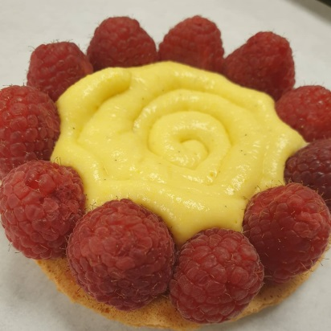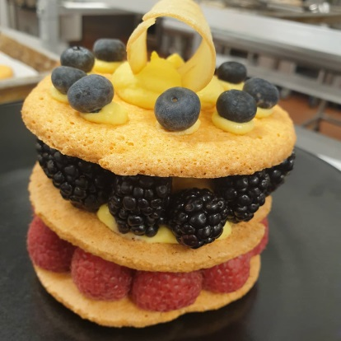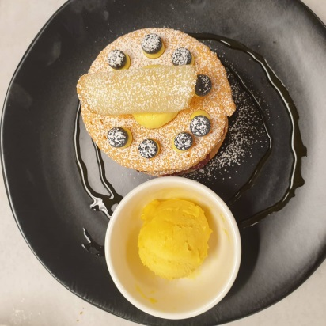

Chocolate Ganache:
In a saucepan, bring the cream, sugar and corn syrup to a boil.

Place chocolate and butter into a large bowl.

When the cream mixture boils, pour it over the chocolate-and-butter mixture. Stir the chocolate with a rubber spatula.

Use immediately to glaze cakes or pastries or refrigerate. Heat refrigerated ganache over a bain
marie to 120°F–130°F.

Fruit Coulis:
Combine the fruit puree with the sugar and glucose syrup. Add as much lemon juice as needed
to balance the flavor of the sauce.

Toasted Coconut with Caramel sauce:

Pour the sugar in center of the pan and add water

Bring to boil over high heat swirling the pan occasionally to even out the colour, once reached desired coloured

Add the boiling cream and mix with a wooden spoon then add the toasted coconut mix well and let it cool.

The Perfect Chocolate Cake:

Sift all dry ingredients mix them together and set aside

Whisk together the eggs, milk, oil and vanilla in a bowl

Add the dry ingredients to the liquid and mix with the whisk attachment on low speed for 5 minutes and gradually add the hot water and mix until just combined.

Bake in the oven for 25-30 minutes and let it cool.

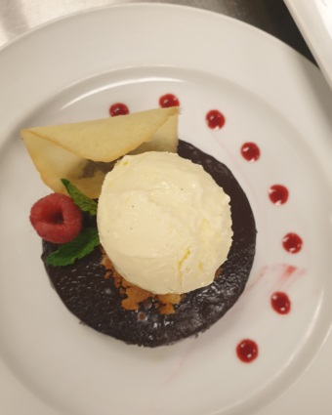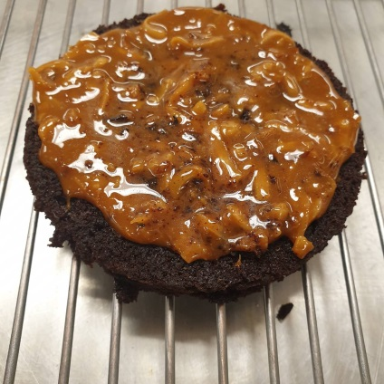

Chef critiques and recommendations week 10

You looked comfortable today, the dacquoise needed to be redone. Ganache looked good, both sorbet and ice cream looked smooth and the right technique was used.
Choc sponge was shorter than your peers, not sure why, good bake
Summary
Before entering culinary arts and during the beginning of my first semester at LaSalle College, I always said that I want to be an international chef. Family and friends always asked “don’t you want to try to make us desserts or pastries?” My answer was always no! “I prefer cooking with meat, chicken and create different recipes with different spices,” I stated.
However, since I started this semester and got enrolled in the pastry course, I loved it. I learned a lot in this class how a pastry chef must work precisely with the ingredients. Something that really caught my attention and interested me is that in baking pastries there is a lot of chemistry happening behind everything or reactions happening when different ingredients are combined or when cooked. However, when cooking vegetables and meat, this is not the case. Being enrolled in this class taught me how to be very patient and also be aware of everything taking place around me. Timing is very important when baking. For example, a croissant can go from perfectly baked to a burnt croissant within the two extra minutes it was left in the oven. Same goes for egg yolks, when making pastry cream or sabayon if you do not concentrate it will curdle.
Even though I learnt a lot and it was a very interesting class that I am glad I took, yet there were lots of difficulties. For instance, in the beginning I had problems with piping the choux paste in the same size. It was very frustrating, because I always failed in piping the same size. But after a couple of times, I got better in doing it. Also cutting the cake in half was a challenge for me and decorating it to be smooth, with equal sides was a hustle for me. The thing that is really hard for me is doing the parchment paper cone for writing with chocolates.
I had a lot of memories in this class. I would never forget how I did my first cake look and how it does now, first time it was a mess and I got a lot of help from my instructor (Chef Mandy), who helped me a lot through this course. I did not like the part where I add the butter cream to the cake and making it smooth but now doing cakes is my favorite. I actually get creative with it now.
I took away many things but the important thing is that I am a culinary student but after this class I loved pastry. Today, when asked do you still prefer cooking then baking, it’s a big no. I fell in love with baking and creating pastries. Once I am done with my certificate I will come back and continue the pastry programme, because this is what I want to specialize in.

