3rd Party Dev metadata

A Company Name.
Red Rock Labs

Exact Title
Star Seeker

An experience description
Star Seeker revolves around catching glowing stars by utilizing the controller's pointer. Muted hues of purple and violet, along with ambient music, aim to make it a calming stellar experience.

A developer description
Red Rock Labs is a group of up-and-coming developers excited to embrace their first foray into virtual reality, and looking to produce the best experience they can deliver.

Developer credits A list of contributors to the experience.
Jeffrey “Jeff” Corrigan
Michelle “Kit” Perez
Steven Bostock
Jesse Givens
Jin “Jimmy” Minjang
AurynSky Star Assets
Loïc Norgeot Rocks
Hedgehog Team Skybox
Website/Contact details.
Jeffjc79@gmail.com

Company Logo
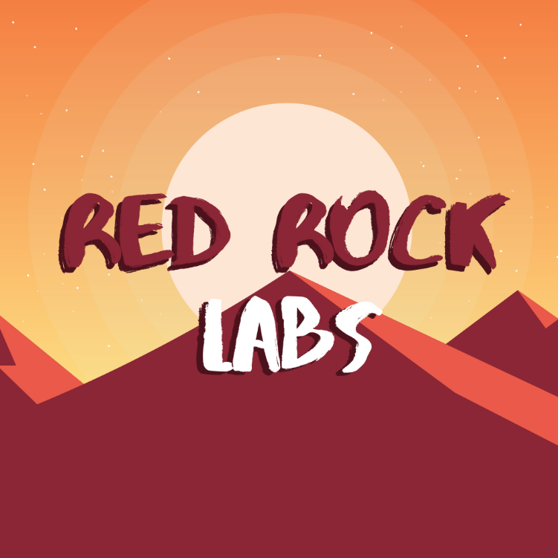

Experience Icon

Three unique screenshots
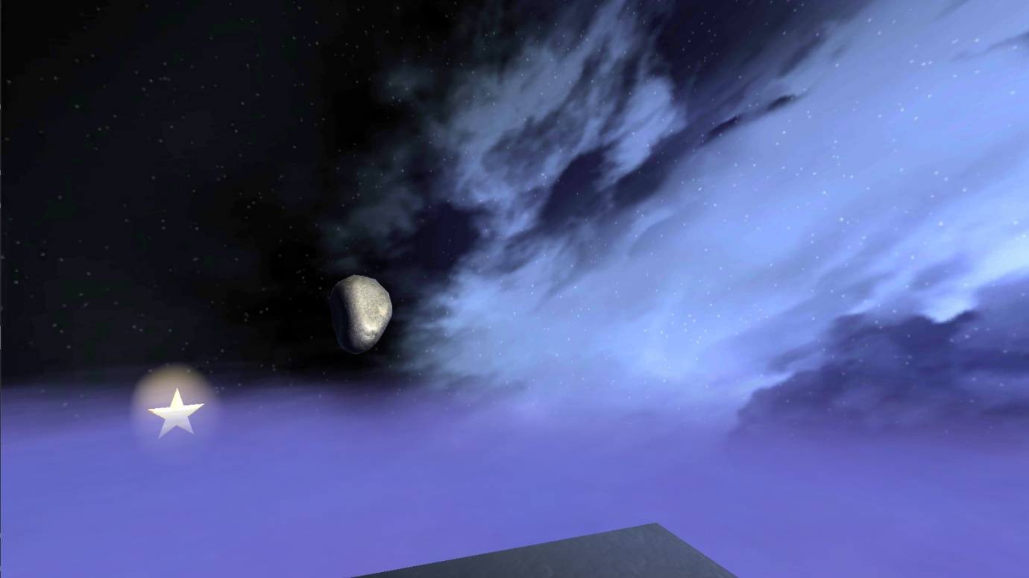

Educational affiliation logo

Choose the tags
- Full 360
- One Controller
- Sitting
- Standing
- Interactive

A duration range
6 minutes

