Baroque & Rococo
Louis XIII (Men) |  | Louis XIV (Women) |  | Enlightenment (English) (Men) |  | Louis XV & XVI (Women)
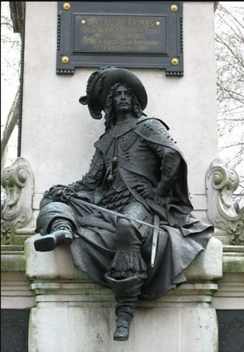 |  | 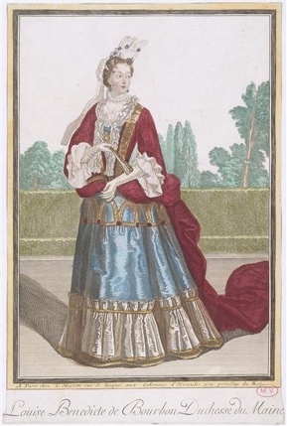 |  | 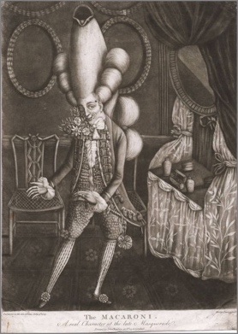 |  | 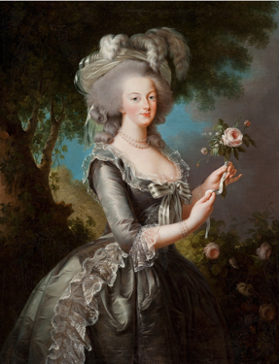
Garments and accessories | Description | Garments and accessories | Description | Garments and accessories | Description | Garments and accessories | Description
Doublet | More relaxed, natural style, without padding. Buttoned at center front, raised waistline, trimmed with false points/ gallants- now decorative. Longer straight or pointed peplum, could be divided into panes/ panels, with shirt visible underneath. Trimmed with buttons, embroidery, braid. | Dress/ manteaux/ mantua | -Bodice ends in V shape at waist, wide and deep neck opening short sleeves with gallants (bow and ribbons)  -from 1670s, becomes even more structures, with longer bodice, lower hips, tight sleeves stomacher with echelle (row of graduated bows at center front) stays are worn over chemise, under the dress | Frock coat | Plain, fitted, long jacket, with high collar, the bottom is gradually pulled towards the back (will eventually become tailcoat in 19th century), tight sleeves and oversized lace ruffles | Mantua and wide skirts | Variety of types of front closures:  -open front mantua laced to the stomacher  -closed with eyelets at center front  -tied in back  -surplice: 2 panels overlap in front (wrap)
Lace collar and cuffs | Soft ruff becomes large lace collar covering the shoulders, lace sleeve cuffs folded over sleeve | Petticoats/ underskirts | Extremely heavy due to decorations and fabadas (ruffles, lace, appliqué, embellishments)  Bottom part of mantua is pulled back in folds to create volume on the hips and back |  |  | Fitted bodices | Wide and deep neck openings, fitted sleeves
Cassock | Cape with sleeves | À la Fontange | Stiff lace headdress | Waistcoat | Buttons all the way down | Straw hats | Trimmed with plumes
Cape | Wide collar, hip-level, circular cape, worn over one shoulder, often in contrasting color to doublet, or with contrasting lining. Trimmed with slashing or braid | Cosmetics and perfume  Mouche/ beauty patch  Detail function: initially to hide blemishes, then later becoming elaborate to communicate mood | Strong contrast with white face powder and red cheeks, lips, etc.  Made of taffeta fabric or thin leather and attached with paste. |  |  | Wide skirt | First bell shaped, then wider at the hips with paniers, and flat front/back.
Breeches | Get longer and wider, worn with hose and fit into boots |  |  | Hair | Bagwig – hair tied in “queue” (ponytail), keep in black bag | Jewelry | Strass necklace and bracelet
Riding boots | Leather, with wide folded top, and spurs boot hose with wide lace edging folded on top of boots |  |  | Accessories | Ribbon rosettes at knees  Stockings with elongating stripes | Hairstyle | Feather  Detail function: Hair adornment
Hair | Long with “cadenette” or lovelock, small pointed beards and mustaches |  |  | Shoes | Flat dancing shoes, also with rosettes
Baldric | Sash for sword, worn across chest (right shoulder to left hip)
Hat | Wide brim, high crown, of beaver felt, trimmed with ostrich feather can be worn or carried as accessory

Marie Antoinetee | Modern Fashion Show
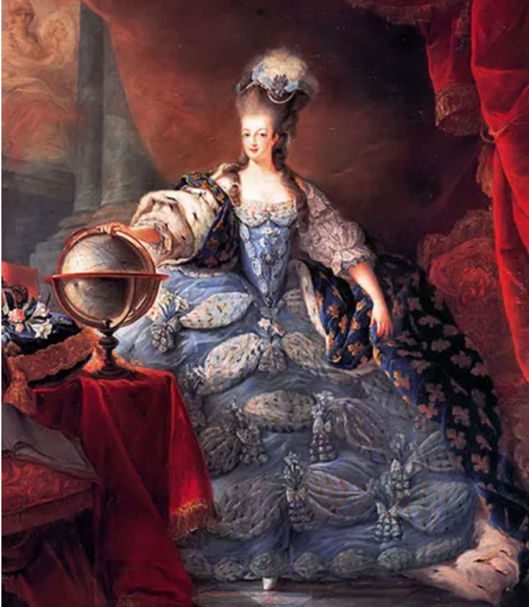 | 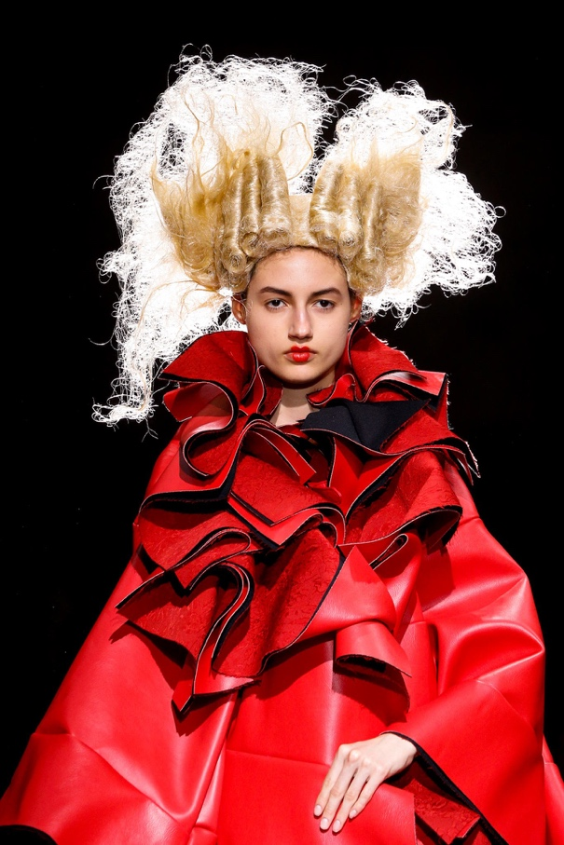
Common elements:
Hair: Hair styled in sausage- shaped rolls
Hair padded with wool or horsehair to give height

Sources:
- Louis XIII
http://musebreak.org/wp-content/uploads/2014/11/Dumas-monument.jpg
- Louis XIV
http://www.gogmsite.net/end_of_the_era_-_1684_to_17/subalbum_duchesse_du_maine/anne-louise-benedicte-de-bo-2.html
- Enlightenment (English)
http://www.homohistory.com/2012/10/our-flamboyant-forefathers-macaroni-and.htmlEnlightenment (English)
- Louis XV & XVI (Women)
https://www.vogue.com/article/vigee-le-brun-metropolitan-museum
- Marie Antoinette
https://www.collegefashion.net/inspiration/fashion-philosophy-marie-antoinette/
- Modern fashion show
https://www.vogue.com/fashion-shows/spring-2015-ready-to-wear/comme-des-garcons/slideshow/details#14
- Information: Smithsonian, Fashion The Definitive Of Costume And Style, First American Edition, 345 Hudson Street, DK publishing, October 1st 2012.

