Table of Contents:

Situation / Introduction ……………………………………... 3

Hel™ Product Features, Advantages and Benefits …... 4-8

Conclusion …………………………………………………... 8

Bibliography …………………………………………………. 9

Annexes ………………………………………………... 10-11

Situation / Introduction

As Vice President of WorldOne Technology, I’d like to personally introduce you to our newest and most advanced technological revolution in our company’s long history. Not only is it the biggest revolution in our history but it also might be one of the biggest revolution of this century. It is that big. I am here to introduce you to our Hel™ android. A life-sized female android that can near replicate a human here on earth today. We are extremely excited to introduce you to this product for the simple fact that you have built an extremely successful hotel industry and we know that this product will help you get your business to the next level. That in turn would allow you to outmatch any other hotel industry today.
Having built such a successful hotel industry yourself, you definitely understand how important customer satisfaction is. Especially today with Internet reviews and social media. Going the extra mile for your customers will no doubt grow your business. Today we will show you how you can get your hotel staff to go an extra TEN miles for customers without an extra cost or effort on your part. Here at WorldOne Tech. we are extremely excited and proud to release this innovation to the hotel industry because we think this is the industry that most suits our new Hel™ android. This android will revolutionize the hotel industry in many ways including, customer service, hospitality and profitability and it can all start with you.

Hel™ Product Features, Advantages and Benefits
Features
Here are WorldOne Tech. we take pride in our work and will only deliver the best quality products. We truly believe in this product and back it 100%. Its features are unique and allow for true personalisation. The Hel™ android also offers serious advantages when comparing it to a competing androids or even a human. Finally our benefits will allow you to be satisfied for years to come. Now let me give you some details regarding our Hel™ android and how it will fit your needs.
To start off we can talk about the Hel™ androids features. For now, our android only comes in one gender and size. Female and 168 cm tall. We do have plans to grow our line but as of now this android is our pride and joy. One of our most innovative features is our realistic synthetic skin. This skin covers the entirety of the android and gives it a comforting human feel which is key in the hotel industry. This synthetic skin comes in a variety of colours which match realistic human skin tones from around the world. The skin can also be swapped with ease and we will go over that later on in this presentation. This model is also equipped with a choice of eye colors. You can go with a realistic look with our Blue, Green, Hazel or Brown eye colors while you can also go for more of a unique look with our Red and Black eye colors.
You might ask how this human like android will stand and human ease. Well our secret is the skeletal structure. This structure is made up of ultra-light weight titanium-carbonite alloys which assembled correctly replicate a human skeletal structure. This structure allows us to construct characteristics which give the android greater freedom of mobility. Using the latest robotic technology the movements performed by the Hel™ android is remarkably similar to human movement with almost no lag between execution of thoughts and time. The titanium-silicon and polymer composite alloys are capable of going through a normal usage span of 20 years or more.
Advantages
Now that you have gotten familiar with the Hel™ android features, we will present to you its advantages and how it can outmatch competing androids and even human capacities. Our Hel™ android can process 1o billion transactions simultaneously per second. This CPU processing power is unmatched and the most complex in existence. This CPU power allows this android to achieve tasks that would never be attainable for other androids / robots.
All of the extra power put in this android also helps with other characteristics like speech capabilities. The Hel™ android can be programed and used in 50 different languages which can be key when dealing with customers in a busy hotel chain. Not only can the android speak and understand 50 languages but it can also process and understand even slight variations in tone and slangs. Another feature which involves communication in this androids capability to learn from verbal descriptions, visual demonstrations or a combination of both. This feature is what really makes this android different.
Another great advantage of this android is its battery life. Hel™ android is capable of self-sufficiency but requires systems check and update downtime for 1hour every 12hours it is in use. This will not be a problem for the android because when it is in operation, its capabilities will outmatch anything. Its maximum weight lifting capabilities is 200 kilograms and it also has a max pressure of 6000 PSI of pressure without any internal or external damage.
Benefits
Now that you know all of the Hel™ androids features and advantages I’d like to show you its future benefits and how they can truly help you maintain the best service for years to come. First off our android comes with a 2-year limited replacement warrantee if the unit becomes non-functional as a result of part or component failure. If the unit is non-functional because of manufactured defects, it will be replaced free of charge within 48hours. Though we maintain this promise we assure you that all of our Hel™ androids are tested and delivered with the highest quality control standards available. We stand by that and you can always be 100% we will deliver.
As for more technical future benefits our company offers free update capabilities which means that your Hel™ android will be able to receive wireless uploads. These updates will allow your android to connect to any workstation and receive any new instructions, modifications or product development versioning updates.

Financial
The financial benefits of this Hel™ android are very important and will also surprise you in a good way. Workers are the biggest cost in your hotel chains around the world. Though you might think that the Hel™ android comes with those same financial needs, it does not. The 20-year lifespan covers the costs associated with purchasing Hel™ up front. Our android costs only $18000 US with a 3% maintenance fee per year which comes out to $540 US. The price might sound like a lot at first because it is a lump sum but it truly is not. This android can complete more work than the average employee. While doing more work and doing that work more effectively the android still ends up costing less. Shown on this graph below you can see how long it will take for a regular employee’s salary to our android. Not only does it reach it but it passes it while the android stays constant at its base price.

Hel™ android at a constant $18540 US through the entire first year after purchase.
A workers salary will increase with time and will always be there. With the android, you will only see this cost of $18540 US during the first year. This will happen while work by the android will always maintain the highest quality. This will bring organization, consistency and ease to your customers but also you as the owner of this hotel industry. Leaders within your establishment will find themselves extremely happy with this new product which will in turn help your profitability and quality of work in general.
Conclusion
Our goal here at WorlOne Tech. is to make your work as a hotel industry owner, simpler, faster and more profitable. This will all be achieved with our Hel™ android by your side. This innovation will bring good attention and publicity to your establishment which can only be a good thing. This revolution in the industry can all start with you and our Hel™ android by your side and us here at WorlOne Technology would be proud and privileged to make that happen.

Bibliography
Provençal, D. (2016). Information and Support Material for Final Project. Sales and Communications I.

Annexes
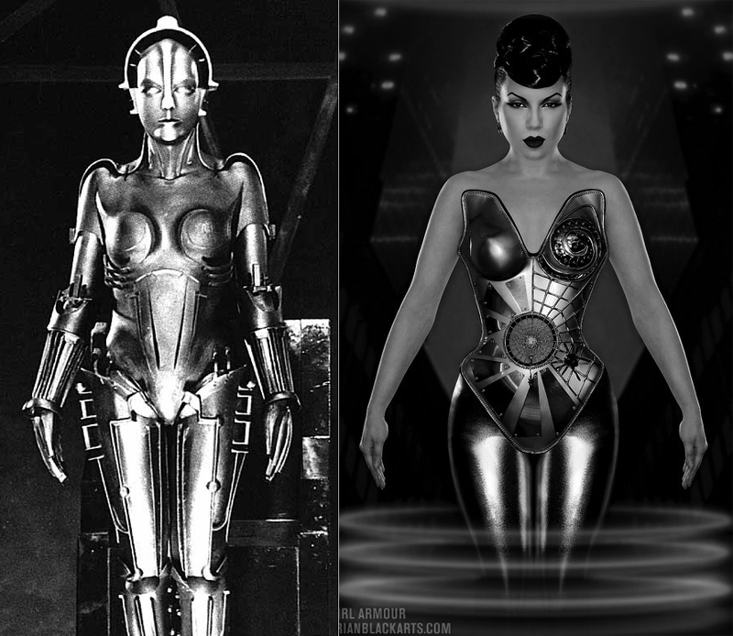 Picture 1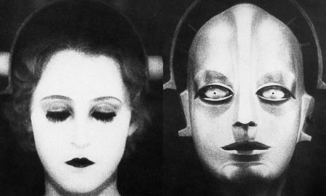 Picture 2
Picture 1: What the Hel™ android looks like with white skin tone on right and basic material on left.
Picture 2: Realistic features on the face of the Hel™ android.
