PROJECT
TEAM:
Iako’ta:raien DELARONDE, Vembanaden PAYEN, David De ARAUJO, David BADIANE

MARKETING RESEARCH
AIRBNB
TABLE OF CONTENTS
Page
Introduction 1
Situation Analysis 1
Trends 1
Demographic 2
Competitors 2
Objectives of the Marketing Research 4
Portfolio 2 5
Data Analysis and Results 6
Conclusions and recommendations 14
Recommendations: 14
BIBLIOGRAPHY 16
APPENDIces: 17

Introduction
The “product” we are going to study in this research is a service offered by the company AirBNB launched in San Francisco in 2008. AirBNB is an online marketplace for vacation rentals that connects users with property to rent with users looking to rent the space. These spaces could be apartments, villas, houses, or even castles for a unique travel experience of various prices. We chose to make our marketing research report on this company because the service that the company offers (regarding the fact that the share economy is a growing sector in the Travel and Tourism industry) was revolutionary. How this company can be so successful for travelers but is still unknown by the general public? Is a question that picks the interest of my team?

Situation Analysis

Trends
In a world where people are more and more connected new industries and market came up. With the advent of technology and particularly Internet, social medias etc. what we called the “sharing economy” industry emerged. Sharing Economy is a socio-economic ecosystem built around the sharing of human, physical and intellectual resources. Last night (March 9th 2013) 40,000 people rented accommodation from a service that offers 250,000 rooms in 30,000 cities in 192 countries. They chose their rooms and paid for everything online. But their beds were provided by private individuals, rather than a hotel chain. Hosts and guests were matched up by Airbnb.

Demographic
Since its launch in 2008 more than 4m people have used it—2.5m of them in 2012 alone. It is the most prominent example of a huge new “sharing economy”, in which people rent beds, cars, boats and other assets directly from each other, coordinated via the internet. (Economist, 2013) With nearly $120 million in venture funding to date, most of Airbnb’s growth can be attributed to its heavy investment in marketing and infrastructure. This investment largely paid off, driving a 120% increase in branded searches and increasing the number of nights booked from 800,000 to 2 million. Sales numbers rose similarly, from merely 365 bookings in 2008 to 15.8 million in 2012. Even the number of employees jumped from 4 in 2009 to over 500 in 2012.Most Company usually segment their market in one segment only but Airbnb on the other hand is able to deal with both at once. Airbnb marketing uses both segment where each one complement each other. Like the hotel industry for example, they need to have a location where to host people and these travelers are aware of hostels and hotels existence. This is almost the same case of Airbnb because they shared most of the common interests and characteristics of travelers that would stay in a average hotel. However, Airbnb is different from average hostels and hotels. Airbnb competitive advantage is the variety of rental choices and prices. In addition, these places are also Airbnb user’s (hosts) homes. The two main segment are vital for the company as it the center of their profitability.

Competitors
Although Airbnb is very successful, it does have some competitors. There’s are some websites that offer the same service, such as Tripping.com, HomEaway.com, Everystay.com, VRBO.com, Wimdu.com, Perfectplaces.com, 9flats.com, Onefinestay.com, Vacationrentals.com, Flipkey.com and Couchsurfing.com. Although all of these websites provide the same service, Airbnb was the first to launch their website, the others are copies of the idea. Another competitor of Airbnb are normal hotels. The reason Airbnb has an advantage over its competitors is the trust associated with each stay. Their verification process is not only for the benefit of the host but also for the guest. Airbnb constructed an easy to use website making it simple to communicate with guest and creates a trusting environment to compel a guest to rent a space. They offer many diverse housing options for guests, such as castles for groups of people

Objectives of the Marketing Research
This marketing research project will be focused on Airbnb Inc. Airbnb represents the perfect study case in the sharing economy industry, with a big success still insufficiently known. Airbnb is currently enjoying a financial stability that will allow it to invest heavily in expanding its current market share of users. With such good numbers and success why Airbnb is still unknown by the general public? Why people sticks to their old habits like renting hotel rooms? How the company can go on increasing its notoriety?
Networking is one of the dominant strategy one can use in marketing. The purpose of this research is also to determine how positively the network effect affects the users of Airbnb. The research will gives us an idea on the weakness of the type of communication. By doing so Airbnb will have the ability to improve its communication method to reach users of this category who is unaware of Airbnb service.
The research will also give an idea if Airbnb should do a partnership strategies with other big brand companies, like airline, famous artist in order to develop its marketing perspective to capture more market share. Or even if they should host events in strategic places where it’s well known.

Portfolio 2

The Methodology Chart

Population | In this marketing research project the population is every person single person (adult) willing to travel. We were focused on people who travel during the last year.
Marketing Research method | Descriptive
Field methodology | Interviewer-administered sample survey
Sampling method | Non-probability (or non-random)  convenience sampling
Sample (total number) | 40 people
Sample frame | None
Response Rate | 100% completed questionnaires
Questionnaire | Time for administering : 3 minutes
Pre-tests done | Total of 4 (1 per interviewer)
Location of administration | School (LaSalle College) perfect spot with international  students often travelling, and young people going into  vacations. In our respective work place.
Date of interviews | From November 1 to November 8, 2017

Data Analysis and Results

Data analysis- MARKETING RESEARCH
1. In the past 5 years, have you heard about Airbnb?

62% have already heard of airbnb compare to 27% who never heard about it.

2. If yes, where did you hear about Airbnb?

The network effect has a great impact on our everyday life. 46% uses the social media to find information and only 12% uses advertising. Being more connected to the world of web can increase the sales and raised more awareness.

3. How many times did you travel in the past year?

The survey shows that most people travel only 1-2 times or 43% compare to 15% of travellers in a year and uses hosting service.

4. What is your job status?

The job status chart shows us that the trend is more among the students than the employed full time who has only 25%. We might say that the student travel more or move from one place to another frequently for any purpose.

5. Thinking back to your last trip, how Long Your Stay was?

The average night of stay as per the survey represent 30% for 2-4nights.

6. Of the following, what was your accommodation during your last trip? Either it’s business or leisure.

Most people usually book hotel rooms, which is easier. According to the survey it represent 67% for hotel occupation compare to a hotel apartment with a rate of 15%. The graph clearly shows the preference for the kind of hosting most people preferred.

7 How Do You Usually Book Your Accommodation for business or leisure trips?

The online booking strategy made life easier. We has a rate of 42% of travellers who book their hosting online through different platform and would even consider to use alternatives

8. Have you already thought about using alternatives to your usual staying facilities?

55% travellers will consider to use an alternatives depending of what they are being offered compare to an average of 45% who will stick to their way of usual

10 If yes, have you looked for information about others hosting types on the following
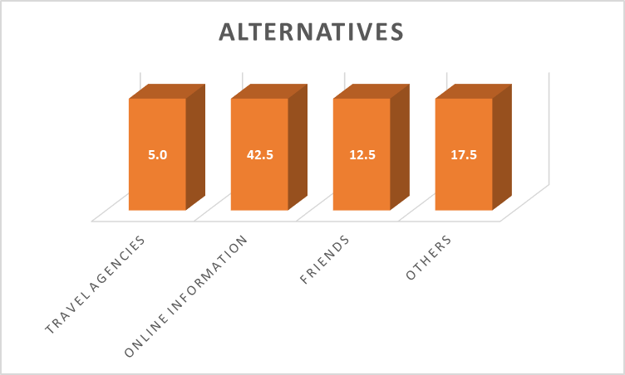

The chart represent the alternatives for those who want changes and we notice that 42% of travellers do a search online before doing any booking. They compare reviews and ask friends about information.
12. During Your Last Few Trips, What Was Your Budget Per Night, Before Taxes?

The survey shows that most travellers want to cut cost and by so doing they have prepare a budget. 35% travellers has a budget of around $75-$100 to spend per night.

13. What Factors Are Most Important When Choosing An Accommodation?

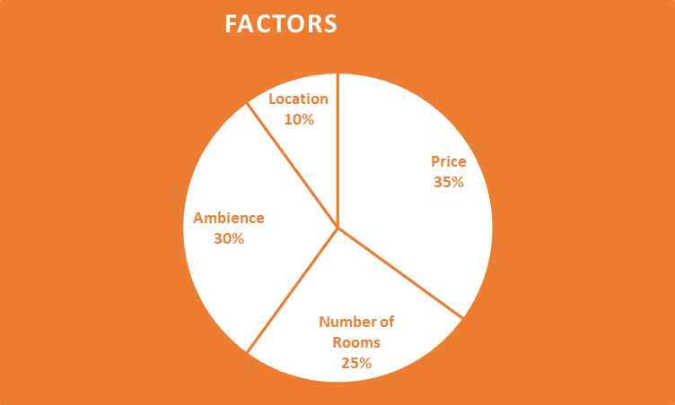

Most travellers who bind themselves around a budget consider some price factors before a decision making. The graph represent the main factors when choosing an accommodation and we noticed that 35% of travellers will consider the price before going for and 30% will choose according to the environment, ambience facility they could get.

14. If another service would Have Given You the Same Preference That You Needed with A
Better price, would You Chosen it Over Others?
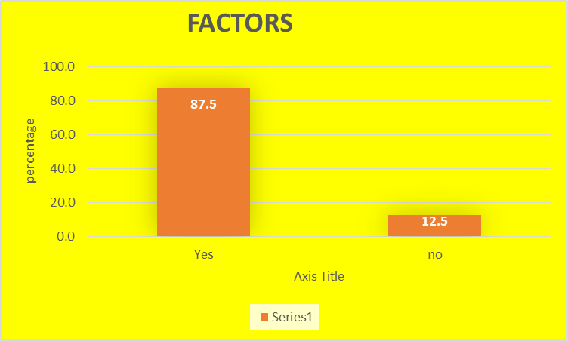
This graph clearly demonstrates that if Airbnb would offer the same preference for a better price positioning 87% of travellers will consider Airbnb.

Limits

Going on with our marketing research project and interviewing people we figured out some limits and obstacles that have maybe affect the results of our research. Indeed, the objective of our project is to find information to identify why AirBnb remains unknown by many people in the general public. The first thing is that interviewing only 40 peoples may not be totally relevant. For example one of our team workers got 30% of his sampling that doesn’t know AirBnb whereas another one had a result of 0%. Also regarding the objective our research, a quota sampling could have been more relevant. By dividing ("stratified") by variables such as income, age, location, country of origin the result of the study could had provide a specific group of people to target. The best sampling selection was maybe people who travel and do not know AirBnb Inc. But it was interesting to also interviewed people that do know the company but don’t use it to see if they are willing to do it and identify AirBnb’s competitors.
Even if they were some limits to our marketing research we got some interesting results to analyze and can provide a conclusion and some recommendations based on our objective.

Conclusions and recommendations

Conclusion:
Leading a marketing research is pretty interesting, starting with some information looking for others, going deeper, identifying a research objective, discovering that coming from that one, others appear… We all loved doing it, especially with a company that is nowadays so successful but like every business have issues to solve. AirBnb Inc. is the number one in the hosting sharing economy area but remains unknown by many people in the general public. Regarding our results almost all the people who were interviewed are willing to change their habits with booking hotel room. AirBnb offers a hosting and cleaning service, like a hotel, instead that people can really feel home, and offers in average a better price (80 dollars per night). Also even if most of people in our sampling have already heard about the company doesn’t mean that they know exactly what the company has to offer, which is a problem for the company.

Recommendations:

AriBnb Inc. is known for its marketing plan and strategy that allows the company a phenomenal growth during the last decade but the company should consider to go bigger with the advertising part. Using the famous social media Instagram to reach more people, go with sponsorship covering big event like the Football World Cup to have a maximum visibility and also with travel agencies that remains used to book flight tickets and vacations plan even by young people. The company could also think about TV spot ob big channel, there’s nothing yet on this field. Of course it’s expensive but the company worth now more than 30 billion $ and with all the people watching TV everyday all around the world the investment will be more than profitable.

BIBLIOGRAPHY
Economist, T. (2013, March 9). The rise of the sharing economy. Retrieved September 25, 2017, from The Economist: https://www.economist.com/news/leaders/21573104-internet-everything-hire-rise-sharing-economy
Fitzpatrick, A. (2015, December 10). Everything To Know About Airbnb. Retrieved February 9, 2017, from Time: http://time.com/4145072/airbnb-rooms-prices/
Gallagher, L. (2016, December 22). How Airbnb Found a Mission—and a Brand. Retrieved Frebruary 9, 2017, from Fortune: http://fortune.com/airbnb-travel-mission-brand/
Steve WU, F. L. (2012). Airbnb. Los Angeles: UCLA Economics.
Unknown. (2015, March 7). Airbnb SWOT Analyses. Retrieved Frebruary 9, 2017, from Cayenne Apps: http://blog.cayenneapps.com/2015/03/07/airbnb-swot-analysis/
Unknown. (2017, February 8). Airbnb Wikipedia. Retrieved February 9, 2017, from Wikipedia: https://en.wikipedia.org/wiki/Airbnb
Wheeler, D. (2015, March 25). 4 Digital Marketing Strategies: An Airbnb Case Study. Retrieved Frebruary 9, 2017, from SEJ: https://www.searchenginejournal.com/4-digital-marketing-strategies-airbnb-case-study/95007/

APPENDIces:
Coding Dictionary
Coding Grid Summary
Coding Grid
Pretested questionnaire (With teacher’s comment)
Final questionnaire

