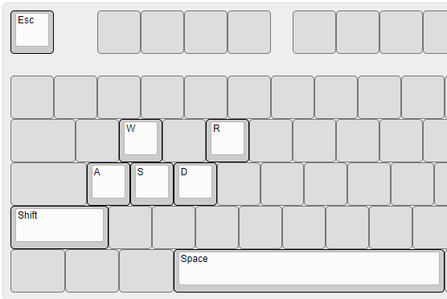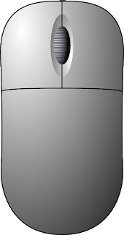

Action | PC Input (Player 1) | Gamepad Input (Player 2)
Directional Move | WASD | Left Stick
Directional Look | Mouse Move | Right Stick
Sprint (Hold) | Shift | Left Bumper
End Climbing/Debug | Space | Bottom Face Button
Fire Weapon | Mouse Left Click | Right Trigger
Zoom In (Hold) | Mouse Right Click | Left Trigger
Reload Weapon | R | Left Face Button
Revive Teammate (Hold) | R | Left Face Button
Exit Game | Esc | N/A

