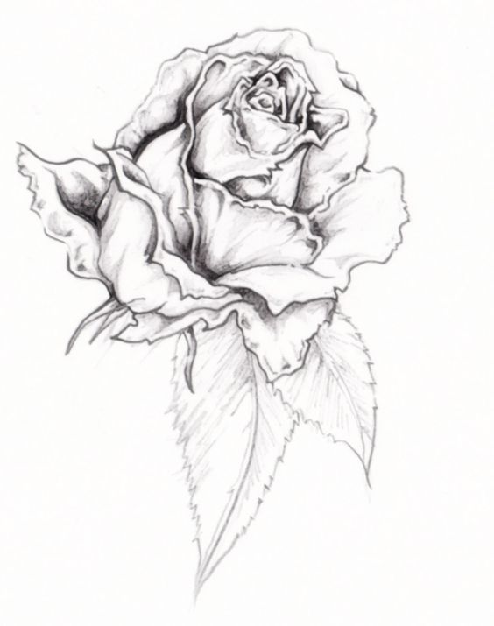
Brenda Vaccaro
Montréal, QC
Brenda-bsb@hotmail.com - (514) 913-6643

Languages:
Fluent in English, French and Italian written and oral

Skills:

Computer Skills: Proficient with Microsoft Word, PowerPoint, illustrator and Internet

Education:

LaSalle College
DEC in Fashion Marketing
Montréal, QC
2013 to 2016

Ashworth College
Diploma in Nutrition, Diet and Health Science
2015 to 2015

LaSalle Community Comprehensive High School
LaSalle, QC
2009 to 2013

Work Experience:

Alia n Tanjay (Nygard)
Sales Associate
Montréal, QC
November 2015 to Present

Theatre Paradox
Hostess and coat check
Montreal, QC
October 2015 to Present

Toxik Boutique
Sales Associate
Montréal, QC
October 2014 to August 2015
Responsibilities
I did both cash and serve each clients with all their needs. I also did some of the facing for the store as well as inventory and ticketing the new merchandise when it came in.
Accomplishments
I helped me improve my customer service skills and my knowledge of the function behind a clothing store. Working in a boutique provides you with the knowledge of each process there is to keep the company going.
Skills Used
The skills that I demonstrated was great communication to make sure the customer was always served as well as punctuality and great organization skills.

Hudson's Bay
Sales Associate
-Montréal, QC
May 2014 to October 2014
I was a sales associate for a boutique in the Hudson’s Bay by the name of Jacque Vert. It was a very structural company that provided me with organizational skills I will carry on with me. Working there i was helping customers with their every need, as well being proficient with working the cash and inventory.

Internships:

Pharmaprix: Worked in the beauty section of the store and got the chance to learn about all their different products and what’s best for your skin.

Uqam University: Was given the opportunity to try out the different fields in the design sectors that were provided.

Achievements:
Leadership Program 2010-2013
- It is a program that allows me to exercise my organizational skills by organizing student events by working In teams. This is a program that was offered during my high school education.

Interests / Activities :
-Being outdoors/Traveling
·Fitness
·Baking
·Fashion
·Reading

*References upon request

