User Manual
College LaSalle
Project - P55 - Internet Programming I User Manual
Presented to: Mihai Maftei

Author: Aga Arafat Hossain Chowdhury (1632663)
4/20/2017

Introduction
“MyAuto” is a car dealer website where different brand and different types of vehicles are exhibited by the author and give opportunity to select or buy a car by online as well as payment facility via online. In this document I will talk about the web pages of “MyAuto” website as well as the functionality and using instruction for this site. To make this manual easy to viewer and provide appropriate knowledge about this site I will break down the page in different block and try to give instruction step by step. I hope this manual help you to understand better about this site and user application which I will describe about later of this document.

About MyAuto
MyAuto is a car dealer based website where you can see of all collection of vehicle and some services related auto. According to this site construction you will get two types of web page. One is for public user and another is for private user. Every viewer can access the public page is called index.html and can check all information about the display product and services. Only registered user can access private user page called user_page.html and check about the user information as well as his activities of this site.
When you open this site (index.html) using specific browser (Mozila Firefox etc.) you will see a web page like the following screenshot 1 : Public user page and you can access the private user page by login using appropriate user information. The screenshot 2: Private user page describe the home page of this page.
In next paragraph you will see how to operate this site step by step. For your better understanding I have mark the specific portion of this site or indicate by red color arrow and address that portion by numeric number.
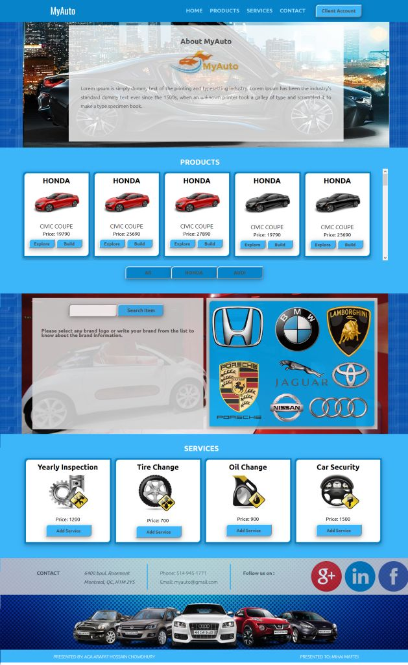
Screenshot 1: Public User Page (index.html)
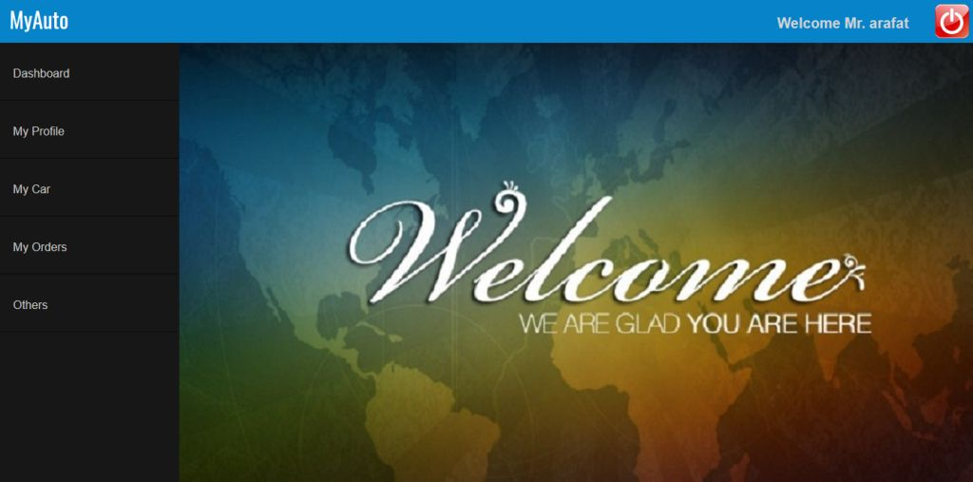
Screenshot 2: Private User Page (user_page.html)

Public User Page

The following screenshot is a header or identification of this website. It contains company logo, link of different portion of this page and the client account login and registration page.
Screenshot 3: Header of this page
- MyAuto is the name or logo of this site.
- By clicking this indicated button you can access client login and registration page.
Now I am introducing with the client account login and registration panel. You will get the panel by clicking “Client Account” button situated in the top of the page. The following screenshot is the snap of the client login and registration panel.
- Left part is client login part to access private user page which I have discussed before.
- Right part is client registration part and it is not active due to the storage problem. Because in my application I have not used any database to store that information.
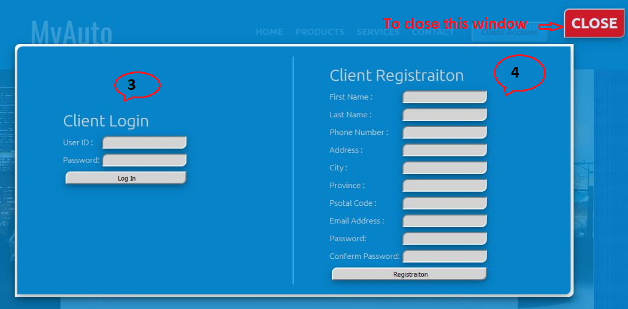
Screenshot 4: Client Login and Registration Panel
To login private user page you can use the following user information.
User ID | Password
mihai | 123456
arafat | 123456

Below the header you will see a home page of this site which screenshot I have not included in this document. I this page you will get some information about “MyAuto”. After this block a navigated product list appear with some button and information that is given in the following screenshot.
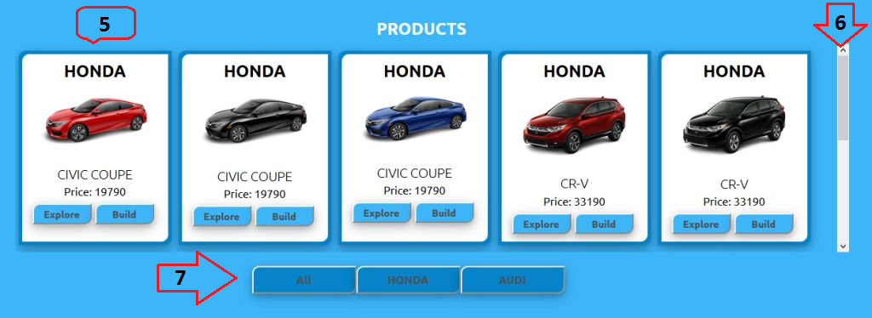
Screenshot 5: Product Exhibition
- These blocks contain product name, image, and price and event button for building a car and explore a car.
- This screen can display maximum 5 products. To display more than five products in right side you will see a scroll bar. This scroll bar help you to find others product listed in this box.
- These buttons help you to filter products according to their brand name.
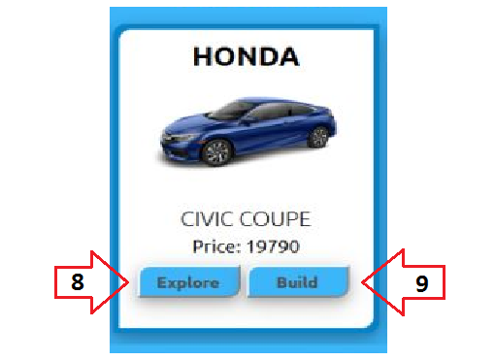
Screenshot 6: Product Exhibition Single Block
- The “Explore” button is used to explore individual model of car in a single page. You will see the page view in screenshot 7. This page contains the information about this model, specification, features, price variation and picture of different color cars.
- By clicking the “Build” button you will see the new window contains basic information and parameter of the car and you can change these parameter according to your choice. You can also add some service with your desired car in this list. After I will discuss about the component of this window.

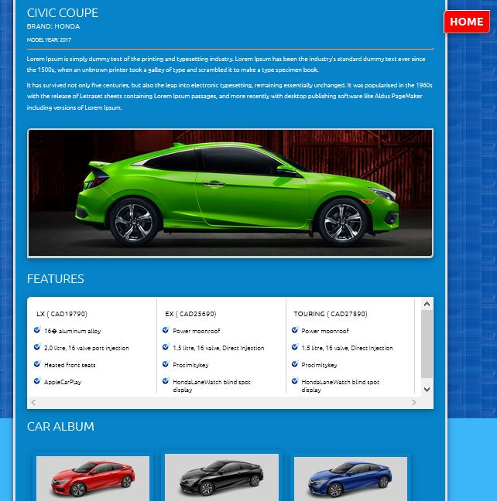
Screenshot 7: Explore a Car in a Single Page
The following screenshot describe the major part of this site. In this is special window, you can build your car as your wish. This window contains various information about the product and related services with this product.
- You can change the color of your selected car by clicking on the color box
- You can select trim of the car by changing the trim
- You can select service from the list by checking the checkbox of individual item.
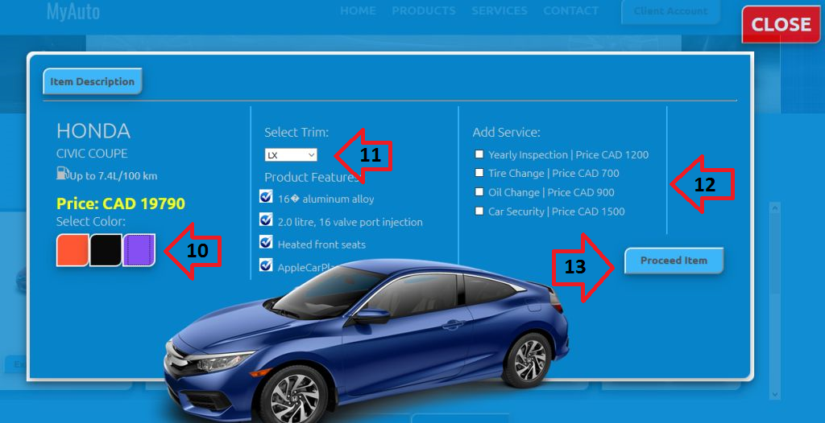
Screenshot 8: Build Car Window
- To proceed your selected item and changed parameter click on the “Proceed” button. Before proceed please check all parameter is ok. You will see the changed price left side of this window.
- After proceed item a new window will appear with cost summary table where included GST and QST on total amount. The top left corner you will find two button to change window “Item Description”
*** An important thing you have to know that, if you change any parameter from item description the cost summary button will disappear.
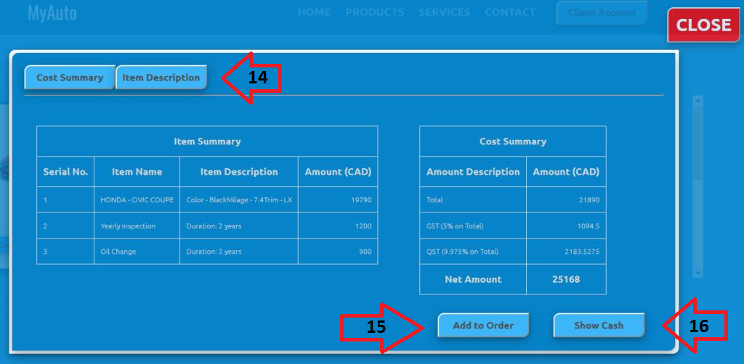
Screenshot 9: Cost Summary Window
- “Add to Order” button help you to add this selected product in your order tab in your user page. I will talk about user page later. If you have already loged in your account it will automatically open a new window to show your account. If not the client login window pop up on this window. You have to login your account to see the order.
- This button display how many note you have to pay for this product.
- Please click “Back” to go previous page of this window.
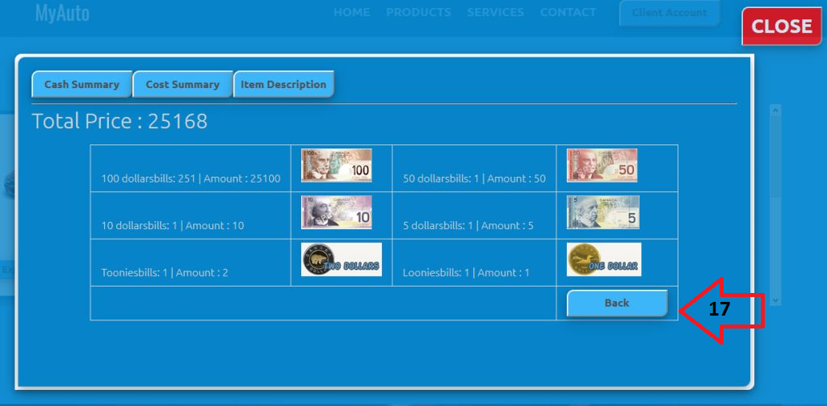
Screenshot 10: Display Cash Bill
The following block is special part of this site. In this part you can know about our collected brand by clicking on the logo or write the brand name in the input box and click on the “Search Item” button.
- This part contain image map to link all individual logo.
- Search item manually
- To go the official page of this item.
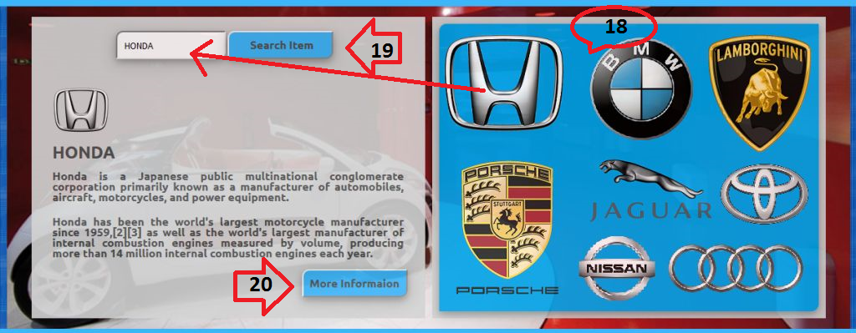
Screenshot 11: Search and Display Item Information
- The following screen shot is display four services providing by MyAuto. You can add services by clicking on the “Add Service” button. If you have already added service in your order list, you can’t add that service again in your list. You can only add that item which you didn’t add in your list. I have added some screenshot about this property.
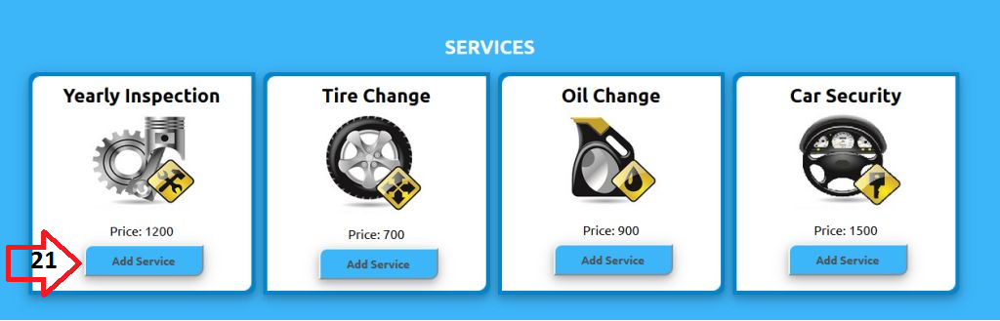
Screenshot 12: Services Exhibition
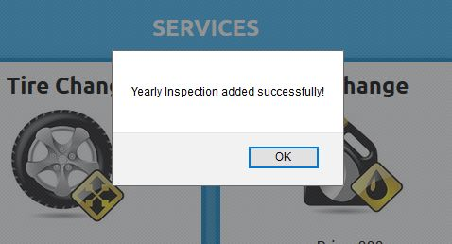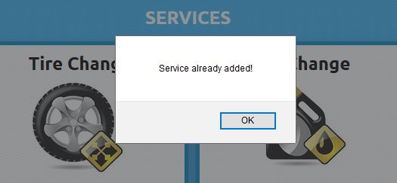
Screenshot 13: Services Exhibition Message Box
The last part of this page is content and footer.
- This logo is for social media link button.
Screenshot 14: Contact Block and Footer

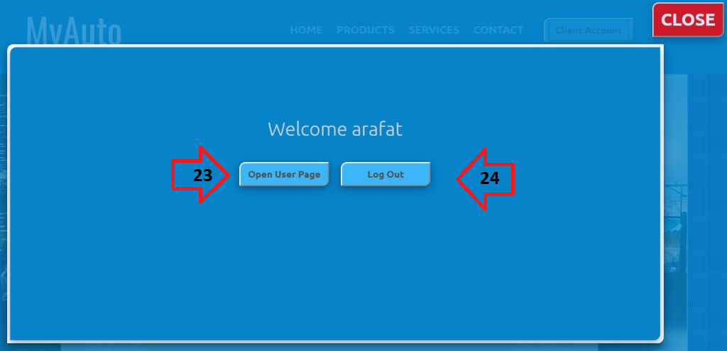
Screenshot 15: Welcome Page after Login
After login if you close private user page you can enter again by clicking 23 marked button and you can also logout by clicking 24 marked button.

Private User Page

The following screenshots display the window of user interface. This window contains five navigation link which calls individual linked page to display when it will call. The number 1 marked button is used to logout from this user page. If you click on this button, it will redirect you to the home page of this site. I am describing all link step by step.

Dashboard: The dashboard display the user information summary in short form and also display the product and service name has been added in order list by the user. The left side item is small summary of user and right side item is for added product or services.
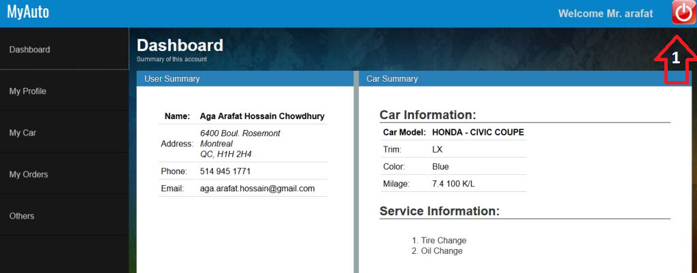
Screenshot 16: Dashboard
My Profile: This portion displays all information about the user which he has given during registration.
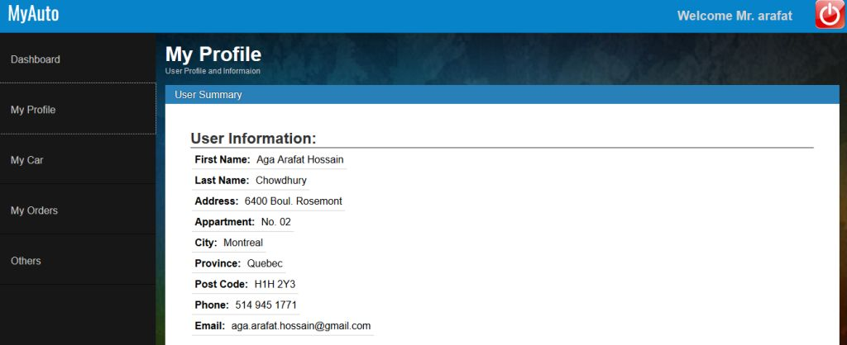
Screenshot 17: My Profile
My Car: This portion displays all information about the car which he has added form the home page.
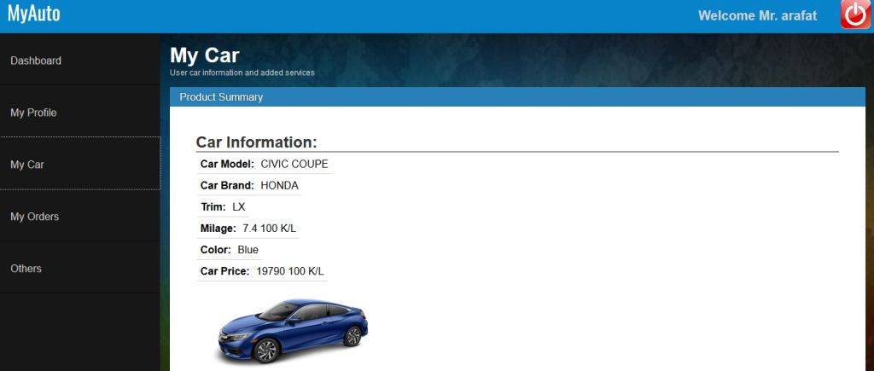
Screenshot 18: My Car

My Order: This page displays the order summary in a tabular form with GST and QST. There are one payment method. You can pay the bill by bank listed in this page.
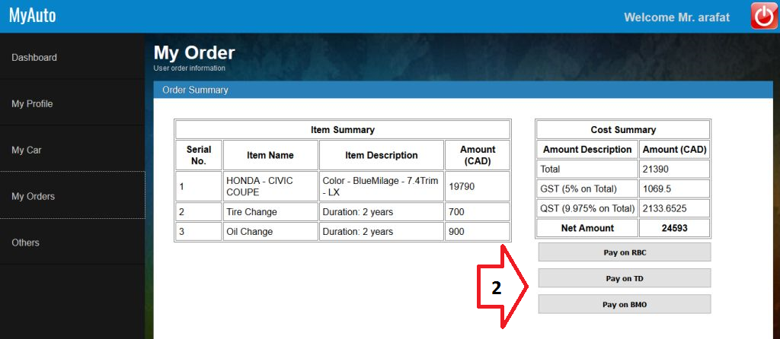
Screenshot 19: My Order

Conclusions: This manual is only for user instruction set. You will learn more when you physically visit this site. Happy Browsing.

