Kadeejah Beswick
May 13, 2017
EVM400
Ann Dow

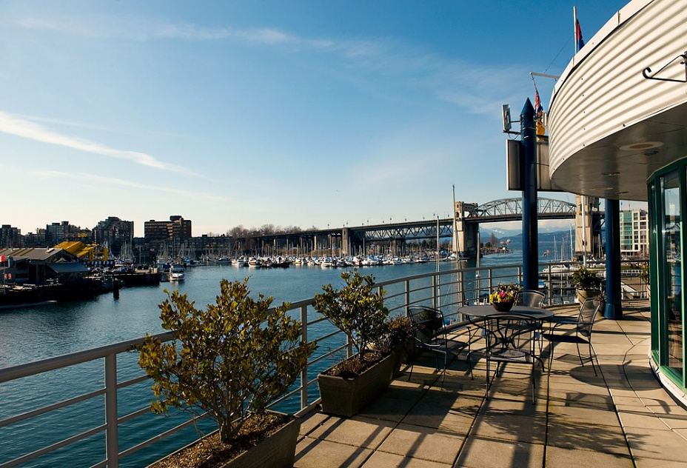
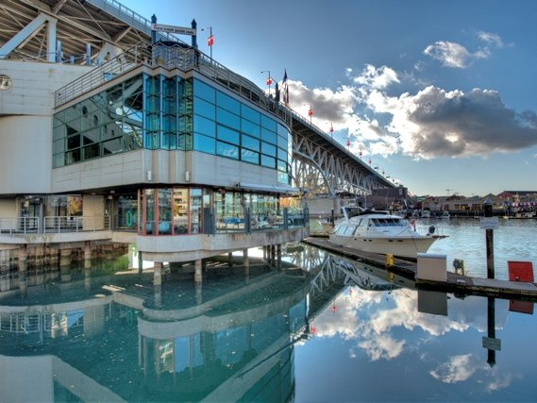
Assignment 3 – Conference Special Events/Food and Beverage

FCYC – False Creek Yacht Club

I decided to take the 25 top executives to the False Creek Yacht Club because, as you can see in the photo’s above, it has a beautiful and truly stunning view of the water. They have the choice of having your event on the wrap around patio with seating, the lounge, the clubhouse and the boardroom. The clubhouse can seat 90 guests comfortably, so for 25 executives, they would be able to have ton of room to be as comfortable as they possibly can. They offer free parking and Wi-Fi, friendly and professional staff, and a full-service bar. I believe this would be a beautiful spot to take the executives out for dinner.

Menu
I created this menu by looking up some delicious dishes that I think everyone would enjoy. Everything in the menu I created is pretty generic, but they have their own twists because they have to meet the dietary restrictions. However, the steak is very easy because it doesn’t come with any gluten, lactose or shellfish. Everything I chose looks really good, and it looks like they wouldn’t have any different ingredients to meet the special dietary restrictions.

RESTRICTIONS:
- Gluten Allergy
- Lactose intolerant
- No shellfish
3 course meal

Appetizer
Veggie Twice Baked Potatoes
This is a delicious bite sized red potato, stuffed with bell peppers, cooked broccoli and green onion with a beautiful garlicy flavour. It is made with Silk Dairy Free Almond Milk, olive oil, sea salt and black pepper, and baked in the oven – twice – to perfection.

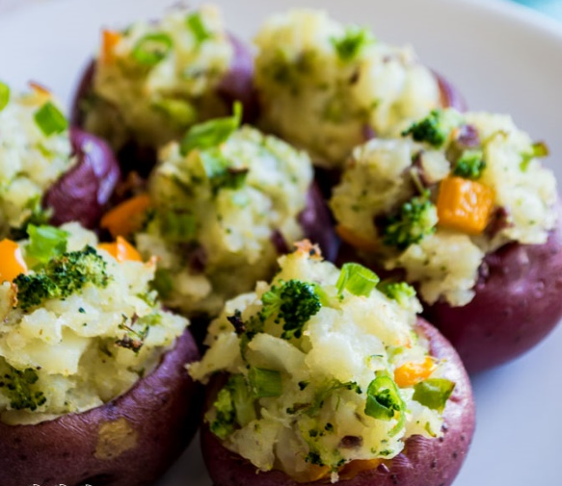

Entrée
Sirloin Steak with Garlic Butter
A very delicious steak cooked to your liking. It has a wonderful garlic glaze, and comes with grilled asparagus and sweet potato.

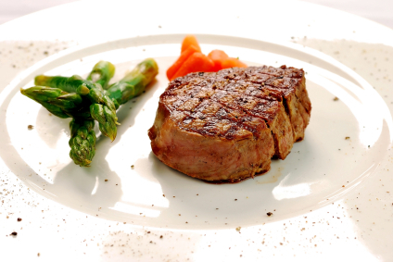

Dessert
Maple Cinnamon Applesauce
This is a beautiful rustic, chunky, and hearty maple sweetened applesauce. It tastes just like apple pie filling but better. The apples are cooked in a maple and cinnamon glaze, and then mixed together with oats and served with Peach Raspberry Sorbet.

The Peach Raspberry Sorbet is made by simmering the peaches with sugar and water until they are soft. The raspberries are blended, and then the seeds are filtered out. After the peaches and the raspberry puree are added together with lemon juice and blended together, then chilled.
Sources:
- http://houseofyumm.com/veggie-twice-baked-potatoes/
- http://cookieandkate.com/2012/maple-cinnamon-applesauce/
- http://cookieandkate.com/2011/peach-raspberry-sorbet/
- http://allrecipes.com/recipe/14554/sirloin-steak-with-garlic-butter/?internalSource=hub%20recipe&referringId=1696&referringContentType=recipe%20hub&clickId=cardslot%2028
- http://fcyc.com/events/

