***SiChuan***

**Restaurant**

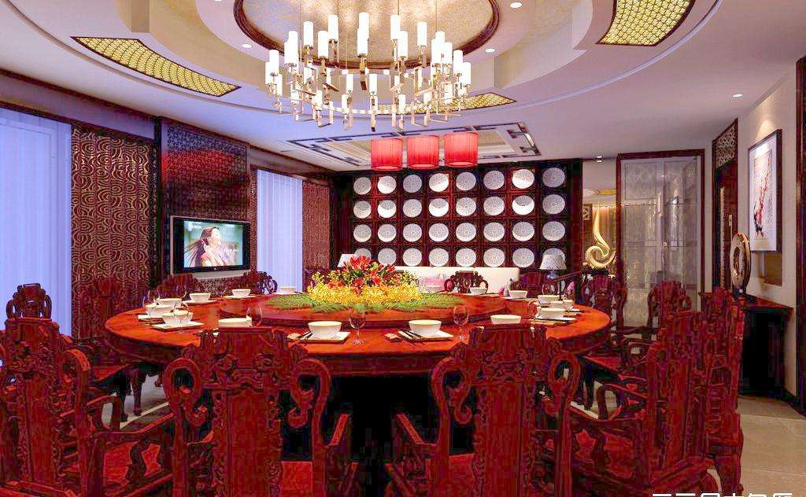

JInze Tan

398313

Chef Paz

Contents

Operation Concept 3

Management Team 4

Table Setting 9

Menu (Standard) 11

Standard Recipe 13

Menu Engineering 32

Equipment list 33

Food Inventory 40

Menu Engineering 42

Floor Plan 45

Human Resources 46

Marketing Plan 52

Financial Plan 59

Financial Analysis 64

Work Cited 67

# Operation Concept

**Description:**

SiChuan Restaurant is a traditional Chinese food restaurant and corporation company Location is 10119 River DR Richmond BC. It is offer Chinese desert include lunch and dinner. Our menu is on major Chinese seafood and pastry that are famous in different part of china. Because of the high percentage of Chinese in Vancouver, it is hard for Chinese to find a good place to enjoy the food they like to eat. Our purpose is offer traditional Chinese flavors to Canadians and help Chinese who live in Vancouver to find the flavor which same from their home city. We will use English-style of service which also known as family service style.

For the family service style, Family style simply means that servers bring out large bowls and platters of food, which are then placed on the tables for guests to pass and self-serve. It often feels like the holidays and creates a fun, family-oriented. It also helps guests get to know each other since they often help serve one another and chat while doing so.

There are lots of additional platters, plates, and bowls that will need homes on the table once the food is brought out. This takes space away from your centerpieces and other fun table décor. Family style can be a nice way to control the quantity of food served while still offering people the ability to decide what they feel like eating that night. Guests won’t have as much freedom as they do at buffet but they’ll get to make some decisions about how much they would like of a certain type of food. This is most likely a time where you’ll want to narrow down your main dish choices. Just because it’s family style, doesn’t mean you have to serve more options. Choose one or two proteins and a vegetarian option, like a homemade ravioli. Add a big salad and a side like rice.

We have 12 table and can serve 48 customer

Employee meals policy: offer in restaurant meal during work time

Quality and pricing policy: High quality of food and medium price

Waste and recycling policies:

* Create a team of responsible persons for this job
* Track and analyze the waste in a restaurant
* Review the documentation on the purchased goods and review the business decisions
* Conduct inventory frequently in order to compare purchase and quantity of garbage
* Change menu in order to minimize quantity of leftovers
* Create a rules for this program
* Recycle everything what can be recycled

# Management Team

Manager: Jinze TAN

|  |
| --- |
| JINZE Tan  Skarotan@gmail.com · 778-891-9689 |
|  |

WORK Experience

|  |
| --- |
| JUNE 2016-SEPTEMBER 2016  Line Cook & pastry, Lucky Baozi, CHINA  Assisted diners with obtaining food from buffet/serving table as needed  Baked, roasted, broiled, and steamed meats, fish, vegetables, and other foods  Cleaned, organized and inspected galley equipment, kitchen appliances, and work areas |
| OCTOBER 2017-JANUARY 2018  PREP COOK, Manchu Wok, burnaby, bc  Prepared daily food items, and cooked simple foods and beverages  Peeled, washed, trimmed, and cooked vegetables and meats  Baked breads and pastries  Baked, roasted, broiled, and steamed meats, fish, vegetables, and other foods  Ensure proper temperatures of freezers, refrigerators, and heating equipment  Operated large-volume cooking equipment: grills, deep-fat fryers, and griddles |

Education

|  |
| --- |
| 2018  Hospitality & restaurant/business management, lasalle college vancouver  Relevant courses:  Safety & Sanitation  Catering & Banquet Operations  Hospitality & Human Resources Management  Food & Beverage Operations Management  Management by Menu  Purchasing & Product Identification World Cuisines |

Skills & certifications

|  |  |
| --- | --- |
| Food Safe Level 1  WHMIS  First Aid  Microsoft Office  Computer skill |  |

**FOH Manager: Marco Wilson**

**Marco Wilson**

100 Broadway East, Vancouver, BC V5E 4N7

Home: 604-553-4205 | Cell: (778) 987-1234

MarcoWilsonbilt@Gmail.com

Summary

Highly reliable and dedicated Restaurant Worker with a strong customer service record and a stellar work ethic. Flexible scheduling availability to include evening’s weekends and special events as required. Able to function well as an independent worker with little to no supervision or as a member of a restaurant worker team.

Highlights

* Excellent grasp of safety and sanitation standards
* Superior organization and problem-solving skills
* Outstanding cash register and credit card machine operation abilities
* Exceptional ability to lift object weighing up to 75 pounds
* Strong interpersonal and customer service skills
* High ability to follow oral and written instructions

Work Experience

**Restaurant Worker**

**6/1/2011 – Present**

**International House of Pancakes**

**Burnaby, BC**

* Greeted and seated guests on a regular basis.
* Delivered beverages and food to guest tables.
* Assisted with cleaning and arranging tables at beginning and end of shift.
* Assisted with accommodations for elderly and disabled guests.
* Informed guests about food ingredients and preparation times.

**Restaurant Worker**

**6/1/2007 – 5/1/2011**

**Brewski’s Bar and Grill**

**Burnaby, BC**

* Prepared and arranged appetizer salad and dessert ingredients for line cooks.
* Operated a variety of food appliances and equipment.
* Operated cash register and credit card machine to process guest payments.
* Assisted with dish washing and other cleaning tasks as required.
* Placed food orders with kitchen and delivered food to guest tables.
* Upheld sanitary and safety standards in completing all tasks.

Education

**High School Diploma**

**2007**

Lincoln East Senior High School

Lincoln, NE

**BOH Manager**

Brandon Yu  
3300 Broadway East, Vancouver, BC V5E 6N4

778-320-0665 | Shutonggong@gmail.com

Restaurant Manager

Profit-driven restaurant manager with multi-outlet experience; proven success leading startup, turnaround and high-growth operations; and strengths in building cohesive, top-performing and customer-centric teams. High-energy F&B professional with a history of achieving record-setting P&L gains.

Experience

Harvils Hotel & Restaurant Group, Burnaby NC

|  |  |
| --- | --- |
| Restaurant General Manager, 7/13 to Present Assistant Restaurant Manager, 2/10 to 7/13 | Lead Server & Trainer, 1/08 to 2/10 Restaurant Server, 1/06 to 1/08 |

*Earned repeated promotions, managing F&B outlets, functions and teams within luxury boutique hotel and resort. Presently manage P&L and front- and back-of-house operations for hotel’s fine dining steakhouse, family-style casual restaurant, poolside spa café and room service operations. Oversee quality controls; budget management; safety compliance; and the recruitment and performance of 125 restaurant team members.*

Key Accomplishments:

* Rebranded image of fine-dining restaurant to reverse a 5-year sales downturn. Worked with executive chef to devise new menu and revamped marketing strategy, triggering 55% sales growth, rave media reviews and a 200% increase in repeat business by local (non-hotel) guests.
* Established mandatory customer service training program for all customer-facing employees. Boosted guest satisfaction scores from 89% to 95% within 6 months of program launch.
* Improved efficiency, sequence of service, order expediting and table-turn times in all dining outlets to achieve a 19% gain in daily covers served with zero additional labor or overhead costs.
* Increased employee satisfaction by 23% while cutting staff turnover in half by developing staff recognition and accountability programs.
* Turned around unprofitable room service operations. Streamlined lunch and dinner options while adding “order-ahead” express breakfasts and late-night fare to increase margins by 7%.
* Partnered with bartenders to create and introduce signature cocktails and gourmet appetizer menu that doubled bar revenues within 2 months.
* Reduced food costs 8% after identifying and eliminating inventory issues such as excess ordering, poor storage and inefficient waste management.
* Collaborated with hotel GM and corporate representatives to plan and execute major kitchen renovation, installing new, modern equipment that increased efficiency by 18%.

Education

ABC State University, Sometown, CO  
Bachelor of Science in Restaurant Management  
  
Professional Development: Dining Room Management · Sanitation and Safety · ServSafe Food Protection Manager Certification · Quantity Food Purchasing · Hospitality Law  
  
Affiliations: Restaurant Facility Management Association · Colorado Restaurant Association

# Table Setting

* **A rice bowl**
* **A plate** under the bowl
* **A small dish** for dipping sauce
* **A tea cup**
* **A small (beer) glass**
* **A pair of chopsticks**
* **A spoon for soup**



# Menu (Standard)

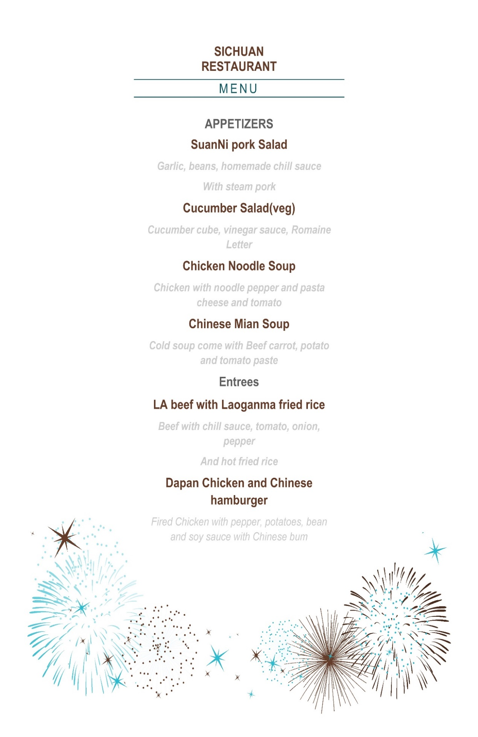



# Standard Recipe

|  |  |  |
| --- | --- | --- |
| **RECIPE NAME:** | **Suanni Pork** |  |
| **SERVINGS:** | **4** |  |
|  |  |  |
| **INGREDIENT** | **RECIPE AMOUNT** | **CURRENT RECIPE UNIT** |
| **Pork** | **1** | **lb** |
| **garlic** | **4** | **clove** |
| **spicy bean paste** | **1** | **tsp** |
| **chili oil** | **2** | **tbsp** |
| **soy sauce** | **1** | **tsp** |
| **black vinegar** | **1** | **tsp** |

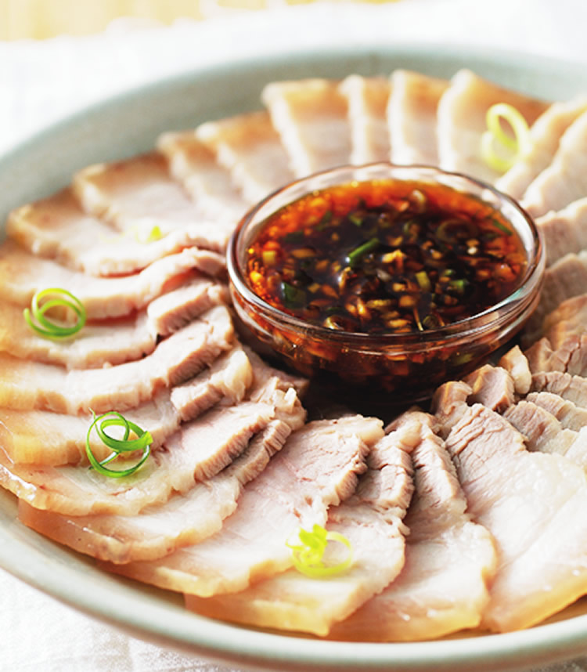

|  |  |  |  |  |  |  |  |  |  |
| --- | --- | --- | --- | --- | --- | --- | --- | --- | --- |
| **Cost Card** |  |  |  |  |  |  |  |  |  |
|  |  |  |  |  |  |  |  |  |  |
| **Recipe Name** | **Suanni Pork** |  |  | **Price** | **$6.99** |  |  |  |  |
| **Yeild** | **4** |  |  | **Budget food cost** | **33%** |  |  |  |  |
| **Weight** | **25oz** |  |  | **Q-Factor** | **0.3** |  |  |  |  |
|  |  |  |  |  |  |  |  |  |  |
| **Ingredient** | **AP pack cost** | **pack size** | **pack unit** | **Ap price** | **Yeild %** | **EP price** | **Recipy Quantity** | **Ep unit** | **Item cost** |
| **Pork** | **$13.74** | **1** | **kg** | **$13.740** | **80%** | **$10.99** | **0.5** | **kg** | **$6.870** |
| **garlic** | **$2.75** | **8** | **clove** | **$0.344** | **100%** | **$0.34** | **4** | **clove** | **$1.375** |
| **spicy bean paste** | **$5.88** | **500** | **g** | **$0.012** | **100%** | **$0.01** | **5** | **g** | **$0.059** |
| **chili oil** | **$2.97** | **200** | **ml** | **$0.015** | **100%** | **$0.01** | **10** | **ml** | **$0.149** |
| **soy sauce** | **$1.78** | **450** | **ml** | **$0.004** | **100%** | **$0.00** | **5** | **ml** | **$0.020** |
| **black vinegar** | **$2** | **500** | **ml** | **$0.003** | **100%** | **$0.00** | **5** | **ml** | **$0.017** |
|  |  |  |  |  |  |  |  |  |  |
|  |  |  |  |  |  |  |  |  |  |
|  |  |  |  |  |  |  | **Total Cost** | **Total Cost** | **$8.489** |
|  |  |  |  |  |  |  | **Cost per postion** | | **$2.12** |
|  |  |  |  |  |  |  | **Q-Factor** |  | **0.3** |
|  |  |  |  |  |  |  | **Budget food cost** | | **33%** |
|  |  |  |  |  |  |  | **Selling price** | | **$5.69** |

|  |  |  |
| --- | --- | --- |
| **RECIPE NAME:** | **cucumber Salad** |  |
| **SERVINGS:** | **4** |  |
|  |  |  |
| **INGREDIENT** | **RECIPE AMOUNT** | **CURRENT RECIPE UNIT** |
| **English cucumbers** | **1** | **ea** |
| **garlic** | **3** | **clove** |
| **black vinegar** | **5** | **ml** |
| **soy sauce** | **5** | **ml** |
| **sugar** | **5** | **g** |
| **sesame oil** | **5** | **ml** |

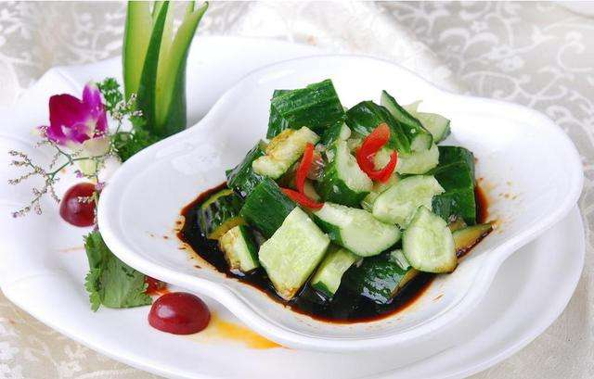

|  |  |  |  |  |  |  |  |  |  |
| --- | --- | --- | --- | --- | --- | --- | --- | --- | --- |
| **Cost Card** |  |  |  |  |  |  |  |  |  |
| **Recipe Name** | **Cucumber Salad** |  | **Price** | **$3.99** |  |  |  |  |
| **Yeild** | **4** |  |  | **Budget food cost** | **33%** |  |  |  |  |
| **Weight** | **25oz** |  |  | **Q-Factor** | **0.3** |  |  |  |  |
|  |  |  |  |  |  |  |  |  |  |
| **Ingredient** | **AP pack cost** | **pack size** | **pack unit** | **Ap price** | **Yeild %** | **EP price** | **Recipy Quantity** | **Ep unit** | **Item cost** |
| **English cucumbers** | **$1.83** | **1** | **ea** | **$1.830** | **60%** | **$1.10** | **1** | **ea** | **$1.830** |
| **garlic** | **$2.75** | **8** | **clove** | **$0.344** | **100%** | **$0.34** | **3** | **clove** | **$1.031** |
| **black vinegar** | **$2** | **500** | **ml** | **$0.003** | **100%** | **$0.00** | **5** | **ml** | **$0.017** |
| **soy sauce** | **$1.78** | **450** | **ml** | **$0.004** | **100%** | **$0.00** | **10** | **ml** | **$0.040** |
| **sugar** | **$2.17** | **500** | **g** | **$0.004** | **100%** | **$0.00** | **5** | **g** | **$0.022** |
| **sesame oil** | **$6** | **327** | **ml** | **$0.018** | **100%** | **$0.02** | **5** | **ml** | **$0.091** |
|  |  |  |  |  |  |  |  |  |  |
|  |  |  |  |  |  |  |  |  |  |
|  |  |  |  |  |  |  | **Total Cost** | **Total Cost** | **$3.031** |
|  |  |  |  |  |  |  | **Cost per postion** | **$0.76** |
|  |  |  |  |  |  |  | **Q-Factor** | **0.3** |  |
|  |  |  |  |  |  |  | **Budget food cost** | **33%** |
|  |  |  |  |  |  |  | **Selling price** | **$2.03** |

|  |  |  |
| --- | --- | --- |
| **RECIPE NAME:** | **Chicken noodle soup** | |
| **SERVINGS:** | **4** |  |
|  |  |  |
| **INGREDIENT** | **RECIPE AMOUNT** | **CURRENT RECIPE UNIT** |
| **Can chicken** | **1** | **ea can** |
| **butter** | **2** | **tsp** |
| **celery** | **140** | **g** |
| **carrot** | **140** | **g** |
| **onion** | **75** | **g** |
| **thyme** | **5** | **g** |
|  |  |  |

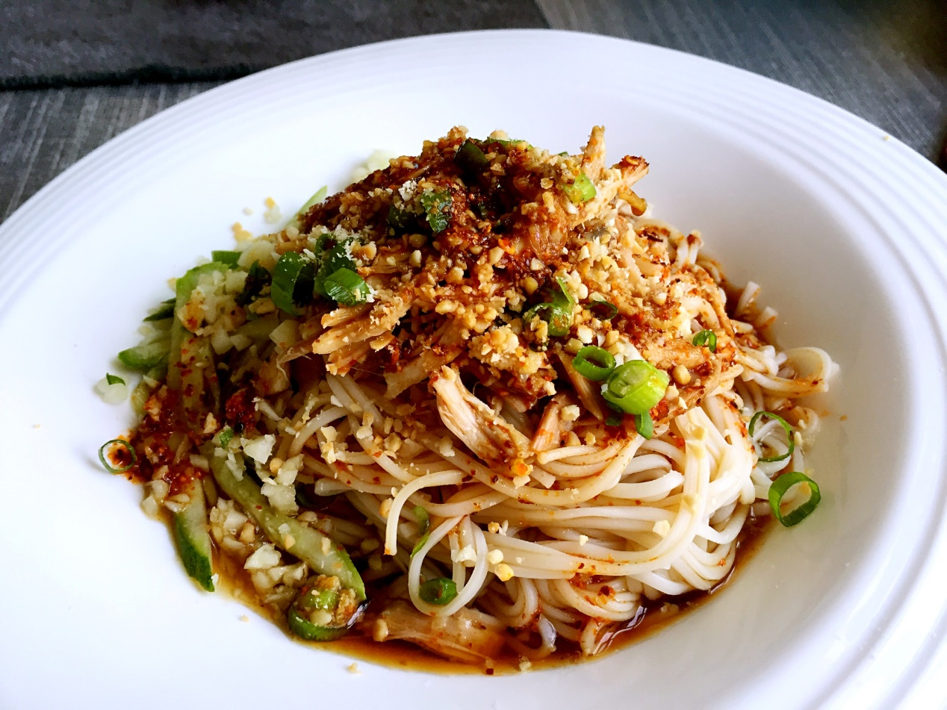

|  |  |  |  |  |  |  |  |  |  |
| --- | --- | --- | --- | --- | --- | --- | --- | --- | --- |
| **Cost Card** |  |  |  |  |  |  |  |  |  |
| **Recipe Name** | **Chicken noodle soup** | |  | **Price** | **$3.99** |  |  |  |  |
| **Yeild** | **4** |  |  | **Budget food cost** | **33%** |  |  |  |  |
| **Weight** | **25oz** |  |  | **Q-Factor** | **0.3** |  |  |  |  |
|  |  |  |  |  |  |  |  |  |  |
| **Ingredient** | **AP pack cost** | **pack size** | **pack unit** | **Ap price** | **Yeild %** | **EP price** | **Recipy Quantity** | **Ep unit** | **Item cost** |
| **Can chicken** | **$2.14** | **1** | **ea can** | **$2.140** | **100%** | **$2.140** | **1** | **ea can** | **$2.140** |
| **butter** | **$3.97** | **454** | **g** | **$0.009** | **100%** | **$0.009** | **2** | **g** | **$0.017** |
| **celery** | **$2** | **500** | **g** | **$0.003** | **80%** | **$0.003** | **140** | **g** | **$0.470** |
| **carrot** | **$1.47** | **1395** | **g** | **$0.001** | **80%** | **$0.001** | **140** | **g** | **$0.148** |
| **onion** | **$1.47** | **1395** | **g** | **$0.001** | **80%** | **$0.001** | **75** | **g** | **$0.079** |
| **thyme** | **$6** | **327** | **g** | **$0.018** | **80%** | **$0.015** | **5** | **g** | **$0.091** |
| **egg noodle** | **$1.67** | **340** | **g** | **$0.005** | **100%** | **$0.005** | **224** | **g** | **$1.100** |
|  |  |  |  |  |  |  |  |  |  |
|  |  |  |  |  |  |  | **Total Cost** | **Total Cost** | **$4.046** |
|  |  |  |  |  |  |  | **Cost per postion** | | **$1.01** |
|  |  |  |  |  |  |  | **Q-Factor** |  | **0.3** |
|  |  |  |  |  |  |  | **Budget food cost** | | **33%** |
|  |  |  |  |  |  |  | **Selling price** | | **$2.71** |

|  |  |  |
| --- | --- | --- |
| **RECIPE NAME:** | **Chinese Mian soup** |  |
| **SERVINGS:** | **4** |  |
|  |  |  |
| **INGREDIENT** | **RECIPE AMOUNT** | **CURRENT RECIPE UNIT** |
| **beef** | **500** | **g** |
| **butter** | **2** | **tsp** |
| **celery** | **140** | **g** |
| **carrot** | **140** | **g** |
| **onion** | **75** | **g** |
| **thyme** | **5** | **g** |
| **egg noodle** | **140** | **g** |

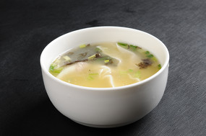

|  |  |  |  |  |  |  |  |  |  |
| --- | --- | --- | --- | --- | --- | --- | --- | --- | --- |
| **Cost Card** |  |  |  |  |  |  |  |  |  |
| **Recipe Name** | **Chicken noodle soup** |  |  | **Price** | **$5.99** |  |  |  |  |
| **Yeild** | **4** |  |  | **Budget food cost** | **33%** |  |  |  |  |
| **Weight** | **25oz** |  |  | **Q-Factor** | **0.3** |  |  |  |  |
|  |  |  |  |  |  |  |  |  |  |
| **Ingredient** | **AP pack cost** | **pack size** | **pack unit** | **Ap price** | **Yeild %** | **EP price** | **Recipy Quantity** | **Ep unit** | **Item cost** |
| **beef ground** | **$10.00** | **850** | **g** | **$0.012** | **100%** | **$0.012** | **500** | **g** | **$5.882** |
| **butter** | **$3.97** | **454** | **g** | **$0.009** | **100%** | **$0.009** | **2** | **g** | **$0.017** |
| **celery** | **$2** | **500** | **g** | **$0.003** | **80%** | **$0.003** | **140** | **g** | **$0.470** |
| **carrot** | **$1.47** | **1395** | **g** | **$0.001** | **80%** | **$0.001** | **140** | **g** | **$0.148** |
| **onion** | **$1.47** | **1395** | **g** | **$0.001** | **80%** | **$0.001** | **75** | **g** | **$0.079** |
| **thyme** | **$6** | **327** | **g** | **$0.018** | **80%** | **$0.015** | **5** | **g** | **$0.091** |
| **egg noodle** | **$1.67** | **340** | **g** | **$0.005** | **100%** | **$0.005** | **140** | **g** | **$0.688** |
|  |  |  |  |  |  |  |  |  |  |
|  |  |  |  |  |  |  | **Total Cost** | **Total Cost** | **$7.376** |
|  |  |  |  |  |  |  | **Cost per postion** | | **$1.84** |
|  |  |  |  |  |  |  | **Q-Factor** |  | **0.3** |
|  |  |  |  |  |  |  | **Budget food cost** | | **33%** |
|  |  |  |  |  |  |  | **Selling price** | | **$4.94** |

|  |  |  |
| --- | --- | --- |
| **RECIPE NAME:** | **LA beef with LAOGANMA Fried Rice** | |
| **SERVINGS:** | **4** |  |
|  |  |  |
| **INGREDIENT** | **RECIPE AMOUNT** | **CURRENT RECIPE UNIT** |
| **beef** | **500** | **g** |
| **Garlic** | **2** | **tsp** |
| **rice** | **500** | **g** |
| **chili sauce** | **20** | **g** |
| **onion** | **100** | **g** |
| **oil** | **5** | **g** |
| **soy sauce** | **20** | **g** |

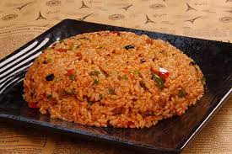

|  |  |  |  |  |  |  |  |  |  |
| --- | --- | --- | --- | --- | --- | --- | --- | --- | --- |
| **Cost Card** |  |  |  |  |  |  |  |  |  |
| **Recipe Name** | **Chicken noodle soup** |  |  | **Price** | **$13.99** |  |  |  |  |
| **Yeild** | **4** |  |  | **Budget food cost** | **33%** |  |  |  |  |
| **Weight** | **25oz** |  |  | **Q-Factor** | **0.3** |  |  |  |  |
|  |  |  |  |  |  |  |  |  |  |
| **Ingredient** | **AP pack cost** | **pack size** | **pack unit** | **Ap price** | **Yeild %** | **EP price** | **Recipy Quantity** | **Ep unit** | **Item cost** |
| **beef ground** | **$10.00** | **850** | **g** | **$0.012** | **100%** | **$0.012** | **500** | **g** | **$5.882** |
| **Garlic** | **$2.75** | **8** | **clove** | **$0.344** | **100%** | **$0.344** | **2** | **clove** | **$0.688** |
| **rice** | **$3** | **2000** | **g** | **$0.002** | **80%** | **$0.001** | **500** | **g** | **$0.868** |
| **chili sauce** | **$5.88** | **500** | **g** | **$0.012** | **80%** | **$0.009** | **20** | **g** | **$0.235** |
| **onion** | **$1.47** | **1395** | **g** | **$0.001** | **80%** | **$0.001** | **100** | **g** | **$0.105** |
| **oil** | **$3** | **200** | **g** | **$0.015** | **80%** | **$0.012** | **5** | **g** | **$0.074** |
| **soy sauce** | **$1.78** | **450** | **g** | **$0.004** | **100%** | **$0.004** | **20** | **g** | **$0.079** |
|  |  |  |  |  |  |  |  |  |  |
|  |  |  |  |  |  |  | **Total Cost** | **Total Cost** | **$7.931** |
|  |  |  |  |  |  |  | **Cost per postion** | | **$1.98** |
|  |  |  |  |  |  |  | **Q-Factor** |  | **0.3** |
|  |  |  |  |  |  |  | **Budget food cost** | | **33%** |
|  |  |  |  |  |  |  | **Selling price** | | **$5.31** |

|  |  |  |
| --- | --- | --- |
| **RECIPE NAME:** | **Dapan Chicken and Chinese hamburger** | |
| **SERVINGS:** | **4** |  |
|  |  |  |
| **INGREDIENT** | **RECIPE AMOUNT** | **CURRENT RECIPE UNIT** |
| **Chicken** | **500** | **g** |
| **Garlic** | **2** | **clove** |
| **rice** | **500** | **g** |
| **chili sauce** | **20** | **g** |
| **Potato** | **100** | **g** |
| **oil** | **5** | **g** |
| **soy sauce** | **20** | **g** |

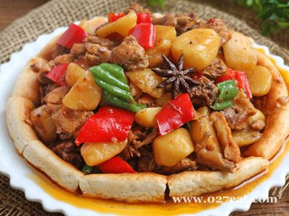

|  |  |  |  |  |  |  |  |  |  |
| --- | --- | --- | --- | --- | --- | --- | --- | --- | --- |
| **Cost Card** |  |  |  |  |  |  |  |  |  |
| **Recipe Name** | **Dapan Chicken and Chinese hamburger** |  |  | **Price** | **$11.99** |  |  |  |  |
| **Yeild** | **4** |  |  | **Budget food cost** | **33%** |  |  |  |  |
| **Weight** | **25oz** |  |  | **Q-Factor** | **0.3** |  |  |  |  |
|  |  |  |  |  |  |  |  |  |  |
| **Ingredient** | **AP pack cost** | **pack size** | **pack unit** | **Ap price** | **Yeild %** | **EP price** | **Recipy Quantity** | **Ep unit** | **Item cost** |
| **Chicken** | **$10.00** | **850** | **g** | **$0.012** | **100%** | **$0.012** | **500** | **g** | **$5.882** |
| **Garlic** | **$2.75** | **8** | **clove** | **$0.344** | **100%** | **$0.344** | **2** | **clove** | **$0.688** |
| **rice** | **$3** | **2000** | **g** | **$0.002** | **80%** | **$0.001** | **500** | **g** | **$0.868** |
| **chili sauce** | **$5.88** | **500** | **g** | **$0.012** | **80%** | **$0.009** | **20** | **g** | **$0.235** |
| **Potato** | **$2.47** | **2000** | **g** | **$0.001** | **80%** | **$0.001** | **100** | **g** | **$0.124** |
| **oil** | **$3** | **200** | **g** | **$0.015** | **80%** | **$0.012** | **5** | **g** | **$0.074** |
| **soy sauce** | **$1.78** | **450** | **g** | **$0.004** | **100%** | **$0.004** | **20** | **g** | **$0.079** |
|  |  |  |  |  |  |  |  |  |  |
|  |  |  |  |  |  |  | **Total Cost** | **Total Cost** | **$7.949** |
|  |  |  |  |  |  |  | **Cost per postion** | | **$1.99** |
|  |  |  |  |  |  |  | **Q-Factor** |  | **0.3** |
|  |  |  |  |  |  |  | **Budget food cost** | | **33%** |
|  |  |  |  |  |  |  | **Selling price** | | **$5.33** |

|  |  |  |
| --- | --- | --- |
| RECIPE NAME: | **Mountain Rib** |  |
| SERVINGS: | 4 |  |
|  |  |  |
| INGREDIENT | RECIPE AMOUNT | CURRENT RECIPE UNIT |
| Pork rib | 500 | g |
| Garlic | 2 | clove |
| Cooking wine | 20 | g |
| Sugar | 20 | g |
| Green onion | 100 | g |
| oil | 5 | g |
| soy sauce | 20 | g |

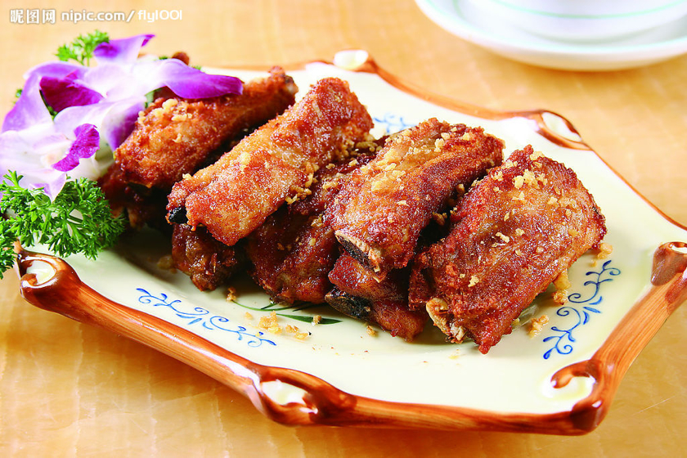

|  |  |  |  |  |  |  |  |  |  |
| --- | --- | --- | --- | --- | --- | --- | --- | --- | --- |
| Cost Card |  |  |  |  |  |  |  |  |  |
| Recipe Name | **Mountain Rib** |  |  | Price | $10.99 |  |  |  |  |
| Yeild | 4 |  |  | Budget food cost | 33% |  |  |  |  |
| Weight | 25oz |  |  | Q-Factor | 0.3 |  |  |  |  |
|  |  |  |  |  |  |  |  |  |  |
| Ingredient | AP pack cost | pack size | pack unit | Ap price | Yeild % | EP price | Recipy Quantity | Ep unit | Item cost |
| Pork rib | $10.00 | 900 | g | $0.011 | 100% | $0.011 | 500 | g | $5.556 |
| Garlic | $2.75 | 8 | clove | $0.344 | 100% | $0.344 | 2 | clove | $0.688 |
| Cooking wine | $2 | 450 | g | $0.005 | 80% | $0.004 | 500 | g | $2.533 |
| Sugar | $2.17 | 500 | g | $0.004 | 80% | $0.003 | 20 | g | $0.087 |
| Green onion | $0.99 | 150 | g | $0.007 | 80% | $0.005 | 100 | g | $0.660 |
| oil | $3 | 200 | g | $0.015 | 80% | $0.012 | 5 | g | $0.074 |
| soy sauce | $1.78 | 450 | g | $0.004 | 100% | $0.004 | 20 | g | $0.079 |
|  |  |  |  |  |  |  |  |  |  |
|  |  |  |  |  |  |  | Total Cost | Total Cost | $9.677 |
|  |  |  |  |  |  |  | Cost per postion | | $2.42 |
|  |  |  |  |  |  |  | Q-Factor |  | 0.3 |
|  |  |  |  |  |  |  | Budget food cost | | 33% |
|  |  |  |  |  |  |  | Selling price | | $6.48 |

|  |  |  |
| --- | --- | --- |
| **RECIPE NAME:** | **Chaomianpi** |  |
| **SERVINGS:** | **4** |  |
|  |  |  |
| **INGREDIENT** | **RECIPE AMOUNT** | **CURRENT RECIPE UNIT** |
| **all-purpose flour** | **300** | **g** |
| **Garlic** | **2** | **clove** |
| **chili powder** | **24** | **g** |
| **Salt** | **2** | **g** |
| **Green onion** | **100** | **g** |
| **oil** | **5** | **g** |
| **soy sauce** | **20** | **g** |

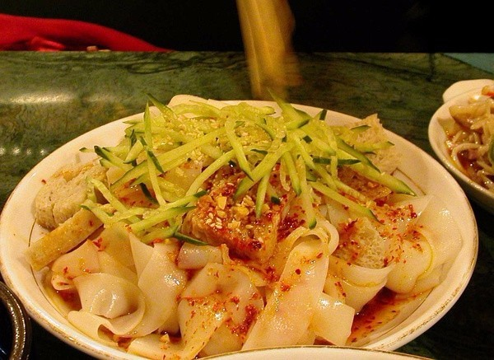

**‘**

**’**

|  |  |  |  |  |  |  |  |  |  |
| --- | --- | --- | --- | --- | --- | --- | --- | --- | --- |
| **Cost Card** |  |  |  |  |  |  |  |  |  |
| **Recipe Name** | **Chaomianpi** |  |  | **Price** | **$4.99** |  |  |  |  |
| **Yeild** | **4** |  |  | **Budget food cost** | **33%** |  |  |  |  |
| **Weight** | **25oz** |  |  | **Q-Factor** | **0.3** |  |  |  |  |
|  |  |  |  |  |  |  |  |  |  |
| **Ingredient** | **AP pack cost** | **pack size** | **pack unit** | **Ap price** | **Yeild %** | **EP price** | **Recipy Quantity** | **Ep unit** | **Item cost** |
| **all-purpose flour** | **$3.97** | **2500** | **g** | **$0.002** | **100%** | **$0.002** | **300** | **g** | **$0.476** |
| **Garlic** | **$2.75** | **8** | **clove** | **$0.344** | **100%** | **$0.344** | **2** | **clove** | **$0.688** |
| **chili powder** | **$2** | **150** | **g** | **$0.013** | **80%** | **$0.011** | **24** | **g** | **$0.315** |
| **Salt** | **$1.00** | **1000** | **g** | **$0.001** | **80%** | **$0.001** | **2** | **g** | **$0.002** |
| **Green onion** | **$0.99** | **150** | **g** | **$0.007** | **80%** | **$0.005** | **100** | **g** | **$0.660** |
| **oil** | **$3** | **200** | **g** | **$0.015** | **80%** | **$0.012** | **5** | **g** | **$0.074** |
| **soy sauce** | **$1.78** | **450** | **g** | **$0.004** | **100%** | **$0.004** | **20** | **g** | **$0.079** |
|  |  |  |  |  |  |  |  |  |  |
|  |  |  |  |  |  |  | **Total Cost** | **Total Cost** | **$2.294** |
|  |  |  |  |  |  |  | **Cost per postion** |  | **$0.57** |
|  |  |  |  |  |  |  | **Q-Factor** |  | **0.3** |
|  |  |  |  |  |  |  | **Budget food cost** |  | **33%** |
|  |  |  |  |  |  |  | **Selling price** |  | **$1.54** |

|  |  |  |
| --- | --- | --- |
| **RECIPE NAME:** | **jiuniang sweet cake** |  |
|  |  |  |
| **SERVINGS:** | **4** |  |
|  |  |  |
| **INGREDIENT** | **RECIPE AMOUNT** | **CURRENT RECIPE UNIT** |
| **rice flour** | **500** | **g** |
| **sugar** | **14** | **g** |
| **egg** | **1** | **ea** |
| **chinese rice wine** | **2** | **g** |
| **Osman thus flowers(dry)** | **14** | **g** |

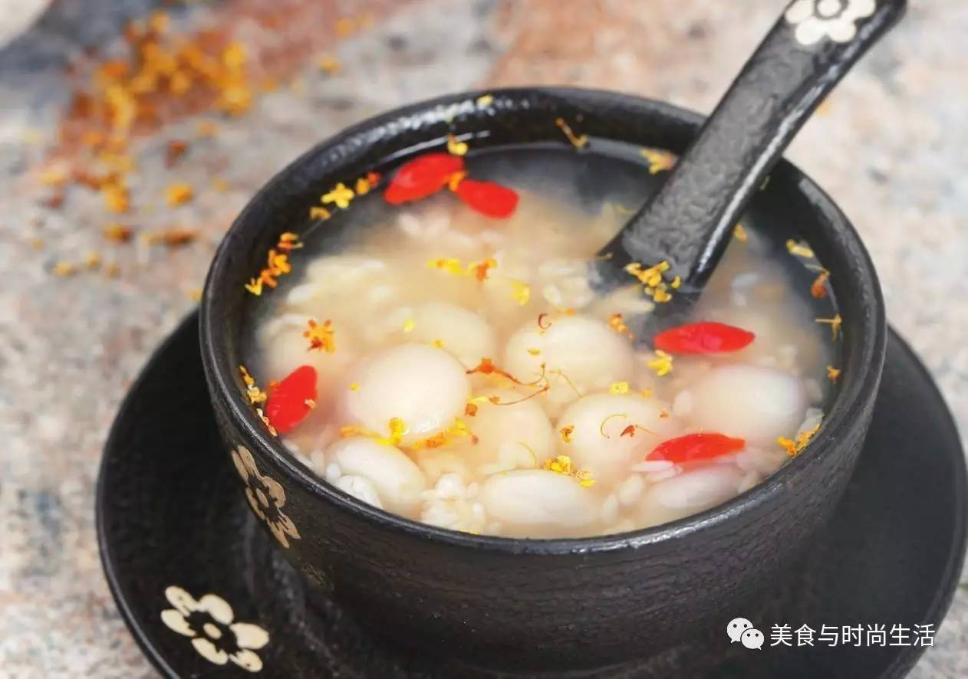

|  |  |  |  |  |  |  |  |  |  |
| --- | --- | --- | --- | --- | --- | --- | --- | --- | --- |
| **Cost Card** |  |  |  |  |  |  |  |  |  |
| **Recipe Name** | **jiuniang sweet cake** | |  | **Price** | **$4.99** |  |  |  |  |
| **Yeild** | **4** |  |  | **Budget food cost** | **33%** |  |  |  |  |
| **Weight** | **25oz** |  |  | **Q-Factor** | **0.3** |  |  |  |  |
|  |  |  |  |  |  |  |  |  |  |
| **Ingredient** | **AP pack cost** | **pack size** | **pack unit** | **Ap price** | **Yeild %** | **EP price** | **Recipy Quantity** | **Ep unit** | **Item cost** |
| **rice flour** | **$2.49** | **1000** | **g** | **$0.002** | **100%** | **$0.002** | **500** | **g** | **$1.245** |
| **sugar** | **$2.17** | **500** | **g** | **$0.004** | **100%** | **$0.004** | **14** | **clove** | **$0.061** |
| **egg** | **$2.27** | **12** | **ea** | **$0.189** | **80%** | **$0.151** | **1** | **g** | **$0.189** |
| **chinese rice wine** | **$3.28** | **355** | **g** | **$0.009** | **80%** | **$0.007** | **2** | **g** | **$0.018** |
| **Osman thus flowers(dry)** | **$11.96** | **100** | **g** | **$0.120** | **80%** | **$0.096** | **14** | **g** | **$1.674** |
|  |  |  |  |  |  |  |  |  |  |
|  |  |  |  |  |  |  |  |  |  |
|  |  |  |  |  |  |  |  |  |  |
|  |  |  |  |  |  |  | **Total Cost** | **Total Cost** | **$3.188** |
|  |  |  |  |  |  |  | **Cost per postion** |  | **$0.80** |
|  |  |  |  |  |  |  | **Q-Factor** |  | **0.3** |
|  |  |  |  |  |  |  | **Budget foo**  **d cost** |  | **33%** |
|  |  |  |  |  |  |  | **Selling price** |  | **$2.14** |

|  |  |  |
| --- | --- | --- |
| **RECIPE NAME:** | **Fa cake** |  |
| **SERVINGS:** | **4** |  |
|  |  |  |
|  | **RECIPE AMOUNT** | **CURRENT RECIPE UNIT** |
| **rice flour** | **500** | **g** |
| **brown sugar** | **150** | **g** |
| **egg** | **1** | **ea** |
| **baking powder** | **14** | **g** |

|  |  |  |  |  |  |  |  |  |  |
| --- | --- | --- | --- | --- | --- | --- | --- | --- | --- |
| **Cost Card** |  |  |  |  |  |  |  |  |  |
| **Recipe Name** | **jiuniang sweet cake** | |  | **Price** | **$2.99** |  |  |  |  |
| **Yeild** | **4** |  |  | **Budget food**  **cost** | **33%** |  |  |  |  |
| **Weight** | **25oz** |  |  | **Q-Factor** | **0.3** |  |  |  |  |
|  |  |  |  |  |  |  |  |  |  |
| **Ingredient** | **AP pack cost** | **pack size** | **pack unit** | **Ap price** | **Yeild %** | **EP price** | **Recipy Quantity** | **Ep unit** | **Item cost** |
| **rice flour** | **$2.49** | **1000** | **g** | **$0.002** | **100%** | **$0.002** | **500** | **g** | **$1.245** |
| **brown sugar** | **$2.17** | **500** | **g** | **$0.004** | **100%** | **$0.004** | **14** | **clove** | **$0.061** |
| **egg** | **$2.27** | **12** | **ea** | **$0.189** | **80%** | **$0.151** | **1** | **g** | **$0.189** |
| **baking powder** | **$3.28** | **355** | **g** | **$0.009** | **80%** | **$0.007** | **2** | **g** | **$0.018** |
|  |  |  |  |  |  |  |  |  |  |
|  |  |  |  |  |  |  |  |  |  |
|  |  |  |  |  |  |  |  |  |  |
|  |  |  |  |  |  |  |  |  |  |
|  |  |  |  |  |  |  | **Total Cost** | **Total Cost** | **$1.513** |
|  |  |  |  |  |  |  | **Cost per postion** |  | **$0.38** |
|  |  |  |  |  |  |  | **Q-Factor** |  | **0.3** |
|  |  |  |  |  |  |  | **Budget food cost** |  | **33%** |
|  |  |  |  |  |  |  | **Selling price** |  | **$1.01** |

# Menu Engineering

|  |  |  |  |  |  |  |  |  |
| --- | --- | --- | --- | --- | --- | --- | --- | --- |
| Menu Items | # of Sold | Menu mix % | Food cost | Mune price | Item CM | Menu cost | Menu revenue | Menu CM |
| Suanni pork | 345 | 7.39% | $ 2.12 | $ 6.99 | $ 4.87 | $ 731.40 | $ 2,411.55 | $ 1,680.15 |
| Cucumber Salad | 322 | 6.90% | $ 0.76 | $ 3.99 | $ 3.23 | $ 244.72 | $ 1,284.78 | $ 1,040.06 |
| Chicken noodle soup | 450 | 9.64% | $ 1.01 | $ 3.99 | $ 2.98 | $ 454.50 | $ 1,795.50 | $ 1,341.00 |
| Chinese mian soup | 432 | 9.25% | $ 1.84 | $ 5.99 | $ 4.15 | $ 794.88 | $ 2,587.68 | $ 1,792.80 |
| LA beef with Laoganma fried rice | 739 | 15.83% | $ 1.98 | $13.99 | $12.01 | $1,463.22 | $ 10,338.61 | $ 8,875.39 |
| Dapan chicken with chinese hamburger | 699 | 14.97% | $ 1.99 | $11.99 | $10.00 | $1,391.01 | $ 8,381.01 | $ 6,990.00 |
| Mountain rib | 738 | 15.81% | $ 2.42 | $10.99 | $ 8.57 | $1,785.96 | $ 8,110.62 | $ 6,324.66 |
| Chao mianpi | 578 | 12.38% | $ 0.57 | $ 4.99 | $ 4.42 | $ 329.46 | $ 2,884.22 | $ 2,554.76 |
| Jiuniang sweet cake | 199 | 4.26% | $ 0.80 | $ 4.99 | $ 4.19 | $ 159.20 | $ 993.01 | $ 833.81 |
| Fa cake | 167 | 3.58% | $ 0.38 | $ 2.99 | $ 2.61 | $ 63.46 | $ 499.33 | $ 435.87 |
|  |  |  |  |  |  |  |  |  |
|  |  |  |  |  |  |  |  |  |
|  |  |  |  |  |  |  |  |  |
| Total | 4669 |  |  |  |  | $7,417.81 | $ 39,286.31 | $31,868.50 |

Number of sold =4669

Food cost percentage= Total menu cost/Total menu revenue=18.8%

Menu mix %popularity Rate=100%Menu items*70%=7%

# Equipment list

FOH equipment :( price from Ikea and Amazon)

1. Chopsticks $1.25/1pairs 100 need

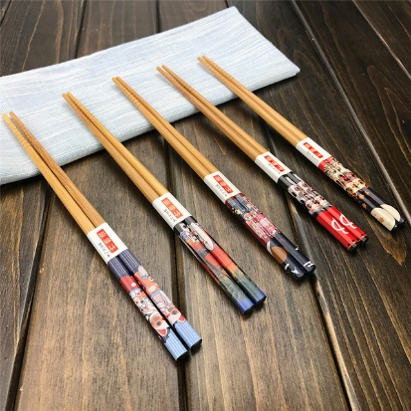

1. China spoon $2/1 100 need



1. Tea cup $1/2 100 need



1. Small china dish $12/1 100need

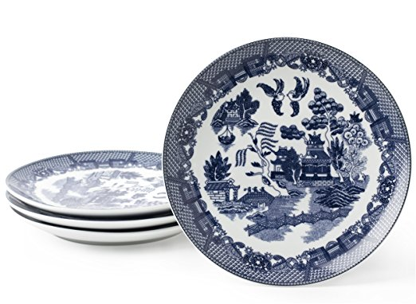

1. Table cloth $11/1 50need



1. Small china bowl $3/1 100need



1. Serve cart $79/1 2need

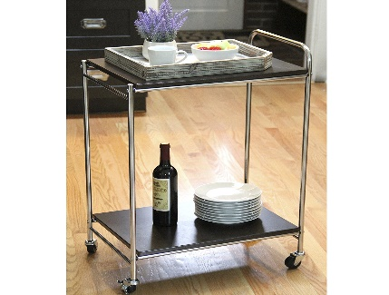

1. Serving pan $26/1 3need



1. Glass cup $1/1 100need



1. Napkin $1/1 100need



Total Cost: 1.25*100+2*100+50+12*100+3*100+79+26*3+100+100=$2232

FOH Furniture:

1. Table set supplier: Lancaster Table & Seating Tables and Dining Sets



1 table and 4 chairs: 182+48*4=374

Total need: 20

Total cost: 374*20=$7480

BOH equipment Supplier: *Regency* *kitchen equipment and kitchen*

Oven $2300 need 1

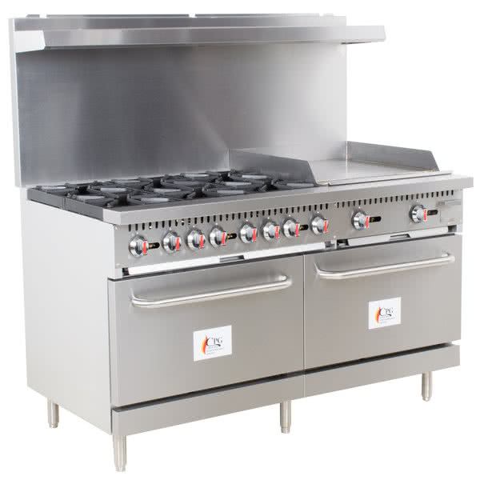

Fryer

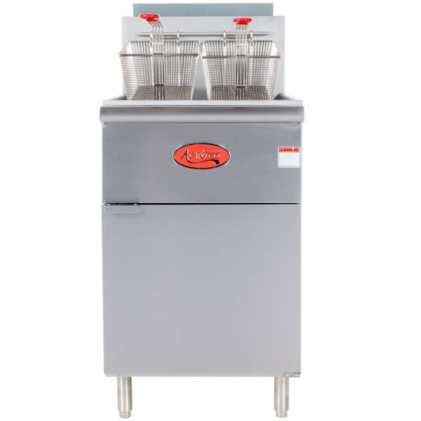

$890*1

Rice Cooker

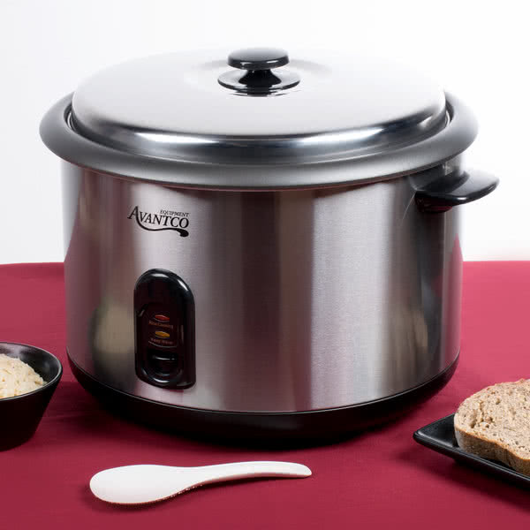

$75*1

Steamer

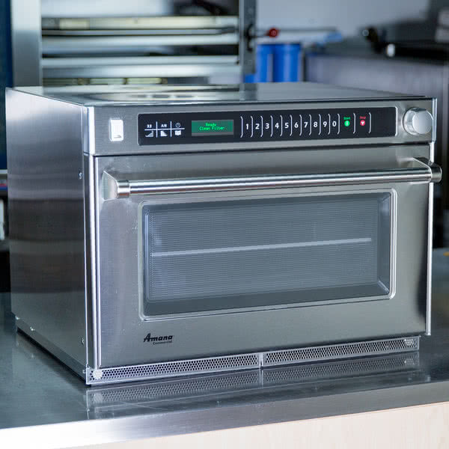

$4000*1

Refrigerator

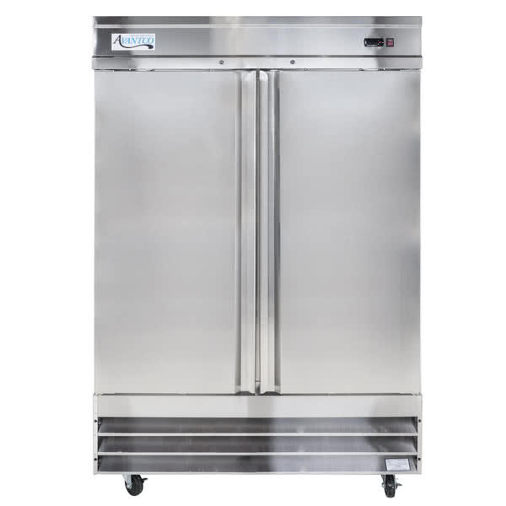

$2100*2

Work table

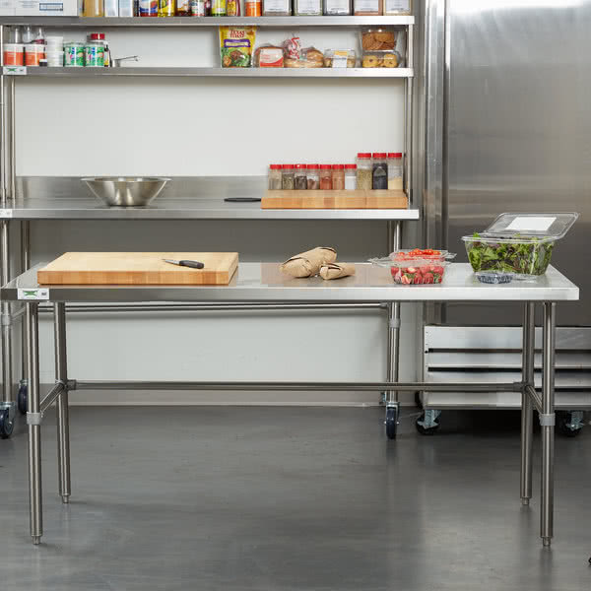

$275*2

Total Cost: 2300+890+75+4000+2100*2+275*2=$12,015

**Total cost of FOH and BOH: 12015+2232=$14,247**

Food Inventory **(Two weeks)**

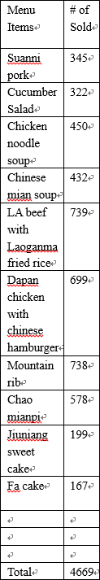Pork: 1*345=345lb

Pork Rib: 1*738=728lb

Chicken breast: 0.25*450=112.5lb

Chicken: 1*699=699lb

Beef: 1*739=739lb

Garlic: 10kg

Cook wine: 10 bottle

Sugar: 50kg

Green onion: 3 box

Oil: 10box

Soy sauce: 10box

All-purpose flour: 4bag

Chili powder: 1 box

Salt: 20kg

Rice flour: 10kg

Egg: 4box

Brown sugar: 10kg

|  |  |  |  |  |
| --- | --- | --- | --- | --- |
| Items | Supplier | Number | Price | Total price |
| Pork | Costco | 345lb | 4.21/lb | |  | | --- | | 1452.45 | | 44.7 | | 107 | | 27.5 | |
| Pork Rib | Costco | 728lb | 3.56/lb | |  | | --- | | 2591.68 | |
| Chicken breast | Costco | 112.5lb | 4.65/lb | |  | | --- | | 523.125 | |
| Chicken | Costco | 699lb | 3.98/lb | |  | | --- | | 2782.02 | |
| Beef | Costco | 739lb | 4.74/lb | |  | | --- | | 3502.86 | |
| Sugar | Yen bros | 1 bag | 18.65/bag | |  | | --- | | 18.65 | |
| Green onion | Yen bros | 3 box | 20.78/box | |  | | --- | | 62.34 | |
| Oil | Yen bros | 10box | 48.76/box | |  | | --- | | 487.6 | |
| Soy sauce | Yen bros | 10box | 20.96/box | |  | | --- | | 209.6 | |
| Garlic | Yen bros | 10kg | 53/10kg | 53 |
| Cook wine | Yen bros | 10 bottle | 14.35/bottle | |  | | --- | | 143.5 | |
| All-purpose flour | Yen bros | 4 bag | 8.99/bag(10kg) | |  | | --- | | 35.96 | |
| Chili powder | Yen bros | 1 box | 20/box | |  | | --- | | 20 | |
| Salt | Yen bros | 20kg | 1.99/KG | |  | | --- | | 39.8 | |
| Rice flour | Yen bros | 10kg | 4.47/kg | |  | | --- | | 44.7 | |
| Egg | Yen bros | 4box | 26.75/box | |  | | --- | | 107 | |
| Brown sugar | Yen bros | 10kg | 2.75/kg | |  | | --- | | 27.5 | |
| **Total** |  |  |  | 12101.79 |

# Menu Engineering

|  |  |  |  |  |  |  |  |  |
| --- | --- | --- | --- | --- | --- | --- | --- | --- |
| Menu Items | # of Sold | Menu mix % | Food cost | Mune price | Item CM | Menu cost | Menu revenue | Menu CM |
| Suanni pork | 345 | 7.39% | $ 2.12 | $ 6.99 | $ 4.87 | $ 731.40 | $ 2,411.55 | $ 1,680.15 |
| Cucumber Salad | 322 | 6.90% | $ 0.76 | $ 3.99 | $ 3.23 | $ 244.72 | $ 1,284.78 | $ 1,040.06 |
| Chicken noodle soup | 450 | 9.64% | $ 1.01 | $ 3.99 | $ 2.98 | $ 454.50 | $ 1,795.50 | $ 1,341.00 |
| Chinese mian soup | 432 | 9.25% | $ 1.84 | $ 5.99 | $ 4.15 | $ 794.88 | $ 2,587.68 | $ 1,792.80 |
| LA beef with Laoganma fried rice | 739 | 15.83% | $ 1.98 | $13.99 | $12.01 | $1,463.22 | $ 10,338.61 | $ 8,875.39 |
| Dapan chicken with chinese hamburger | 699 | 14.97% | $ 1.99 | $11.99 | $10.00 | $1,391.01 | $ 8,381.01 | $ 6,990.00 |
| Mountain rib | 738 | 15.81% | $ 2.42 | $10.99 | $ 8.57 | $1,785.96 | $ 8,110.62 | $ 6,324.66 |
| Chao mianpi | 578 | 12.38% | $ 0.57 | $ 4.99 | $ 4.42 | $ 329.46 | $ 2,884.22 | $ 2,554.76 |
| Jiuniang sweet cake | 199 | 4.26% | $ 0.80 | $ 4.99 | $ 4.19 | $ 159.20 | $ 993.01 | $ 833.81 |
| Fa cake | 167 | 3.58% | $ 0.38 | $ 2.99 | $ 2.61 | $ 63.46 | $ 499.33 | $ 435.87 |
|  |  |  |  |  |  |  |  |  |
|  |  |  |  |  |  |  |  |  |
|  |  |  |  |  |  |  |  |  |
| Total | 4669 |  |  |  |  | $7,417.81 | $ 39,286.31 | $31,868.50 |

Number of sold =4669

Food cost percentage= Total menu cost/Total menu revenue=18.8%

Menu mix %popularity Rate=100%Menu items*70%=7%

|  |  |  |  |  |  |
| --- | --- | --- | --- | --- | --- |
|  | item CM | CM category item CM<or> Average CM 5.7 | Menu Mix | Menu Mix% 7%<or> Popularity | Area |
| Suanni pork | $ 4.87 | low | 7.39% | high | Plowhorse |
| Cucumber Salad | $ 3.23 | low | 6.90% | low | Dog |
| Chicken noodle soup | $ 2.98 | low | 9.64% | high | Plowhorse |
| Chinese mian soup | $ 4.15 | low | 9.25% | high | Plowhorse |
| LA beef with Laoganma fried rice | $ 12.01 | high | 15.83% | high | Star |
| Dapan chicken with chinese hamburger | $ 10.00 | high | 14.97% | high | Star |
| Mountain rib | $ 8.57 | high | 15.81% | high | Star |
| Chao mianpi | $ 4.42 | low | 12.38% | high | Plowhorse |
| Jiuniang sweet cake | $ 4.19 | low | 4.26% | low | Dog |
| Fa cake | $ 2.61 | low | 3.58% | low | Dog |

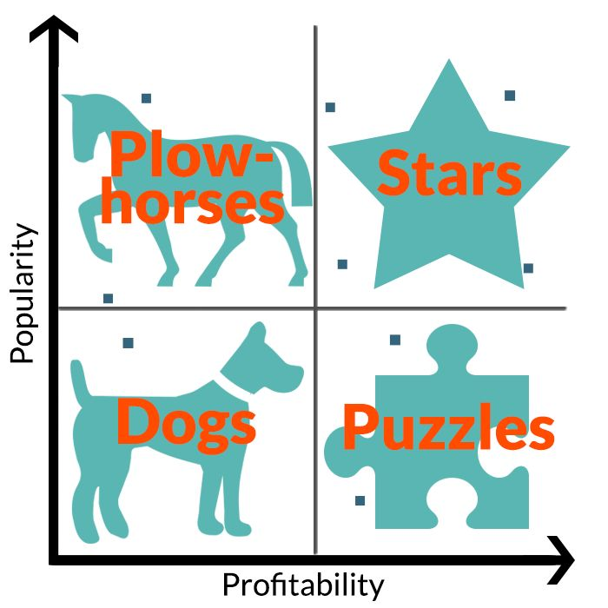

Summary

After the menu engineering, we can find that most of the menu items are in the plow-horse which means they sales well but steel can earn more money so I will increase the menu price of that menu items. As for the items which in Dogs, They do not have good sales and benefit. I will make a development on the flavor and change the menu items if needed. I will also make a marketing on that two desert and add some more flavor to them. For the Cucumber salad, I will make a combo with the star entrees to increase the sales.

# Floor Plan

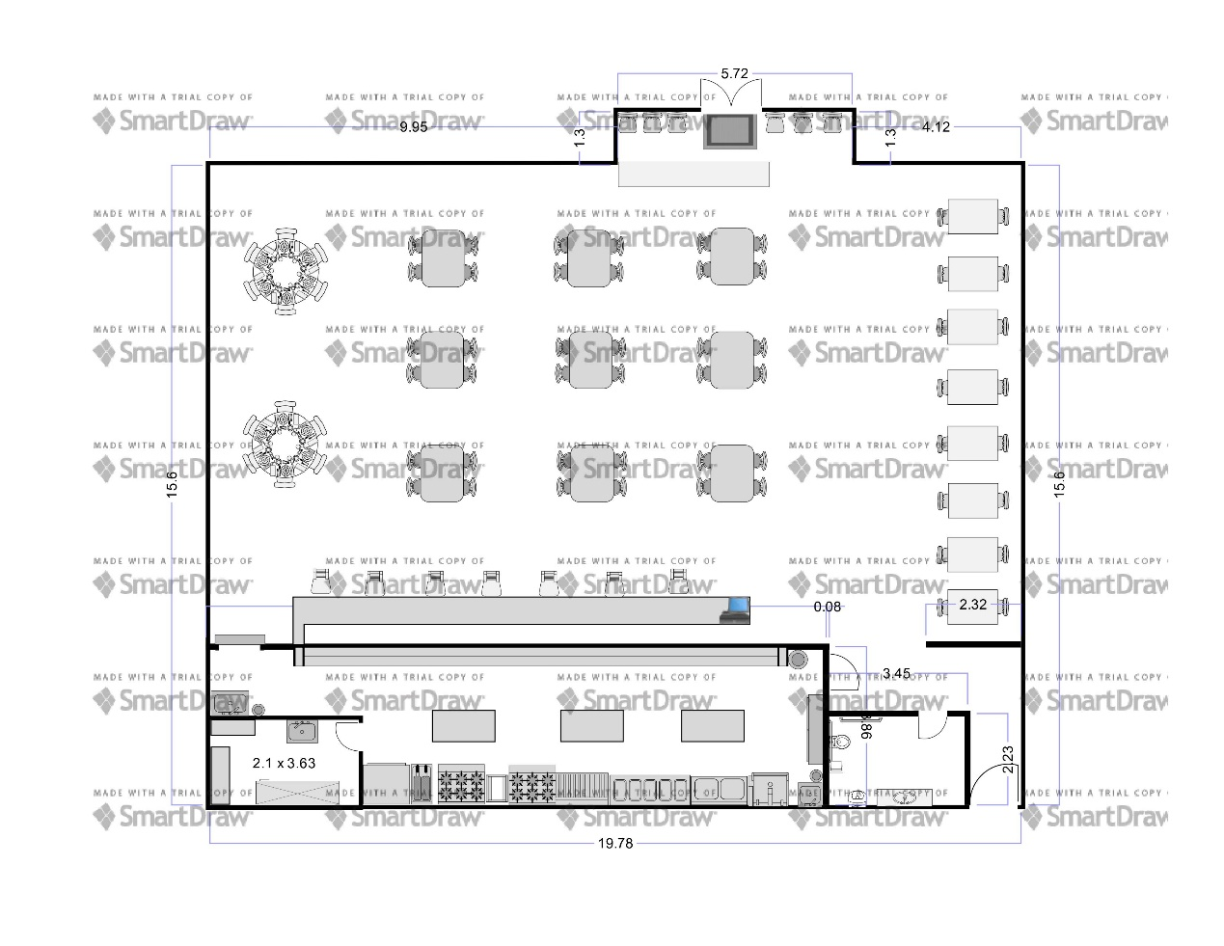

# Human Resources

**Part 1 Job description**

**FOH Restaurant Server Job description**

**Server:**

* + - * Prepare restaurant tables with special attention to sanitation and order
      * Attend to customers upon entrance
      * Present restaurant menus and help customers select food/beverages
      * Take/serve orders and answer questions or make recommendations for other products
      * Collaborate with other restaurant servers and kitchen/bar staff
      * Deal with complaints or problems with a positive attitude
      * Issue bills and accept payment
      * Promote dedication from customers

**FOH Manager:**

* Coordinate daily Front of the House and Back of the House restaurant operations
* Deliver superior service and maximize customer satisfaction
* Respond efficiently and accurately to customer complaints
* Regularly review product quality and research new vendors
* Organize and supervise shifts
* Appraise staff performance and provide feedback to improve productivity
* Estimate future needs for goods, kitchen utensils and cleaning products
* Ensure compliance with sanitation and safety regulations
* Manage restaurant’s good image and suggest ways to improve it
* Control operational costs and identify measures to cut waste
* Create detailed reports on weekly, monthly and annual revenues and expenses
* Promote the brand in the local community through word-of-mouth and restaurant events
* Recommend ways to reach a broader audience (e.g. discounts and social media ads)
* Train new and current employees on proper customer service practices
* Implement policies and protocols that will maintain future restaurant operations

**BOH Restaurant Server Job description**

**Kitchen Manager:**

* Customer-Service: Kitchen managers might have to interact with customers. Being friendly and courteous will help keep customers coming back.
* Attention to Detail: Kitchen managers have to keep their eyes on a lot of elements: food standards, costs, safety, etc.
* Leadership: Kitchen managers must be leaders in the back of house, rallying their team during heavy shifts, resolving conflicts and getting the job done.
* Management Skills: Kitchen managers not only deal with food, they also have to deal with costs, pricing, creating work schedules and more.
* Organizational Skills: Keeping work schedules, shipments, cleaning schedules and more organized is crucial to the job.
* Problem-Solving Skills: Dealing with employee conflict, irate customers and wrong stock orders is part of a kitchen manager’s job. Being able to come up with a solution quickly is a needed skill.
* Speaking Skills: Kitchen managers need to accurately and easily communicate standards and cooking methods to staff, give orders and speak with customers clearly.
* Stamina: Kitchen managers can expect long days around hot cooking elements, much of it on their feet.

**Chef:**

* Manage relationships with distributors and resolve issues with vendors promptly
* Follow the budget established by the restaurant manager
* Ensure safety and sanitation practices in the kitchen
* Manage kitchen staff and delegate tasks related to meal prep, cooking and delivering food to diners in a timely fashion
* Maintain the schedule for kitchen staff
* Monitor food and labor costs
* Keep up with industry trends and create new recipes in collaboration with the Sous Chef

**Sous Chef**

* Work with the executive chef to produce diversified menus in accordance with the restaurant’s policy and vision
* Come up with new dishes which appeal to the clients, whenever required
* Establish the working schedule and organize the work in the kitchen so that everything works like a “well-oiled machinery”
* Produce high quality dishes that follow up the established menu and level up to location’s standards, as well as to clients’ requirements
* Plan the food design in order to create a perfect match between the dish’s aspect and its taste
* Discover talented chefs and train them in order to reach the high standards of the location
* Train the auxiliary kitchen staff in order to provide best results in minimum time and using at the maximum the available resources
* Maintain order and discipline in the kitchen during working hours
* Create tasting menus for clients interested in contracting the food for different events (wedding, banquets, corporate dinners, birthday parties, etc.) from their kitchen
* Developing a cross-marketing strategy in order to increase profit, such as pairing drinks with the food served

**Cook:**

* Inspect food preparation and serving areas to ensure observance of safe, sanitary food-handling practices.
* Turn or stir foods to ensure even cooking.
* Our Personality Test will show you your top career choices
* Season and cook food according to recipes or personal judgment and experience.
* Observe and test foods to determine if they have been cooked sufficiently, using methods such as tasting, smelling, or piercing them with utensils.
* Weigh, measure, and mix ingredients according to recipes or personal judgment, using various kitchen utensils and equipment.
* Portion, arrange, and garnish food, and serve food to waiters or patrons.
* Regulate temperature of ovens, broilers, grills, and roasters.
* Substitute for or assist other cooks during emergencies or rush periods.
* Bake, roast, broil, and steam meats, fish, vegetables, and other foods.
* Wash, peel, cut, and seed fruits and vegetables to prepare them for consumption.
* Estimate expected food consumption; then requisition or purchase supplies, or procure food from storage.
* Carve and trim meats such as beef, veal, ham, pork, and lamb for hot or cold service, or for sandwiches.
* Coordinate and supervise work of kitchen staff.
* Consult with supervisory staff to plan menus, taking into consideration factors such as costs and special event needs.
* Butcher and dress animals, fowl, or shellfish, or cut and bone meat prior to cooking.
* Bake breads, rolls, cakes, and pastries.
* Prepare relishes and hors d'oeuvres.
* Keep records and accounts.

**Part 2 Flow Chart**

Sous Chef

Chef

Server

BOH manager

FOH manager

Restaurant Manager

Cook

Part 3 Labor Cost Table

|  |  |  |  |
| --- | --- | --- | --- |
| Jobs | Numbers | Wage/Hour | Total Cost |
| CHEF | 1 | 22 | 22 |
| Sous chef | 1 | 17.25 | 17.25 |
| BOH Manager | 1 | 16 | 16 |
| FOH manager | 1 | 14 | 14 |
| Cook | 2 | 13.5 | 27 |
| Server | 3 | 12.25 | 36.75 |

Part 4 Week schedule

# Marketing Plan

Sichuan restaurant. It is a traditional Chinese food restaurant and it also offer Chinese desert include lunch and dinner. Our menu is on major Chinese sea food and pastry which are famous in different part of china. Our purpose is offer traditional Chinese flavors and help Chinese who live in Vancouver to find the flavor which same from their home city.

The Sichuan restaurant will be located near the Richmond Center. Located in 6390 Buswell Street, Richmond, every weekends many Chinese will shopping in Richmond Center so I think there will be many customers who from china would like to eat in my restaurant. There is no restaurant near that location

**Mission Statement**

The Sichuan restaurant mission is to serve our customers healthy and delicious foods with a traditional flavor! Our service must represent excellence and we must show our shining appearance and positive attitude at all times when serving our customers. Our goal is to help people both Chinese and Canadian people to taste special food which from China different area

**Current Situation/ Concern**

In Vancouver there are many Chinese which from different area of China live in there but in Vancouver Chinese always cannot eat the food which have traditional flavor from their home city. Sichuan restaurant can offer this chance for many Chinese who want to eat traditional flavor food. Especially in Richmond, the location of Sichuan restaurant is near a mall which many Chinese would like to shopping. This section will need to be expanded by the final Marketing Plan to include some key areas of concern. Specifically, more information will need to be obtained regarding

1. requirements, (2) how to attract Canadian and (3) find the food material

**Marketing Plans**

Sichuan restaurant will do most of its advertising through Chinese social media which Chinese people use in Canada such as QQ, Weibo and WeChat. These online media sites are growing each and every day and more people are getting involved. Also it is easy for Chinese people to find our restaurant.

It is also an easy way to display and share images of our various dishes and our smiling and happy customers!

We will maintain a WeChat page that will be updated daily about our current promotions, menus, changes, daily specials about us, and our wall where our customers can leave unsolicited comments. We will also maintain an active Weibo that will be updated daily and timely about our whereabouts.

**Budgeting/ Forecasts**

We will be forecasting our sales using the three important financial statements: profit & lost statement, cash flow statement, and balance sheet. Through these statements, it will help create a base for the operation and help keep track of where the money are going and coming from. Through social media, we hope to be able to market our restaurant to our audience each day and serve between 300 and 600 people.

The Sichuan restaurant Restaurant can accommodate a maximum of 40 people. It need 12 employees for daily work. It will earn $120,000 year. The food cost came out to25%.

**The goals**

The first goal for Sichuan restaurant is improve the Profitability

A common business goal is to run a profitable operation, which typically means increasing revenue while limiting expenses. Revenue objectives could consist of increasing annual sales by 10 percent or landing three new accounts each month. Expense objectives could involve finding a new operating facility that decreases your rent by $200 a month or cutting monthly utility bills by 15 percent.

The next goal will be developing a perception that the restaurant is easy to do business with or to improve the response time to customer complaints. Objectives to help meet these goals could be increasing customer service staff from one to three workers by the end of the year or implementing a policy where customers are guaranteed to receive a return phone call before the end of the business day. It is very important because customers will book a table and the services will depend whether they will come back again.

The objectives

A comprehensive analysis of the activities of the competition should be an ongoing business objective for organization. Understanding where products rank in the marketplace helps to better determine how to improve your standing among consumers and improve your revenue. There a lot of Chinese restaurant in Richmond so good competitive analysis can help Sichuan restaurant to find out the pros and cons for open a Chinese restaurant in there.

Employee turnover also costs money in lost productivity and the costs associated with recruiting, which include employment advertising and paying placement agencies. High turnover rate is the reason for many restaurants closed, so how to avoid employee turnover frequently is important for Sichuan restaurant. Chinese people would like to go to the restaurants that the waiter speak Chinese so Sichuan restaurant will hire the person who can speak Chinese and good at English. So it will waste a lot of time and money on hire new employees.

Strategies

Product differentiation

Making different dishes from other Chinese restaurants is very useful for Sichuan restaurant to develop its own market. This is because in Richmond, there are many Chinese restaurants, most of then make same dishes, if Sichuan restaurant still make the same dishes there will be hard to attract customers to come here.

Pricing strategies

Pricing is one of the most vital and highly demanded component within the theory of marketing mix. It helps consumers to have an image of the standards the firm must offer through their products, creating firms to have an exceptional reputation in the market. The firm’s decision on the price of the product and the pricing strategy impacts the consumer’s decision on whether to purchase the product. When firms are deciding to consider applying any type of pricing strategy they must be aware of the following reasons to make an appropriate choice which will benefit their business. The competition within the market today is extremely high, for this reason, businesses must be attentive to their opponent’s actions to have the comparative advantage in the market. The technology of internet usage has increased and developed dramatically therefore, price comparisons can be done by customers through online access. Consumers are very selective regarding the purchases they make due to their knowledge of the monetary value. Firms must be mindful of these factors and price their products accordingly.

Gaining a technological advantage

Another objective for Sichuan restaurant is develop the technology. This is the part of cost control because if Sichuan restaurant use technological equipment instead of hire many people to work will save a lot of money.

Competitors:

1.Yipin restaurant

Location: near No3 road cross from Richmond center

Pros:

Good to find

Traffic benefit (near skytrain)

history famous Restaurant

Cons:(compare with Sichuan restaurant)

Small restaurant

Bad Environment

Cash only (not convenient)

Long waiting time

2. Chengdu restaurant

Location: aberden centre

Pros:

Near mall (many customers)

Traffic benefit (near skytrain)

history famous Restaurant

Cons:(compare with Sichuan restaurant)

Small restaurant

Bad Environment

Cash only (not convenient)

Long waiting time

Not good at flavor

3.Chongqing Hotpot

Location Voctoria Dr Vancouver

Pros:

Traffic benefit (near Marin Dr)

history famous Restaurant

Cheap price

All you can eat hot pot

Cons:(compare with Sichuan restaurant)

Small restaurant

Bad Environment

Cash only (not convenient)

Long waiting time

Hot pot style (limit dishes)

4. chuanshu People restaurant

Location Burnaby Kingsway near High Gate

Pros:

Traffic benefit (near Kingsway)

Good environment

Offer fresh seafood

Cons:(compare with Sichuan restaurant)

Expensive

Burnaby not too much Chinese

Do not have too much seat

Not very famous

# Financial Plan

**Executive Summary**

The name of my restaurant is Sichuan Restaurant. It is a traditional Chinese food restaurant and it also offer Chinese desert include lunch and dinner. Our menu is on major Chinese spicy food and pastry which are famous in Sichuan part of china. Our purpose is offer traditional Chinese flavors and help Chinese who live in Vancouver to find the flavor which same from their home city.

**Situation Analysis**

Sichuan Restaurant has just begun business, and marketing is essential to its success and future profitability.  The restaurant offers a place for people to meet together in a comfortable environment.  The basic market need is place where families can meet together.

Market Summary

Sichuan Restaurant possess good information about the market and knows a great deal about the common attributes of the prized and loyal customers.  Sichuan Restaurant will leverage this information to better understand who is served, their specific needs, and how the Chinese restaurant can better communicate with them.

Sichuan Restaurant will do most of its advertising through Chinese social media which Chinese people use in Canada such as QQ, Weibo and WeChat. These online media sites are growing each day and more people are getting involved. Also, it is easy for Chinese people to find our restaurant.

It is also an easy way to display and share images of our various dishes and our smiling and happy customers!

We will maintain a WeChat page that will be updated daily about our current promotions, menus, changes, daily specials about us, and our wall where our customers can leave unsolicited comments. We will also maintain an active Weibo that will be updated daily and timely about our whereabouts.

**Budgeting/ Forecasts**

We will be forecasting our sales using the two important financial statements: income statement and balance sheet. Through these statements, it will help create a base for the operation and help keep track of where the money are going and coming from. Through social media, we hope to be able to market restaurants to our audience each day and serve between 300 and 600 people.

**The goals**

The first goal for Sichuan Restaurant is improve the Profitability

A common business goal is to run a profitable operation, which typically means increasing revenue while limiting expenses. Revenue objectives could consist of increasing annual sales by 10 percent or landing three new accounts each month. Expense objectives could involve finding a new operating facility that decreases your rent by $200 a month or cutting monthly utility bills by 15 percent.

The next goal will be developing a perception that the restaurant is easy to do business with or to improve the response time to customer complaints. Objectives to help meet these goals could be increasing customer service staff from one to three workers by the end of the year or implementing a policy where customers are guaranteed to receive a return phone call before the end of the business day. It is very important because customers will book a table and the services will depends whether they will come back again.

The objectives

A comprehensive analysis of the activities of the competition should be an ongoing business objective for organization. Understanding where products rank in the marketplace helps to better determine how to improve my standing among consumers and improve my revenue. There a lot of Chinese restaurant in Richmond so good competitive analysis can help Sichuan Restaurant to find out the pros and cons for open a Chinese restaurant in there.

Employee turnover also costs money in lost productivity and the costs associated with recruiting, which include employment advertising and paying placement agencies. High turnover rate is the reason for many restaurants closed, so how to avoid employee turnover frequently is important for Sichuan Restaurant. Chinese people would like to go to the restaurants that the waiter speak Chinese so Sichuan Restaurant will hire the person who can speak Chinese and good at English. So it will waste a lot of time and money on hire new employees.

Strategies

Product differentiation

Making different dishes from other Chinese restaurants is very useful for Sichuan Restaurant to develop its own market. This is because in Richmond, there are many Chinese restaurants, most of then make same dishes, if Sichuan Restaurant still make the same dishes there will be hard to attract customers to come here.

Pricing strategies

Pricing is one of the most vital and highly demanded component within the theory of marketing mix. It helps consumers to have an image of the standards the firm must offer through their products, creating firms to have an exceptional reputation in the market. The firm’s decision on the price of the product and the pricing strategy impacts the consumer’s decision on whether to purchase the product. When firms are deciding to consider applying any type of pricing strategy they must be aware of the following reasons to make an appropriate choice which will benefit their business. The competition within the market today is extremely high, for this reason, businesses must be attentive to their opponent’s actions to have the comparative advantage in the market. The technology of internet usage has increased and developed dramatically therefore, price comparisons can be done by customers through online access. Consumers are very selective regarding the purchases they make due to their knowledge of the monetary value. Firms must be mindful of these factors and price their products accordingly.

Gaining a technological advantage

Another objective for Sichuan Restaurant is develop the technology. This is the part of cost control because if Sichuan Restaurant use technological equipment instead of hire many people to work will save a lot of money.

Financial Analysis **(2016)**

**Income Statement**

|  |  |
| --- | --- |
| **Income Statement** | **2016** |
| Sales | $205,50020 |
| Net Income | $205,500 |

|  |  |
| --- | --- |
| **Expense** | **2016** |
| Food cost | $100,840 |
| Rent of the place | $39,200 |
| Equipment change | $4,200 |
| Advertisement | $7,000 |
| Total Expense | $151,240 |

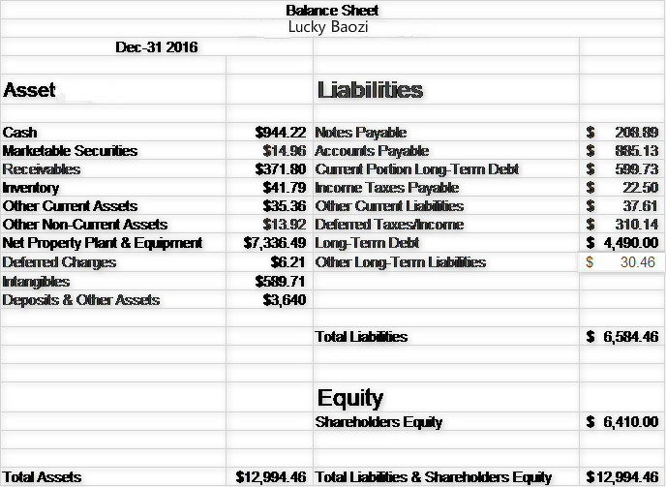

**Data Analyze**

**Essential ratios**

**Liquidity Raito: current:** current assets / current liabilities=12,994.46/6,584.46=1.97

**Solvency ratio:** **Debt-Equity: liabilities / owner’s equity**

6,584.46/6,410=1.03

**Activity ratio: Asset Turnover**

Total revenue / average total assets

2,055.42/12,994.46=0.16

**Operational ratios**

**Fixed-asset turnover**

Net sales/Average Fix Asset=205500/12994=15.8

**Sales/revenue per employee**

Net Income/Number of employee= 10600/20=530

**Operating Ratio**

Expense/net sale=151240/205500=0.73

# Work Cited

Gregson, Andrew. *Pricing Strategies for Small Business* 2008 Self Counsel Press

*The Marketing Mix (Pricing Strategies)*. (2016, 03 26). Retrieved from Learn Marketing.net: http://www.learnmarketing.net/price.htm

*5 Reasons Pricing Strategy is Increasing in Importance*. (2016, 03 27). Retrieved from Marketing

Kotler & Gary Armstrong, *Principles of Marketing 13E*, 2010, Pearson Prentice Hall

Kent B. Monroe, *The Pricing Strategy Audit*, 2003, Cambridge Strategy Publications

Gregson, Andrew *Pricing Strategies for Small Business* 2008

T., Gale, Bradley (3 March 2011). "Customer Value Assessment for Value-Based Pricing"

Canada, 2011 National Household Survey

Special to The Globe and Mail

Published Monday, Mar. 02, 2015 12:28PM EST

7 Fresh Ideas on How to Brand Your Business **Liz Papagni**  
 http://www.business2community.com/branding/7-fresh-ideas-brand-business-0823233#RIA65xgSjIcoRDJC.99