HOTEL MANAGEMENT TECHNIQUES
BAR OPERATION TECHNIQUES
430-HR4-AS sect. 05152

BAR OPERATION TECHNIQUES

PRESENTED TO:
Mr. MARTIN VALIQUETTE

PRESENTED BY:
GAREN MOURADIAN
NGUYEN TUNG TRAN

NOVEMBER 7TH, 2019
LASALLE COLLEGE
TABLE OF CONTENTS

INTRODUCTION 2
I. TYPE OF ESTABLISHMENT 3
1. Name 3
2. Type of Venue 3
3. History and Theme 3
4. General Atmosphere 4
5. Glassware and Furniture 4
II. LOCALISATION OF THE ESTABLISHMENT 5
1. Specific Location 5
2. Environment and Surroundings 5
III. COCKTAIL MENU 6
1. Traditional Recipes 6
2. Cocktail Creations 16
3. Mocktails 19
3. Pricelist 21
4. Inventory List - Alcohol Products' Information 24
5. Inventory List - Other Products' Information 25
CONCLUSION 27
WORKS CITED 28

INTRODUCTION
Since the early 1600s, mixed drinks have been enjoyed by the four corners of the world. That has been continued till this day. Inspired by the great Jerry Thomas, cocktails have gone through an exponential evolution over the years. This semester we have the pleasure of following a Bar Techniques class, where we learn about the history of bartending, recipes, ingredients and techniques to introduce us into the industry. We also have the privilege to have a project in which we can create a bar concept, where we go in depth and explain what kind of bar it is, the atmosphere and also create an inventory of all our products as well as calculate all the costs that go with running a bar.

I. TYPE OF ESTABLISHMENT

1. Name
Our bar is named after the opera Carmen, which is written by French composer Georges Bizet and which was first performed in Paris on 3rd March 1875. The opera is about a flirtatious young woman Carmen, who adventures the ups-and-downs of her free life but ended up having a tragic death. During her lifetime, Carmen is famous for her attractiveness toward every man, which sparked us the inspiration to establish Carmen Bar.

2. Type of Venue
We choose to make Carmen a specialty opera bar built up on one main theme. Carmen Bar with its authentic setting and gracious beverage list, is devoted to delighting customers with the best drinking experience in an artistic and romantic ambience.

3. History and Theme
Throughout the many milestones of bartending history, especially in Quebec where drinking has developed not only as a casual activity, but also an act of enjoying life. Knowing this trend, Carmen Bar was established in November 2000, when cocktails have already set their ‘revival’ stage in our modern life.
As stated, our bar is formed based on the famous opera Carmen, which makes it carry the spirit of European vintage architecture and settings, hence the theme of passion and lust for drinks.

4. General Atmosphere
Carmen Bar is targeted to be a romantic bar. With the typical patterns and illustrations giving the ideas of new ingredients from our modern time in cocktail-making, customers will be welcomed with the new spirit of the current cocktail renaissance era with the embrace of contemporary jazz which will give off a very relaxing and smooth vibe to all our guests. When listening to contemporary jazz our customers will feel right at home and very comfortable enjoying their drinks and their company. Our bar will also contain very dim lighting to give off a very tranquil vibe. We will also have the most attractive light bulbs cast in lovely pink which are the most flattering ones. We will have these specifically in front of the bar to attract people to the bar and make them enjoy our bartenders making drinks under the pink lights.

5. Glassware and Furniture
Customers are promised to experience the best time of their life enjoying exclusive beverages based on the following detailed design of glassware and furniture:
- All types of wine and cocktail glasses fill the long line of hanger rack up above the bartending section, which will be listed in detail in the following section of “Inventory List - Other Products' Information".
- Wooden tables and chairs are used to satisfy the classical and vintage style,
- Shining utensils including silver forks, spoons and knives are ready to serve customers who are in need of small snacks.

II. LOCALISATION OF THE ESTABLISHMENT

1. Specific Location
With the theme of European vintage colours, our bar is set in the heart of Montreal, Quebec, Canada, where cultures from all over the globe meet and harmonize. In order to get accessed to as many customers as possible, we decided to locate Carmen Bar inside Place des Arts, which is in between the grand path connecting Places des Arts itself with Complexe Desjardins and other surrounding tourist spots.

2. Environment and Surroundings
Place des Arts witnesses numerous public events throughout the years. Is it here where people come for shopping, leisure activities, and surely for the happiness of drinking as well.
In terms of authenticity, this specific venue is a place of frequent exhibitions of artists and performers from everywhere, making it a valuable place for Carmen Bar to welcome customers who have high taste of arts with our beverages.
The bar is designed as an open space with glass barrier allow our customers to admire the exterior architecture of Place des Arts.

III. COCKTAIL MENU

1. Traditional Recipes
1.1 Dry Manhattan
Ingredients | Instruction
- 2 oz bourbon  - 1 oz Carpano Antica Formula vermouth  - 2 dashes Fee Brothers whiskey-barrel-aged bitters  - Garnish: lemon twist  - Glass: cocktail | - Add all the ingredients to a mixing glass with ice and stir until exceedingly well-chilled.  - Strain into a chilled cocktail glass.  - Garnish with a lemon twist.

1.2 Mint Julep
Ingredients | Instruction
- ¹⁄₄ oz simple syrup  - 8 mint leaves  - 2 oz bourbon  - Garnish: bitters, mint sprig  - Glass: Julep or rocks | - In a Julep cup or rocks glass, lightly muddle the mint and syrup.  - Add the bourbon and pack tightly with crushed ice.  - Stir until the cup is frosted on the outside.  - Top with more crushed ice to form an ice dome and garnish with a mint sprig and few optional drops of bitters.

1.3 Gimlet
Ingredients | Instruction
- 2 ¹⁄₂ oz gin  - ¹⁄₂ oz fresh lime juice  - ¹⁄₂ oz simple syrup  - Garnish: lime wheel  - Glass: cocktail or coupe | - Add all ingredients into a shaker with ice and shake.  - Strain into a chilled glass filled with fresh ice.  - Garnish with a lime wheel.  (We can substitute 1 oz lime cordial, such as Rose's lime juice, for both the lime juice and simple syrup).

1.4 Mojito
Ingredients | Instruction
- 2 oz white rum  - 3 mint leaves  - ³⁄₄ oz fresh lime juice  - ¹⁄₂ oz simple syrup  - Club soda, to top  - Garnish: mint sprig, lime wheel  - Glass: highball | - Lightly muddle the mint in a shaker.  - Add the rum, lime juice, simple syrup and ice and give it a brief shake.  - Strain into a highball glass over fresh ice.  - Top with the club soda.  - Garnish with a mint sprig and lime wheel.

1.5 Planter's Punch
Ingredients | Instruction
- 3 oz dark rum  - ³⁄₄ oz fresh lime juice  - 1 oz simple syrup  - 1 bar spoon Grenadine  - 3 dashes Angostura bitters  - 1 splash soda water  - Glass: Collins | - Add all the ingredients into a shaker with ice, and shake vigorously.  - Strain into a Collins glass over crushed ice.  - Top with a splash of soda water.  - Garnish with a mint sprig.

1.6 Whiskey Sour
Ingredients | Instruction
- 2 oz bourbon  - ³⁄₄ oz fresh lemon juice  - ¹⁄₂ oz simple syrup  - ¹⁄₂ oz egg white (optional)  - Garnish: Angostura bitters  - Glass: coupe | - Add all ingredients into a shaker with ice and shake.  - Strain into a coupe.  - Garnish with 3 dashes of Angostura bitters.

1.7 Sazarac
Ingredients | Instruction
- 1 ¹⁄₂ oz Hennessy V.S.O.P Privilège cognac  - 1 ¹⁄₂ oz Bulleit rye whiskey  - ¹⁄₂ oz simple syrup  - 3 dashes Angostura bitters  - 2 dashes Peychaud’s bitters  - 1 spray rinse Vieux absinthe  - Garnish: star anise pods  - Glass: Snifter | - Add the Angostura bitters to a beaker, then add the Peychaud's bitters, simple syrup, cognac and rye.  - Add ice to the beaker and stir for 10 seconds.  - Spray a snifter once with the absinthe.  - Strain the drink into the snifter.  - Garnish with 3 star anise pods.

1.8 Pisco Sour
Ingredients | Instruction
- 2 oz Pisco  - 1 oz fresh lime juice  - ¹⁄₂ oz simple syrup  - 1 egg white  - Garnish: Angostura bitters  - Glass: rocks, or Nick & Nora | - Add all ingredients into a shaker with ice and shake vigorously.  - Strain into a chilled rocks glass over fresh ice. (Alternately, you can pour it neat into a Nick & Nora glass.).  - Garnish with 3 drops of the bitters. Using a straw, swirl the bitters into a simple design.

1.9 Old Fashion
Ingredients | Instruction
- ¹⁄₂ teaspoon sugar  - 3 dashes Angostura bitters  - 1 teaspoon water  - 2 oz Bourbon  - Garnish: orange peel  - Glass: rocks | - Add the sugar, bitters and water into a rocks glass, and stir until sugar is nearly dissolved.  - Fill the glass with large ice cubes, add the bourbon, and gently stir to combine the flavors.  - Express the oil of an orange peel over the glass, then drop in.

1.10 Tom Collins
Ingredients | Instruction
- 2 oz London dry gin  - 1 oz fresh lemon juice  - ¹⁄₂ oz simple syrup  - Club soda  - Garnish: lemon wheel, Maraschino cherry  - Glass: Collins | - Add the gin, lemon juice and simple syrup into a Collins glass.  - Fill with ice, top with club soda and stir.  - Garnish with a lemon wheel and maraschino cherry (optional).

1.11 Dry Martini
Ingredients | Instruction
- 2 ¹⁄₂ oz Gin  - ¹⁄₂ oz dry vermouth  - 1 dash orange bitters  - Garnish: lemon twist  - Glass: cocktail | - Add all the ingredients into a mixing glass with ice and stir until very cold.  - Strain into a chilled cocktail glass.  - Garnish with a lemon twist.

1.12 Gibson
Ingredients | Instruction
- 2 ¹⁄₂ oz Gin or vodka  - ¹⁄₂ oz dry vermouth  - Garnish: cocktail onion  - Glass: cocktail | - Add the ingredients into a mixing glass with ice and stir.  - Strain into a chilled cocktail glass.  - Garnish with a cocktail onion.

1.13 Daiquiri
Ingredients | Instruction
- 2 oz light rum  - 1 oz fresh lime juice  - ³⁄₄ oz Demerara sugar syrup  - Garnish: lime twist  - Glass: coupe | - Add all the ingredients into a shaker with ice, and shake until well-chilled.  - Strain into a chilled coupe.  - Garnish with a lime twist.

1.14 Gin Fizz
Ingredients | Instruction
- 2 oz Gin  - 1 oz fresh lemon juice  - ³⁄₄ oz simple syrup  - 1 egg white (about ¹⁄₂ oz)  - 1 oz club soda  - Glass: Fizz or Collins | - Add the first four ingredients to a shaker and dry-shake (without ice) for about 10 seconds.  - Add 3 or 4 ice cubes and shake very well.  - Double-strain into a chilled fizz glass and top with club soda.

1.15 Boulevardier
Ingredients | Instruction
- 1 ¹⁄₂ oz Templeton rye whiskey  - 1 ¹⁄₂ oz Carpano Antica Formula  - ³⁄₄ oz Campari  - Garnish: orange peel  - Glass: Old Fashioned | - Fill a mixing glass with ice, add all of the ingredients, and stir until diluted and chilled for about 30 stirs.  - Strain and serve up or on the rocks in an Old Fashioned glass.

1.16 Aperol Spritz
Ingredients | Instruction
- 3 oz Prosecco  - 2 oz Aperol  - 1 oz Soda water  - Garnish: orange wheel  - Glass: Wine | - Add all ingredients into a wine glass with ice and stir.  - Garnish with an orange wheel.
1.17 Negroni
Ingredients | Instruction
- 1 oz Gin  - 1 oz Campari  - 1 oz sweet vermouth  - Garnish: orange peel  - Glass: rocks | - Add all the ingredients into a mixing glass with ice, and stir until well-chilled.  - Strain into a rocks glass filled with large ice cubes.  - Garnish with an orange peel.

1.18 Sidecar
Ingredients | Instruction
- 1 ¹⁄₂ oz Cognac  - ³⁄₄ oz Cointreau  - ³⁄₄ oz fresh lemon juice  - Garnish: orange twist, sugar rim  - Glass: coupe | - Coat the rim of a coupe glass with sugar and set aside.  - Add all ingredients into a shaker with ice and shake.  - Strain into the prepared glass.  - Garnish with an orange twist.

1.19 Margarita
Ingredients | Instruction
- 2 oz Blanco tequila  - 1 oz fresh lime juice  - ¹⁄₂ oz orange liqueur  - ¹⁄₂ oz Agave syrup  - Garnish: lime wheel, Kosher salt  - Glass: rocks | - Add all the ingredients into a shaker with ice, and shake until chilled.  - Strain into prepared rocks glass over fresh ice.  - Garnish with a lime wheel and kosher salt (optional).
1.20 Vieux Carré
Ingredients | Instruction
- ³⁄₄ oz Rye whiskey  - ³⁄₄ oz Cognac  - ³⁄₄ oz sweet vermouth  - ¹⁄₄ oz Bénédictine  - 2 dashes Peychaud’s bitters  - 2 dashes Angostura bitters  - Garnish: lemon peel  - Glass: rocks | - Add all ingredients into a mixing glass with ice and stir until well-chilled.  - Strain into a rocks glass over fresh ice.  - Garnish with a lemon peel.

1.21 Moscow Mule
Ingredients | Instruction
- 2 oz Vodka  - 3 oz ginger beer, juice of half a lime  - Garnish: lime wheel  - Glass: Moscow Mule mug or highball | - Add all of the ingredients into a Moscow Mule mug (or highball glass) over ice.  - Garnish with a lime wheel.

1.22 Bloody Caesar
Ingredients | Instruction
- Celery salt  - 1 ¹⁄₂ oz Vodka  - 4 oz clamato juice  - 2 dashes Worcestershire sauce  - 2 dashes Tabasco sauce, prepared horseradish, to taste (optional)  - Garnish: cucumber spear, lime wedge, parsley sprig  - Glass: Pint glass or Mason jar | - Coat the rim of a tall glass with celery salt, fill with ice and set aside.  - Add remaining ingredients into a mixing glass with ice.  - Pour back and forth into another mixing glass a few times to mix.  - Strain into the prepared glass.  - Garnish with a cucumber spear, lime wedge and parsley sprig.

1.23 Cosmopolitan
Ingredients | Instruction
- 1 ¹⁄₂ oz citrus vodka  - 1 oz Cointreau  - ¹⁄₂ oz fresh lime juice  - 1 dash cranberry juice  - Garnish: lime wheel  - Glass: cocktail | - Add all ingredients into a shaker with ice and shake.  - Strain into a chilled cocktail glass.  - Garnish with a lime wheel.

1.24 Paper Plane
Ingredients | Instruction
- ³⁄₄ oz Bourbon  - ³⁄₄ oz Aperol  - ³⁄₄ oz Amaro Nonino Quintessentia  - ³⁄₄ oz fresh lemon juice  - Glass: coupe | - Add all ingredients into a shaker with ice and shake.  - Strain into a coupe glass.

2. Cocktail Creations
2.1 More Than Velvet
Ingredients | Instruction
- 2 oz red wine Bourgogne 2016  - ¹⁄₂ oz fresh lemon juice  - ¹⁄₂ oz raspberry syrup  - 1 dash Flora Swedish bitter  - Garnish: 1 raspberry  - Glass: cocktail | - Add all ingredients into a shaker with ice and shake.  - Strain into a chilled cocktail glass.  - Garnish with a raspberry.

2.2 The Holiday
Ingredients | Instruction
- 3 oz beer Verdus Cabernet-Sauvignon IPA  - 6 oz fresh peach juice  - 1 oz honey syrup  - Garnish: strawberry  - Glass: Collins | - Add all ingredients into a shaker with ice and shake.  - Strain into the Collins glass filled with ice cubes.  - Garnish with a strawberry slice.

2.3 Mario Galaxy
Ingredients | Instruction
- 2 oz Domaine Tempier Bandol Rosé  - 1 oz of Fruit Punch  - 1 oz egg white  - ¹⁄₂ oz of sprite  - Garnish: 2 dashes of angostura  - Glass: | - Chill the glass with ice  - Add all ingredients into a shaker and shake  - Garnish with 2 dashes of angostura

2.4 The Patrick Collins
Ingredients | Instruction
- 2 oz Vodka  - 1 oz of simple syrup  - ¹⁄₂ oz fresh lemon juice  - ¹⁄₂ oz of sparkling water  - Garnish: Lemon wheel  - Glass: Collins | - Add the first 3 ingredients into a shaker and shake  - Strain into the Collins glass  - Add the sparkling water to the drink  - Garnish with Lemon wheel

2.5 The Dictator
Ingredients | Instruction
- 2 oz of Vodka  - 1 oz of Milk  - 1 oz of coffee  - 1 teaspoon of sugar  - Garnish: Angostura bitter  - Glass: rocks | - Fill the glass with Ice  - Add all ingredients into the shaker  - Strain into a rocks glass with the ice

3. Mocktails
3.1 Blue Shoe
Ingredients | Instruction
- 3 oz blue Hawaiian Punch  - 2 oz white cranberry juice  - 7-Up to top  - Glass: cocktail | - Chill the ingredients beforehand.  - Pour the blue Hawaiian Punch into a large, chilled martini glass.  - Add the white cranberry juice.  - Fill the rest of the way with 7-Up.

3.2 Basil-ade
Ingredients | Instruction
- ¹⁄₄ cup fresh berries  - 3 fresh basil leaves  - 8 ounces fresh lemonade  - Glass: highball | - Muddle fresh, seasonal berries in a tall glass until crushed.  - Add basil and bruise gently.  - Add lemonade.  - Add ice and stir.

3.3 Serano Fizz
Ingredients | Instruction
- 1 oz fresh squeezed lime juice  - 1 fresh Serrano pepper  - ¹⁄₂ fresh apple  - 1 oz simple syrup  - Club soda  - Glass: rock | - Cut pepper width-wise into ring shapes.  - Slice apple and discard core, then dice it into cubes.  - Muddle 2 rings of Serrano with 3-4 small cubes of apple and ¹⁄₂ oz simple syrup in the rocks glass.  - Add lime juice and additional ¹⁄₂ oz simple syrup.  - Add ice and top off with soda water.
3.4 Chocolate Mock-tini
Ingredients | Instruction
- ¹⁄₂ oz chocolate syrup  - ¹⁄₂ cup chocolate milk  - 1 cup mint-chocolate chip ice cream  - Garnish: candy cane  - Glass: highball | - Coat inside of glass with chocolate syrup.  - Stir together chocolate milk, mint-chocolate chip ice cream and 4 ice cubes.  - Garnish with candy cane.

3.5 Language of Flowers
Ingredients | Instruction
- 2 oz blackberry syrup  - 1 oz lemon juice  - 4 mint leaves  - Splash of soda water  - Garnish: 2 skewered blackberries and mint sprig  - Glass: rocks | - Dry shake all ingredients except soda water.  - Double strain into glass with crushed ice.  - Top with a splash of soda water and garnish.

3. Pricelist
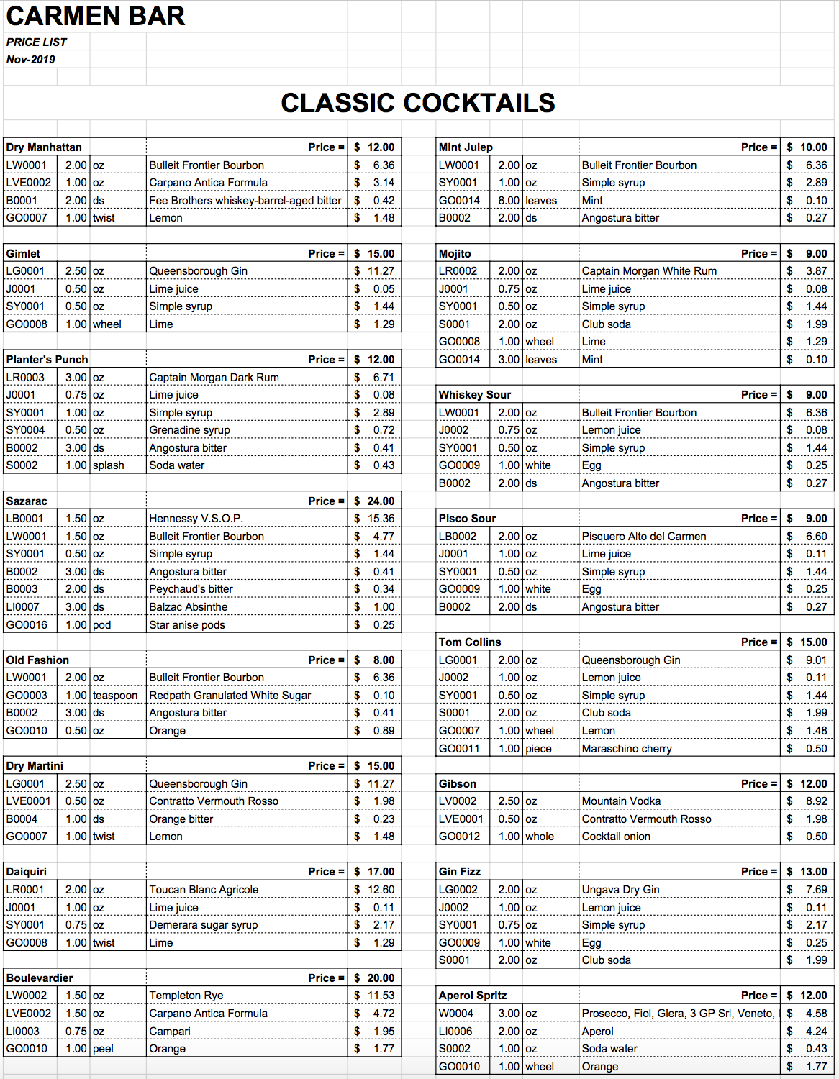
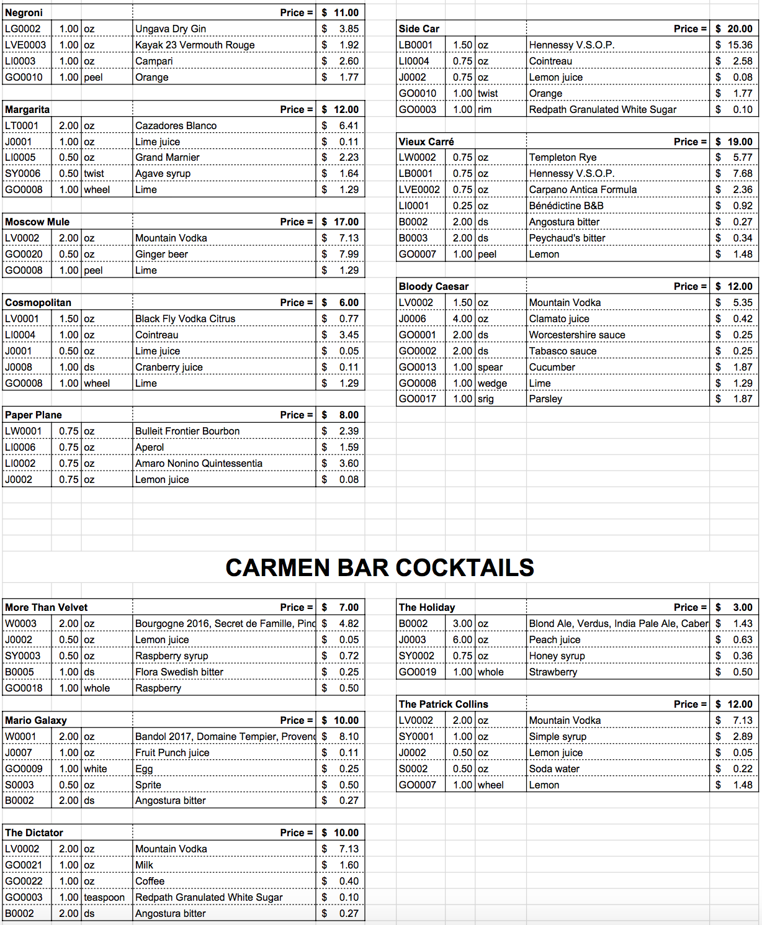
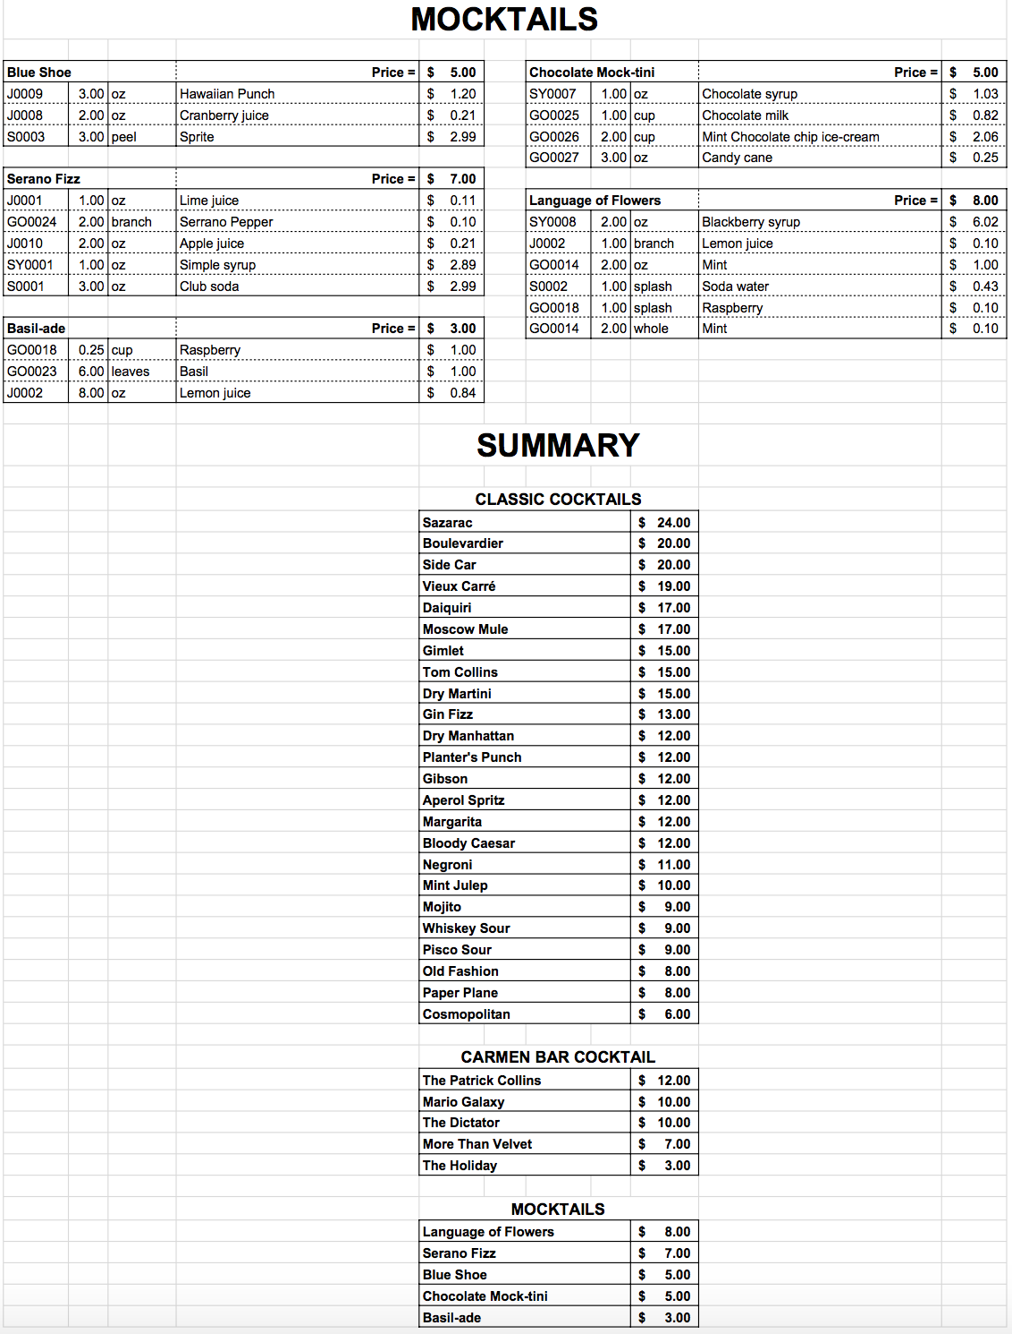

4. Inventory List - Alcohol Products' Information
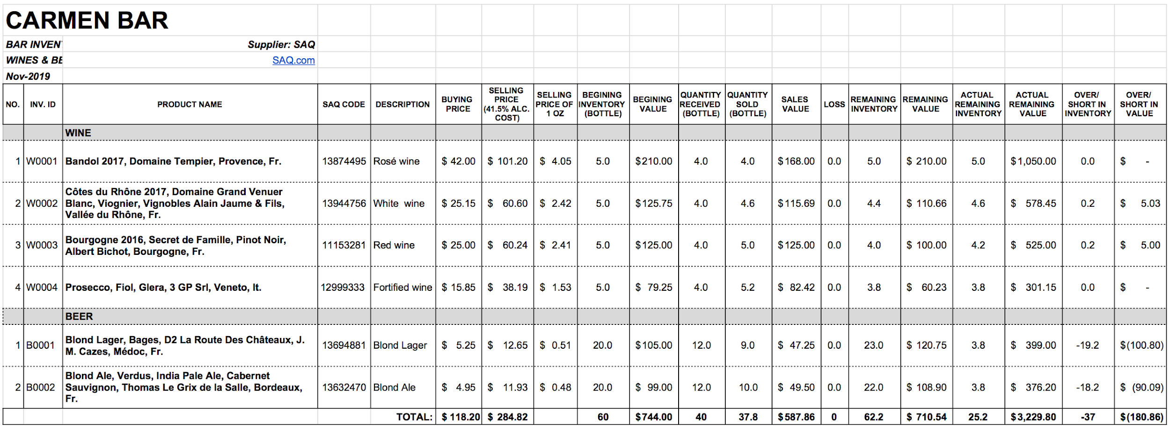
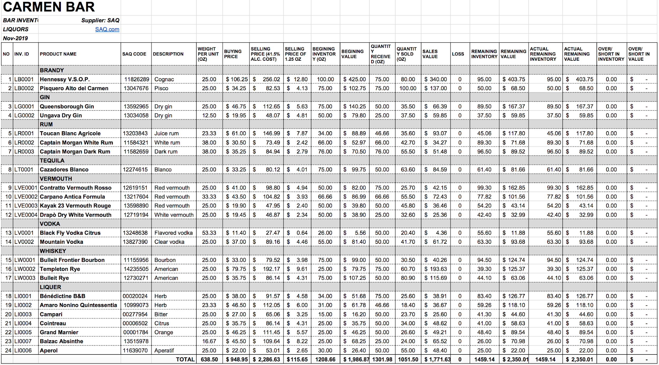

5. Inventory List - Other Products' Information
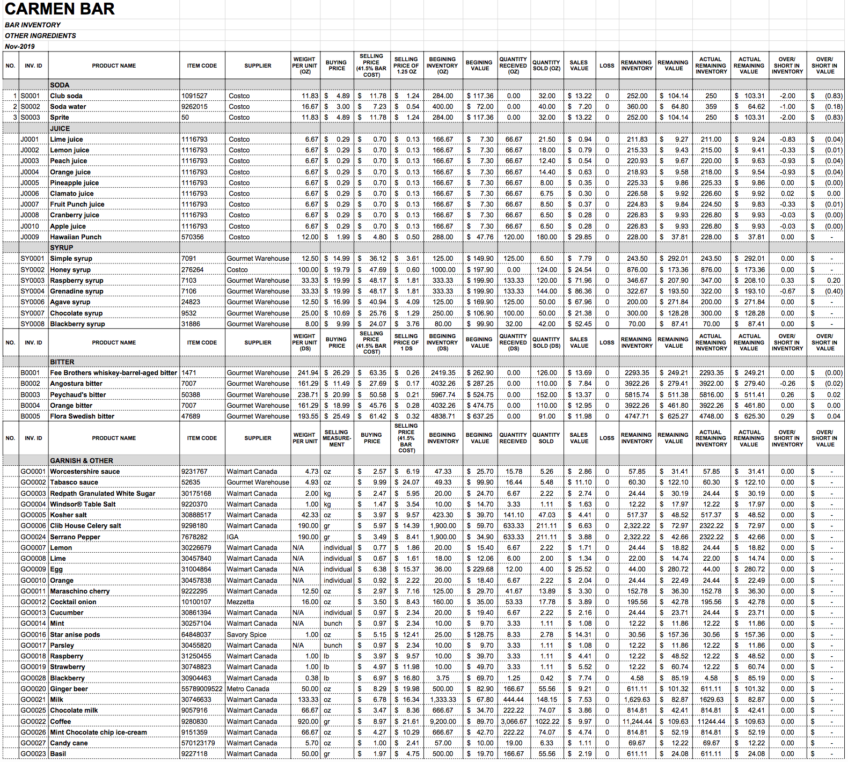

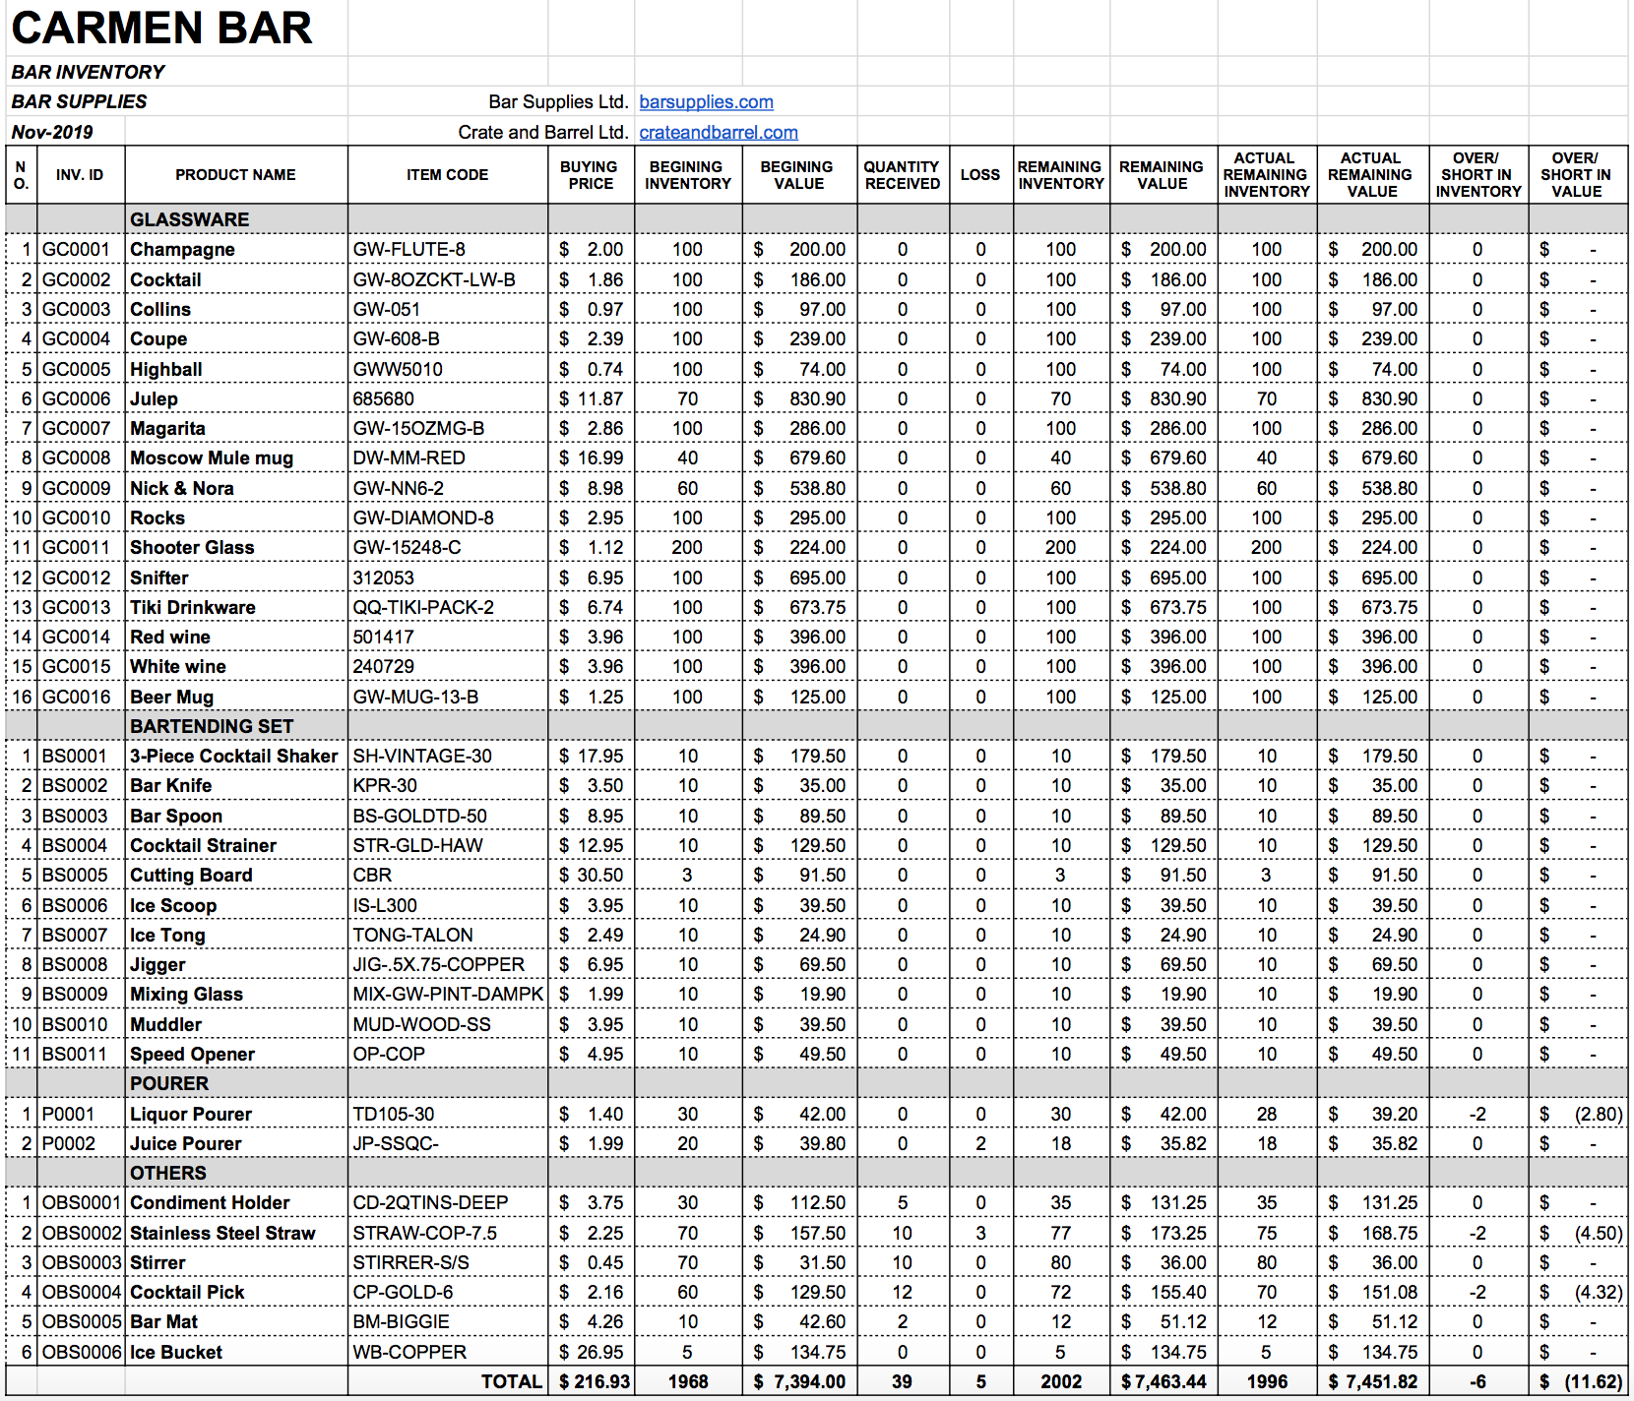

CONCLUSION
In conclusion, this project allowed us to really dive deeply into the aspects of creating and running a bar. In the beginning we did not have a lot of information concerning the subject nor the slightest clue that it would take this much time and research to actually just have an idea of a bar concept. Not until the completion of our project did we start to understand the effort and commitment it requires to run and manage the inventory, yet it was very enjoyable to work on. It widened our information about the industry and made us rethink a few things. In general, the project took time to complete but was a very mind broadening experience.

WORKS CITED
“2 Mocktail Recipes From San Diego's JSix Restaurant.” La Jolla Mom, 22 Apr. 2019, lajollamom.com/mocktail-recipes-jsix-restaurant-san-diego/.
“12 Delicious Mocktail Recipes.” Parenting, www.parenting.com/food-recipes/mocktails-recipes/.
“16,096,807 Royalty Free Vector Images.” VectorStock, www.vectorstock.com/.
Liquor.com. “A Halloween Twist on a Spanish Coffee.” Liquor.com, Liquor.com Https://Www.liquor.com, 23 Oct. 2019, www.liquor.com/recipes/.
Mix That Drink. “Blue Shoe Mocktail Recipe.” Mix That Drink, 13 Apr. 2019, mixthatdrink.com/blue-shoe/.
“Official Site for Bartending Supplies &amp; Bar Equipments.” Bar Supplies.com : The Supply Superstore for Bar Supplies, Wine Accessories, and Restaurant Supplies., barsupplies.com/.
“Online Shopping Canada: Everyday Low Prices at Walmart.ca!” Walmart.ca, www.walmart.ca/en.
“Supermarket in Quebec: Recipes, Online Grocery, Flyer.” IGA, www.iga.net/.
“Vineyard Red Wine Glasses: Crate and Barrel.” Crate&Barrel, www.crateandbarrel.com/vineyard-red-wine-glasses/f50762.
“Wines, Alcohols &amp; Spirits.” SAQ.com, www.saq.com/content/SAQ/en.html.

