MARKETING PLAN PROPOSAL

Vegan for Green Co.
1111 Robson St, Vancouver, BC, V6Z3C1
6049888888
9/6/2018
Andy Ngo
Project for the “Vegan for Green” includes the entire business plan with market and financial analysis

Introduction
This marketing proposal presents the business plan of “Sugar for Green”, a chain of retail store providing specialty food products for people who is lactose intolerance and/or avoid all of the animal products for a better lifestyle and healthier.
With the growing number of people with Vegan diet in Canada comes to an increasing demand for specialty food products. Although there are multiple manufacturing companies entering the market and launching different product lines that carter for such a demand, not many Canadian distributors and retail stores carry those goods. Having recognized consumers’ needs and the gap in the Canadian specialty food market, our mission is to fulfill and offer solutions for all special dietary needs.

Objectives
We have built our strategic team along with marketing in order to achieve our success in any market in BC. This mission will be carried and upheld in all of our stores, along with our main objectives:
- To deliver a variety of specialty groceries to the right groups of customers i.e. people who are looking for a healthier eating style or those who are intolerance with any animal products.
- To focus on our customers’ needs and provide excellent services and build customers’ loyalty.
- To become a consumers’ choice brand by offering top quality with wide range of choices and credibility to our customers. We have an advisor team that always focus on customers’ need to provide the right products with highest efficiency.
- To maintain the income availability through our profit in order to be sustainable and expandable in the future.
- To analyse and prepare for our future plan which is to expand and penetrate into new customer market.

Company Description
“Vegan for Green” is a start-up retail chain that provides food products and substitutes for people following a non-animal product diet. We also offer catering for buyers who suffer from food sensitivities and illnesses, namely lactose-intolerance, and milk allergy. Our stores carry a wide range of specialty products, including but not limited to lactose-free dairy products, milk substitutes, dairy-free ice cream and yogurt, gluten-free baking goods and frozen food.
Our company participates in specialty food industry, with its headquarter in Vancouver, British Columbia and mainly operations in two main locations: West Vancouver & East Vancouver,

MISSION
Our main goal is to turn our stores into go-to places which provide food solutions to all special dietary needs. We promise to provide the best service to customers by having a team of food intolerance experts and professionally trained employees giving customers beneficial advice and recommendations for right choices.

Environmental Analysis

Microenvironment

3.1.1 Customers
As we target people with food intolerance, the majority of our customers will be individuals or households. Also, the increase in trends for the las few years, the age group is becoming wider as people have seen the positive benefits that vegan diet is bringing to their bodies.

3.1.2 Publics
Our potential customers are a public force whose opinions are crucial to the operation of “Vegan for Green”. Those buyers might also be members other public groups such as Meatless Meetup Association, Canadian Digestive Health Foundation, Canadian Celiac Association, Food Allergy Canada, etc.

3.1.3 Suppliers
There have been more and more manufactures entering the food intolerance market as this segment was predicted to have growth level of 61.4% in 2017¹. According to a 2015 report by Agriculture and Agri-Food Canada, product categories that had the highest sales including lactose-free (48.1%) and other special milk alternatives (23.5%).
The growing number of producers and product availability allow us to bring customers a wide range of choices and thus, fulfil their specific needs.
Since our market is in Vancouver, we will mostly distribute products through online stores that are available in North America, specifically in Canada and the US. We plan to establish partnerships with different distributors and companies for sources of different product categories, including but not limited to:
- Lactose-free: Natrel, Liddells Breyer’s & Yoplait
- Dairy-free: So Delicious, Earth’s Own, Kraft & Lactaid

3.1.4 Competitors
Regarding the grocery stores & supermarket industry in which our company operates, as well as the special types of products we aim to provide, we have identified our main competitor, namely Pomme Natural Market.
Pomme Natural Market:
Pomme Natural Market is a newly established grocery chain since 2015 whose target market is people with health-consciousness or food sensitivities such as celiac disorder, dairy intolerance, as well as those who follow special diets, i.e. vegan, vegetarian, paleo. Its products are mostly organic, gluten-free and dairy-free; lactose-free and no-sugar-added choices are more limited. Pomme also provides supplements that are organic and made from natural sources.
The market has three locations in total, one in West End, downtown Vancouver, one in Port Coquitlam, and another in Nanaimo Island. Although its stores are all located in British Columbia, three stores is still a small number to make it convenient for customers to visit, especially when Pomme does not offer online shopping.
Considering that the former two companies only target diabetics as well as customers with weight and health consciousness, we recognize that the untargeted segments in their markets could be our potential business and intend to fill in that gap. The limited numbers of stores of our competitors prompt us to carter for people who shop for convenience by having multiple branches at different locations.

Macro-environment

3.2.1 Political Analysis
The Government of Canada recognizes lactose intolerance disease as a medical issue. People who suffer from lactose allergy are entitled to claim the incremental costs associated with the purchase of gluten-free products as a medical expense from the Government of Canada. The incremental cost is calculated by subtracting the cost of a non-GF product from the cost of a GF product. Besides that, the government is encouraging people to eat healthier with minimum of animal products as possible. As people who follow vegan diet have less chronic disease with lower cholesterol; and tend to have higher fiber, magnesium and vitamin. Letters from a medical practitioner confirming that the person suffers from celiac disease and a receipt to calculate the incremental cost are required when filing for the return.

3.2.2 Economic Analysis
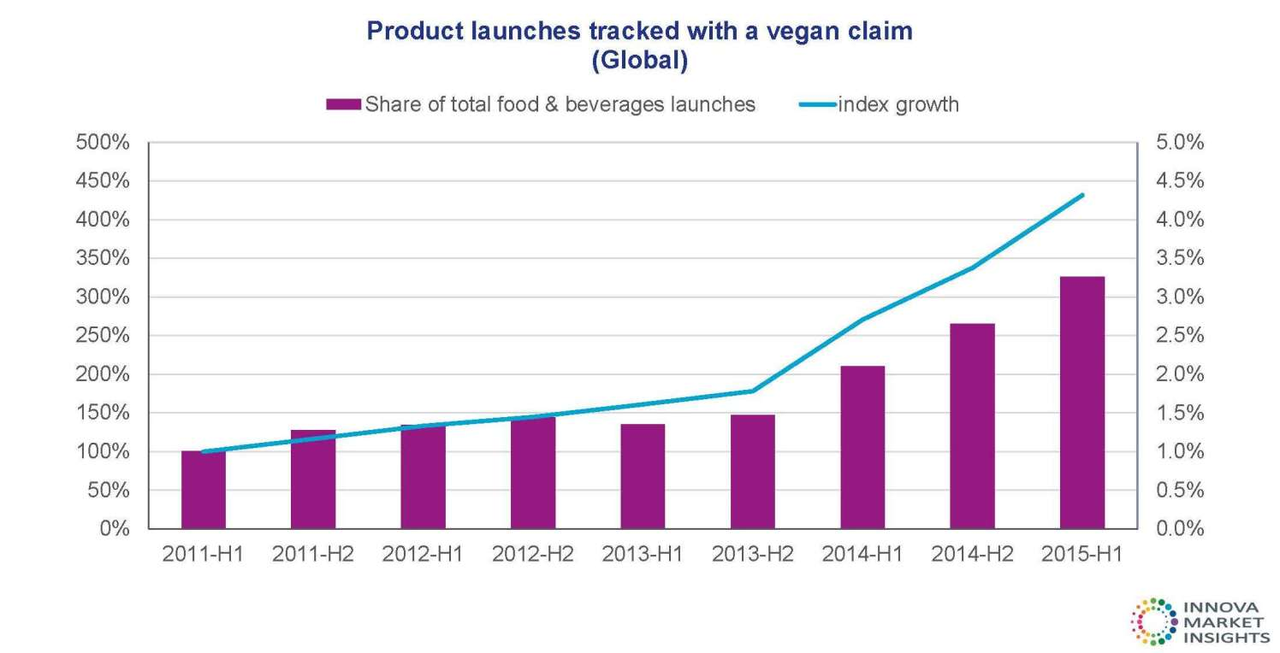
According to the figure, the demand for plant-based products seems to be increasing worldwide. The consumption is increasing more than three times within 5 years while index growth reaches up to 450%. The vast majority perceive plant-based products as a healthier choice; and/or in some cases have a family member with a medical need.

3.2.3 Social
Sales of food intolerance products grew by 5% in 2011, reaching just under US$170 million. While lactose-free products maintain the largest proportion of food intolerance product sales (US$108 million). Diabetic foods, valued at US$10 million, have shown slow but steady growth¹⁵. An aging population and the growing incidence of food allergies and intolerances contribute to the growing sales in this niche market.
According to the Public Health Agency of Canada (PHAC), nearly 1.2 million Canadians (or 1 in 17) have been following to vegan diet, with a higher prevalence among older demographics. By the end of 2017, it is projected that almost 1.8 million Canadians will have been diagnosed with the disease, marking a 22% increase since the rate recorded in 2011.
As stated in a Forbes article, 88% of those polled are willing to pay more for healthier foods. All demographics—from Generation Z to Baby Boomers–say they would pay more for healthy foods, including those that are GMO-free, have no artificial coloring/flavors and are deemed all natural. Last but not least, Researches have shown that younger Canadian are more likely to follow vegans than older generation. The report also shows that more than half Canadian who identified as vegan and/or have lactose intolerance were under the age of 35.

3.2.4 Technological
In 2015, more than 76% of Canadians households place online shopping with the average of 4-10 orders per person. Orders totalled $136 billion worth of goods and services, with an average value of $3,578 per person per year. Travel arrangements, such as hotel reservations, tickets and rental cars were made by 55% of online shoppers, and 48% of shoppers purchased tickets for entertainment events. When paying for purchases, 89% of shoppers used a credit card online, and 31% used an online payment service. Most shoppers (83%) placed orders from companies in Canada, while 60% ordered from vendors in the United States, and 18% from vendors in other countries.

Objectives & Issues
As mentioned, the company's overall mission is basically becoming a place that provides substitutes used in different dietary needs and giving off the value of caring about the buyers' health as much as they do. In line with those, our main objectives are as follows:
⦁ To provide a wide selection of specified groceries to people with special needs.
⦁ To create excellent buying experience.
⦁ To become well-known among targeted segment of customers for quality, range of choices, services and credibility.
⦁ To start making profit by the second year.

SWOT Analysis
Strengths:
⦁ Focus to enter a niche market that focus on specific market segments gives us a stable customer base, unlike some start-ups who may struggle to find their position in the market.
⦁ Our team is knowledgably about the health conditions of the customers that we aim to attract helps sharpen our ability to provide the adequate services as required.
⦁ We have a team of professionally trained employees to help and assist customers whenever they need. With some employees having experienced special dietary needs, they can relate with our customers on a more personal level with both zeal and necessary experience.

Weaknesses:
⦁ The fact that we only focus on the niche market renders our customer range to be less than usual.
⦁ The expansion of products is limited because there are selected brands manufacturing the specialty foods.
Opportunities:
⦁ There are not so many competitors in the market. There is a gap that needs to be filled.
⦁ We know where the majority of customers can be found, that is in associations, groups, etc., so we can develop specifically designed promotion strategies.
⦁ Our market can potentially be expanded to include health-conscious customers as well.
⦁ The number of people following Vegan diet is on the rise every year, meaning more potential customers.
Threats:
- Canada is not a huge manufacturer of the products we are providing. The import from the United States might encounter changes in legislation or any foreign trade laws.
- Trading depends on the fluctuating exchange rate between Canadian Dollars and US Dollars, the high cost of the specialty food is now topped up with difference in currency conversion which directly effect to the purchase power
- The increasing number of people with special dietary needs could turn this market into a feasible business and attract more competitors.

Marketing Strategy

5.1 Target market

5.1.1 Segmentation
We divide the market into segments based on the following variables:
- Geographic: According to Statistic Canada, on July 1, 2015, 13.1% Canadians were living in British Columbia, making it the third concentrated province nationwide. A report by BC Stats shows that Vancouver is the most densely populated city in British Columbia compared to other neighbour regions such as Surrey, Richmond, Burnaby, etc., despite the declining growth rate. This indicates that Vancouver is a relatively more attractive market to target.
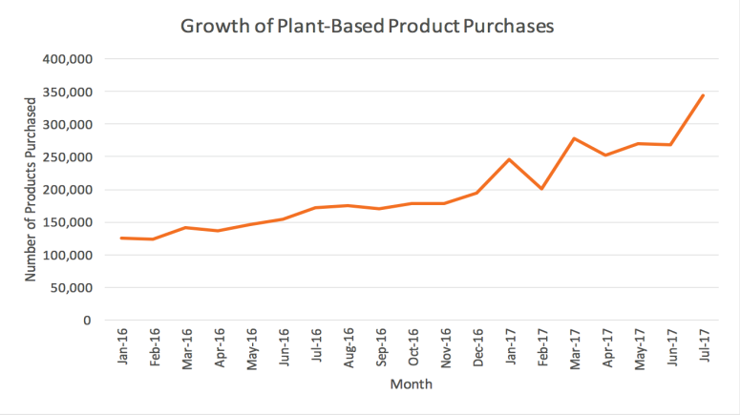
- Demographic: Buyers within these segments control the intake of food containing gluten, dairy and sugar because of disease or intolerance. They shop for mostly “free from” and “low in” food products and supplements. The entire group comprise of all ages and genders and the age group tend to younger than it used to be.
- Behavioral: people with food restrictions are heavy users of specified products catering for their special dietary needs. Moreover, convenience seekers also contribute largely to the customer pool.

5.1.2 Targeting
Our target market is predominantly people with special dietary needs, particularly those who have diabetes, gluten and lactose intolerance, and dairy allergy living in Vancouver and other surrounding regions. We choose to target this market because of the rapid growth rates of diabetes and other food sensitivities. In a report of Canadian Vegan Association, the proportion of Canadians with Vegan rose by 47.4% between 2005 and 2017; this rate is expected to reach 56.9% by 2020.
Moreover, according to Canadian Digestive Health Foundation, number of people suffering from lactose intolerance in western countries has increased nearly a quarter in the last 25 years. In Canada, it is estimated that about 330,000 people have lactose intolerance, among whom more than 110,000 are clinically diagnosed and another 220,000 are suspected to have this disease. .
Overall, given the market we target and the wide variability of “free from” products, our targeting strategy will be a combination of differentiated and concentrated marketing, with a focus on local promotions.

5.2 Value proposition

5.2.1 Differentiation
We are confident to have several competitive edges. The first and most important one is our store locations. There will be at least one store in West Vancouver and East Vancouver. Each store is located close to a bus stop or a sky train station, making it convenient for customers all over Vancouver to access our places.
The product selection range we provide is also a value proposition. Our partnerships with various distributors and the large quantity we purchase allows us not only to bring customers more product categories and a wide variety of goods but also to lower product cost and thus, lowering our selling prices. We will also work to offer the best online shopping experience as well as more competitive shipping price and safety policy to our customers.
Our third competitive edge is the high quality of services and experiences we provide. Our well-trained and well-informed team has full capability to aid and please each customer.
Another differentiation of “Vegan for Green” is our participation in various health programs. The support we offer is not limited within the stores; our employees also volunteer to help people food sensitivity in the larger community as well.

5.2.2 Positioning
We strive to position our store brand as a go-to and trustworthy place in which people with food illnesses and/or looking for healthier food products can satisfy their needs and cravings without the risk to their health.

5.3 Growth Strategy
To facilitate the growth of our brand, the following would take place over the course of time i.e. 5-10 year plan
- There will be a vertical backward integration: as a food retailing outlet, in the long-run to cut major costs, to fully satisfy the needs of our customers and to create new products for our niche market, we could look into acquiring a food manufacturing firm which would give us a comparative advantage within our target market
- We could diversify the products by adding new products through marketing.

5.4 Marketing expense
The table below provides a brief view of our estimated marketing expense for the first year:
Expenditure | Jan | Feb | Mar | Apr | May | Jun | Jul | Aug | Sep | Oct | Nov | Dec
Rent | 15000 | 15000 | 15000 | 15000 | 15000 | 15000 | 15000 | 15000 | 15000 | 15000 | 15000 | 15000
Training | 8000 | 8000 | 10000 | 10000 | 10000 | 10000 | 10000 | 8000 | 8000 | 8000 | 8000 | 8000
Advertising | 3000 | 3000 | 3000 | 7500 | 7500 | 7500 | 7500 | 7500 | 7500 | 3000 | 3000 | 3000
Print | 1500 | 1500 | 1500 | 1500 | 1500 | 1500 | 1500 | 1500 | 1500 | 1500 | 1500 | 1500
Utilities | 50000 | 0 | 0 | 0 | 0 | 0 | 0 | 0 | 0 | 0 | 0 | 0
Business Insurance | 15000 | 0 | 0 | 0 | 0 | 0 | 0 | 0 | 0 | 0 | 0 | 0
Registered business name | 400 | 0 | 0 | 0 | 0 | 0 | 0 | 0 | 0 | 0 | 0 | 0
Website | 400 | 0 | 0 | 0 | 0 | 0 | 0 | 0 | 0 | 0 | 0 | 0
Miscellaneous | 2000 | 2000 | 2000 | 2000 | 2000 | 2000 | 2000 | 2000 | 2000 | 2000 | 2000 | 2000
Import | 4000 | 4000 | 4000 | 4000 | 4000 | 4000 | 4000 | 4000 | 4000 | 4000 | 4000 | 4000
Promotion | 1500 | 0 | 0 | 0 | 2000 | 2000 | 2000 | 2000 | 2000 | 2000 | 1500 | 1500
Total | 100800 | 33500 | 35500 | 40000 | 42000 | 42000 | 42000 | 40500 | 40500 | 36000 | 36000 | 36000

Implementation

6.1 Product
Variety
As a specified grocery retailer, our merchandise comprises of food, condiments, baking needs, snacks, desserts, and drinks that are approvable to people with special dietary needs. We offer a wide variety of product lines from different manufacturers listed in microenvironment section.
In the future, we plan to expand our offerings to include supplements. By regularly analyzing our business portfolio we can make a strategic plan on carrying new product lines from existing suppliers and discontinuing products that have low turnover. This strategy gives customers more choices of latest offerings while avoids having too many alternatives that might confuse customers.
Quality
During the first months or years of operation, sales and turnover are expected to be break-even or low. Hence, in order to ensure the best quality of our products, the quantities of merchandise purchased are based on shelf life in conjunction with sales forecast. In addition, we will constantly conduct quality checks to avoid having expired goods on shelves and timely take action if such situation occurs.

Services
Aside from the wide product selection offered in each location, our customers also receive high quality services and helps from our special team members. Our employee base will consist mostly of people with milk allergy and/or lactose intolerance. As they experience what our customers experience, our team is able to give understanding for the needs of customers and empathizes with them more. This employee base also creates good first impressions and adds credibility to the information they provide shoppers, which helps building trust and attracting new customers. Moreover, additional training is mandatory to all team members in order to aid customers with their questions and product choices as well as to build long-term relationships with them.

6.2 Price
List price
Products that cater for people with special needs are generally higher in prices compared to normal goods. For instance, products that are lactose free or milk-substitute products are usually twice higher price than normal products. However, as mentioned in our value propositions, we manage to get low, wholesale price from our suppliers due to the large quantity of product we purchase. This allows us to offer the best prices to customers. Compared to our main competitors, our prices are approximately 2% to 4% lower for the same products.
Discount
A membership rewards program will be launched along with the opening of the stores. Similar to that of other companies, our membership program consists of free registration for membership and earning points for rewards and discounts (up to 15%).
Furthermore, we will also have weekly discounts by up to 5% for selected items based on costs of goods sold and products’ turnover rates. Seasonal discounts will be launched during summer and holidays seasons as well as other special occasions, including Black Friday, Christmas, Boxing Week, New Year, back to school season, etc.

6.3 Place
We plan to first open 2 stores, each in a different Vancouver area, namely East Vancouver & West Vancouver. The stores are located near bus stops or sky train stations, making it convenient for customers all over Vancouver to access our places.
In the future when the first stores start making profits, we plan to develop expanding strategy based on surveys gathering customers’ preferred locations and other market researches. Based on the results, we will open one more stores at new strategic location at a time. New locations will not be targeted until the old ones start generating profit. We will also evaluate sales annually and consider phasing out stores that have low turnover or cannot make profit despite promotions and marketing campaigns.

6.4 Promotion
We intend to build and maintain relationships with current customers as well as reach potential shoppers through various channels. As mentioned in the service section above, our well-trained employees create good first impressions, deliver high quality services and build trust among customers. In addition to that, our membership program helps us to not only obtain customer loyalty but also keep in touch with them as well as send out our flyers and newsletters via mail, email or phone.
- Consumers can find information about our products, company as well as the illnesses we cater for on our website. The webpage will contain simple yet eye-catching aesthetics and user friendly functions.
- Buyers can also reach us via email with their questions and concerns. Emails will be checked regularly and our well-informed team members will reply as soon as emails are received. Furthermore, we will create a forum in which buyers can raise questions, which will be answered by either our employees or other customers, as well as share their experiences, health tips and recipes.
- Our employees will occasionally reach customers via our forum and ask for feedbacks about their experiences using different items to make necessary improvement for our product selections.
- Social media and online networks such as newspapers, YouTube channel and Facebook page will be our main advertising tools. We also plan to place posters on public transports such as buses, bus stops, sky trains and stations. These commercials and posters will be changed on a seasonal or yearly basis to make it fresh and attractive to customers.

Summary
This marketing proposal is for our business “Vegan for Green”, a chain of retail stores that provides specialty food products for people who are following vegan diet as their health benefits or with symptom such as lactose intolerance, and milk allergies. We predominantly target people with special dietary needs, particularly those who have lactose intolerance and dairy allergy living in North America especially in BC. With the aim to keeping the targeted buyers and attracting new consumer groups, we plan to focus on delivering wide variety of high quality products at competitive prices, excellent customer services, special store design, and convenient locations. Having identified and analyzed the company’s micro- and macro-environments, we believe that, with the proposed marketing strategies, “Vegan for Green” has the full potential to succeed in the Vancouver Mainland Area.

References
Cleary, Catherine. “The Rise of Veganism: We Are What We Don't Eat.” The Irish Times, The Irish Times, 18 Nov. 2017
www.irishtimes.com/life-and-style/food-and-drink/the-rise-of-veganism-we-are-what-we-don-t-eat-1.3287187.
“Online Shopping Blitz: Canadian Sales Rise by $14B to $136B in 2013 | CBC News.” CBCnews, CBC/Radio Canada, 11 June 2014
www.cbc.ca/news/business/online-sales-by-businesses-rise-to-136b-in-canada-1.2671935.
Friend, David James. “Three Quarters of Canadians Bought Something Online Last Year, Canada Post Says | CBC News.” CBCnews, CBC/Radio Canada, 12 May 2015
www.cbc.ca/news/business/76-of-canadians-shopped-online-last-year-canada-post-says-1.3070651.
Oberst, Lindsay. “Vegan Statistics: Why The Global Rise in Plant-Based Eating Isn't A Fad.” Food Revolution Network, 7 May 2018
foodrevolution.org/blog/vegan-statistics-global/.
http://www.pommenaturalmarket.com/who-we-are/

