Daniel Amador Rodríguez

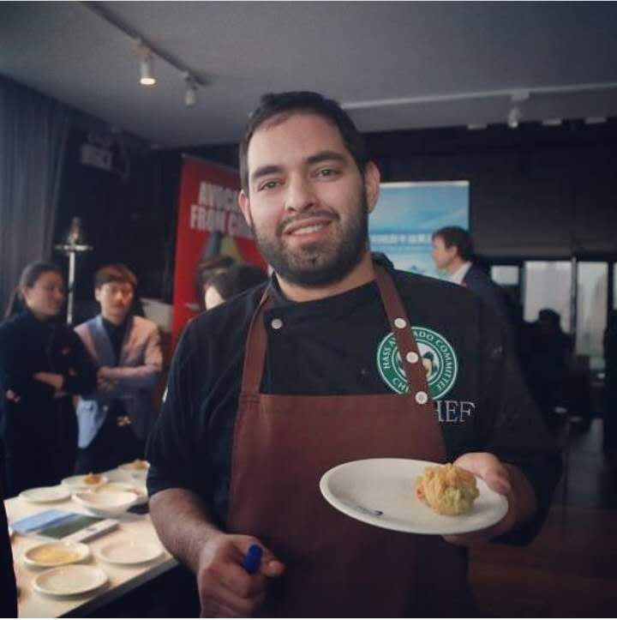
Date of Birth: (26-October-1987)
Permanent Address: Carrera 52 # 70 Apt 606 -201 Barranquilla, Atlantico, Colombia
Phone / s Contact: +86 18721758124 CHINA (mobile) +57 3187515281 COLOMBIA (mobile)
Email: dar11@euht-santpol.org, danimatador9@hotmail.com
Driving license: 08296-2081590 I (Republic of Colombia)
Wechat: daniamador10

Academic Formation

October 17 2011 – May 30 2012 Escuela Universitaria de Hotelería y Turismo Sant Pol de Mar, Barcelona (EUHT StPOL)
Centro adscrito a la Universitat de Girona
Postgrado en Dirección de Cocina (Diploma de Especialización en Dirección de Cocina en convenio con la Fundació Universitat de Girona: Innovació i Formació)

September 2007-November 2010 Escuela Internacional de Diseño y Comercio Lasalle College, Bogotá, Colombia
Gastronomía y Servicio de restaurantes

Professional Experience

June 6, 2018 - present Estado Puro, Shanghái China
Chef de Cuisine

March 1, 2018 – May 31, 2018 Styx, world of skewers, Shanghai, China
Chef de Cuisine
Responsibilities
- Supervising food wise, ordering.
- Changing the food menu for more variety.
- Checking operation wise.
- Maintaining food cost.

Sep 1, 2016 – February 28, 2018 Azul Tapas Lounge, Shanghai, China
Sous Chef – Chef de cuisine

Responsibilities
- Ordering and planning for food wise operation, caterings and events.
- Develop menus according to the restaurant needs.
- Maintaining food cost
- Training the staff for operation wise and recipes.
- Making schedules and planning days for vacations and days off.
- Maintain order and discipline in the kitchen during working hours.
- Organization of kitchen equipment as well as the hygiene part.

Nov 5, 2014 – June 20, 2016 - Loama Resorts Maldives at Maamigili, Raa Atoll, Maldives
- -Junior Sous Chef
Responsibilities

- To minimize payroll costs by maximizing the productivity and efficient scheduling of colleagues.
- To Ensure that all the required food transfers are completed to the appropriate outlet/department
- To develop menus and set standard recipes (as per SOPs) which allow the restaurants to run at an acceptable food cost, thereby satisfying guest needs and expectations.
- To work in any section of the kitchen when necessary, due to business levels or colleague shortages.
- Check incoming produce, ensuring that all food merchandise is in accordance with order sheets, receiving records and purchasing specifications.
- Planning and implementing effective food promotions in co-ordination with the Chefs office.
- Responsible for the Italian outlet restaurant as well as well the main kitchen operation.
- Making fresh pasta ravioli, tagliatelle, tortellini, etc.
- To train kitchen colleagues according to the monthly training plan, CSI report “comment cards”, hygiene reports and any other highlighted areas for improvement/development that would benefit the department.
- To ensure that all outlet reports, schedules, standard recipes, menus, food presentation photographs and correspondence are completed in liaison with the Executive Chef and Executive Sous Chef in an accurate and punctual manner.
- Attends meetings and briefings as instructed by the Executive Chef and Executive Sous Chef.

Nov 4, 2013 – Sep 1, 2014 - Fridays Boracay Hotel, Boracay, Aklan, Phillipines.
- Sous Chef
Responsibilities
- Working with the executive chef to produce diversified menus in accordance with the restaurant’s marketing.
- Coming up with new dishes which appeal to the clients, whenever required.
- Establishing the working schedule and organizing the work in the kitchen.
- Producing high quality dishes that follow up the established menu and level up to location’s standards, as well as to clients’ requirements.
- Plan the food design in order to create a perfect match between the dish’s aspect and its taste.
- Train the auxiliary kitchen staff in order to provide best results in minimum time and using at the maximum the available resources;
- Maintain order and discipline in the kitchen during working hours;
- Create tasting menus for clients interested in contracting the food for different events (wedding, banquets, corporate dinners, birthday parties, etc.)from their kitchen;
- Developing a cross-marketing strategy in order to increase profit, such as pairing drinks with the food served.
- Making sure the hygiene and food safety standards are met in all stages of food preparation, starting with the ingredients and ending with the finished dish which leaves the kitchen door.

January 15 2013 - October 20 2013 -Independent Chef
-Events and reunions (Paellas, Spanish dishes), Barranquilla, Colombia
Responsibilities
- Making sure the operation is smoothly as my own business checking the quality and cooking as well the marketing is going well.
- Checking the hygiene and safety of the merchandise as well getting connections with the suppliers to get an even better price and quality for the customers.
- Preparing and cooking the merchandise making the costing and presentation of the dishes.

June 4 2012 - December 15 2012 (Hotel NH Almenara), (Hotel NH Sotogrande),(NH Playa Club Cucurucho), Sotogrande, Spain
- Chef de Partie

Responsibilities
- Responsible for the day to day running of any given section.
- Checking the cleanliness, stock control, organization and standards of the section
- Ordering on a daily basis, while keeping in mind stock usage, menu planning and business levels.
- Constantly advising Chef on needs and ordering requirements.
- Assisting other Chef de Parties and help each other keep motivated and focused.
- Assisting the Executive Chef and the rest of the team to maintain quality, standards and cleanliness required by the Chef.

June 2011 -October 2011 Restaurant Casa Cultural Española Sabina, Barranquilla, Colombia
-Chef de Partie Spain “Tapas”, and Paellas

Responsibilities
- Responsible for the hot station.
- Cooking spanishes dishes, specially paellas and traditional dishes of Spain
- Assisting the head chef and team for smooth operation an ideas to the team

October 2009 -April 2010 La Fragata Fish Market, Bogota, Colombia
Cuisiner commis Hot Station
-Responsible specifically for the hot station, preparations and mise place.
September 2009 Fair ice cream sales booster Brand "Colombina”
-Sales booster with an Ice Cream stand elaborating recipes with the “Colombina” Brand.
January 2008 - September 2009 Lasalle College Restaurant “La Academia”
-Cuisinier commis at all stations of the Restaurant
-Mise plase of all the operation

Skills

- Cost management and control in kitchen
- Food Hygiene Control
- Application of balanced diet
- purchasing management
- application knowledge of wine in kitchen
- Organization of kitchen items
- International kitchenettes elaborations
- elaborations of themed cuisine
- application of new cooking technologies
- elaborations of kitchen buffets and events

Other Knowledge:
First Aid Course: Participate in the process of knowledge and practice of first aid course.
License in PADI as open water scuba diving.

Computer uses: Ms Windows, Ms Office, Internet Browsers, MICRO, OPERA, FUSION

Languages: Spanish, English, Italian and portuguese (understand), Mandarin very basic.

GEOGRAPHIC PREFERENCE: Cataluña / Rest of Spain (Barcelona). ; Asia - Pacific: Philippines, China, Fiji, Maldives, Australia; (Latin-American) Colombia, Netherlands

DEPARTMENT PREFERENCE: Kitchen

