Financial Analysis Report

Coca Cola Company
Atlanta, Georgia, U.S.
RCM264-Financial Management
Valerie Foster
12/4/2018
Anh Ngo
This report consisting of the financial analysis with the annual data of 2017 in order to maximize the revenue & profit based on the top ten global hospitality trends.

Introduction
With the convenience and reasonable price, soft drinks have become more popular nowadays as they become regular drinks for every household worldwide. They have showed their success throughout the existence of their products from every place that we can go (grocery, shopping mall, movie theatre, on the street, etc.). How can the industry become so popular and how they can expand their business worldwide even many people believe that soft drinks are totally negative to their health? This analysis report will focus on the financial data of 2017 from Coca-Cola Company to sketch a better idea on how the business function and maximize their profit.
Coca-Cola is an American company that manufacturing, retailing & marketing of beverage concentrate & syrup. They have a wide variety of products but best well-known for their flagship product Coca-Cola soft drinks which we can see them everywhere nowadays. Other than that, Coca-Cola products are not only available in North America but worldwide even from the rural area in almost every country in the world.

Company Description
- History & Business size
Began in 1886, the first soda beverage were sold by a glass for 5 cents. The early growth was impressive but slow has encouraged a strong bottling system development that made Coca-Cola became the world-famous brand as they are today. However, after nearly 30 years in 1916, the contour bottle was used and became one of the most recognized icons in the world today. The business has expanded dramatically within then outside U.S. and many factories were built in Latin America, UK, Europe, Asia, Africa especially in the half late of 20th century. However, with the higher consciousness of health and appearance, people are considering to consume healthier choice. Coca-Cola has already passed their peak of success; however, with their marketing efforts, their brand name still be best world-famous until nowadays.
- Legal Form of Operation & Services
Coca-Cola is a corporation that is manufacturing, retailing their beverage products worldwide. They were building their syrup plants worldwide and incorporate with bottling operation then manufacture, package, merchandise and distribute products to their customers and vending partners
- Annual Revenue
According to the 2017 annual report, the revenue of company has dramatically dropped out from $46.9B (2013) to $35.4B (2017). It was 25% lesser within 5 years because of many factors (competitors, customers’ perspective)
- Products
Coca-Cola sells the concentration & syrup from their secret recipe to authorized bottling operation partners. Then their partners will combine/mix the concentration with sweeteners, sparkling water to produce finished beverages. After that, the finished beverages will be packaged in their signature bottles/containers that bearing Coca-Cola trademarks. Lastly, the bottles will be distributed to retail stores, vending partners for consumption

Coca-Cola owns various valuable beverage brands, including the following:
Coca-Cola | Georgia | Dasani | Ice Dew
Diet Coke | Powerade | Simply | I LOHAS
Coca-Cola Zero | Del Valle | Glaceau Vitaminwater | Ayakata
Fanta | Schweppers | Gold Peak | Sprite
Aquarius | Fuze tea | Minute Maid | Minute Maid Pulpy
Glaceau Smartwater

- Competitors
Because of the huge revenue and popularity, the non-alcoholic beverage industry is highly competitive consisting of numerous of companies from emerging to universe and well established. Most of them are multi geographic area competitors including the following:
Pepsi Co. (Primary) | Nestle | Dr.Pepper Snapple | Groupe Danone
Mondelez | Kraft Heinz Co | Suntory | Unilvever

Strategies
- Customers demographics
Because of the numerous of products provided, the segmentation enables Coca-Cola to define the appropriate products for different types of customers. However, Coca-Cola main strategy is not to focus on any specific segment but adapt to its marketing by developing new products
- Age: it might be difficult to define the age range for their products as it is not limited to any person regardless of health issue. However, the main consumers are from the age of 12-30 years old. Other than that, not only the younger age but some middle age might consume instead of soda beverage, but fruit juices from Coca-Cola brand
- Gender: Other than that, their marketing does not target on gender as the results show that both genders show 50/50 of consumption
- Life style & Habit: Again, Coca-Cola does not specifically focus on any life-style target but their products are highly consumed with those who are more likely busy and mobile generation. It is popular to see the youth especially those who has been more actively in the social network consume the Coca-Cola products while they working.
- Target Market
Coca-Cola is expanding and marketing their products & services in the three segmentations (2017):
  - Established Markets (29% in volume): Austria, Cyprus, Greece, Italy, Northern Ireland, Republic of Ireland & Switzerland
  - Developing Markets (19% in volume): Croatia, Czech Republic, Estonia, Hungary, Latvia, Lithuania, Poland, Slovakia & Slovenia.
  - Emerging Markets(52% in volume): Armenia, Belarus, Bosnia & Herzegovina, Bulgaria, Republic of Macedonia, Moldova, Montenegro, Nigeria, Romania, Russian Federation, Serbia & Ukraine
The main strategy is to focus on the wider but balanced diversity. According to the report, no single country dominates their portfolio; in fact, none of them represents more than 20% in sales.

Business Analysis on the top ten trends
- Business Positioning:
Even experienced the declined in the past few years, Coca-Cola has still showed their efforts in changing the strategy with their new “Taste the Feeling” global campaign launched in late 2016. This new campaign has delivered the message of encouraging customers of finding fun and refreshment in every single moment of their life. Although the improvement in sales have not shown on the results yet; but definitely this plan is promising to help the company to overcome their challenges such as new products, new designs and healthier and convenience options. It has changed a total new face of Coca-Cola as the previous program “Open Happiness” only focus on their brands instead of customers’ needs.
This section will focus on the new top ten global trends of the Hospitality Industry and how Coca-Cola should respectively respond.
- Millennials the New Power Segment (Primary Positive)
As analyzed above, this segment should be the top priority trend that Coca-Cola should focus on because of its huge direct impact on the sales volume and customer demographic. The Millennials generation was different to other because of they are inherited all the experience and technology from the previous generation, on the other words, their life has become easier but faster so the demand of convenience products definitely higher than other generations. For example: there is high percentage of Millennials works from home/office most of the time, thus the requirement of fast/convenience food is absolutely higher.
On the other hand, as the globalization has become more popular and all culture has been connected into the multi-cultural community, it is also an advantage for Coca-Cola to exploit by targeting on their interest and benefits with variety of choices.
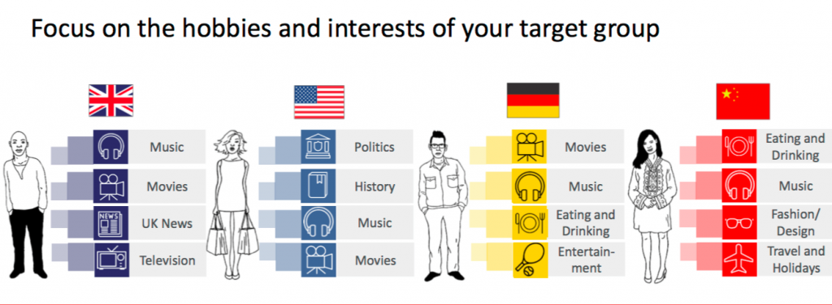
- Political Tensions & Terrorism (Negative)
The political issues have always been big problems to any business especially the large-scale company such as Coca-Cola. It does not only damage the business physically, but also effect to the supply and demand in every industry. Unfortunately, only developing plan to adapt to the political tensions rather than changing it. For example: U.S embargo with Cuba before which eliminated the existence of Coca-Cola products within Cuban territory even at that time Coca-Cola has already been world-famous brand. Until the last few years, since U.S. open traded with Cuba again, the first Coca-Cola product was sold after decades. Another example is in the Middle East market, where the political tension and terrorism has been majority, none of the factory were built or were not licensed to be built that can effects not only the sales volume but also the transportation in which can increase the cost. Last but not least, political tension will always damage any business and most of the time it will negatively effect to the business. Thus, it is always better to plan ahead on the negative situation regarding of the purchase power, taxation policies, security & safety in any case of incidents.
- Deepening Income Inequality & the Working Poor (Positive)
Inequality has always been a huge issue for any community regardless of developed or developing countries. There are many lessons behind the Black Friday Corruption or the crisis in 2008 that effect dramatically worldwide. More than that, Hospitality industry is always directly affected by the fluctuating in the economy. However, Coca-Cola is fortunate to be in different segmentation as the income does not really effect to their sales volume. It is difficult to find any business that is not affected by the income level. For example: Cactus Club can deliver food to customers who are at least average middle class because of their stable income. Those who are working under average might not be able to dine in frequently or ever. However, Coca-Cola can do the total opposite way while they can sell the products to any customers regardless of their income. It is common to see some homeless people and businessman with their products. This way, Coca-Cola should keep focusing on their numerous of product instead of focus on the income because their products are reasonable for any classes.
- Taking Control of Health & Personal Well Being (Primary Negative)
As the living condition improved, people are being more concerned about their health since they can be more affordable to go with organic & natural products to maintain their health over age. Which means, all of those food that are considered as “bad” such as fatty food, soft drinks, sweeten food will be dramatically declined. Coca-Cola is not an exception as their business has been affected extremely because of people changing their eating habits. It is definitely a negative affect because up to 75% of the products from Coca-Cola contains high amount of sugars. So how they will face and overcome these challenges? The answer come from the “Taste the Felling” program that they launched in 2016, since they provide the numerous of healthier products (smart-water, vitamin water, etc.) and they try to change their image close to the active lifestyle. It is definitely a smart move as people slowly changing their point of view about the Coca-Cola products. It will take extra time until their image can be perceived officially.
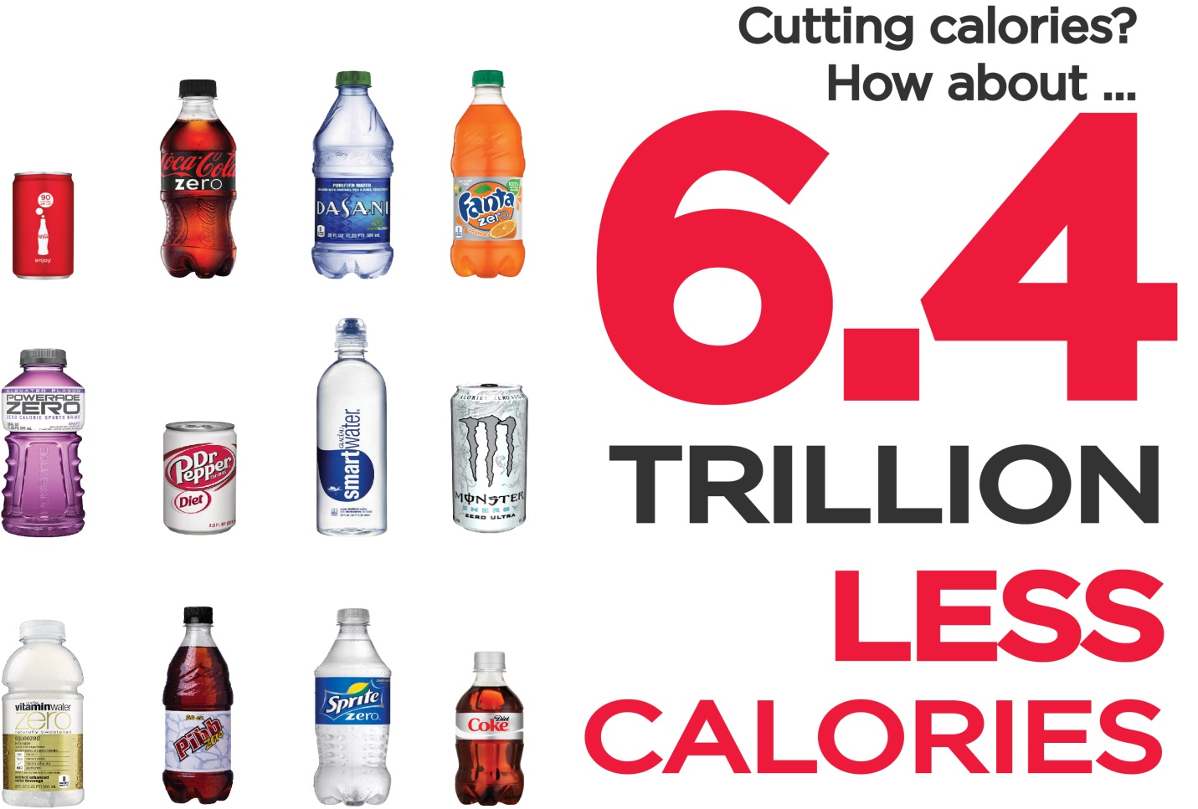
- Technology Driven Self-Sufficient Travelers (Positive)
Nowadays, everything is very easy just by one click. Everybody can order anything online. Life now is way easier than before especially for those who lifestyles are within the office/home. Just about 20 years ago, if people want to buy a can of Coca-Cola, they have to walk to the grocery store down the street. But now, they can just buy it from the vending machine or delivered online. Technology has changed our lives way better than before which made everything become really convenient. That is one of the biggest advantage that Coca-Cola should consider to develop their service in order to increase their sales. Another thing that really important is with the improvement of technology especially social network, the business can understand their customers better to focus on their wants & needs. Other than that, communicating with customers are always the top key to become successful in any industry. Last but not least, technology development will make everything becomes easier but the competition will absolutely more intense and difficult. That should be another challenge that Coca-Cola should oversee and plan on their long-term solutions.
- Sustainability & Resource Constraints

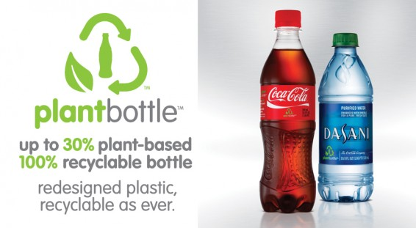
The development of people’s living standard has increased which make it easier for us to compare with decades or centuries before. However, there is a huge side factor that has been damaged extremely is the environment. Definitely, the expansion of industrial zone with thousands of factories built every year has created environmental degradation. Moreover, it also comes from the high usage of plastic and non-recyclable material has contributed to the environment as well. For the last few years, WHO has encouraged people to be willingly cooperated together to save the environment; however, because of the high income from those factories or the convenience of plastic products, it seems to be a long way ahead until we can change our environment. Thus, Coca-Cola has been changing themselves into the “green” status with their environmentally friendly buildings and products (Rating by the U.S. Green Building Council). Coca-Cola has improved their status every year with these features:
- 20% of the entire building construction were recyclable materials and 90% of construction waste was salvaged, reused or recycled
- The landscaping features includes light-coloured paving, vegetable grounds, green mini park with reflective roof were built to reduce the “heat island effect”
- Inside the building, instead of providing the AC, the air quality has been enhanced through low-emission paint, adhesive, sealants & carpeting as well as building structure to maximize the are in and out flow
- The building was designed to optimize the energy efficiency up to 30% than the standard requirements
- The technology “Plantbottle Tech” has been developing to provide new plant-based and organic products (bottles, glasses, etc.)
- Disruption & the Sharing Economy
With the globalization nowadays, there is a lot of connection between companies with various of new business models such as peer-to-peer network. Since 1984, Coca-Cola has been working with the same type of model by selling syrup to bottling company. More than that, Coca-Cola has building their image extremely every year through their advertising campaign and retail stores all over the World. They have focused on the P2P network for decades. Furthermore, with the growing popularity of advertisement engine (social network, email, products presence), Coca-Cola definitely has leading the global commercial with their stable network. Other than that, Coca-Cola is “moving at the speed of the consumer” by evolving their business models. Their success come from their strategies of how to driven by their abilities to give their customers what they want and love. Definitely, people lifestyle’s has always changed; Coca-Cola will still focus on building customer-centric to meet their needs
- A Global Worldview (Neutral)
Once again, the globalization has not only affected the business; but it can also bring some opportunities with huge profit to those who can understand and perform into their expansions. Coca-Cola has been leading the world on their worldwide expansion for decades; and as mentioned above, their products present almost every places in the world nowadays. Not only has them, also the competitors been developing their infrastructure to merge into the world commercial with unlimited boundary. The globalization has encouraged more connections between regions; thus, the traveling policies and law has been loosen up not only for visitors but for businesses. Those are considered as new challenges for Coca-Cola because of the new competitors emerging into the market. However, Coca-Cola still prove they are a big player in the market by buying some of those companies to strengthen their position as well as power in the industry
- Fewer People & More Data (Neutral)
The communication worldwide has been easier than ever due to the building of social network. Just only 20 years ago, it would be really difficult and costly to be able to talk with other people from the region. Nowadays, those difficulties have been done by only 1-click. The world has become smaller than ever with several of communication. Besides that, a really important that all the business wants to gather from the communication is customer data. In some country, it might be illegal to gather personal information, whilst other might seems to be easier. Of course, It has contributed a lot to the cost-efficiency plan by cutting down the labor and operational cost but still can be able to maintain their communication with customers. i.e. before, to gather feedbacks or reviews about products, Coca-Cola had to send out their employees to every neighborhood with samples, coupons, etc. For now, it is easier to perform the job online with direct interaction and higher efficiency.
- Emerging Growth Markets (Neutral)
The economy has always difficult and hard to understand because of their fluctuation, political involves, people’s behaviours, etc. Definitely, the worldwide market is never stable at any period. As we experienced the prosperity of Europe in the 1960s and 1970s, The EU now has been in their lowest growth due to many problems that might affect to Coca-Cola Revenue as well. For instance, the majority of Coca-Cola products were distributed to North America & European region in the 1970s that due to the expansion of a lot of factories has been built. However, with the higher labor cost and unstable economy, they have to move their based to other market such as Asia, Africa to maintain the operation. However, it is very costly especially when the market becomes more competitive these days. Even Coca-Cola has been planning to provide different types of products and distributors, the declines in sales might be also a huge challenge for their business as well.

Internal & External Financial Analysis
- Internal
Coca-Cola operational function has been more and more complicated due to the characteristic of the soda industry besides the different type of dividends contributions. This section will focus mainly on the 4 essential ratios:

Ratio | 2013 | 2014 | 2015 | 2016 | 2017
Liquidity Ratio
Current Ratio | 1.13 | 1.02 | 1.24 | 1.28 | 1.34
Quick Ratio | 0.90 | 0.81 | 0.89 | 0.98 | 0.90
Cash Ratio | 0.73 | 0.67 | 0.74 | 0.84 | 0.76
Solvency Ratio
Debt-Equity | 1.12 | 1.38 | 1.73 | 1.98 | 2.79
Debt-Capital | 0.53 | 0.58 | 0.63 | 0.66 | 0.74
Activity Ratio
Inventory Turnover | 5.63 | 5,61 | 5.83 | 5.90 | 4.97
Net Profitability Ratio
Profitability Ratio | 18.32% | 15.43% | 16.60% | 15.59% | 3.52%
According to the financial ratios above, we have seen the decline in Coca-Cola Operation in the last 5 years. One good new for the investor is they can still access their investment safely due to the stable of liquidity ratio as well as debt-capital is in the safe zone. However, the Debt-equity ratio is really high especially in 2017 (almost 2.5 times higher than 2013) that can effect in their long term debts and how they can build their plan to pay off their liabilities.
On the other hand, they have experience the decline in sale which makes their inventory turnover drops over the last 5 years. Their operation will have to make adjustment to either lower their cost and/or increasing the average food inventory by increasing sales volume. Last but not least, the profitability ratio has dramatically cut down from 18.32% (2013) to 3.52% (2017).
- Competitors analysis
Income Statement Comparison 2017 (value in 000’s)
Categories | Coca-Cola | % | Pepsico | %
Revenue | $35,410,000 | 100% | $63,525,000 | 100%
Cost of Revenue | $13,256,000 | 37.4% | $28,785,000 | 45.3%
Gross Profit | $22,154,000 | 62.6% | $34,740,000 | 55.7%
Operating Expenses
Sales, General & Administration | $14,653,000 | 41.38% | $24,231,000 | 38.14%
Operating Income
Operating Income | $7,501,000 |  | $10,509,000
Operating Net income
Operating Net Income | $1,182,000 |  | $4,857,000
Net Income
Net Income | $1,248,000 | 3.52% | $4,857,000 | 7.65%
According to the financial comparison 2017 with their main rival Pepsico, we have seen the lesser in their sale volume ($35B to compare with $63B). However, Coca-Cola’s cost of goods sold is lower than Pepsico (37.4% with 45.3%) is an advantage that they have to focus and strengthen. On the other hands, other records such as operation expenses are higher in percentage and operating income are lower might be another challenge for Coca-cola as well. Last but not least, due to the decline in general operation, the financial statement of Coca-Cola has shown that they are losing to their competitors in their sales and profits.

Conclusion & Recommendation
Overall, 2017 has experienced one of the worst performance year for Coca-Cola since all the records has been declining especially in their sales volume and profitability. All of those declines come from many internal and environmental factors even they have been leading in the industry for long history. Definitely, the management has to come up with their executive plan to be able to overcome their current challenges and come back on the right track in the market.
On the other hands, Coca-Cola should take serious consideration on the new top-ten trends in the hospitality industry as a part of their strategy. They need to understand their advantages and disadvantages based on each trend in order to find a proper plan on how to execute and perform their works.
Personally, I would recommend Coca-Cola to focus mainly on the Millennials generation-their biggest hope in the future by providing extra products based on their needs. Moreover, Focusing on the income inequality in the community is actually their benefits as well as the beverage industry are unique from others by the flexibility regardless of income. Last but not least, building a strong P2P network with a connective platform with their customers and other distributors is highly recommended in order to maintain their image as well as understand their customers better. In contrast, there are still huge challenges for Coca-Cola to overcome from the political tension around the world, the healthier lifestyle consideration and sustainable resources have been damaged their business and image for last few days. Lastly, if Coca-Cola can analyze their advantages and weakness, they can be able to step back into their position before with a stronger team and reputation.

