Middle Ages
Byzantium (Men) |  | Great migrations (Men) |  | Romanesque (Women) |  | Gothic (Wonen) |  | Burgundian (Women)
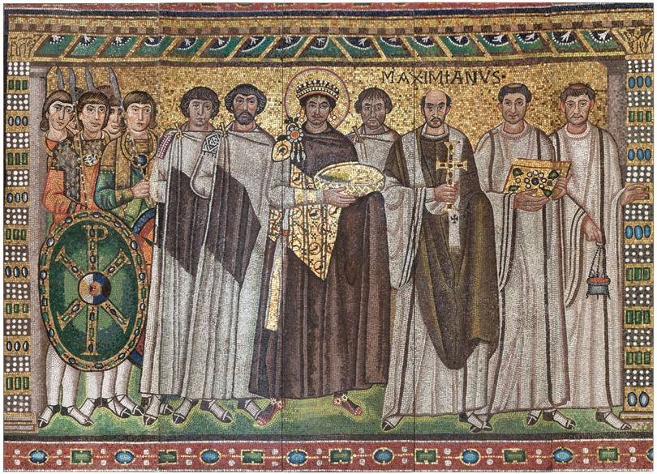 |  |  |  |  |  | 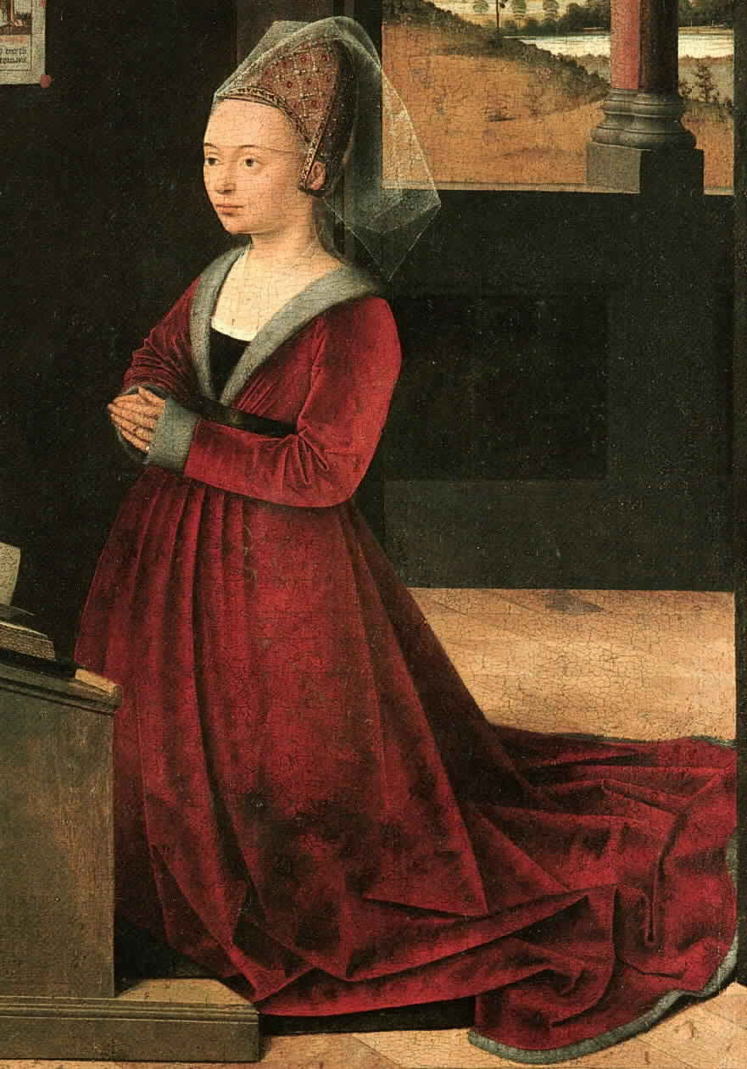 |  | 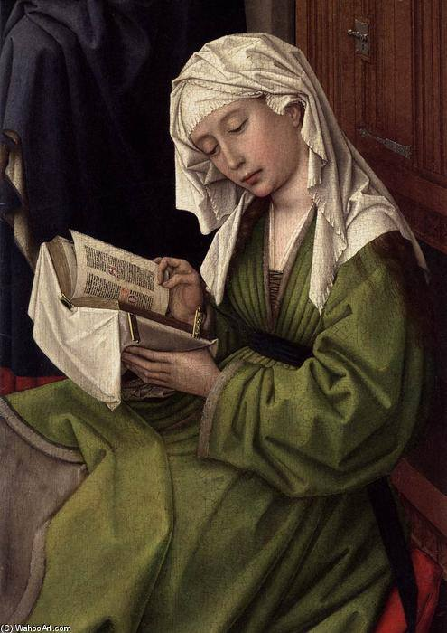
Garments and Accessories | Descriptions | Garments and Accessories | Descriptions | Garments and Accessories | Descriptions | Garments and Accessories | Descriptions | Garments and Accessories | Descriptions
Tunic dalmatic | Silk/ linen/ wool garment, long sleeves, belted and bloused at waist, ankle- knee length. Could be several layers (top layer was shorter with wide sleeves)  Decorated with clavi or segmentae | Tunic | Linen/ wool garment, long sleeves, belt at waist, knee length. Sleeves and torso could be rucked/ long but gathered into seams. Decorations consisted of simple patterns along hem edges, opening, etc.  Could be several layers: under tunic (chainse)/ Tunic (bliaut)/ super tunic | Tunic | Linen garment, long tight sleeves, belted at waist, dress clings to belly, ankle length. The tunic may have buttons at the front, and fits closely | Houppelande | Long, full grown, wide open V neckline, with long sleeves, sometimes wide and dagged, fullness pleated into high belted waist | Houppelande | Long, full grown, wide open V neckline, with long sleeves, sometimes wide and dagged, fullness pleated into high belted waist
Mantle | Worn sideways | Mantle | Worn sideways, knotted or pinned with fibula |  |  | Henin | Truncated or towering cone | Tablet-woven | Silk with gold ends
Gold and silk woven tablion  Detail function: indicates status, only worn by officials, courtiers and nobility (different color indicates rank) | Decorative patch appliqued to left front of paludamentum. | Braises/ hosa | Fitted trousers worn under tunic, lower half covered with cross gartering (strips or bands of leather or fabric crossed over lower legs; detail function: protection) | Veil | Long and covers all the hair | Veil | Fine linen or silk rectangle or oval | Hair | Braided under linen veil with frilled selvedges
Hair | Short and simple. Clean- shaven | Footwear | Fine, supply leather boots | Hair | Worn up | Cosmentics | Plucked hairline, eyebrows, eyelashes | Veil | Fine linen or silk rectangle or oval, edged with embroidery
Headdress | Crown inlaid with jewels |  |  | Spinning yarn with a distaff and spindle | Raw wool on distaff
4Shoes | Embroidered and encrusted with pearls
Accessories:  - Praipendula  - Large fibula | Jewels hanging around face  Detail function: holds mantle in place

Middle Ages Gothic Fashion | Modern Fashion Show
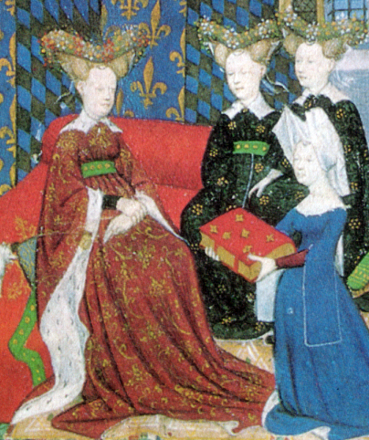 | 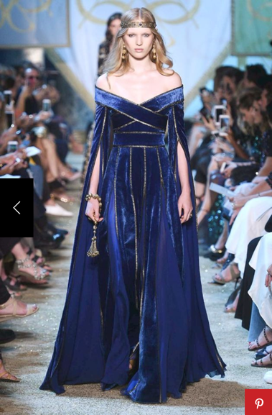
Dress: Houppelande with ground- length trails
scooped neckline
Sleeves evolved from earlier small tippets

Sources:
- Byzantium
https://www.metmuseum.org/art/collection/search/466586
- Great Migrations
http://www.hubert-herald.nl/FranPortraits.htm
- Romanesque
https://vianostra.at/scriptorium/handarbeiten/historisches-spinnen.htm
- Gothic
https://i.pinimg.com/736x/41/43/39/414339c23d7a561a7b73d0146cf8a4d6.jpg
- Burgundian
https://www.nationalgallery.org.uk/paintings/rogier-van-der-weyden-the-magdalen-reading
- Modern Fashion Show
https://www.elle.com/es/moda/pasarelas-alta-costura-otono-invierno-2017-2018/g794526/elie-saab-paris-794526/?slide=4
- Middle Ages Gothic Fashion
https://bellatory.com/fashion-industry/FashionHistoryoftheHIghandLateMiddleAgesClothingo-the11th-15thCentury
- Information: Smithsonian, Fashion The Definitive Of Costume And Style, First American Edition, 345 Hudson Street, DK publishing, October 1st 2012.

