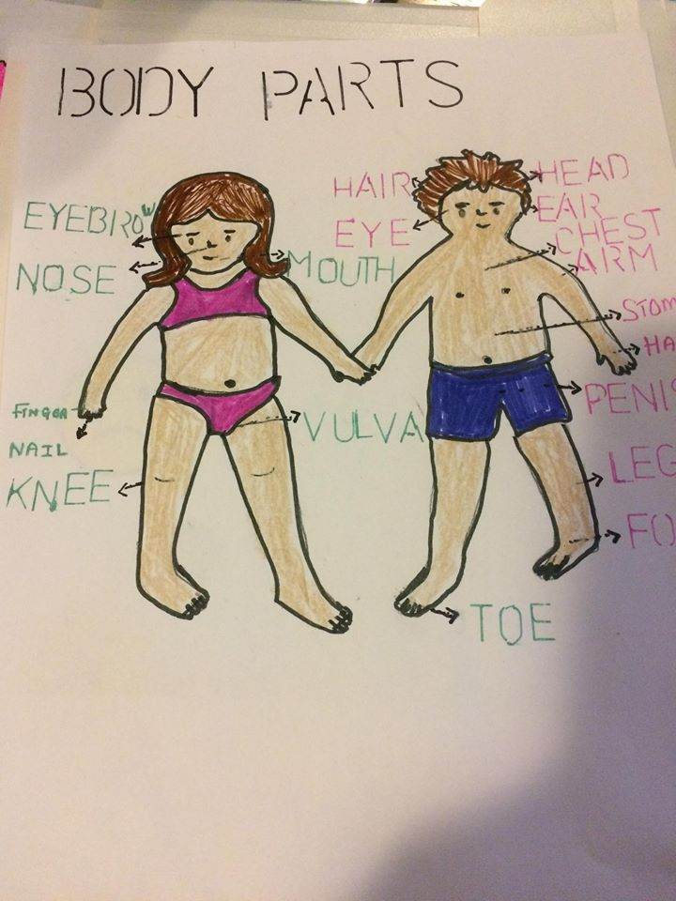

Guide for the children:

* The body parts.
* Smiley.
* Clothes to wear
* Different persons.
* Things to do and not to do.
* Not to follow a stranger.
* Not to kiss on the lips.
* Not to let someone take a picture of yours.
* Not to let someone touch your private parts.
* Wear appropriate clothes.
* Hug mum.
* Mother can wash and apply cream.
* Play together without touching.

Activity with the children

“LE ROI DAGOBERT”



Guide for parents:

* Protect your child.
* Importance.
* Facts.
* Statistics.
* Appropriate behavior of a child.
* What should parents do to protect their children.
* Definition of sexual and physical abuse.
* Consequences.
* When should the parent feel concern.
* What should the parents do in case of concerns.
* DYP report.
* Communication skill, books.

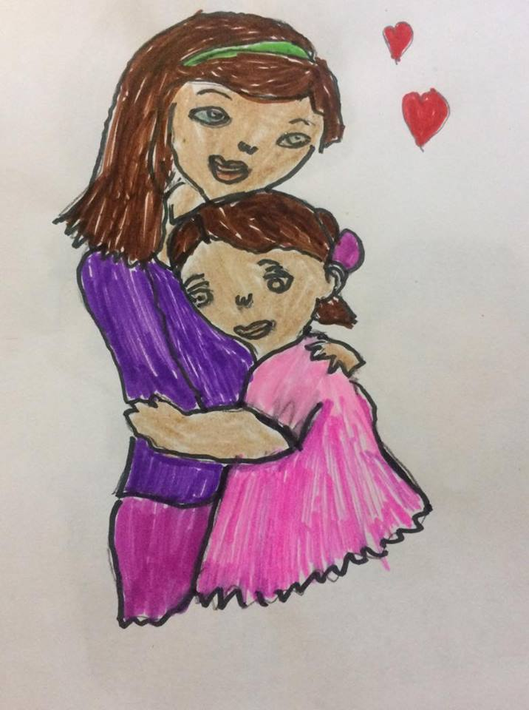

“RESPECT”

TO BE ASSERTIVE

“NO is NO”

Protect our children

Prepared by Ranee Nundoo

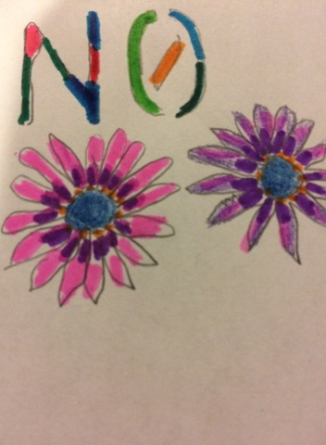

# http://www.ugdsb.on.ca/uploadedImages/program/kindergarten/elp_kids.gif

GUIDE FOR HOME FAMILY DAY CARE PROVIDERS

Guide:

* Codes of ethics
* Importance of saying “no”
* Facts.
* Statistics
* The laws and regulations.

The appropriate behaviors of a child:

* To respect others.
* To be assertive and be able to say no.
* Using of words and no aggression.
* Love is body
* Not to keep secrets.

The home family day care providers should do to help and protect the children:

* To provide a safe and caring environment.
* To use effective communication skills.
* Explain the children the importance of being assertive and how to say “no” to others.
* Show the children the rules of privacy.
* Observe the children and plan activities.
* Be a model. Not to take picture. Educational program.
* Knowledge about developmental phase
* Answer questions.
* Read book

What is sexual abuse and physical abuse

Consequences:

* Major emotional and physical health problems.
* Stress, change in mood and behaviors, fear, depression, aggressive.

When the home family day care providers should feel concern:

* Child talks about sex.
* Changes in child behavior.
* Injuries and bruises.

What to do in case of concerns:

* To use effective communication skills. Ask open ended questions.
* To stay calm and support.
* Do not lie and to file a report.

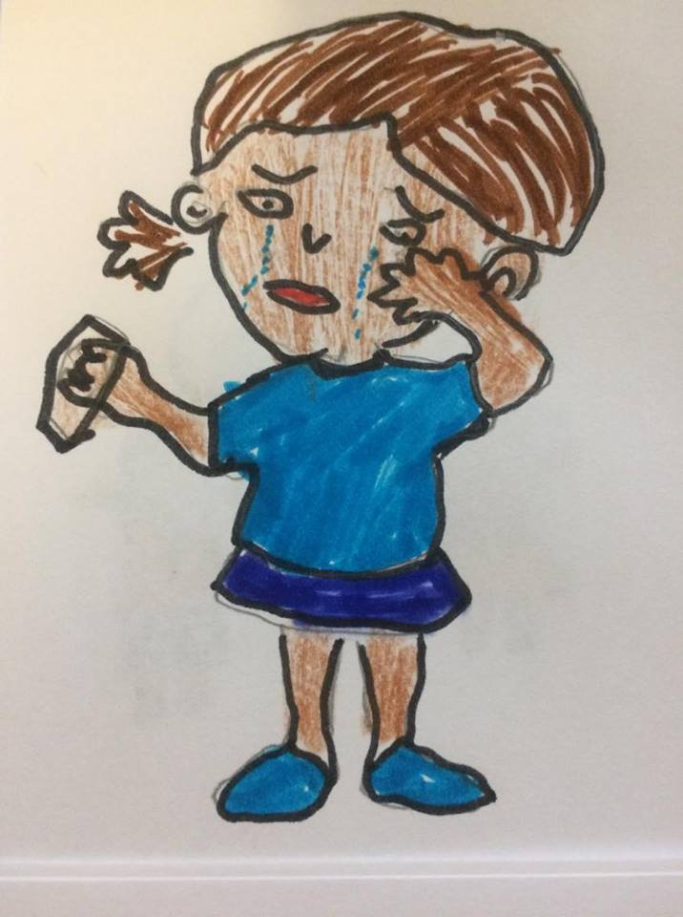

THE DYP REPORT

End or prevent a situation.

Analyze the situation and decide if retain or not.

(when, After filing report)

Information required for filing a report.

Others: Communication, educational program, observation, planning, activities, books to read.

Importance of respect and to be assertive: “NO” is “NO”

* To prevent a child from being a future victim.
* To be happy.
* Form a secure attachment. Free to talk, comfortable.
* Build on their confidence and self-esteem.
* Build on social and emotional skills.
* Express themselves in a better way. Speak up.
* Positive relationship with others. Sexually safe, community safe.

Facts: Children not aware of dangers.

* Lack of knowledge.
* Incapable of protecting themselves.

STATISTICS:

* 1 in 5 girls, 1 in 10 boys having sexually abused before the age of 18.

Personal Experience

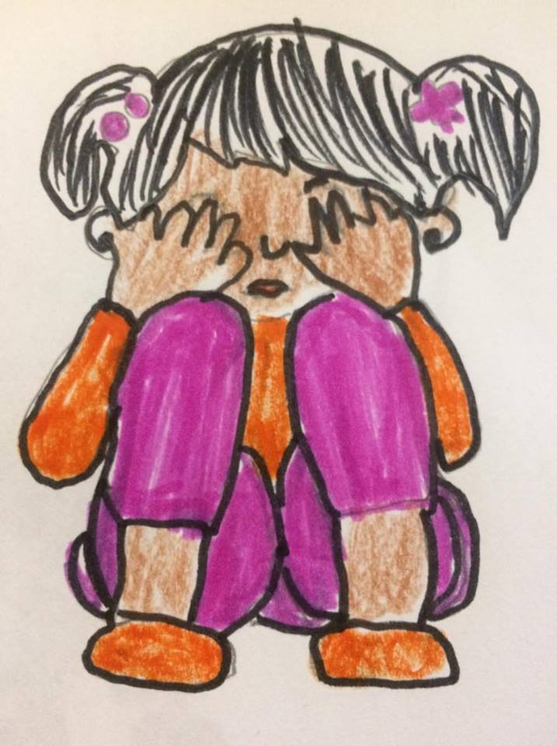

#### To establish and affective relationship with children:

#### According to Bowlby:Plays a critical role in the later developmental and mental functioning of a child.

.