

Project Charter©
For [Project Na
Table of Contents

1 Executive Summary 2
1.1 Business History 2
1.2 Mission Statement 2
1.3 Goals and Subjective 2
1.4 Purpose of the Business Plan 2
1.5 Short and Medium-Term Sales Goals 2
1.6 Location and Facilities 2
2 Human Resources, Team, Staff, Organization & Directors 3
2.1 Ownership 3
2.2 Management 4
2.3 Experience and Expertise 5
2.4 Staffing- Human Resources 5
2.5 Strategic Alliances 5
3 Operations, Products and Services 5
3.1 Description of Product and Services 5
3.2 Key Features 6
3.3 Comparative Advantage 6
3.4 Production of Goods and Services 6
3.5 Adaptation and Redesigning 6
3.6 Future Products and Services 7
4 Marketing, Market Overview 7
4.1 Market Search. 7
4.2 Target Market Segment. 8
4.3 Size of Target Market. 8
4.4 Purchasing and buying habits of customers. 8
4.5 Market Share Held by Imports. 9
4.6 Economic Environment 9
4.7 Taxes and Tariffs 9
4.8 Industry trends and other market factors. 9
5 Marketing, Newcomer Entry Strategy 10
5.1 Description of Your Competitors 10
5.2 Analysis of Competitive Position 10
5.3 Pricing Strategy 11
5.4 Distribution of Intermediaries 11
5.5 Description of Intermediaries & Partners 11
5.6 Promotion Strategy / Develop Sales 12
6 Purchasing, Suppliers, Regulatory and Logistics Issues 12
6.1 Main suppliers 12
6.2 Terms of purchase from suppliers and terms of selling to customers 12
6.3 Regulatory issues, trade documentation 12
6.4 Incoming transport & cargo insurance 13
6.5 Outgoing transport - service providers 13
6.6 Intellectual property protection 13
7 Risk Factors 14
7.1 Market, Marketing and General Business Risks (Text & Table) 14
8 Implementation Plan 14
8.1 Key Activities and Tasks to Be Done 14
8.2 Time Lines of Activities & Execution 15
8.3 Benchmark Evaluation Criteria 15
9 Resources 15
9.1 Knowledge Sources & Resources Used 15
10 Financial Plan-First Year Monthly & Summaries for Additional 2 Years 16
10.1 Opening Balance Sheet 16
10.2 Other Sources of Funding 16
10.3 Revenue- Income from Operations 16
10.4 Cost of Sales 16

Executive Summary

Business History
Idvertising, is an integrated advertising company and we produce smart technical boards imbedded with a touch-monitor screen that provides easy and expandable advertising solutions. The company, promotes products, services or an event on the smart technical boards for a reasonable fee and thereby imprint their brand image on the user while creating an everlasting presence in the subconscious minds.

Mission Statement
Our mission statement is to facilitate advertising, information gathering and wed searching through proprietary programs on display screen.

Goals and Subjective
The machine is compatible with Android systems, which allows customers to be able to access information from different platforms. Our objective is to thrive on benefiting citizens of the world at any time, any place.

Purpose of the Business Plan
We create the business plan to guide our company as a road map in a cohesive vision. It helps our company to ensure the operational and financial objects are on the right track, such as budgeting and market planning. In addition, the process of writing a business plan can help to smoothen the startup period and prevent some unforeseen problems. As a new company, we can improve our competitive power by analyzing the plan for marketing, sales, operations, finance. Moreover, the business plan demonstrates our company as a roadmap which leading us to success to a financial institution or other lenders to invest our company. It is to secure funding, such as bank loans.

Short and Medium-Term Sales Goals
- Short Term:
Start up with 10 machines and create 20 hotspot locations within Quebec by 1 year.
We will constantly grow our sales by 744,000$ by year 2.

- Medium Term:
Grow the sales of 15% by increasing the volume of contracting companies and contacting large companies for long term cooperation. Expand our business locations across Canada, especially in Toronto and Vancouver.

Location and Facilities
Today although radio, newspapers and flyers are still playing a dominant role for marketing and advertising in Canada, digital media has already penetrated the market and the allocation is expanding. During the country’s digital advertising rising stage, marketers are flipping over from traditional media to digital media. As a digital advertising company, we believe that Canada is a huge potential country, which can provide us big opportunity to expand our products and services.
More specifically, we plan to locate our business in Montreal as the startup stage and we will steady expand all over Canada even heading to the world.

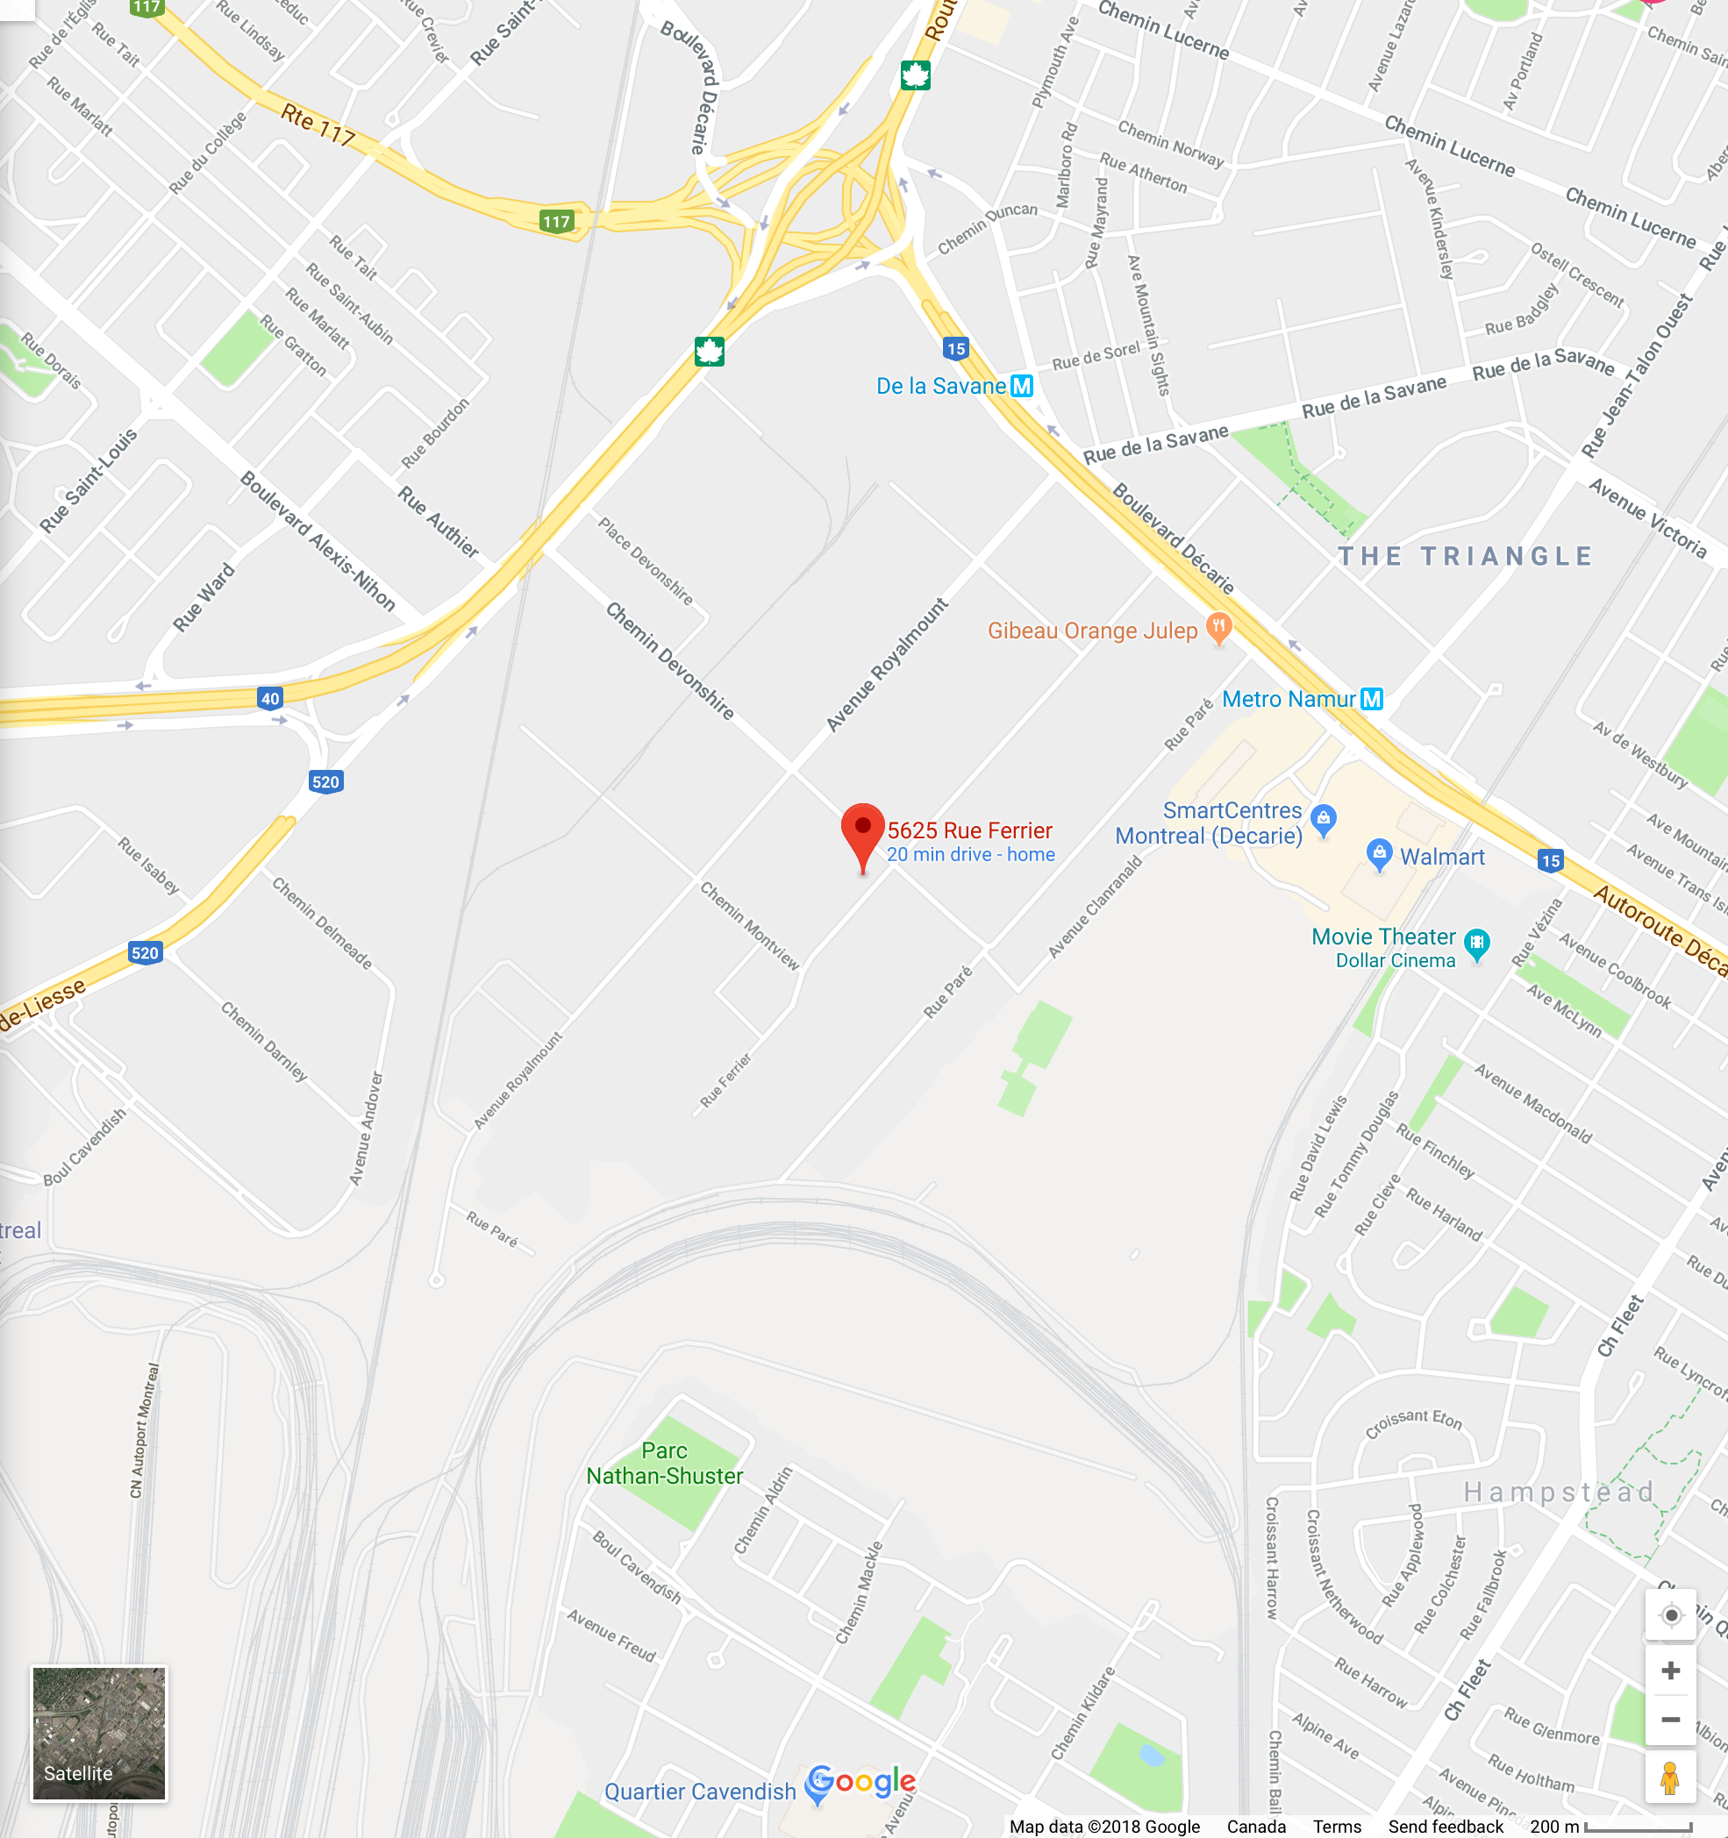

Company Location: 5625 rue Ferrier Mont-royal, Montreal, QC H4P 1N1

Human Resources, Team, Staff, Organization & Directors

2.1 Ownership
The shares of the company are equally divided by each member shown as follows:
  - Gregory Dohan………………………………………20%
  - San Shan Liu………………………………………...20%
  - Byeonghoon Lee………………………………….....20%
  - Mei Jiao……………………………………………….20%
  - Rong Wang…………………………………………...20%

Management

Department in Charge | Name | Job Description | Partnership Percentage
Marketing & Advertising | Gregory Dohan | -Analyse competitors and market trends  -Help to increase market share and contribute to company growth  -In charge of after sale activities  -Determine and satisfy of our customer needs  -Build strong customer relationship | 20%
Finance | San Shan Liu | -Manage balance of payment  -Work on capital management  -Arrange new sources of financing under the company’s debt facilities  -Provide and interpret financial information  -Determine the amount of funds to be invested | 20%
Purchasing | Byeonghoon Lee | -Establish and choose subcontractors that can supply machine parts of good quality  -Order preparation  -Follow up with suppliers  -Inspection of goods we received from China  -Dealing with invoicing and payment | 20%
Operations | Mei Jiao | -Plan and schedule for assembling the digital board  -Design the production work and establish work standards  -Purchase the production tools and equipment  -Take care of issues relating to the operation problems  -Production equipment tools maintenance and repairs | 20%
HR | Rong Wang | -Look for the right employees  -Design for the job training  -Employee training and performance evaluation  -Plan for staffing needs  -Promote a work environment that supports a good quality of work life | 20%

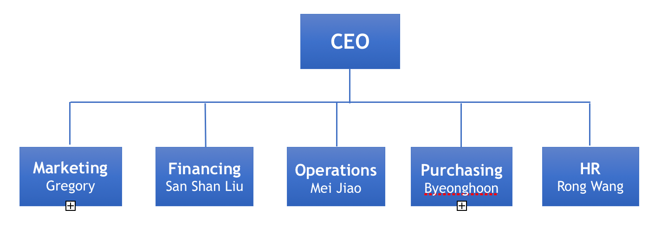
Experience and Expertise
We are students who were born in different countries and growing up in different cultures, therefore, we are able to contribute to the company in our own ways.

Staffing- Human Resources
During the first year of the business, all the employees will be paid minimum wage according to the labor law. All members will work together to smooth over the company’s startup period. The working schedule is as follows :
Name | Working Days | Total Hours per week
Gregory | Monday-Friday 9:00-15:00 | 30
San Shan Liu | Monday-Friday 9:00-15:00 | 30
Mei Jiao | Monday-Friday 9:00-15:00 | 30
Byeonghoon | Monday-Friday 9:00-15:00 | 30
Rong Wang | Monday-Friday 9:00-15:00 | 30

Strategic Alliances
There is a manufacturing company called Ou Shen electronics Inc.” which is located in Qingdao, China. Ou Shen electronics is our main suppliers for the parts of our technical boards. We are still looking forward to build more alliances as the company grows.

Operations, Products and Services

Description of Product and Services
Idvertising is an integrated advertising company that thrives on benefiting citizens of the world at any time, at any place. We are the leading manufacturer, distributor and supplier of touch screens and expandable advertising solution. Users can surf the web on our smart display or consult information from an index board. Companies promote products, services or an event on the smart display for a reasonable fee and thereby imprint their brand image on the user while creating an everlasting presence in the subconscious minds. The touch screen market is huge and is growing day by day. As companies discover the variety of uses offered by touchscreens, we find ourselves merging customer ideas with our technology to create amazing solutions.

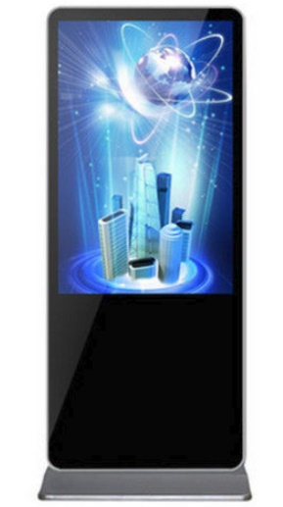
Key Features
Shock and Dust proof
Android/ Windows system
Touch Screen
High Resolution
Build-in Speaker
Background Stage
Automatic playlist
Easy operation

Comparative Advantage
Our product is approved by UL certificate and ISO 9001 Quality Management System. Our product and services provide the better solution for the advertising industry. We are also the first company who provide touch-screen advertising machine in Quebec.
Although we have many competitors in the advertising industry, our company offers the lowest price and highest technology in the industry compared to the market. We believe that low prices and high quality are our strategies for entering this market.

Production of Goods and Services
- About production of goods

We produce our own products. From the imported parts to the assembly of the machines, it is all done by us. We purchase motherboards, LG commercial touchscreen, aluminium shells, components, PCB board, and microchip from China. We assemble the machines in our local warehouse.
- About Service
We also provide advertising services. Through our high-tech products, we help customers experience new advertising options.

Adaptation and Redesigning
The development of technology and the upgrading of products happen fast, so we have to update our systems, and update the latest processors. Our advertising machine use an Android system. Along with the Android system upgrade, we also need to update the processor in time to increase the speed of operating.

Future Products and Services
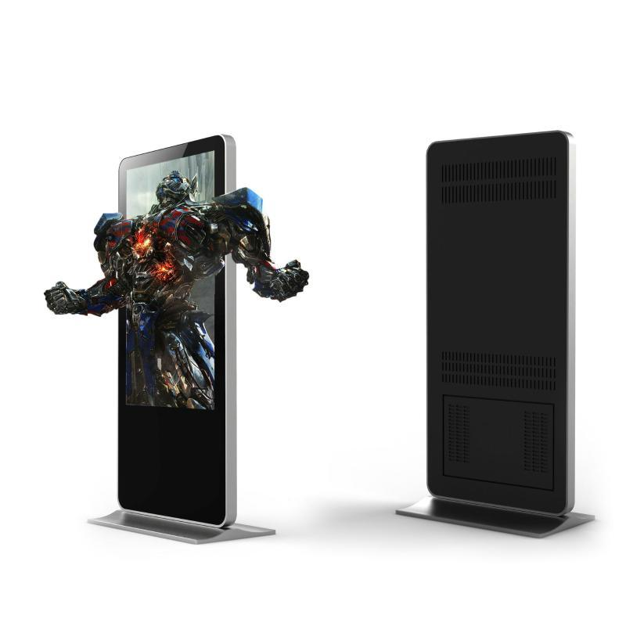
We are now developing new products, such as 3D glassless for our advertising machine. The real world seen by the human eye is 3D, and the screen presents us with only 2D. In other words, we now need to wear 3D glasses for 3D movies and TV. We are developing a new advertising machine which will directly show in 3D. The effect of advertising looks 3D, but you don't need to wear glasses.

Marketing, Market Overview

Market Search.
Primary and Secondary Market Search.
Our technical boards allow companies to advertise their services or products to a mass population of different individuals. From teenagers, adults, parents with household income, students, young couples, elderly shoppers and office goers. The companies being advertised appeal to a wide range of consumers.
- Gen Z, or Centennials: Born 1996 and later.
- Millennials or Gen Y: Born 1977 to 1995.
- Generation X: Born 1965 to 1976.
- Baby Boomers: Born 1946 to 1964.
- Traditionalists or Silent Generation: Born 1945 and before.
Primary Market Search: Based on a survey that we completed, asking over 200 people from all different generations, although anyone can use our machines, or walk by and view the advertisements, the real target market interested in our machines were: Generation Z, Millennials, Generation X and a few Baby Boomers. The main and strongest results came from Generation X, with Millennials trailing not far behind.
Secondary Market Search: An interesting study produced by MarketCharts.com with data collected by the company Neilson, showed that the highest smartphone, tablet, PC and TV connected device users per weekly reach (% of population) and per weekly household (usage), were individuals belonging to Generation X!
This came as a surprise, because we would tend to think that Millennials and people from Generation Y, would be a lot more tech savvy.
https://www.marketingcharts.com/demographics-and-audiences-77668

Target Market Segment.
As of now, our company is targeting Montreal and the greater Montreal areas such as:
- Ville LaSalle
- Ville Saint-Laurent
- Longueil
- Brossard
- Laval
- West-Island
- Vaudreuil
Our goal is to have our machines placed in malls, schools, hospitals, corporate airports to attract the most potential viewers and users as possible.
The type of people we are targeting are individuals looking to access information about the establishment they are in, use our machines to navigate online or for any other reasons.
Since they are placed in public places, anyone can honestly be a potential user, so there is no real age we can associate to our machines. However, advertisers can attract a specific age group or customer base because of the different products or services they provide which may be more appealing for some than others.

Size of Target Market.
The typical malls such as Alexis-Nihon, (10,000-40,000) and the Centre-Eaton, (20,000-60,000) foot traffic per day. Factors to take in consideration are week days, which are usually a lot busier than weekends.

Anyone of those individuals can use our machines, so to put a practical number on the number of potential users varies. The numbers of people who view the advertisements on our machines vary from a wide range as well.

When it comes to a School like LaSalle College, around 5000 students attend the College, not including the staff and the people coming into visit the school, the advertisements can be viewed by anyone. The users of our machines however, will most likely be students, or individuals visiting the school.

Purchasing and buying habits of customers.
Our customers, companies looking to advertise, buy directly from us.
They contact our Sales and Marketing director, (Gregory Dohan), and arrange for a meeting with him.
The contracts agreed upon can be Seasonal, Monthly or Yearly.

Market Share Held by Imports.
Similar products being sold or imported are limited in Canada as of now.
Companies like Cineplex and McDonald's have similar but different technical boards.
The machines cost them respectively around 3000$ and up.
They pay the same tariffs and fees as us, since their machines also come from China.

Economic Environment
The economic environment in Canada is beneficial for our company and its growth. Just this year, according to an article published on bdc.ca, it mentions that Canada has a growth of 2.2 percent in 2018.
This is very good news for the future of our company, as we expand, more jobs can and will be created to assemble our machines here in Canada. Meaning our company growth will expand and more machines will be able to advertise, and our company can make more money.
https://www.bdc.ca/en/blog/pages/2018-economic-outlook-global-growth-brings-good-news-canadian-entrepreneurs.aspx

Taxes and Tariffs
It terms of zoning, since we bring our machines in for free into the establishments, and make our money on advertisement, we do not have to pay a tariff for our machines, and neither does the building the machines are in.
However, a tax of 2% is imposed on the price of airtime for the companies wanting to advertise on our machines. The amounts collected must be sent to the Minister of Revenue, within 30 days of the broadcast of the advertisement.
http://legisquebec.gouv.qc.ca/en/showDoc/cs/T-2?&digest=

Industry trends and other market factors.
The advertisement industry is an industry with endless opportunities and expansions.
The product we have created is a one of kind gem when it comes to what it can do.
Malls, Clinics, Corporate offices and many other establishments, will no longer need a receptionist or a customer service representative physically on hand, because our machines will be there to assist customers or individuals with all their informational needs.
As we look around now, a lot of advertisements are no longer on billboards, but on digital screens, seen on some taxis, trucks, inside malls on TV screens and on tablets.
Our product will deliver the highest definition of LED screens so our advertisers can feel good knowing they have a crisp and sharp definition.
Since touch screens are on the rise now and will keep getting more popular, are product will age perfectly age with the times and will still be relevant as time goes by.

Marketing, Newcomer Entry Strategy

Description of Your Competitors
As an advertisement company, the list of our competitors is far and wide.
When we take a look at major competitors in Montreal, we notice companies such as:
- Publicis Montreal
- Rank Media Agency
- Sid Lee
- Neo-Traffic

The company Neo-Traffic is currently our biggest competitor in terms of product and location.
They use video walls, banners, posters and digital displays for companies to advertise.
Their products can be seen in malls across Canada, in provinces such as:
- Ontario
- Quebec
- Manitoba
- British Columbia
- Alberta
- Saskatchewan
- Maritimes

They are currently located in Alexis-Nihon mall, and have 7 digital display screens across the mall.
The advantage our company has over theirs, is that are smart technical boards are multifunctional and touch screen, unlike their products, who can only display but cannot be used for other purposes such as web searching or information gathering.
http://neo-traffic.com/#index

Analysis of Competitive Position
Our company is new, so to know exactly where we stand vs are competitors is an estimation. Here is a list of two of our competitors, in the Montreal area right now, that use similar products for companies to advertise on.

Company | Products | Price | Quality | Service | Reliability | Location | Market growth
Idvertising | Smart technical boards | 0.5$ for every second per advertiser | Latest technology has to offer | Advertising for companies, informational platforms, wed searching | 90% | Montreal and its surrounding areas | N/A
Neo-Traffic | Video walls and digital displays | 190$ per machine every week | Latest technology has to offer | Advertising for companies | 90% | All over Canada | Planning on expanding to other products
Cineplex | Digital displays | 210$ per digital display a week | Latest technology has to offer | Advertising for companies | 90% | All over Canada | 5.5 million dollar fourth-quarter growth in 2018
http://business.financialpost.com/pmn/business-pmn/concession-stand-demand-helps-boost-fourth-quarter-profit-at-cineplex-inc

Pricing Strategy
Here is a display of how much our company charges advertisers.

Prices for customers:

Package | Prices/sec | Duration/ads | Duration/day | Number of machine | Total Amount/ month
Package A | $0.5/sec | 20sec/ ads | 12 hours | 2 | $600
Package B | $0.5/sec | 20sec/ ads | 12 hours | 4 | $1200
Package C | $0.5/sec | 20sec/ ads | 12 hours | 6 | $1800
Package D | $0.5/sec | 20sec/ ads | 12 hours | 8 | $2400
Package E | $0.5/sec | 20sec/ ads | 12 hours | 10 | $3000

Income for our company:

Number of clients | Prices/sec | Duration/ads | Total income/ month
5 | $0.5/sec | 20sec/ ads | $1500
10 | $0.5/sec | 20sec/ ads | $3000
15 | $0.5/sec | 20sec/ ads | $4500

Customers who would like a special rate or require a specific rate, can negotiate with our sales director Gregory Dohan.

Distribution of Intermediaries
Our sales agents will contact the public establishment we wish to put our machines in.
If the establishment accepts, we put our machines in the establishment free of charge, and existing companies inside each establishment can advertise on our machines at our rates.
Exterior companies looking to advertise on our machines inside the public establishments, must first receive permission from the Owner, and once accepted, we will give a percentage of the exterior advertising revenue to the establishment. So every party involved is happy.

Description of Intermediaries & Partners

Right now, our company is beginning its first steps. We only have our sales director Gregory Dohan to handle the sales. Once we start making profit and see that our company can grow, we will look for sales agents.
.

Promotion Strategy / Develop Sales

Once individuals use our machines for wed searching or information gathering, or companies advertise on our machines, are brand awareness grows. Companies interested in advertising on our machines will be able to see our company name on the machines and visit our website to find out more information or to book an appointment with our sales director.

Purchasing, Suppliers, Regulatory and Logistics Issues

6.1 Main suppliers

The main supplier, OuShen.inc, provides parts for the smart technical boards. Ou Shen electronics Inc. is a huge company in Guangzhou, China to product many reliable digital parts as reasonable prices. They also have various models of each part. Therefore, we purchase parts from them.
The products, which our company buys, are as follow:
- Monitor
- Motherboard
- Graphic card
- Tempered glasses

Our company starts manufacturing three types of monitors (55”, 65” and 70” size smart electric board).

Terms of purchase from suppliers and terms of selling to customers

To deal with the method of payment between Ou Shen Inc. and Idvertising inc. Only L/C on sight is accepted when our company pays for the parts that we purchase.

Clients who need advertising service from Idvertising Inc. can pay through – debit/credit cards, e-transfer and PayPal or they can pay by cash directly to our employees. Our company can provide free trials for three months to our customers if they make one-year contract with us.

According to Quebec law, our customers need to pay 15% taxes.

Regulatory issues, trade documentation

There are no restrictions from the government to our business.

In terms of companies and public or private areas for installing our smart technical boards, there are no strict restrictions except duty and sales tax. The only restrictions are negotiable and the conditions will be contained in the contract between Idvertising and public or private establishments. The conditions can change and include renting an area for the smart electric board.

As for public or private buildings such as schools, hospitals, airports and malls, further negotiations will be needed with the city's respective mayor and communities (Establishment owners) before Idvertising Inc. can expand into these areas.

The tariffs that we need to pay for the products are as follow:

- Monitor: Hs code 8528.49.30 Tariff 3%, GPT 3%
- Motherboard: Hs Code 8542.31.00 Tariff free, GPT free
- Graphic card: Hs Code 8542.31.00 Tariff free, GPT free
- Tempered glasses: Hs Code 7011.10.00 Tariff free, GPT free

Incoming transport & cargo insurance

As we mentioned in 6.1, Idvertising Inc. imports monitors, motherboards, graphic cards, tempered glass from Ou Shen Inc.
The quantity of the parts ordered at first will be enough for 10 machines. Our first import quantities are small so that we choose air transportation to save cost and time. The quantity of the importing parts will change throughout the year. As more demand for more machines will grow.

Every importing part exceeding $10,000 will be covered by our cargo insurance. Cargo insurance will cover 100% of the insured invoice value, plus an additional 10%. The insurance protects our cargo against “all risk” of physical loss or damage from any external cause no matter what the percentage of loss, and with no deductible. Our total cost for the first order will be $30,000.

Outgoing transport - service providers

Even though Idvertising Inc. does not export the product internationally due to the limitation of our business, we will provide advertising through the smart technical boards to the clients worldwide when our business grows. For outgoing transport to provide our service, Idvertising Inc. delivers by rapid transit like trucks and install in the places of customers.

Intellectual property protection

N/A

Risk Factors

Market, Marketing and General Business Risks (Text & Table)

Risks Associated with Our Project

Consideration | Risk | Solution
Consumers/Customers | Do not use our product. | Give the customers or users a free tutorial in public places so more people can learn how to use it.
Competition | Other companies make better machines. | Counter the competition by making our product even better.
New Players | Similar product at a lower cost. | Increase the visibility and brand awareness of our product
Substitution | Flyers, billboards, posters, etc. | Highlighting the advantage of using a smart technical board and the benefits it creates.
Suppliers | Suppliers do not deliver on time. | Arrange a specific delivery deadline and time frame on a contract.
Government | Restrictions and laws. | Make adjustments to the products and update the software accordingly.

Implementation Plan

Key Activities and Tasks to Be Done

- Sources imported by China
- Assemble in Canada
- Marketing
- Production
- Deliver to our suppliers
- Installation of our machines

Time Lines of Activities & Execution
 | January | February | March | April | May | June
Sources
Assembling
Marketing
Production
Deliver
Installation

- To start our business, it is important to bring the sources from the main supplier. Then, our company assembles them together. On March, we start marketing first if there are customers who determine to purchase our advertisement renting and we start producing smart technical boards in April and May. We start delivering in May and also installing in May. In case of being behind schedule, June is also good for delivering and installing our machines.

Benchmark Evaluation Criteria

Our benchmark criteria are that our company provides advertising by giving customers our smart electric boards. We provide a high and improved product that will be relevant for years to come. Also, we are able to ensure the consistency of advertisement services to our customers. We have feasible plans and ideas to organize how our business is future-orientated.

Resources

Knowledge Sources & Resources Used

 UL Certification
https://www.ul.com/aboutul/?_ga=2.30304890.492466956.1521811212-44522146.1521811212

 International Organization for Standardization
https://www.iso.org/iso-9001-quality-management.html

 Canadian Consumer Product Safety Act
http://laws-lois.justice.gc.ca/eng/acts/C-1.68/

Business Industry Canada
https://www.canada.ca/en/services/business.html

 Advertising industry in Canada - Statistics & Facts
https://www.statista.com/topics/1837/advertising-in-canada/

Financial Plan-First Year Monthly & Summaries for Additional 2 Years

Opening Balance Sheet

Other Sources of Funding

Revenue- Income from Operations

Cost of Sales

