Works cited

Artwork by Hedi Xandt - http://hedixandt.com
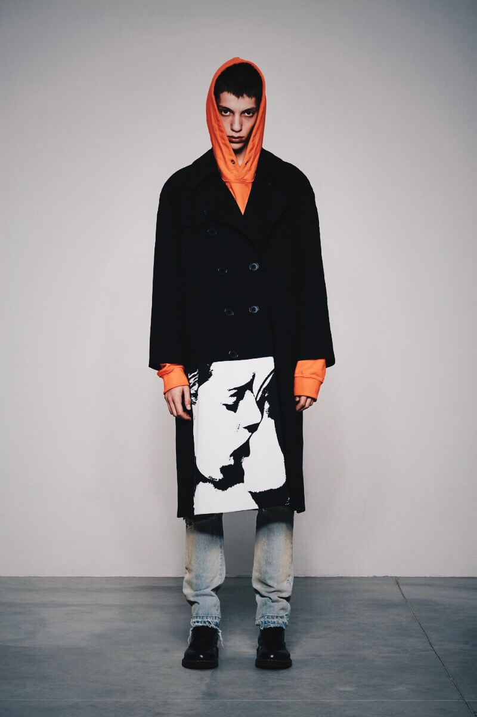
Misbhv clothing company - https://misbhv.com
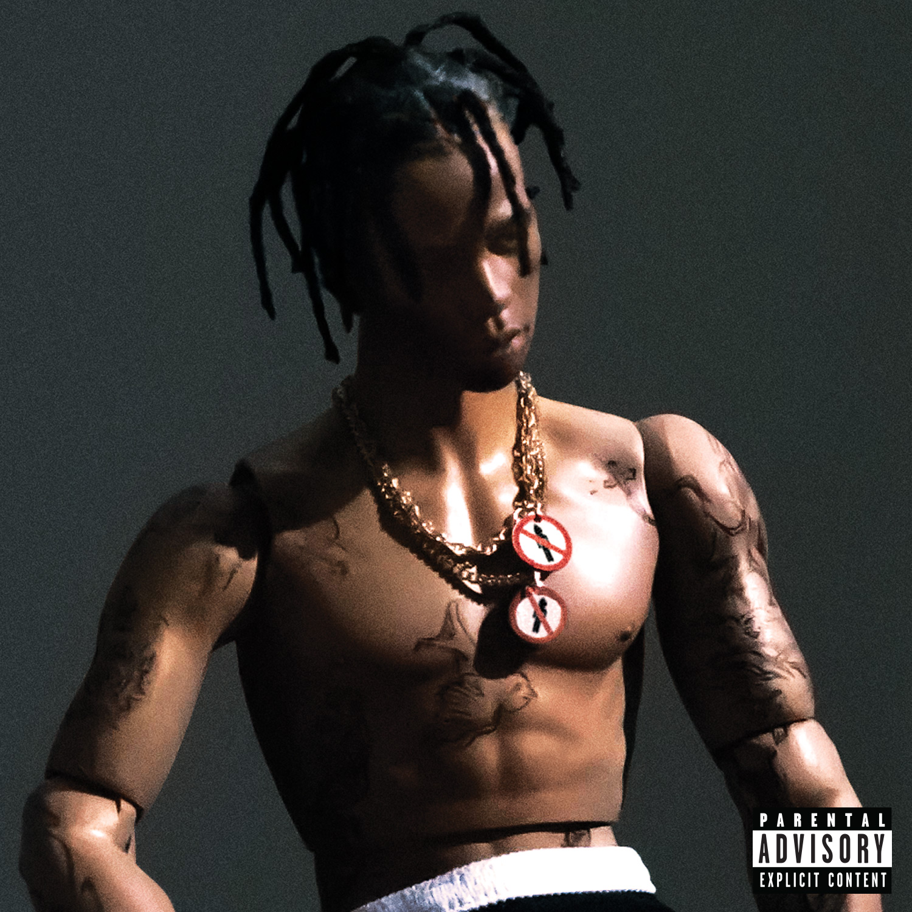
Music artist travis scott - https://i1.wp.com/allhiphop.com/wp-content/uploads/2015/09/travisscottrodeo-cover-1.jpg?fit=300%2C200&ssl=1
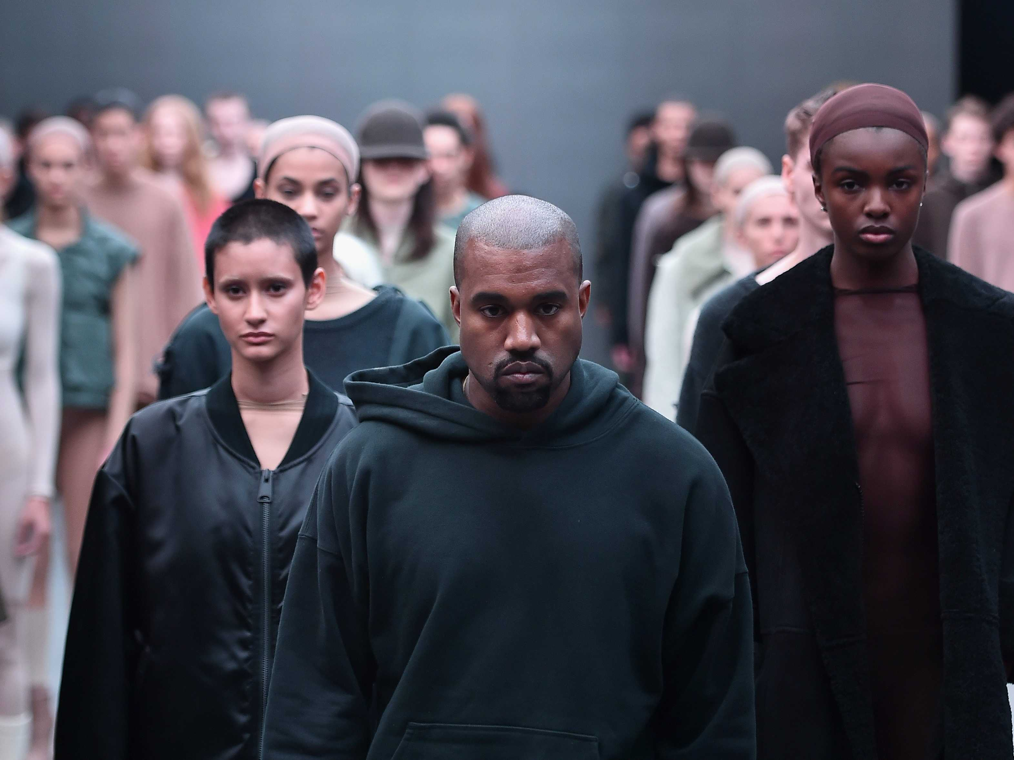
Music artist/ Designer Kanye west – hypebeast.com
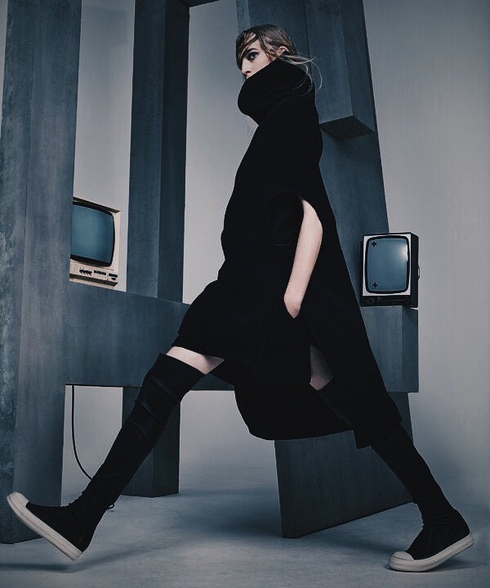
Rick owens designer - Pinterest
Balenciaga clothing brand – (N/A) saved on my phone from a while ago but cannot find link to original image
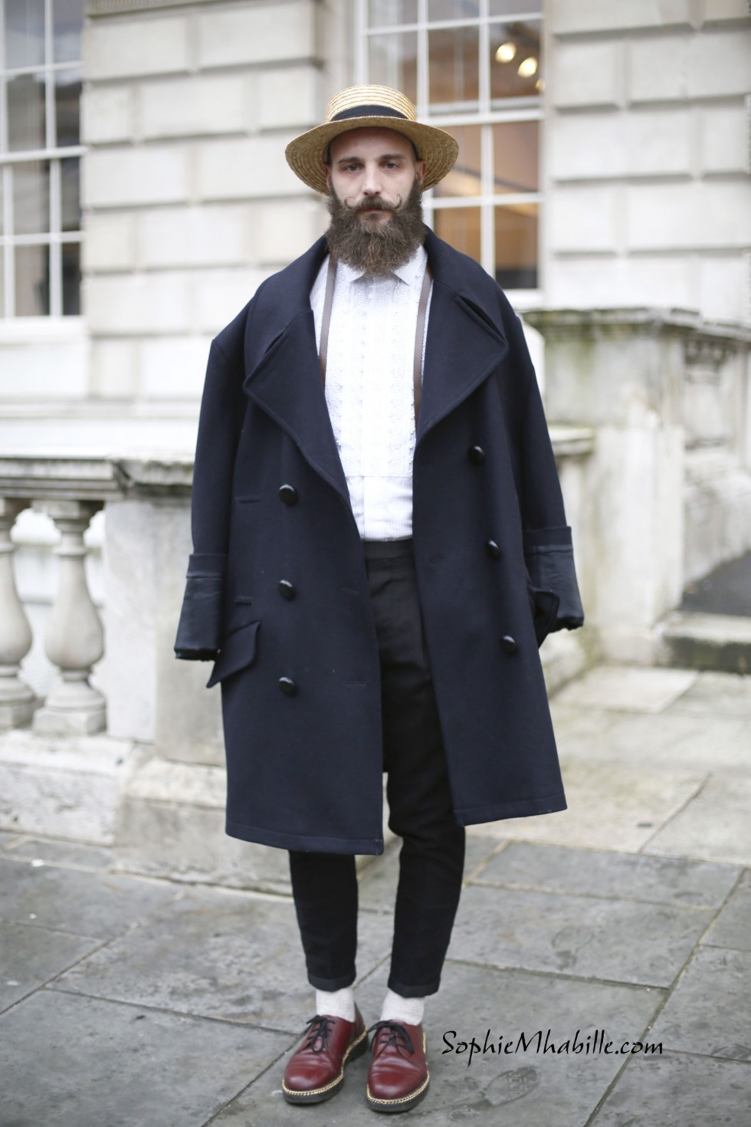
Paris fashion week shots – SophieMhabille.com
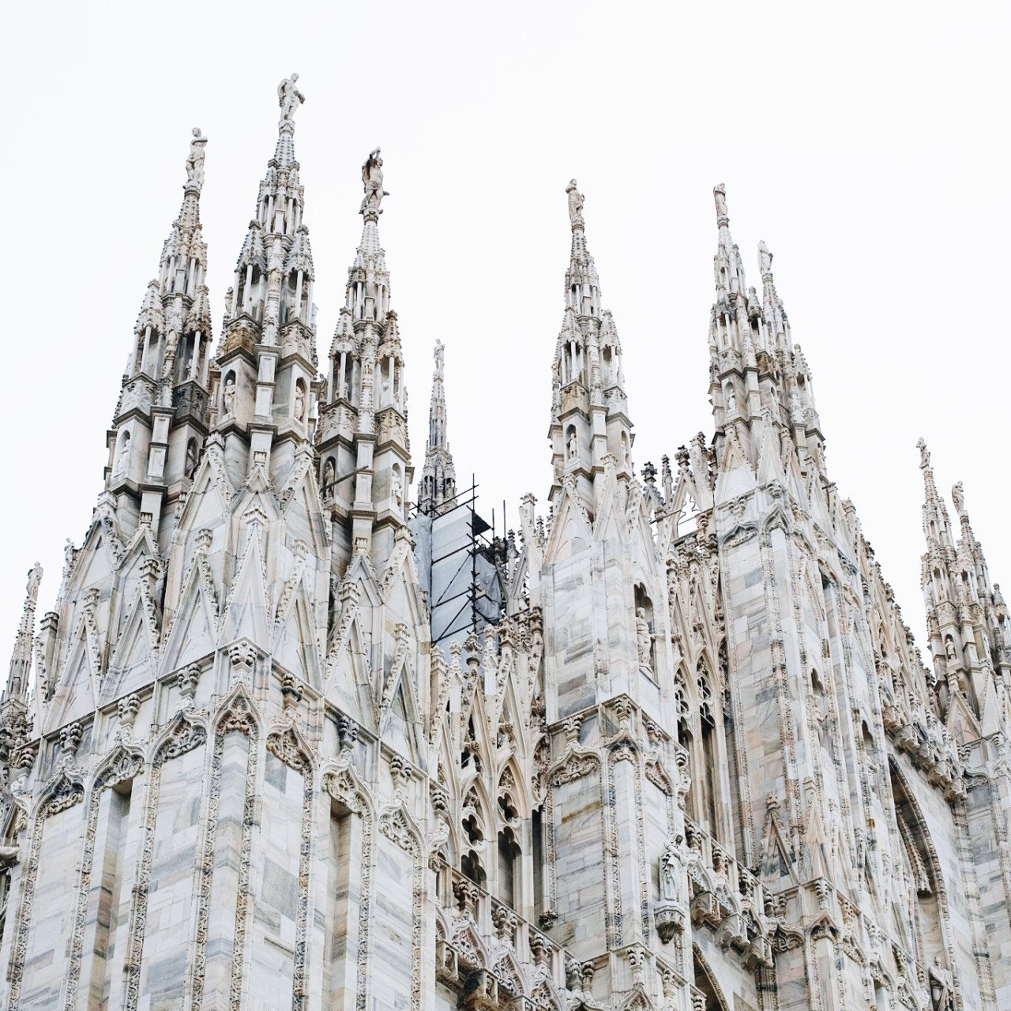Church architecture – tumblr.com/proximit-yy

