WORLD CUISINES
Portfolio Assignment

CUL247
sect. 10001
Instructor: Azriel Paz
Name: Ruobing Jia
Date: December 10, 2018

Week one 3
Today’s objective: 3
method of cooking: 3
Outcome and Chefs Critique: 4
Summary 5
Timeline: 5
Picture 8
Week three 9
Today’s objective: 9
method of cooking: 10
Outcome and Chefs Critique: 10
Summary 11
Timeline: 12
Picture： 14
Week four 15
Today’s objective: 15
method of cooking: 16
Outcome and Chefs Critique: 17
Summary 17
Timeline: 18
Picture 20
Week five 21
Today’s objective: 21
method of cooking: 22
Outcome and Chefs Critique: 23
Summary 23
Timeline: 24
Picture: 27
Week six 28
Today’s objective: 28
method of cooking: 28
Outcome and Chefs Critique: 29
Summary 30
Timeline: 31
Picture: 35
Week eight 36
Today’s objective: 36
method of cooking: 36
Outcome and Chefs Critique: 37
Summary 37
Timeline: 38
Picture: 42
Week nine 43
Today’s objective: 43
method of cooking: 43
Outcome and Chefs Critique: 44
Summary 45
Timeline: 46
Picture: 48
Week ten 49
Today’s objective: 49
method of cooking: 49
Outcome and Chefs Critique: 50
Summary 51
Timeline: 52
Picture: 54
Summary: 55

Week one

Today’s objective:
This week we learned how to make Spanish cuisine, the dishes we made are green olives filled with piquillo peppers and anchovy, queso idiazábal，tomato toast, squid with caramelized onions, black olive, anchovy, and caper spread, serrano ham fritters, bacalao hash, potato omelet, sizzling garlic shrimp

method of cooking:
green olives filled with piquillo peppers and anchovy: for this dish, we don’t need to use the hot cooking method, but the knife skill is very important since we have no time to make it, the chef Paz help us to make it.
queso idiazábal: for this dish, we don’t need to use the hot cooking method, but the knife skill is very important since we have no time to make it, the chef Paz help us to make it.
tomato toast: for this dish, we used the grill cooking method for the breaded
squid with caramelized onions: for this dish, stir-fry cooking method,
black olive, anchovy, and caper spread: for this dish, we don’t need to use hot cooking method, just mixed all ingredients together process to a medium-fine paste, since we have no time to make it, the chef Paz help us to make it.

serrano ham fritters: for this dish, we don’t need to use the hot cooking method, but the knife skill is very important since we have no time to make it, the chef Paz help us to make it.
bacalao hash: for this dish, we use stir-fry cooking method,
potato omelet: for this dish, we use the Shallow Frying cooking method,
sizzling garlic shrimp: for this dish, we use stir-fry cooking method,

Outcome and Chefs Critique:
For the tomato toast, the temperature of the oven was not high enough, so the surface color of bread is white, and the bread is too hard, before the service, we didn’t move the seeds from bread. For squid with caramelized onions, the flavor is okay but too much liquid. bacalao hash the taste is okay, but we cut ingredients too small. for potato omelet is good. For sizzling garlic shrimp, the taste is okay but we overcooked, the shrimp is too dry and hard to eat.

Summary
This week we learned how to cook spinach cuisine and the differences and similarities in the regional cuisines of Spain and Portugal. Usually, Spain uses braising, frying and grilling cooking method very often. Olive oil is popular in Spain.
In today’s class, because I didn’t have a timeline, my cooking is a mess. So next time I will bring handwritten recipe and timeline. During the cooking, I learned if the oven temperature not high enough, the color of my bread will not change, and it will be very hard.

Timeline:

Green Olives Filled with Piquillo Peppers and Anchovy

7:00 prepare all ingredients
7:30 Using the flat side of a chef knife, press each olive until the pit pops out; do not split the olive in half.
7:45 Place one slice anchovy and pepper in each olive
8:00 Combine garlic, olive oil, orange zest, and sherry vinegar to make a dressing.
8:15 Marinate stuffed olives in dressing for 30 minutes.

Queso Idiazábal
7:00 prepare all ingredients
7:30 Combine all ingredients and coat the cheese thoroughly.
7:45 Marinate at room temperature, for as long as overnight

Squid with Caramelized Onions

7:00 prepare all ingredients
9:00 Heat the olive oil over medium heat in a medium sauté pan.

9:10 Add garlic and cook 2 minutes or until brown; remove.
9:15 Combine garlic, olive oil, orange zest, and sherry vinegar to make a dressing.
9:25 Add onions and bay leaf; cook over medium-low heat until lightly brown, about 10 minutes.
9:45 Reduce heat to low and continue cooking until onions are soft and caramelized, about 20 minutes longer.
9:50 Remove onions from pan and set aside, leaving the oil in a pan.
10:10 Return heat to high and sprinkle pan with salt. Add squid, making sure not to overcrowd the pan; there must be ample space so the squid does not boil. Sauté 15 to 20 seconds on each side. Remove from pan and repeat the process with remaining squid.
10:15 Sprinkle with parsley and serve.

Garum
7:00 prepare all ingredients
7:30 Combine olives, anchovy, capers, garlic, egg yolk, rum, and mustard in a food processor or mortar; process to a medium-fine paste.
7:45 Gradually add olive oil
7:55 Let stand 1 hour at room temperature to allow flavors to develop
8:55 Serve with grilled bread or tomato toast.

Tomato Toast
7:00 prepare all ingredients
7:30 Toast or grill bread.
7:45 Rub the open face of the tomato into one side of each piece of toast until all the flesh is grated. Discard skin
8:15 Drizzle olive oil over tomato and season with salt
8:30 Serve with garum if desired, or a thin slice of jamón serrano

Picture
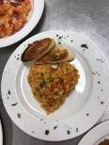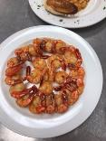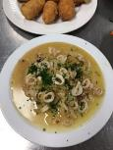
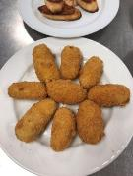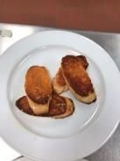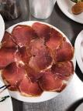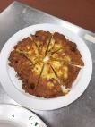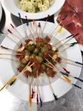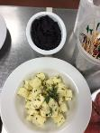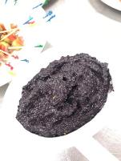

Week three

Today’s objective:
This week we learned how to make middle east cuisine, the dishes we made are Chickpea and Sesame Dip, Triangle Spinach Pies, Cracked Wheat and Herb Salad, Whole Wheat Flat Bread, Lamb and Okra Casserole, Rice with Lentils, Dried Fruit Compote, Arabic Coffee.

method of cooking:
Chickpea and Sesame Dip: for this dish, we don’t need to use the hot cooking method, just mixed ingredients in food processor using a metal blade
Triangle Spinach Pies: for this dish, we use baking method
Cracked Wheat and Herb Salad: for this dish, we don’t need to use the hot cooking method, just mix all ingredients together.
Whole Wheat Flat Bread: for this dish, we use baking method, since we have no time to make it, the chef Paz help us to make it.
Lamb and Okra Casserole: for this dish, we need to use simmer cooking method
Rice with Lentils: for this dish, we need to use braise method
Dried Fruit Compote: for this dish, we don’t need to use the hot cooking method, just mix all ingredients together, since we have no time to make it, the chef Paz help us to make it.

Outcome and Chefs Critique:
For the Chickpea and Sesame Dip, we did a good presentation and the taste was good. For Triangle Spinach Pies, the size and shape of pie was good, and the flavor was perfect. For Cracked Wheat and Herb Salad, the presentation was good but need more seasoning. For the Whole Wheat Flat Bread, since we have no time to make it, the chef Paz help us to make it. For the Lamb and Okra Casserole, the presentation and flavor were good but too much oil in the plate. For Rice with Lentils, the flavor was good but over mixed. For Dried Fruit Compote, since we have no time to make it, the chef Paz help us to make it.

Summary
This week we learned how to cook middle east cuisine which include Lebanon, Jordan, Iraq, Saudi Arabia, Syria, Iran, Greece, and turkey. At the end of this chapter i learned how to identify food ingredients and dishes frequently served in the middle eastern countries and how the spice route in the 1400s impacted the cuisine of the middle east. In middle east, there are a few cooking methods are very important which are braising, grilling, roasting and pickling
In today’s class, because I come to class late, so I have no time to prepare equipment, so my cooking is a mess. So next time I will come to school early and prepare for the class. During the cooking, I learned if I stir rice very often, the rice will be destroyed, I should gently to mix the rice and keep on the lower heat to keeping hot.

Timeline:

7:00 prepare all ingredients
7:30 start Chickpea and Sesame Dip
7:31 combine all ingredients of Chickpea and Sesame Dip
7:40 serve Chickpea and Sesame Dip
7:45 start Triangle Spinach Pies
7:50 combine ingredients ( Dough)
8:00 Knead for 10 to 15 minutes until the dough is soft and not sticky.
8:05 combine ingredients (Spinach Filling)
8:10 Bake in a 350°F (180°C) preheated oven 10 to 15 minutes or until
golden brown.
8:15 start Cracked Wheat and Herb Salad
8:20 Combine dry bulgur and green onions; squeeze mixture so bulgur
absorbs onion flavor.
8:25 Gently stir in tomato; cover and chill 1 hour or more
8:30 start Whole Wheat Flat Bread
8:40 Knead for 10 minutes. Dough will feel slightly sticky at first but will
become smooth as it is kneaded
8:45 Cover and rest for at least 2 hours
9:00 Cover and rest rounds 20 minutes.
9:10 When browned on the first side, turn and cook 1 minute or until
bread looks cooked
9:15 start Lamb and Okra Casserole
9:30 cook 2 to 3 minutes until transparent. Add cumin, tomatoes, tomato
paste, and cook 1 minute
9:50Prepare ta&#39;leya and pour while hot over bamia. Serve at the table
from the cooking dish
10:10 start Rice with Lentils
10:30 Add boiling water and salt; return to a boil, stirring occasionally.
Reduce heat to low, cover pan, and simmer gently 25 to 30 minutes.
10:50 start Arabic Coffee
11:00 Combine all ingredients and bring to boil.
11:20 serve
12:00 clean finish

Picture：
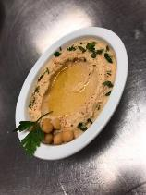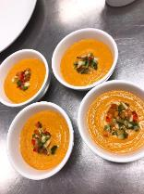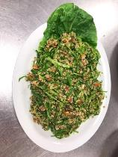

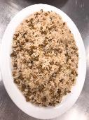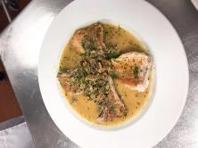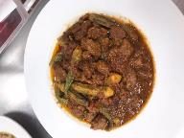

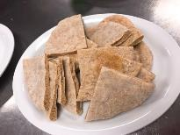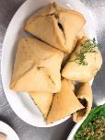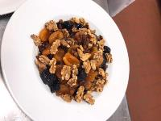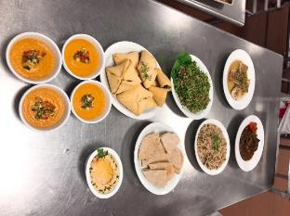

Week four

Today’s objective:
This week we learned how to make middle east cuisine, the dishes we made are Beet and Yogurt Salad, Dried Bean Croquettes, Taratour bi Tahini, Arabic Flat Bread, Eggplant Dip, Chicken with Rice, Lentil and Swiss Chard Soup, Fillo and Nut Pastries

method of cooking:
Beet and Yogurt Salad: for this dish, we use the roasting method for the beet,
Dried Bean Croquettes: for this dish, we use Boiling
method
Taratour bi Tahini: for this dish, we don’t need to use the hot cooking method, just mix all ingredients together.
Arabic Flat Bread: for this dish, we use the baking method, since we have no time to make it, the chef Paz help us to make it.
Eggplant Dip: for this dish, we need to use Deep Frying
cooking method
Chicken with Rice: for this dish, the rice use simmering method and the chicken use Stewing method
until and Swiss Chard Soup: for this dish, Stewing cooking method

Fillo and Nut Pastries: for this dish, we use the baking method.

Outcome and Chefs Critique:
For Beet and Yogurt Salad, our presentation is good, the color and taste is perfect. For the Dried Bean Croquettes, it is a uniform size, the flavor is good. For Arabic Flat Bread, since we have no time to do it, the chef help us to make it. for the Chicken with Rice, the chicken is too big, we need to cut into the small size and serve, for the Lentil and Swiss Chard Soup, all good. For Fillo and Nut Pastries, the chef didn't try it but he said looks good.

Summary
This week we learned how to cook middle east cuisine which includes Beet and Yogurt Salad, Dried Bean Croquettes, Taratour bi Tahini, Arabic Flat Bread, Eggplant Dip, Chicken with Rice, Lentil and Swiss Chard Soup, Fillo and Nut Pastries. In the class, we learned the cooking methods in the middle east which are Braising one pot, grilling, roasting, and pickling. We also learned the influence from the new world, the 1700s and 1800s, foods like peppers, tomatoes, string beans, pumpkins, sweet potatoes, and white potatoes from the New World were introduced to the Middle East by Europeans. These foods penetrated the Middle Eastern cuisine and still play a dominant role.
Compare with last class, this week we did a good job, In today’s class, we followed our timeline so we can finish dishes on time. Next time before going to class, we should watch the video online and prepare for class.

Timeline:
7:00 prepare all ingredients
7:30 start Beet and Yogurt Salad
7:31 combine all ingredients of Beet and Yogurt Salad
7:40 start Dried Bean Croquettes
7:45 combine ingredients
7:50 Deep-fry in two inches of oil at 375°F
8:00 Serve hot as an appetizer with tarator bi tahini
8:05 start Taratour bi Tahini
8:10 combine ingredients with a food processor.
8:13 Correct seasoning; flavor should be tart
8:15 start Arabic Flat Bread
8:20 make the dough
9:25 Rubstone with oil and then slide dough rounds a few at a time onto it. Bake for 4 to 5 minutes
8:30 start Eggplant Dip
8:40 Grill eggplant or roast in a hot oven, turning often; cook until soft
8:45 Blend in ¾ of the lemon juice and gradually add the tahini
9:00 Crush garlic to a paste with 1 teaspoon salt and add to eggplant. Beat well; adjust flavor with more lemon juice and salt.
9:10 Beat in olive oil and parsley. Do not puree the parsley.
9:15 start Chicken with Rice
9:30 seasoning chicken and add fruit and cook 5 minutes over low heat
9:50 place lid on tightly and cook over low heat (or in the oven) for 40 minutes or until chicken is tender. The cloth absorbs the steam and makes the rice fluffy and light
10:00 before serving, sprinkle saffron liquid over rice and stir in gently. Serve piled on a platter
10:10 start Lentil and Swiss Chard Soup
10:30 over lentils with the cold water; bring to boil, skimming if necessary, then cover and simmer gently for 1 hour or until soft.
10:50 Add onion mixture to cooked lentils, add remaining ingredients, and simmer gently, 15 to 20 minutes.
11:00 start Fillo and Nut Pastries.
11:20 Bake at 350°F (180°C) for 30 minutes; reduce to 300°F (150°C) and cook 15 minutes longer.
11:35 Spoon cool thick syrup over hot pastries
11:40 serve all dishes and do the cleaning

Picture
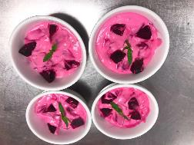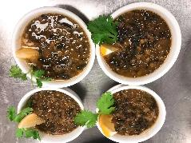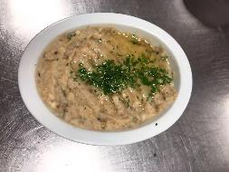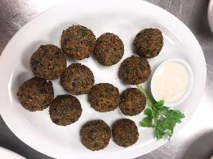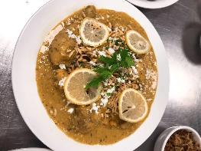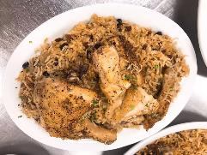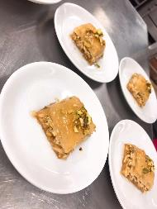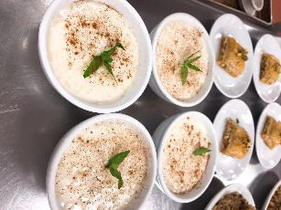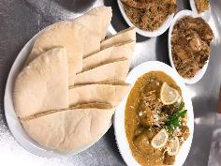

Week five

Today’s objective:
This week we learned how to make Greece cuisine, the dishes we made are Grape Vine leaves, Fried Cheese, Orange and Olive Salad, Fried Fish with Rosemary and Vinegar, Eggplant Moussaka, Fresh Green Beans Ragout, Nut stuffed Shredded Wheat Rolls

method of cooking:
Grape Vine leaves: for the leaves, we soak it first, then we use baking method
Fried Cheese: for this dish, we used pan frying cooking method
Orange and Olive Salad: for this dish, just mix all ingredients together
Fried Fish with Rosemary and Vinegar: for the fish, we use stir frying cooking method. For the sauce, we just combine ingredients and decrease the liquid.
Eggplant Moussaka: for this dish we use baking method
Fresh Green Beans Ragout: for this dish we used simmering cooking method
Nut stuffed Shredded Wheat Rolls: for this dish we use baking method

Outcome and Chefs Critique:
For the Grape Vine leaves, the taste is good but the color of leaves was a little bit dark, chef said we should decrease the baking temperature. For Fried Cheese, the taste not bad, but some cheese stick was empty, we should keep cheese in the cooler then frying. For Orange and Olive Salad, the taste and color both good, good knife skills. For Fried Fish with Rosemary and Vinegar, the color and taste of sauce is good, for the fish, it is gold color and taste was nice. For Eggplant Moussaka, before serve we should cut into 4 pieces, the taste is good. For Fresh Green Beans Ragout, the taste and look are bad, because I didn't put too much salt and pepper, chef this dish is not a soup, I cannot put too much water too simmer. For Nut stuffed Shredded Wheat Rolls, the color is gold, taste is sweet, crispy, overall it is good.

Summary
This week we learned how to cook Greece cuisine which include Grape Vine leaves, Fried Cheese, Orange and Olive Salad, Fried Fish with Rosemary and Vinegar, Eggplant Moussaka, Fresh Green Beans Ragout, Nut stuffed Shredded Wheat Rolls.
For me the taste of today’s dishes is good, but I like more spicy food. The fried cheese is good, but nothing special, I think if we add some seasoning or serve with fruit sauce maybe the taste will better. Today I cooked Fresh Green Beans Ragout and Fried Fish with Rosemary and Vinegar. That vegetable dish I made wrong, I should put more seasoning because the vegetable has weak flavor, I simmer that dish for a long time, it became a soup, the color of vegetable is change to dark color, and the ingredients too soft, some potatoes disappeared. If I have chance to do this dish again, I will correct seasoning, just put a little water to simmer for a short time. The second dish I made is Fried Fish with Rosemary and Vinegar, although the chef said I did very well, but I don’t like the flavor of sauce, it is too sour for me, but I like the taste of fish, and I think if I want to do better for this dish, I should soak the fish in the milk to take off the bad flavor of fish, then deep frying.

Timeline:
7:00 Gather equipment, turn on the stove and oven, measure ingredients (Mise en place)
7:15 Start Moussaka Sauce
Start Stuffed Grape Vine Leaves
7:30 Start Nut-Stuffed Shredded Wheat Rolls
Make the Rosemary and Vinegar Sauce and Hold for service
8:00 Bake Nut-Stuffed Shredded Wheat Rolls
Start the Green Beans Ragout
8:15 Start Garlic, Cucumber and Yogurt Dip and chill. Hold for service
Start Moussaka Cream Sauce
8:30 Prepare the Fried Cheese
Simmer the Stuffed Grape Vine Leaves
8:45 Grill the eggplant for moussaka
Prepare the Tzatziki and hold for service
9:00 Take out Nut-Stuffed Shredded Wheat Rolls from the oven. Let it cool and hold for service
Assemble the Moussaka
Start the Fried Fish
9:15 Bake the Moussaka
9:25 Make the Orange and Olive Salad and hold in cold holding before service
9:30
9:45 Clean-up station
10:00
10:15 Take-out the Moussaka and let it cool before cutting
10:30 Fry the cheese

10:35
10:45 Plating

11:00 Food Presentation

11:15 Start CLEAN-UP

11:30 Clean up

Picture:
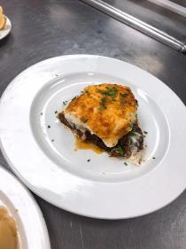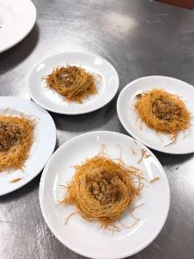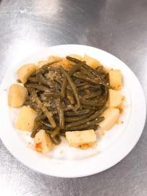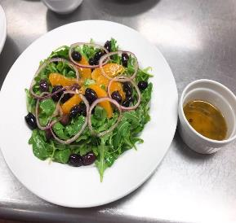
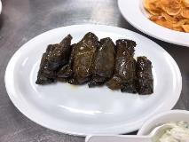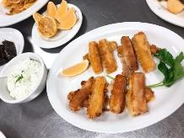
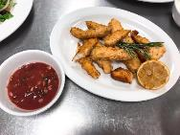

Week six

Today’s objective:
This week we learned how to make Greece cuisine, the dishes we made are Zucchini and Eggplant Fritters, Tarator Hazelnut Sauce, Stuffed Mussels, Skewered Lamb and Vegetables, Fish Balls, Tomato Salad, Braised Carrots, Plain Pilaf, Figs in Syrup.

method of cooking:
Zucchini and Eggplant Fritters: for this dish, we used deep frying cooking method.
Tarator Hazelnut Sauce: for this sauce, we just mix all ingredients together
Stuffed Mussels: for this dish, we use braising cooking method for rice, the stewing cooking method for mussels
Skewered Lamb and Vegetables: for this dish, we use grilling cooking method
Fish Balls: for this dish we use deep frying cooking method
Tomato Salad, Braised Carrots: for this salad, we just combine all ingredients together and mixing.
Plain Pilaf: for this dish we use stewing cooking method
Figs in Syrup: for this salad, we just combine all ingredients together and mixing.

Outcome and Chefs Critique:
For the Zucchini and Eggplant Fritters, we did a good job, the color is gold color, the outside is crispy, the inside is soft and moisture. For Tarator Hazelnut Sauce, the taste is good. For the Stuffed Mussels, the mussels not over cooked, the rice is full in the mussels, and taste is good. For Skewered Lamb and Vegetables, the skewer was a little bit burned, if we soak skewer for a long time it won’t happened, but the taste of dish is good and the knife cut is uniform size. For the Fish Balls, the color is correct, the outside is crispy, the inside is soft and moisture. For Tomato Salad, the taste is good, but I need put more sauce on the salad. For Braised Carrots, it looks shiny, the taste is sweet and a little bit salty, it is good. For the Plain Pilaf, the color is gold yellow, but taste is a little bit salty, we should put too much seasoning because the rice need eat with other dishes, so we cannot too much salt. For the Figs in Syrup, it is sweet, all ingredients mixed very well.

Summary
This week we made Greece cuisine again, for me Greece dish is good, I like that taste, for this week my favorite two dishes are Zucchini and Eggplant Fritters and Skewered Lamb and Vegetables. The Zucchini and Eggplant Fritters use deep frying cooking method, actually, I think this dish is simmiler as Japanese food, tempera, but it still has a little bit different with tempera, because tempera is more crispy, and the tempura need to eat with tempura sauce. For the Skewered Lamb and Vegetables, it is my hometown dishes, I am from inner Mongolia, so BBQ is our main dish every day. In my opinion, this dish taste is good but if we can add some spicy flavor, it will be better.
Overall, this week we did a great job except the Plain Pilaf is a little bot salty, and we learned if we make BBQ we have to soak the skewer for a long time to avoid burned.

Timeline:

7:00 Gather equipment, turn on the stove and oven, measure ingredients (Mise en place)

7:15 Marinate the Lamb. Soak the skewers in water

7:30 Start Figs in syrup. Hold in the fridge until service
Salt the eggplant for Zucchini and Eggplant fritters

8:00 Make Yogurt Salcasi Sauce. Hold in the fridge until service

8:15 Make Taratour bi Tahini for Stuffed Mussels and hold for service

8:30 Make Tarator Hazelnut. Hold in the fridge until service

8:45 Prepare the Mussels for Stuffed Mussels

9:00 Start Tomato Salad
Start fish balls. Chill the shaped fish balls. Hold until ready to deep fry

9:15 Prepare the filling for Stuffed mussels
Blanch bell peppers and shocked in ice cold water

9:30 Start Braised Carrots
Start sautéing the rice for Plain Pilaf

9:45 Simmer the rice

10:00 Make the batter for fritters

10:15 Assemble the lamb skewers
Place the filling in the mussels

10:30 Deep fry the Fish Balls
Start grilling the lamb skewers

10:35 Deep fry the Zucchini and Eggplant

10:45 Plating

11:00 Food Presentation

11:15 Start CLEAN-UP

11:30 Clean up

Picture:
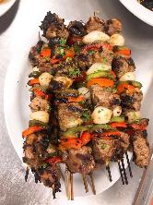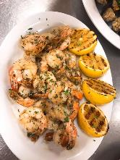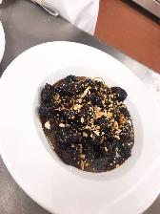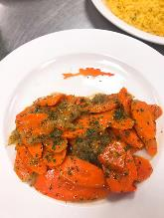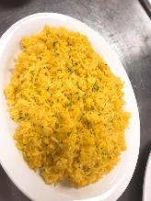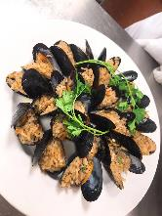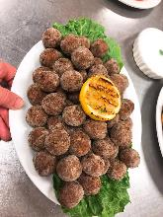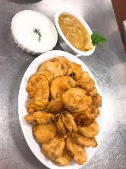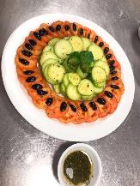

Week eight

Today’s objective:
This week we learned how to make Africa cuisine, the dishes we made are Harira: Lamb and Vegetable Soup, Fava Bean Salad, Tagine of Chicken, Preserved Lemon, and Olives, Couscous, Harissa, Fish Chermoula Carrots with Black Currants, Mescouta: Date Cookies

method of cooking:
Harira: Lamb and Vegetable Soup: for this dish, we used simmering cooking method.
Harira: Lamb and Vegetable Soup: for this salad, we just combine all ingredients together and mixing
Tagine of Chicken, Preserved Lemon, and Olives: for this dish, we use pan frying and saute cooking methods.
Couscous: for this dish, we use steaming cooking method
Harissa: for this dish we just combine all ingredients together and mixing
Fish Chermoula Carrots with Black Currants: for this dish we use pan frying cooking method for fish and sauté cooking method for carrot.
Mescouta: Date Cookies: for this daish, we use baking cooking method.

Outcome and Chefs Critique:
For the Harira: Lamb and Vegetable Soup, the cutting skills are good, the color of soup is correce, gold and light brown, the soup is tasty. For Fava Bean Salad, the beans are soft and not overcook, the dressing is good. For Tagine of Chicken, Preserved Lemon, and Olives, the cutting of chicken is a little bit big, the inside of some chicken is pink color, but it is not a big problem, taste is good. For Couscous, the color is gold, it is not to hard. taste is good, for Harissa, the chef made for us, the taste not too spicy, the color is dark red. For the Fish Chermoula Carrots with Black Currants, the fish outside is crispy the inside is soft. Taste is good, not too salty. The carrot had the correct flavor. For the Mescouta: Date Cookies, the color is dark brown, not too sweet.

Summary
This week we made Africa cuisine, for meafrica dish is good, I like that taste, for this week my favorite two dishes are Harira: Lamb and Vegetable Soup and Tagine of Chicken, Preserved Lemon, and Olives. The Lamb and Vegetable Soup taste good, because I’m from inner Mongolia, in my hometown we eat lamb very often, this dish the taste is similar with my hometown dish. I know this dish is a soup, but I think if we put more lamb and a little bit chilly, the flavor will increase. The second dish which I like is Tagine of Chicken, Preserved Lemon, and Olives, even though I don’t like the olive taste, but the chicken taste good, today chef said the size of chicken is a little bit big, but for me the size is okay, Because I think big size meat taste is better than small size meat, but there is a big problem is the big size meat hard to cook evenly, because sometimes the outside is cooked but the inside is undercook.
Overall, this week we did a great job except the chicken is a little undercooked, and we learned we need to dry fish first then put into flour.

Timeline:

7:00 Gather equipment, turn on the stove and oven, measure ingredients (Mise en place)

7:15 Make the rub for the chicken
Make the Chermoula marinade

7:20 Marinade the fish

7:25 Rub the chicken and set for 2 hours

7:30 Cook the Fava beans until tender (not mushy)

7:45 Make the dressing for the fava beans and reserved

8:00 Drain the Fava beans and toss with the dressing while still warm and hold for service

8:15 Soak currants in hot water for 30 minutes. Reserved.

8:30 Start Harissa and hold for service

8:45 Start the Dates Cookies

9:00 Start Lamb and Vegetable Soup
9:15 --------CLEAN-UP STATION-------------

9:20 Simmer the lentils for 45 minutes and hold

9:30 Start to cook the Couscous

9:45 Brown the chicken on all sides

10:00 Simmer the chicken until tender

10:10 Start Carrots with Black currants

10:15 Take out the fish from the marinade then pat dry

10:25 Add the parsley, cilantro and tomatoes to the simmered lamb and lentils

10:30 Toss green onions and radishes to the fava beans+dressing
Pan-fry the fish chermoula

10:35 Add the vermicelli until done, adjust seasoning

Add other ingredients for the chicken and reduce the sauce to desired consistency. Correct seasoning

10:45 Plating

11:00 Food Presentation

11:15 Start CLEAN-UP

11:30 Clean up

Picture:
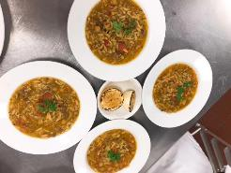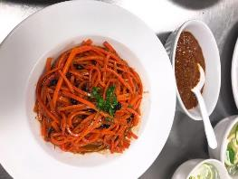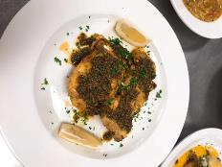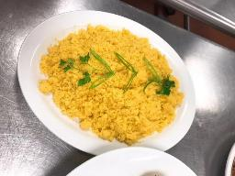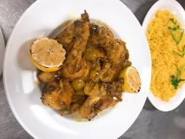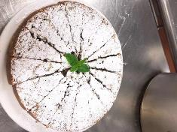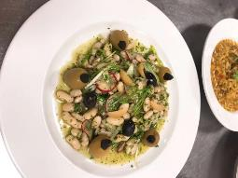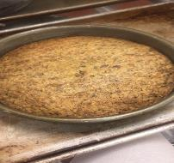

Week nine

Today’s objective:
This week we learned how to make middle east cuisine, the dishes we made are Ananas Sharbat: Pineapple Smoothie, Vegetable Samosas, Chicken Korma Kashmiri Style, Cucumber, Tomato, and Onion Katchumber, Garam Masala: Ground Spice Mixture, Podina Chatni: Green Chutney, Palak Paneer: Spinach with Curd Cheese, Rajmah: Red Kidney Bean Dal, Mango Chutney, Chapatis: Flat Bread, Khumbi Pullao: Mushroom Rice

method of cooking:
Ananas Sharbat: Pineapple Smoothie: for this dish, we don’t need to use the hot cooking method, just mix all ingredients together.
Vegetable Samosas: for this dish, we use deep frying method
Chicken Korma Kashmiri Style: for this dish, we use pan frying and simmering cooking method.
Cucumber, Tomato, and Onion Katchumber: for this dish, we don’t need to use the hot cooking method, just mix all ingredients together.
Garam Masala: Ground Spice Mixture: for this dish, we don’t need to use the hot cooking method, just mix all ingredients together.
Podina Chatni: Green Chutney: for this dish, we don’t need to use the hot cooking method, just mix all ingredients together.
Palak Paneer: Spinach with Curd Cheese: for this dish, we use simmering and pan-frying cooking method.

Rajmah: Red Kidney Bean Dal: for this dish, we use simmering cooking method.
Chapatis: Flat Bread: for this dish, we use baking cooking method
Khumbi Pullao: Mushroom Rice: for this dish, we use simmering cooking method.

Outcome and Chefs Critique:
For Ananas Sharbat: Pineapple Smoothie, we can taste the pineapple and the taste was not too sweet, good. For the Vegetable Samosas, the color is correct, it smooth, and the taste is good. For the Chicken Korma Kashmiri Style, looks good, but need more seasoning like salt and pepper. for Cucumber, Tomato, and Onion Katchumber, the knife skills are good, and taste is good, not salty. For Garam Masala: Ground Spice Mixture, it smooth, the taste is good the color is correct. Fot the Podina Chatni: Green Chutney, the color is dark green, and taste good. For the Palak Paneer: Spinach with Curd Cheese, we did a good job, the taste is good but too much liquid. For Rajmah: Red Kidney Bean Dal, it is dark brown color, the taste is good. For Mango Chutney, the color is dark brown, but not too sweet. For Chapatis: Flat Bread, it is not very crispy it is good. For Khumbi Pullao: Mushroom Rice we did a great job, the rice cooked very well and didn’t over seasoning.

Summary
This week we learned how to cook India cuisine which include Ananas Sharbat: Pineapple Smoothie, Vegetable Samosas, Chicken Korma Kashmiri Style, Cucumber, Tomato, and Onion Katchumber, Garam Masala: Ground Spice Mixture, Podina Chatni: Green Chutney, Palak Paneer: Spinach with Curd Cheese, Rajmah: Red Kidney Bean Dal, Mango Chutney, Chapatis: Flat Bread, Khumbi Pullao: Mushroom Rice
For me the taste of today’s dishes is good, this is my first time trying Indian food other than curry. The Chicken Korma Kashmiri Style is good, this dish use two kind of cooking method which are pan frying and simmering. I like spicy food, although I used two kinds of chili powder in this dish, I still feel not very spicy. In my opinion if we can add some fresh chili with seeds maybe the flavor of the dish will increase. And today from this dish I learned we cannot 100% follow the recipe, sometimes we need to make adjustment of seasoning, before the severing we should taste the dish and seasoning again.

Timeline:

7:00 review of recipes
7:30 mise en place
8:00 Start garam masala, pineapple smoothie, mango chutney, fabricate chicken, start cucumber, tomato and onion katchumber, green churney
8:30 start veg samosas
9:00 start khumbi pullao, paneer, chicken korma
9:30 start flat bread
10:45 plating
11:00 food presentation
11:30 clean up

Picture:
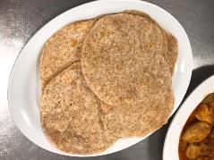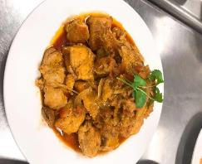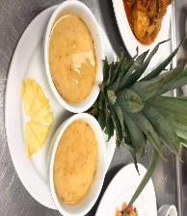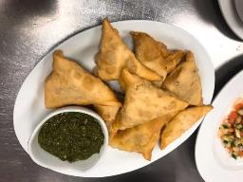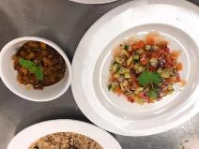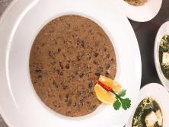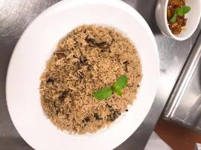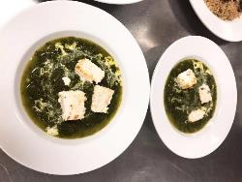

Week ten

Today’s objective:
This week we learned how to make Greece cuisine, the dishes we made are Yogurt Cucumber Mint, Buttermilk Kadhi Soup, Sambhara: Gujerati Style Cabbage with Carrots, Eggplant, and Potato, Eggplant and Potato Matira Curry,Pomfret Caldeen: Fish in Coconut Sauce,Chana Dal: Yellow Dal,Hara Dhania Chatni: Cilantro Chutney with Peanuts, Naan, Pork Vindaloo

method of cooking:
Yogurt Cucumber Mint: for this dish, we just mix all ingredients together
Buttermilk Kadhi Soup: for this dish, we used simmering cooking method
Sambhara: Gujerati-Style Cabbage with Carrots, Eggplant, and Potato: for this dish, we use stir frying cooking method and sauté.
Eggplant and Potato Matira Curry: for this dish, we use simmering cooking method.
Pomfret Caldeen: Fish in Coconut Sauce: for this dish, we use simmering cooking method.
Chana Dal: Yellow Dal: for this dish, we use simmering cooking method.
Hara Dhania Chatni: Cilantro Chutney with Peanuts: for this dish, we just mix all ingredients together
Naan: for this dish, we use baking cooking method.
Pork Vindaloo: for this dish, we use pan frying and sauté cooking method.

Outcome and Chefs Critique:
For the Yogurt Cucumber Mint, the color is white, taste good. For the Buttermilk Kadhi Soup, the color is yellow, can taste the milk falavor, taste good. for Sambhara: Gujerati Style Cabbage with Carrots, Eggplant, and Potato, all good, but the eggplant and potato is a little bit salty, but still can serve. For the Pomfret Caldeen: Fish in Coconut Sauce, can taste the coconut flabour but not too strong, the taste is good. For the Chana Dal: Yellow Dal, it should be more liquid, but taste is good. For the Hara Dhania Chatni: Cilantro Chutney with Peanuts, the color is correct, green color, the taste is good. For the Naan, the shape is good, inside is very soft, not too dry, taste is good. For the Pork Vindaloo, we used lamb, too much oil in this dish, but taste is good.

Summary
This week we learned how to cook India cuisine again which include Yogurt Cucumber Mint, Buttermilk Kadhi Soup, Sambhara: Gujerati Style Cabbage with Carrots, Eggplant, and Potato, Eggplant and Potato Matira Curry,Pomfret Caldeen: Fish in Coconut Sauce,Chana Dal: Yellow Dal,Hara Dhania Chatni: Cilantro Chutney with Peanuts, Naan, Pork Vindaloo. For me the taste of today’s dishes was good, I like Naan and Lamb Vindaloo. The Naan is very soft and not too dry, I think it can eat with anything, especially eat with lamb vindaloo is the best. Today we use lamb to instead of pork, the chef said we can use different meat to make this dish, like beef, chicken or something else. The color of lamb vindaloo is not good, it was dark brown, and also have lots of oil in this dish, I think those oil was from the lamb. Overall the taste was good, but for me if we can add some spicy powder or other species the flavor will increase, it will be better.

Timeline:
7:00 Gather equipment, turn on the stove and oven, measure ingredients (Mise en place)
7:20 Marinade the Pork for Pork Vindaloo
Start Naan
Start Chana Dal
Marinade the Fish for Pomfret Caldeen
7:30 Soak the Basmati rice in water for 30 minutes
Start Yogurt with Cucumber Mint. Hold
8:00 Drain the Basmati rice and start cooking it
8:15 Start Cilantro Chutney with Peanuts. Hold for service
8:30 Start cooking Pork Vindaloo
8:45 Start Sambhara
9:00 Preheat a tray for the Naan and start rolling out the dough
9:15 Start making Matira Curry
9:25 Start Pomfret Caldeen
9:30 Start Buttermilk Kadhi Soup
9:45 Start baking Naan
10:00
10:15
Clean-up station, prepare plates and garnish
10:30

10:35
10:45 Plating

11:00 Food Presentation

11:15 Start CLEAN-UP

11:30 Clean up

Picture:
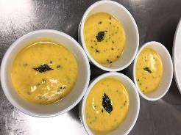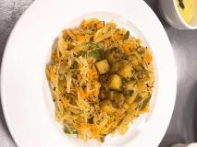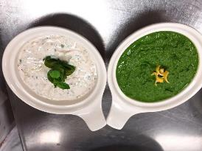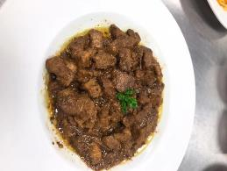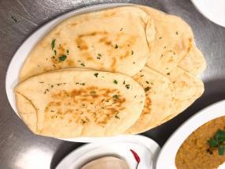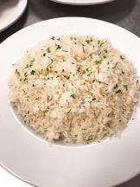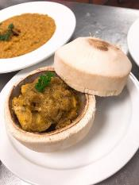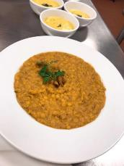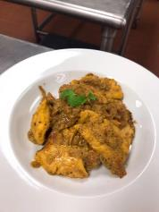

Summary:

I learned lots of dishes from other countries’ cuisine from this class. Different countries have different cooking skills, and the ingredients, species are also different. When I leave school and go to work, it can help me know how to serve clients from different countries. Also, this class can make me know the correct taste of different countries cuisine. Meanwhile, it explores more work opportunities as I can work in environment with different cuisine from worldwide which can help me to gain more knowledge and working experiences.

