SHAN XIAO
571-KX5-AS

MIND MAP PROJECT
LASALLE COLLEGE - FASHION - WINTER 2018

Presented to Ms. Josee Pepin

LASALLE COLLEGE
March 19th,2018

Step 1:
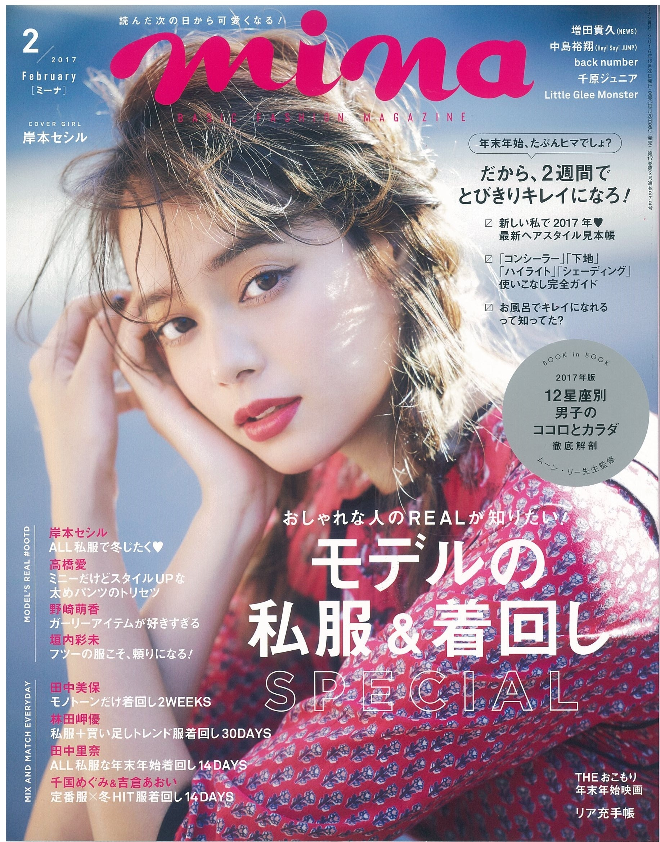
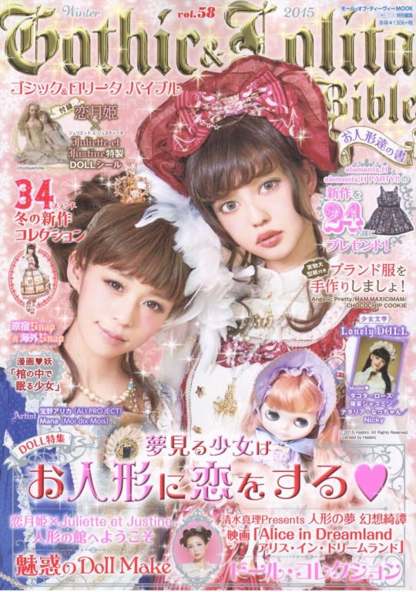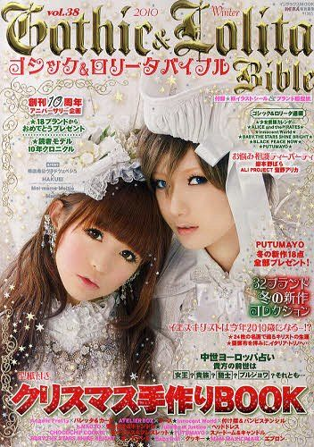
MiNa: It is a very popular magazine in japan, almost every woman in japan know it. This magazine is about fashion look and makeup look in every year and seasons. They usually use the currently most popular Japanese actress as the cover girl.
ViVi (ヴィヴィ)： is a Japanese fashion magazine published by Kodansha. It is one of Asia's top fashion magazines and is published in Japan, China, Taiwan, Hong Kong, and Thailand。
Gothic Lolita: This magazine is pretty minority in Japan, since is content the subculture which is gothic Lolita fashion. This magazine is about present some small Lolita brands that are Baby the Star Shine Bright, Angelic Pretty, Jane Marple, lizlisa and some small individual brand.
Magazine/Reader:Unplugged entity magazine/readers

WGSN Trend: The Vision 2019: Part 2 – Free Style
Reader's life style: Kawaii life style. Girl (mostly Asian) age between 16 to 25 in a small group is like to dress up differently than other. They like kawaii stuff, animation and "Doll" look. In addition, they desire to be a graceful and beautiful woman. Most of them are students.
Reader's value: Since most of the readers are students, they may not able to afford the Lolita brand since most of them are expensive. In this case, they usually don't buy too much close. In addition, they are willing to buy the second-hand dress or create their own Lolita dress. Sometimes they may spend all of her money to buy a limited addition Lolita brand and have not money for the basic life need.
Analysis the trend: the reasons why "The vision 2019: Part 2 – Free Styles are matching the readers are clarified as follows. First of all, they both Extreme forms of self-expression and identity will emerge, as shame is discarded, not only for personal reasons but also as a powerful form of resistance. Secondly, they both represent the consumer's creation. If consumers can’t find a box that fits them, they will simply create a new one. for example, the lolita girl will create her own dress, since the lolita fashion industry is very small and cannot fit they basic need.

MINDMAPPING WORKSHEET

STEP 1:
Name: Shan Xiao
Magazine/Reader: Unplugged entity magazine/readers
WGSN Trend: The Vision 2019: Part 2 – Free Style (Radical Self-Expression)

STEP 3:
FACTORS | impact on consumers’ behavior  (emotion, concern, need for action, reaction)
politics/economy: | The web economy will become the mainstream in the future since the virtual currency has become very popular. In this case, the bitcoin has become a symbol of the future economy. However, our economy industry are not ready for this development since most people are still using cash.
consumer behavior | As young people gradually become the mainstream of consumer groups. They would likely to choose lives in the moment lifestyle and sometimes they are not able to control their to buy things without consideration.This kind of shopping attitude is called consumerism.
technology | The technology and fashion design has mixed together and shown new effect. for example, Smart textiles Lights with fabric and fashion. Consumers may start to more attention on the garment textile with High-tech feeling.
environment | As fast fashion has played an important part in the fashion industry in the different country. the issue of fabric pollution also has become an issue that should be a concern. In this case,the garment recycling program in the fashion industry in pretty urgent.
advertising | Melaleuca: an ice cream advertising, it has used the women's social strategies of attractive men to represent that ice cream also has many layers of flavors.
movies/tv | Kamikaze Girl: this movie has present the concept of urban couture. it has expression who we are and what we want to be.dress whatever we want to dress and don't care what others say.
music | The music "new rule" was inspired by the theme of "feminism." It also told young women should keep a distance from those who are bad to her. Dua Lipa said that she "will keep a distance from those who are not good for herself and set some new rules for herself", She writes this song. The song is telling other people that "women will take care of each other and we have mutual support".
arts/design/ architecture | moonlight architecture has shown the young people's desire of change lifestyle. it not only brings us the high-tech feeling but also created an illusion reality.
celebrity personal style (no red carpet OR character) | RIHANNA :"I love to play with silhouettes as well, but I think it’s important to make sure that you wear the thing that works for your body the best, and that’s flattering"
subculture streetstyle | Gothic lolita: it is kind of style has evolved into a widely followed subculture in Japan and the rest of the world. The lolita fashion was inspired by Western culture influenced and the book Alice in Wonderland. It has strongly influenced the young women and the teenage girl who want to be grateful, cute and special and dress differently than others.

Reference:
1. https://freeyork.org/photography/rowan-papier/
2.https://www.web2carz.com/tech/pleasure/2610/bionic-fashion-technology-you-can-wear
3. http://www.londonfashionweek.co.uk/404.aspx?aspxerrorpath=/content.aspx
4. https://www.theguardian.com/fashion/2017/jul/29/fashion-must-fight-scourge-dumped-clothing-landfill
5. https://www.toneden.io/vicetone/post/dua-lipa-new-rules-vicetone-remix
6. http://theendearingdesigner.com/
7.https://www.thetimes.co.uk/article/rihanna-exclusive-interview-the-launch-of-fenty-beauty-t6stj7pst
8. https://1nceagain.com/products/9781421513959
9. https://i.pinimg.com/originals/1b/75/1c/1b751c8e5f5e3878942e404470b9647f.jpg
10. https://i.pinimg.com/originals/1b/75/1c/1b751c8e5f5e3878942e404470b9647f.jpg
11. https://en.wikipedia.org/wiki/Lolita_fashion#Sources_of_Inspiration
12. http://www.capitalxtra.com/artists/rihanna/news/secret-behind-personal-style-fenty-puma-fashion/
13. https://genius.com/Dua-lipa-new-rules-lyrics
14. http://smallbusiness.chron.com/kinds-pollution-textile-factories-give-off-77282.html

