introDUCTION to baking
Portfolio Assignment
Yvonne ZHAO - 1830187
SUBMITTED TO CHEF PAZ
CUL 121 A
September 3, 2018

Table of Content
Week 1 0
Menus 0
Blueberry Muffins 0
Peanut Butter Cookies 0
Soft Yeast Dinner Rolls 0
Recipes and Methods: 0
Blueberry Muffins (Yield: 12 muffins) 0
Peanut Butter Sandies 1
Soft Yeast Dinner Rolls 2
Reflection 3
1. Describe the key points of the lesson: 3
a.) Menu list of your products 3
b.) Pictures of your products 3
c.) Method Mixing, baking 3
d.) Outcome 3
2. Create a time line of your production 3
3. List your temperature chart 4
4.Discuss your personal thoughts about your production. 4
5. Describe the chef's critique and recommendations for improvement. 4
6. Write any questions that you need clarified. If you have no questions about the content we are covering, please feel free to pick my brain about other things pertaining to the industry. No personal questions, please. This section is NOT optional. 4
Week 2 5
Menu 5
Focaccia 5
Chocolate Chunk Cookies 5
Pie Dough and Apple Pie 5
Recipes and Methods: 5
Focaccia (Roman Flatbread) 5
Chocolate Chunk Cookies: 6
Pie Dough (Yield: 1 x 9” pie crust – top & bottom) 7
Apple Pie 8
Reflection 9
1. Describe the key points of the lesson: 9
a.) Menu list of your products 9
b.) Pictures of your products: 9
c.) Method Mixing, baking 9
d.) Outcome: 9
2. Create a time line of your production 10
3. List your temperature chart 10
4. Discuss your personal thoughts about your production. 10
5. Describe the chef's critique and recommendations for improvement. 10
6. Write any questions that you need clarified. If you have no questions about the content we are covering, please feel free to pick my brain about other things pertaining to the industry. No personal questions, please. This section is NOT optional. 11
Week 3 12
Menus 12
Italian Rosemary Rolls 12
Carrot Bread 12
Banana Bread 12
Fudge Brownie Batter 12
Recipes and Methods: 12
Italian Rosemary Rolls 12
Carrot Bread 13
Banana Bread 14
Fudge Brownie Batter 15
Reflection 16
1. Describe the key points of the lesson: 16
a.) Menu list of your products 16
b.) Picture of my products: 16
c.) Method Mixing, baking 17
d.) Outcomes: 17
2. Timeline for my products: 17
3. List my temperature chart 17
4. My personal thoughts about my production 17
5. Describe the chef's critique and recommendations for improvement. 17
6. Write any questions that you need clarified. If you have no questions about the content we are covering, please feel free to pick my brain about other things pertaining to the industry. No personal questions, please. This section is NOT optional. 18
Week 4 19
Menus 19
Whole-Wheat Sandwich Bread Scaled 19
Traditional Shortbread(Cookies) 19
Cheddar-Chive Scones 19
Recipes and Methods: 19
Cheddar–Chive Scones (Yield: 8 Scones) 19
Traditional Shortbread 20
Whole-Wheat Sandwich Bread scaled 21
Reflection 22
1. Describe the key points of the lesson: 22
a.) Menu list of your products 22
b.) Picture of my products: 22
C.)Method Mixing, baking: 22
d.) Outcomes: 23
2. Timeline for my products: 23
3. List my temperature chart 23
4. My personal thoughts about my production 23
5. Describe the chef’s critique and recommendations for improvement. 23
6. Write any questions that you need clarified. If you have no questions about the content we are covering, please feel free to pick my brain about other things pertaining to the industry. No personal questions, please. This section is NOT optional. 24
Week 5 25
Menu 25
Baguette 25
Pie dough and Pecan Pie 25
Bird’s Nest Cookies 25
Recipes and Methods: 25
Baguette 25
Pie Dough 25
Pecan Pie 25
Bird’s Nest Cookies 26
Reflection 28
1. Describe the key points of the lesson: 28
a.) Menu list of your products 28
b.) Picture of my products: 28
c.) Method Mixing, baking 28
d.) Outcomes: 28
2. Timeline for my products: 29
3. List my temperature chart 29
4. My personal thoughts about my production 29
5. Describe the chef's critique and recommendations for improvement. 29
6. Write any questions that you need clarified. If you have no questions about the content we are covering, please feel free to pick my brain about other things pertaining to the industry. No personal questions, please. This section is NOT optional. 30
Week 6 31
Menus 31
Raisin and Cheese Bread 31
Pie dough and Chocolate Cream Pie 31
Soft Yeast Dinner Rolls 31
Oatmeal Cookies 31
Recipes and Methods: 31
Raisin Bread 31
Chocolate Cream Pie 31
Soft Yeast Dinner Rolls 32
Oatmeal Cookies 33
Reflection 34
1. Describe the key points of the lesson: 35
2. Timeline for my products: 36
3. List my temperature chart 37
4. My personal thoughts about my production 37
5. Describe the chef's critique and recommendations for improvement. 37
6. Write any questions that you need clarified. If you have no questions about the content we are covering, please feel free to pick my brain about other things pertaining to the industry. No personal questions, please. This section is NOT optional. 37
Week 7 38
Menus 38
Pound Cake 38
Multigrain Sourdough Bread 38
Cranberry White Chocolate Orange Scones 38
Morning Glory Muffins 38
Recipes and Methods: 38
Pound cake 38
Multigrain Sourdough Bread 38
Cranberry White Chocolate Orange Scones (Yield: 8 scones) 40
Morning Glory Muffins 41
Reflection 42
1. Describe the key points of the lesson: 42
a.) Menu list of your products: 42
b.) Picture of my products: 42
c.) Method Mixing, baking: 43
d.) Outcomes: 43
2. Timeline for my products: 43
3. List my temperature chart: 43
4. My personal thoughts about my production 44
5. Describe the chef's critique and recommendations for improvement. 44
6. Write any questions that you need clarified. If you have no questions about the content we are covering, please feel free to pick my brain about other things pertaining to the industry. No personal questions, please. This section is NOT optional. 44
Week 8 45
Menus 45
Soft Yeast Dinner Rolls 45
Sour Cream Coffeecake 45
Cinnamon Buns and caramel Glaze 45
Butter Cookies 45
Recipes and Methods: 45
Soft Yeast Dinner Rolls 45
Sour Cream Coffeecake 46
Cinnamon Buns 47
Caramel Glaze 48
Butter Cookies 48
Reflection 49
1. Describe the key points of the lesson: 49
a.) Menu list of your products: 49
b.) Picture of my products: 49
c.) Method Mixing, baking: 50
d.) Outcomes: 50
2. Timeline for my products: 50
3. List my temperature chart: 51
4. My personal thoughts about my production 51
5. Describe the chef's critique and recommendations for improvement. 51
6. Write any questions that you need clarified. If you have no questions about the content we are covering, please feel free to pick my brain about other things pertaining to the industry. No personal questions, please. This section is NOT optional. 51
Week 9 52
Final Practical Exam 52
Menus 52
Soft Yeast Dinner Rolls 52
Pie dough and pecan pie 52
Cheddar-Chive Scones 52
Butter Cookies 52
Recipes and Methods: 52
Soft Yeast Dinner Rolls 52
Pie Dough 54
Pecan Pie 54
Cheddar–Chive Scones (Yield: 8 Scones) 55
Butter Cookies 56
Reflection 57
1. Describe the key points of the lesson: 57
a.) Menu list of your products: 57
b.) Picture of my products: 57
c.) Method Mixing, baking: 58
d.) Outcomes: 58
2. Timeline for my products: 58
3. List my temperature chart: 59
4. My personal thoughts about my production 59
5. Describe the chef's critique and recommendations for improvement. 59
6. Write any questions that you need clarified. If you have no questions about the content we are covering, please feel free to pick my brain about other things pertaining to the industry. No personal questions, please. This section is NOT optional. 59
Summary 60
1. What did I learn during the 11 weeks? 60
2. What were some difficulties or challenges? 60
3. What was the highlight or the most memorable event? 60
4. What did you take away from the intro to Baking course? 60

Week 1

Menus

Blueberry Muffins

Peanut Butter Cookies

Soft Yeast Dinner Rolls

Recipes and Methods:

Blueberry Muffins (Yield: 12 muffins)

Ingredients:

Unsalted Butter 125 g
Sugar 250 g
Salt 3 g
Eggs 100 g
All Purpose Flour 300 g
Baking Powder 10 g
Buttermilk 120 ml
Frozen Blueberries 200 g
Flour for dredging

Method: (Creaming and quick bread Method)

Directions:
- Cream butter, sugar and salt.
- Beat eggs in one at a time.
- Sift together the flour and the baking powder.
- Alternately add the dry ingredients and buttermilk to the creamed mixture.
- Dredge blueberries in a small amount of flour and gently fold into batter.
- Portion into greased muffin tins.
- Bake muffins at 375°F for about 30 minutes or until golden brown.
- Remove from pan shortly after removing from oven. Cool.

Peanut Butter Sandies
Ingredients:
flour, pastry (or all-purpose flour) | 302g
baking soda | 2g
baking powder | 2 g
butter, unsalted (softened) | 202g
sugar, granulated | 219g
eggs | 42g
peanut butter | 126g
salt | 2g
sugar, granulated | as needed
peanuts (use halves, optional) | 25g

Method: Creamy Method

Directions:
- Sift together the flour, baking soda and baking powder. Set aside. Cream the butter. Add the sugar and continue creaming. Gradually add the eggs, followed by the peanut butter and salt.

- Add the dry ingredients to the butter mixture and mix to make a firm dough.

- Scale the dough into 1-pound (480-gram) pieces. Roll the dough into 12-inch (30-centimeter)
logs. Cut into 1-inch (2.5-centimeter) pieces.

- Roll each cookie into a ball and place on a paper-lined sheet pan. Press each ball down using the bottom of a measuring cup to slightly less than 1/2 inch (1.2 centimeters). The edges of the cookies will develop some cracks, which is a desired look.

- Using a fork, press crisscross markings on the surface of each cookie. Lightly brush the cookies with water. Sprinkle lightly with granulated sugar and press one peanut half into each cookie, if using.

- Bake at 400°F (200°C) until golden brown, approximately 12 minutes.

Soft Yeast Dinner Rolls

Ingredients:
yeast, dry active | 20g
water (temperature controlled) | 243 g
flour, bread | 446 g
salt | 10g
sugar, granulated | 41 g
milk, nonfat dry | 20 g
shortening, vegetable | 20g
butter, unsalted (softened) | 20 g
eggs | 32g(1 egg)
Egg Wash | as needed

Methods: Straight Dough Method

Directions:
- Dissolve the yeast in the water in a bowl. Combine the flour, salt, sugar, milk powder, shortening, butter and eggs in the bowl of a mixer fitted with a dough hook.

-Add the water-and-yeast mixture to the mixer bowl; stir to combine.

-Knead on medium speed 10 minutes or until the dough reaches 77°F (25°C).

-Transfer the dough to a lightly greased bowl, cover and place in a warm spot. Ferment until doubled, approximately 1 hour.

-Punch down the dough. Let it rest a few minutes to allow the gluten to relax.

-Divide the dough into 1 1/4-ounce (38-gram) portions and round. Shape as desired and arrange on paper-lined sheet pans. Proof until doubled in size.

-Carefully brush the proofed rolls with egg wash. Bake at 400°F (200°C) until medium brown, approximately 12 to 15 minutes.

Reflection

1. Describe the key points of the lesson:

a.) Menu list of your products
- Blueberry Muffins (Unsalted Butter, Sugar, Salt, Eggs, All Purpose Flour, Baking Powder, Buttermilk, Frozen Blueberries, Flour for dredging)
- Peanut Butter Sandies (Flour, Baking Soda, Baking Powder, Softened Unsalted Butter, Granulated Sugar, Eggs, Peanut Butter, Salt, Peanuts (use halves))

b.) Pictures of your products
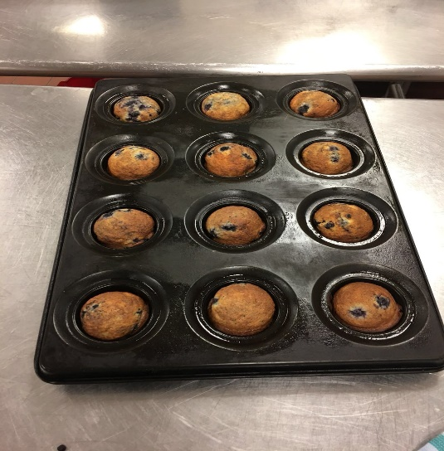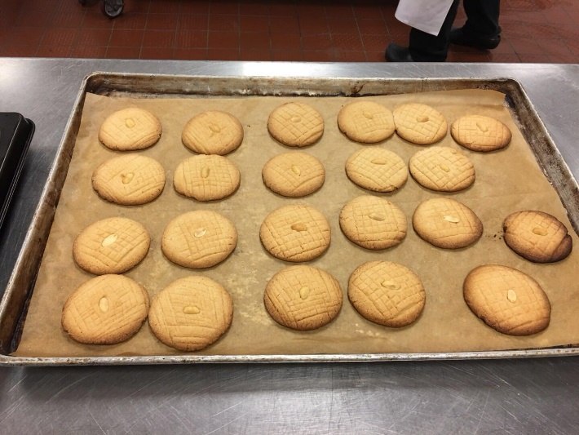
Blueberry Muffins Peanut Butter Cookies

c.) Method Mixing, baking
- Timing
- Straight dough
- Yeast dough
- Creaming
- Softened the butter

d.) Outcome
We successfully baking the blueberry muffins and finish cookies, but some cookies were over cooked.

2. Create a time line of your production
12:00 – 13:00 Get ready for the class and listened to the chef instructions
13:00- 13:30 Weight and prepared the cookies ingredients, looking for the equipment and tools for the recipes
Between 13:30 to 14:00 learnt some skills from chef and got back to the station prepare the cookies
14:00 to 15:00 Mixed cookies ingredients and started to bake
15:00- 15:14 Baking the cookies for about 14 minutes
15:20- 15:40 Looking for and preparing the blueberry muffin ingredients for 20 minutes
15: 40- 15: 55 Mixture all the muffins ingredients and put into the oven
16:00- 16:30 Clean up the kitchen and finished up with the muffins

3. List your temperature chart
- Blueberry muffins were baking in the 375F
- Peanut butter cookies were baking in 400F(200C)

4.Discuss your personal thoughts about your production.
For the blueberry muffins I thought the surface color might be a little too brown, but overall were pretty good. However, the size of the muffins was smaller compared with other group so I should approved skills to measure and equally distribute the products.
For cookies, I though the taste were pretty good, and the shape looks good. The surface was golden, but some cookies back side were over baked which cause the colour were too dark. As a result, some of them taste burnt, so next time I should pay more attention on the timing and made sure checked frequently. After the surface turning golden take out right way.

5. Describe the chef's critique and recommendations for improvement.
This week we supposed to bake three products which were blueberry muffins, peanut butter sandies and soft yeast dinner rolls, but our group only finished blueberry muffins and peanut butter sandies.
Chef’s critique:
- Even though four of students shared one table, 2 of us should work as a group instead of four worked together;
- Our cookies a little overburnt
Recommendation for improvement:
1) Next class work in pairs (2 people) only
2) Make sure avoiding over baked again

6. Write any questions that you need clarified. If you have no questions about the content we are covering, please feel free to pick my brain about other things pertaining to the industry. No personal questions, please. This section is NOT optional.
- How to make sure the yeast was activated?
- If the yeast did not work, were there some ways to solve the issues?
- If the yeast over activated, what we could do?

Week 2

Menu

Focaccia

Chocolate Chunk Cookies

Pie Dough and Apple Pie

Recipes and Methods:

Focaccia (Roman Flatbread)

Ingredients:

sugar, granulated | 11g
yeast, dry active | 11g
water (temperature controlled) | 355mL
flour, all purpose | 510g
salt, kosher | 9 g
oil, olive | 15mL
rosemary, fresh (crushed) | 6g

Directions:

- Combine the sugar, yeast and water. Stir to dissolve the yeast. Stir in the flour, 4 ounces (120 grams) at a time.

- Stir in 1 1/2 teaspoons (7 milliliters) of the salt. Mix well, then knead on a lightly floured board or in the bowl of a mixer fitted with a dough hook until smooth.

- Place the dough in an oiled bowl, cover and ferment until doubled.

- Punch down the dough, then flatten it onto an oiled sheet pan. It should be no more than 1 inch (2.5 centimeters) thick. Brush the top of the dough with the olive oil. Let the dough proof until doubled, approximately 15 minutes.

- Sprinkle the crushed rosemary and the remaining 1/2 teaspoon (2 milliliters) salt on top of the dough. Bake at 400°F (200°C) until lightly browned, approximately 20 minutes.

Chocolate Chunk Cookies:

Ingredients:

butter, unsalted (softened) | 109g
sugar, granulated | 5g
sugar, light brown | 82g
eggs | 1 egg
vanilla extract | 2mL
salt | 3 g
flour, pastry | 136g
baking soda | 1g
pecan pieces (can use chopped walnuts) | 54g
chocolate chunks (can use chips) | 218 g

Methods: Creamy Method

Directions:
- Cream the butter and the sugars in the bowl of a 6 quart (6.5 liter) or larger mixer fitted with the paddle attachment. Beat until light, approximately 5 minutes at medium speed.
- Add the eggs to the creamed mixture one at a time. Add the vanilla.
- Stir the salt, flour and baking soda together and add to the creamed mixture.
- Stir in the pecans or walnuts and chocolate chips.
- Portion the dough using a #20 scoop onto a paper-lined sheet pan and bake at 350°F (180°C) until the cookies are golden brown and cooked through, approximately 10 to 12 minutes.

Pie Dough (Yield: 1 x 9” pie crust – top & bottom)

Ingredients:

Pastry Flour 350 g
Salt 5 g
Sugar 12 g
Cold, Unsalted Butter, cut into small cubes 225 g
Ice Water 75 – 100 ml

Method:

Directions:
Sift flour, salt and sugar into bowl.
Cut or rub butter into flour to desired size.
Gradually add water to flour mixture. Mix gently, just until water is absorbed and dough comes together. Do not overwork dough.
Wrap dough in plastic wrap and chill for at least an hour.
Scale dough at 300 g for bottom crust and 250 g for top crust.
Roll pastry 1/8” thick.

Apple Pie

Ingredients:

Apples, peeled, cored & sliced (~5) 820 g
Lemon, zested & juiced. 1
Sugar 180 g
Cornstarch 60 g
Salt Pinch
Cinnamon Pinch
Nutmeg Pinch
Butter 20 g

Method:

- Combine apple slices with lemon juice in a bowl.

- In a separate bowl combine sugar, cornstarch, salt and spices.

- Add dry ingredients to apple slices. Toss gently until well mixed.

- Fill previously-rolled bottom pie crust. Dot with butter. Egg wash edges of pastry.

- Roll pastry for top crust. Place on top of filling. Press down at edges.

- Finish edge of pie.

- Before baking, brush with egg wash and sprinkle with sugar.

- Bake @ 400°F for approximately 45 minutes or until pastry is browned, and filling is bubbly and soft.

Reflection

1. Describe the key points of the lesson:

a.) Menu list of your products
Focaccia(Roman Flatbread): Made by yeast, sugar, warm water, all purpose flour, salt, olive and rushed fresh rosemary

Chocolate Chunk Cookies: Incorporate with softened unsalted butter, sugar, brown sugar, eggs(3/4), vanilla extract, salt, pastry flour, baking soda, chopped pecan, chocolate chunks(chips)

Pie Dough and Apple Pie
Dough: Pastry flour, salt, sugar, unsalted cold butter, iced water
Apple Pie: Apple, lemon, sugar, cornstarch, salt, cinnamon, nutmeg

b.) Pictures of your products:
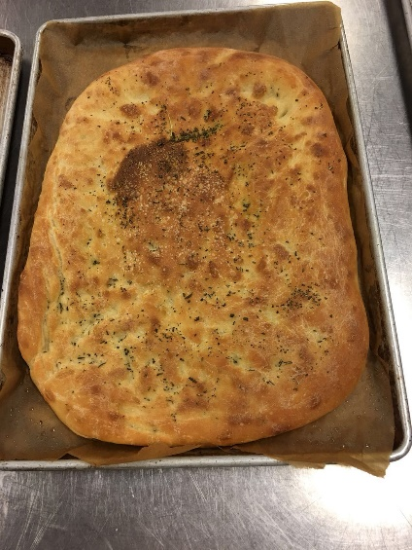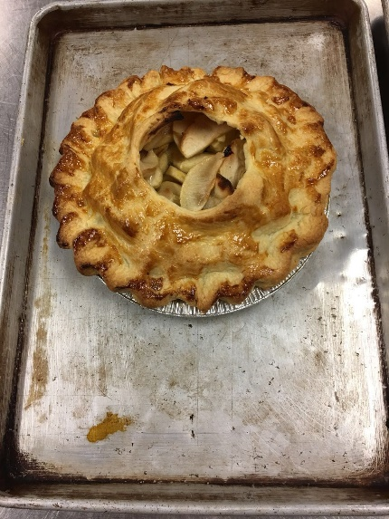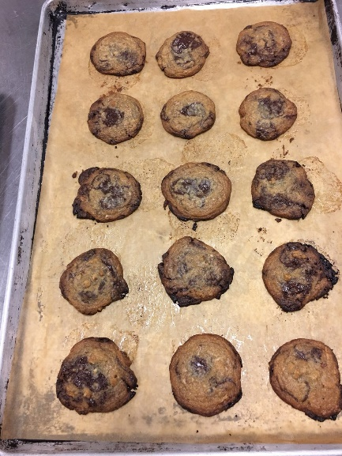
Focaccia(Roman Flatbread) Apple Pie Chocolate Chunk Cookies

c.) Method Mixing, baking
Cut and rub butter into flour, mix gently without using arms, mixture until the butter absorbed and can fold together, cut apple into the similar small slice and mix well with different ingredients and must bake enough time

d.) Outcome:
The results were much better compared with first week, and our group completed all the assigned product. This week, we learned many new skills about how to make dough and the important steps of making a successful flatbread. However, there were still many mistakes during the baking procedures which we must practice more in the future.

2. Create a time line of your production
12:00 – 13: 00 Listen to the instruction, prepare all the ingredients, watched flatbread process demo
13:25 – 14:00 Repeat the steps of folding and proof the flatbread dough and started to make pie dough
14:00 – 14:15 Watched the pie dough demo
14:16-14:46 mixed butter and flour to complete the pie dough and put into the fridge for half hour
15:00 – 15:20 Started to make apple pie fillings by adding all the ingredients together and baking the flatbread
15:20- 15:46 Mixed all cookies ingredients and got ready to bake
16:00 – 16:40 Complete combine the pie dough and apple fillings by following the instructions and putted cookies dough and apple pie to the oven and baked
16:40 to 17: 15 Cleaned up and chef's critique(grades).

3. List your temperature chart
- For the Focaccia flatbread and apple pie, we cooked in 400F
- Cookies we supposed to bake in 350°F (180°C), but we also put in 400°F oven and shorten the baking time instead

4. Discuss your personal thoughts about your production.
I thought we did a good job this week and worked hard to produce some nice products, but I found our apple pie were lack of liquid inside and apples did not stick together. Some apple slices on the top were over burned. The bread looked nice and taste pretty good. There were some cookies were a little bit overbaked, but overall I thought we were successfully complete the week 2 products.

5. Describe the chef's critique and recommendations for improvement.
For our products this week, the chef explained that our flatbread had too many bubbles. The apple pie were not baked long enough. Our cookies did not have the similar shape because we did not portion well before baking.
Chef Paz recommended us next time we should push hard for bread dough and make sure reduce the bubbles as many as possible. We should bake the apple pie longer that the apple filling would become bubbly and soft. This week the pastry was nicely baked, but the filling was hard. Finally, he pointed out that our cookie was well baked, but next time we should make sure the shapes of every cookies should looked the same. We should learn how to portion the cookies dough equally.

6. Write any questions that you need clarified. If you have no questions about the content we are covering, please feel free to pick my brain about other things pertaining to the industry. No personal questions, please. This section is NOT optional.
- Why the apple pie filling was not soft, but the pie dough was golden? If I baked longer whether the dough will be over burned?
- How to checked flatbread bubble were release properly?

Week 3

Menus

Italian Rosemary Rolls

Carrot Bread

Banana Bread

Fudge Brownie Batter

Recipes and Methods:

Italian Rosemary Rolls
Ingredients:

Warm water 180 g
Yeast (fresh) 18 g
Olive Oil 35 g
Dried Rosemary, Crushed 1 tsp
Eggs 100 g(2 eggs)
All Purpose Flour 506 g
Olives (Pitted), Chopped 80 g

Method: Straight Dough Method
- Straight dough method. Use all ingredients except the dates or olives.
Autolyze for 10 to 15 mins.

- Knead until smooth and shape into a round ball.

- Ferment (covered) until soft and doubled. (at least an hour)

- Degas (or punch down) dough.

- Knead in the olives/dates.

- Portion into 50g portions

- Bench (covered).

- Shape into rolls and place them on a parchment-lined sheet tray.

- Press down and proof until doubled. (at least 20 mins)

- Brush with egg wash and top with more dried rosemary.

- Snip the top with an “X” and bake @ 400 F for 12-15 minutes or until done.

- Cool on rack.

Carrot Bread

Ingredients:

Eggs 100 g
Sugar 200 g
Vegetable Oil 135 g
Bread Flour 220 g
Baking Powder 4 g
Baking Soda 3 g
Salt Pinch
Cinnamon 2 g
Finely Grated Raw Carrot 1 Cup

Method: Muffin Method

Directions:
- Muffin Method. (As follows)

- Sift the dry ingredients together and set aside.

- In a mixing bowl beat the eggs and sugar until thick.

- Add the oil gradually and continue beating until thoroughly combined and homogenous.

- Mix the grated carrot with the dry ingredients until coated and separate.

- Stir the dry ingredients into the wet ingredients until just combined.

- Pour into prepared pan and allow the batter to stand in the pan for ~ 10 mins.

- Bake in a preheated 325 F oven for an hour until light golden brown and a skewer comes out clean.

- Cool. Remove from pan when half cool.

Banana Bread

Ingredients:

Peeled Ripe Bananas 150 g
Brown Sugar 150 g
Eggs 35 g
Vegetable Oil 85 g
Milk 85 g
Baking Soda 5 g
Bread Flour 155 g

Method: Muffin Method
Directions:
- Combine bananas and sugar in a mixing bowl with the paddle attachment.
- Add remaining wet ingredients and combine.
- Sift flour and baking soda together in a large bowl. Make a well.
- Add wet ingredients to the dry ingredients and mix until dry ingredients are just moistened.
- Pour into greased and lined loaf pans.
- Bake @ 350F for approximately 40-50 minutes until golden.
- Cool.

Fudge Brownie Batter

Ingredients:

butter, unsalted (room temperature) | 169g
chocolate, unsweetened | 150g
eggs | 150(3 eggs)
sugar, granulated | 376g
salt | 2g
vanilla extract | 10mL
coffee extract (optional) | 5mL
flour, pastry (can use all-purpose) | 150g
pecan pieces | 75g
sugar, confectioners (optional) | as needed

Directions:
- Melt the butter and chocolate over a double boiler to 120°F (49°C). Hold the chocolate at this temperature.

- While the chocolate is melting, beat the eggs and granulated sugar in the bowl of a large mixer fitted with the paddle attachment on medium speed for 10 minutes. Add the salt and extracts. Scrape down the bowl, then add the melted chocolate, blending until well combined. Add the flour and mix until combined. Fold in the nuts.

Reflection

1. Describe the key points of the lesson:

a.) Menu list of your products
Italian Rosemary Rolls: Made by combination of warm water and yeast, olive oil, crushed dried rosemary, eggs, all-purpose flour and olives
Carrot Bread: Combination of eggs, sugar, vegetable oil, bread flour, baking powder, baking soda, a pinch of salt, cinnamon and one cup finely grated raw carrot
Banana Bread: Peeled ripe bananas and add brown sugar, eggs, vegetable oil, milk, baking soda and bread flour
Fudge Brownie Batter: Melting chocolate chips, room temperature unsalted butter, 3 eggs, granulated sugar, salt, vanilla extract, coffee extract, pasty(all purpose) flour, pieces pecan, powder sugar

b.) Picture of my products:
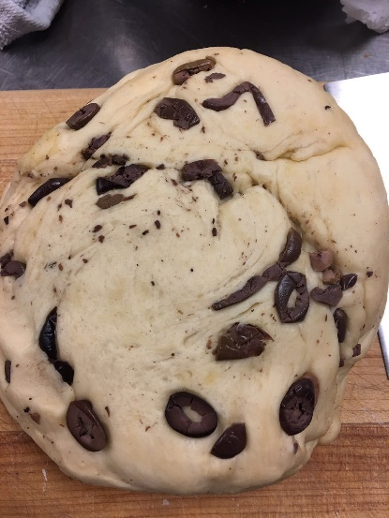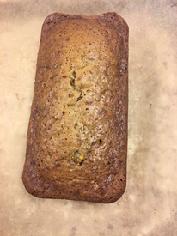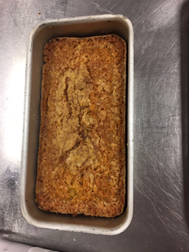
Italian Rosemary Rolls Banana Bread Carrot Bread

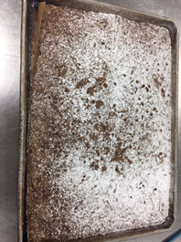 Fudge Brownie Batter 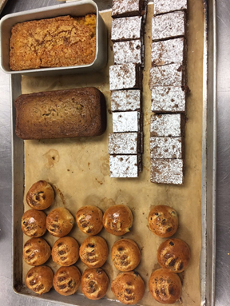 Final Product

c.) Method Mixing, baking
Straight dough method, make the Italian rosemary rolls into a round ball, punch down dough, snip x or cut top for 3-4 times, apply muffin methods for bananas and carrots bread, mixed grate carrots with flour and stir dry ingredients into the weight ingredients, banana bread was adding wet ingredients into dry ingredients, melt the butter and chocolate over a double boiler, beat eggs and sugar in a dry bowl, cut baked brownie into similar sizes.

d.) Outcomes:
We successfully baked all four products, even though we made some mistakes overall were good. However, we broke the carrots bread inside which split from the middle of the bread because we did not wait until the bread cool enough before we tried took out from the cooking pan.

2. Timeline for my products:
12: 00 – 13:35 Lectures and prepare/weight all ingredients
13:35 – 13:37 Demo for Italian Rosemary Rolls
13:37 – 13:48 Started to make Italian Rosemary Rolls by adding all the dry ingredients together and oil, eggs, yeast to knead the dough
13:48 – 14:09 Carrots Bread Demo
14:13 – 14:20 Banana Bread Demo
14: 30 – 14: 50 Mix all the banana and carrots ingredients put into the oven
15: 20 Finish banana and carrots bread sit aside to cool
15:00 Watched Demo for Fudge Brownie Batter
15: 46 – 16: 15 Baked Brownie and Clean up the kitchen
17: 25 Chef's critique and recommendations (Marks)

3. List my temperature chart
1) Baked Italian rosemary rolls in 400F
2) Carrots bread require temperature was 325F and banana bread was 350F
3) The brownie baked at 325F

4. My personal thoughts about my production
I thought we were improving over comprehensive baking skills week by week and we were successfully complete all the assigned products. However, we still need to learned and keep practicing some baking techniques such as the right time to remove the bread from the cooking pans, the right time and temperatures for bread to proofed to desire size and how to make the round ball with a smooth surface for bread before baking.

5. Describe the chef's critique and recommendations for improvement.
1) Chef's critique:
Overall were good for banana bread and brownie.
The Italian Rosemary Rolls size were not big enough
It was so bad that our carrots bread was splits into two pieces from the middle
2) Recommendation:
The Italian Rosemary Rolls should proof for extra 10 to 20 minutes that allows the dough achieve the desired sizes.

6. Write any questions that you need clarified. If you have no questions about the content we are covering, please feel free to pick my brain about other things pertaining to the industry. No personal questions, please. This section is NOT optional.
1) How to make the dough become a round ball with a smooth surface
2) What was the difference between creamy methods and muffin methods?
3) How to check the dough was proofed to desired size

Week 4

Menus

Whole-Wheat Sandwich Bread Scaled

Traditional Shortbread(Cookies)

Cheddar-Chive Scones

Recipes and Methods:

Cheddar–Chive Scones (Yield: 8 Scones)

Ingredients:

All Purpose Flour 200 g
Salt 2g
Baking Powder 12 g
Cold, Unsalted Butter 80 g
Chopped Fresh Chives 10 g
Grated Cheddar Cheese 50 g
Eggs 30 g
Milk 45 g
Cream 45 g

Egg wash and grated cheddar for garnish

Method: Biscuit Method

Directions:
- Combine dry ingredients with paddle attachment.

- Add cold, cubed butter and blend to pea sized pieces.

- Add chives and grated cheddar cheese.

- Add egg, milk and cream and mix just until dough comes together.

- Roll into a ½” thick circle and cut 8 wedges.

- Egg wash and garnish with grated cheddar.

- Bake at 400°F for about 15 – 20 minutes.

Traditional Shortbread
Ingredients:

butter, unsalted (softened) | 169g
sugar, confectioners | 84g
vanilla extract | 6mL
salt | 2g
flour, pastry (or use all-purpose flour) | 200g
Egg Wash | as needed

Directions:

- Blend the butter and powdered sugar in a mixing bowl without creaming. Stir in the vanilla and salt, mixing thoroughly. Add the flour and mix until just combined.

- Divide the dough into four equal portions. Roll each piece of dough into 8-inch (20-centimeter) disks. Wrap in plastic. Freeze until hard, approximately 30 minutes.

- Remove from the freezer and unwrap, then lightly brush each disk with egg wash. Cut each disk into eight wedges. Dock the wedges with a fork.

- Bake at 375°F (190°C) until pale golden brown, approximately 15 to 20 minutes.

Whole-Wheat Sandwich Bread scaled
Ingredients:

water (temperature controlled) | 355mL
milk, nonfat dry | 35g
sugar, granulated | 28g
salt | 14g
yeast, dry active | 14g
flour, bread | 340g
flour, whole wheat | 340g
butter, unsalted (softened) | 28g
eggs | 91g
Egg Wash | as needed

Directions:

- Combine the water, milk powder, sugar, salt, yeast and 12 ounces (360 grams) of the flour. Blend well. Add the butter and eggs and beat 2 minutes.

- Stir in the remaining flour, 2 ounces (60 grams) at a time. Knead 8 minutes or until the dough reaches 77°F (25°C).

- Place the dough in a lightly greased bowl, cover and ferment at room temperature until doubled, approximately 1 to 1 1/2 hours.

- Divide the dough into two uniform pieces. Shape into loaves, place the dough into greased loaf pans and proof until doubled.

- Brush the dough with egg wash. Bake at 375°F (190°C) until brown and hollow-sounding, approximately 50 minutes

Reflection

1. Describe the key points of the lesson:

a.) Menu list of your products
Whole-Wheat Sandwich Bread scaled: mixture of water, milk powder, sugar, salt, yeast with flour, add butter and eggs. Egg wash before baking
Traditional shortbread (Cookies): Blend the butter and powdered sugar with our creaming, stir in vanilla and salt, mixing thoroughly shifts the flour into the mixture until combined
Cheddar-Chive Scones: Combine all purpose flour, salt, baking powder, add cold cubed butter and mix leave the butter chunk, put chives and cheddar, combine milk, cream, brush and add some extra cheese on the top, egg brush and put to the oven

b.) Picture of my products:
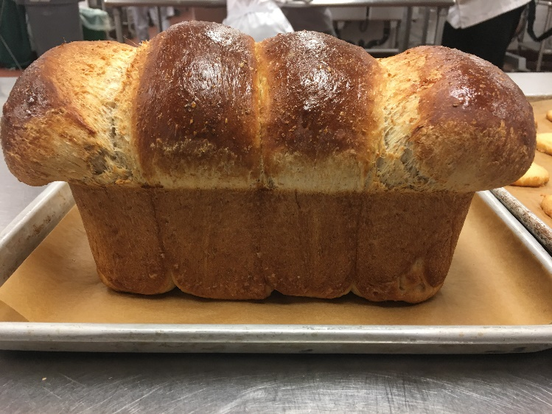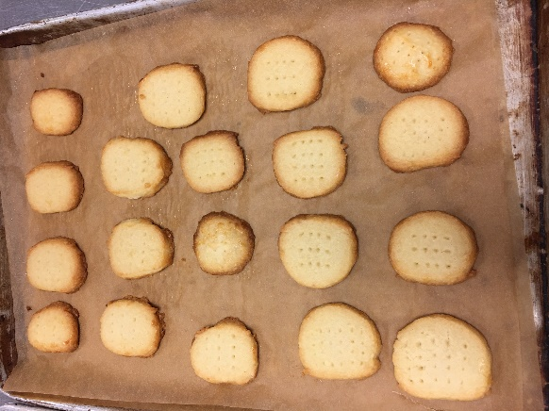
Whole-Wheat Sandwich Bread scaled Traditional shortbread (Cookies)
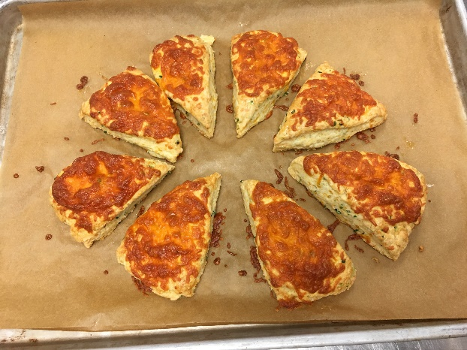
Cheddar-Chive Scones

C.)Method Mixing, baking:
- Divide dough into 4 uniform pieces and shape into loaves
- Egg wash
- Butter chunk(Mix cold cube butter with flour)
- Granish with grated cheddar
- Blend the butter and powdered sugar without creaming
- Divide dough into two portion, roll to disks, wrap in plastic, freeze until hard
- Egg wash freezer and unwrap disk and cut each disk into eight wedges

d.) Outcomes:
- Whole-Wheat Sandwich bread surface has a nice colour, but did not fully cooked
- Cookies were baked well, but the shapes were different
- Cheddar-Chive scones looks nice, but few pieces were not firm

2. Timeline for my products:
- 12:00- 13:00 Instrucitons and started scale all ingredients
- 13:05- 13:25 Demo for whole wheat sandwish bread
- 13:30 Started to make sandwich bread and kept scaling
- 13:50 – 13:59 Traditional shortbread (Cookies) demo
- 14:12 Put cookies dough into fridge
- 14:17 Put sandwich dough into proofer
- 14:23-14:52 Demo for cheddar-chive scone
- 15:20 Put cheddar into oven
- 15:30 Demo for whole wheat bread again and proof again
- 15: 50-16:20 Baked bread
- 16:00-16:30 Baked cookies
- 16:35-17:15 Clean up, grading and demo of how to make old dough(as yeast)

3. List my temperature chart
- Cookies: 375F
- Scones: 400F
- Bread:375F

4. My personal thoughts about my production
I thought the bread looks nice, even though the bread may needed long time to bake, overall was nice because the bread proofed to the desired size and surface were dark brown without burning. The cookies were not over baked, but we did not portion well that they did not have equally nice looking. Cheddar-Chive Scones cut in similar size and baked golden brown but some scones did not firm well.

5. Describe the chef’s critique and recommendations for improvement.
1.) Chef’s critique:
Bread need to cook longer because it was under baked
Cookies shape did not equal portions
We put too much cheddar cheese on the top of scones which cause some pieces did not look nice.
2.) Recommendation:
Let the bread cook longer next time
Tried to portioned cookies dough equally before putting into the oven
Reduce the grated cheddar for garnishing the scones

6. Write any questions that you need clarified. If you have no questions about the content we are covering, please feel free to pick my brain about other things pertaining to the industry. No personal questions, please. This section is NOT optional.
- How to check whether the bread fully cooked without breaking the bread surface?
- If the bread surfaces looks nice, how to indicate internal also ready?
- Why we cut the cookies dough equally, but after baking the shape did not present like desired shape?
- How can we know that we did not put too much cheddar on the top of the scones?

Week 5

Menu

Baguette

Pie dough and Pecan Pie

Bird’s Nest Cookies

Recipes and Methods:

Baguette

Ingredients:

Bread Flour 1 kg
Water 625 ml
Salt 20 g
Yeast 25 g

Method: Straight dough method

Pie Dough
Ingredients:

Pastry Flour 350 g
Salt 5 g
Sugar 12 g
Cold, Unsalted Butter, cut into small cubes 225 g
Ice Water 75 – 100 ml

Directions:

- Sift flour, salt and sugar into bowl.

- Cut or rub butter into flour to desired size.

- Gradually add water to flour mixture. Mix gently, just until water is absorbed and dough comes together. Do not overwork dough.

- Wrap dough in plastic wrap and chill for at least an hour.

- Scale dough at 300 g for bottom crust and 250 g for top crust.

- Roll pastry 1/8” thick.

Pecan Pie
Ingredients:

Pie Dough 225 g
Pecan Halves 150 g
Brown Sugar 170 g
Golden Corn Syrup 170 g
Eggs 150 g
Butter 35 g
Vanilla Extract 2 g

Method:

- Line form with pie dough. Chill in fridge.

- Line with foil and par bake at 300°F.

- Deposit pecans evenly in pastry shell.

- Heat brown sugar, corn syrup vanilla and butter into a pot until melted & combined.

- Whisk eggs and temper with sugar mixture.

- Strain & cool.

- Pour filling over pecans.

- Bake at 300°F until set.

Bird’s Nest Cookies
Ingredients:
Bread Flour 180g
Butter 140g
Sugar 80g
Baking Soda 1g
Raspberry Jam 50g

Method:
- Mix all ingredients except the raspberry jam with the paddle attachment until smooth. Do not overmix.

- Divide dough into 2 x 200g balls.

- Roll each piece into a cylinder about 12 inches long. Roll each cylinder in coconut.

- Cut each cylinder into 12 portions.

- Place 6 x 4 on a parchment lined pan.

- Press a small indent in the centre of each cookie and fill with raspberry jam

- Bake at 375°F for approximately 15-20 minutes.

Reflection

1. Describe the key points of the lesson:

a.) Menu list of your products
Baguette: Made by bread flour, warm water, salt, fresh yeast and old dough(300g)
Pecan Pie:
1.) Pie dough: Combination of pastry flour, salt, sugar, cold unsalted butter, ice water
2.) Fillings: Mixture of pecan halves. brown sugar, golden corn syrups, eggs, butter, vanilla extract
Bird’s Nest Cookies: Incorporate of bread flour, butter, sugar, baking soda, before putting into the oven press a small indent in the center of each cookies and add a little bit raspberry jam

b.) Picture of my products:
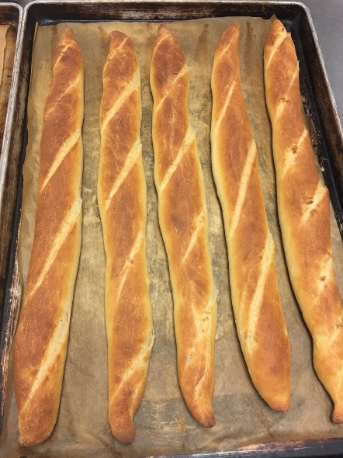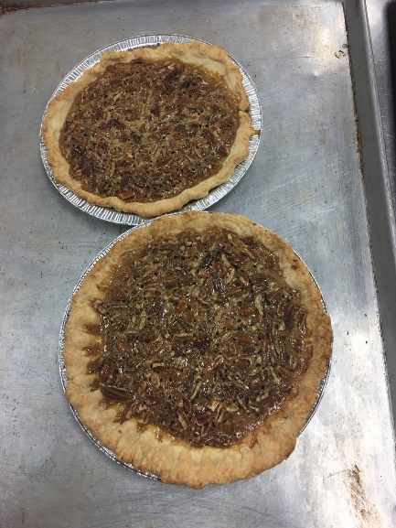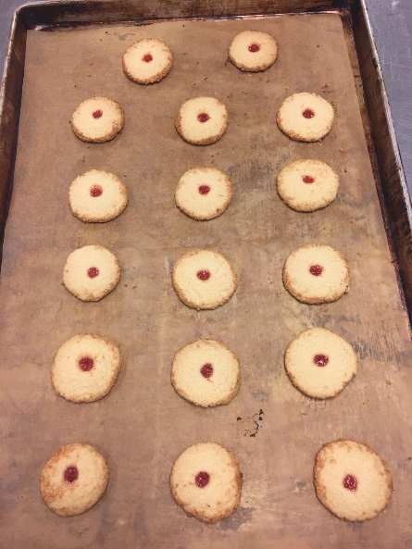
Baguette Pecan Pie Bird’s Nest Cookies

c.) Method Mixing, baking
Using the straight dough method, make the baguette and make sure separate each of them by using special towel, and cutting the carefully/evenly before putting into the over; Chilled the pie dough and fold nicely put into the oven baking for few minutes and then adding the filling for pecan pie. For bird’s nest cookies we applied the shortbread methods from last week lessons and learned how to press a small indent in the centre of the cookie by using our wood spoon.

d.) Outcomes:
We baked baguette to nice golden color and our cookies nicely portioned this week. We made sure the shape of the cookies was looking similar. The pie dough did not look nice but we baked properly without browning them.

2. Timeline for my products:
12: 00 – 13:15 Lectures and prepare/weight all ingredients
13:19 Demo for Baguette
13:25 Started to make Baguette
13:50 Demo for pie dough
14:16 Bird’s Nest Cookies Demo
14: 30 – 14: 50 Mix all the cookie ingredients put into the fridge
15:00 Demo about made the baguette into desired shape and put into the proofer
15:15 Pecan filling demo
15:30 Baked cookies
16:00 Started to bake the baguette
16:10 Domo for folding dough and add fillings
16:20 Started to bake pecan pie

3. List my temperature chart
1) Baked Baguette in 400F
2) Cookies and pie baked at 375F

4. My personal thoughts about my production
I thought we were improving skills of portion and creating a nice/even looking for our cookies. We did a good job this week by complete a high quality products for baguette and cookies. Even though the pie doughs were not meet some requirements, we still bake them in the right temperature and properly control the cooking time that overall the pie taste good and cooked nicely.

5. Describe the chef's critique and recommendations for improvement.
1) Chef's critique:
Good job and our group were the only group received full marks for baguette
Nice cookies, the shapes were good and baked well
Pecan pie dough was not look nice, but baked long enough that the dough was crispy and filling was properly cooked without maintain any liquid running

2) Recommendation:
Just keep practicing how to make a good pie dough by folding nicely. Keep up the good work.

6. Write any questions that you need clarified. If you have no questions about the content we are covering, please feel free to pick my brain about other things pertaining to the industry. No personal questions, please. This section is NOT optional.
1) How to make sure the pie dough can equally lay into the baking tray because sometimes we have some challenges to balance the thickness for all sides when we folded dough?
2) How long we suppose to chill the Bird’s Nest cookies dough? If we did not put the dough into the fridge can we still received same outcomes?

Week 6

Menus

Raisin and Cheese Bread

Pie dough and Chocolate Cream Pie

Soft Yeast Dinner Rolls

Oatmeal Cookies

Recipes and Methods:

Raisin Bread
Ingredients:
Bread Flour 450 g
Salt 8g
Butter 36 g
Sugar 20 g
Milk Powder 28 g
Egg 20 g
Water (warm) 260 g
Fresh Yeast 28 g
Raisins 226 g

Method:

- Combine first 6 ingredients in the mixing bowl.
- Dissolve yeast in the water and add to ingredients in the bowl.
- Combine until sides of bowl are clean.
- Knead dough into a round ball. Autolyze.
- Knead dough for 2 minutes or until supple, smooth and elastic feeling.
- Ferment until doubled.
- Degas and knead in raisins until fully incorporated.
- Portion dough into two and round off. Bench 20 minutes.
- Shape dough into loaves and place into prepared bread tins.
- Proof.
- Bake at 400 F for 25 – 30 minutes.
- Wash the top of the crust with melted butter while still hot.
- Cool.
VARIATION: For Cheese Bread – Replace raisins with 120 g grated cheese.

Chocolate Cream Pie

Ingredients:
Brown Sugar 140 g
Milk 640 ml
Cocoa Powder 10 g
Egg Yolks 48 g
Cornstarch 30 g
Bittersweet Chocolate 140 g
Butter 40 g
Vanilla Extract 10 ml
Pre-baked Flaky Pie Shell 1
Whipping Cream 300 ml
Vanilla Extract 7 ml
Icing Sugar 10 g
Chocolate Shavings 80 g

Methods:

- In a sauce pan, dissolve half of the brown sugar in the milk. Add the cocoa powder and bring to a boil.
- Mix the egg yolks and remaining sugar until smooth. Add cornstarch, whisking well.
- Temper the egg mixture with some of the hot milk mixture. When the eggs are hot, pour them back into the remaining milk mixture and boil, whisking constantly.
- Allow the cream to boil for 2 minutes until thick, while whisking constantly.
- Remove from heat and add the chocolate, vanilla and butter. Stir until incorporated.
- Pour into pie shell and cool completely. Refrigerate.
- Whip cream until soft peaks. Add vanilla and icing sugar. Whip until stiff peaks.
- Top pie with whipped cream, making sure that the entire surface is covered.
Decorate with chocolate shavings.

Soft Yeast Dinner Rolls

Ingredients:
yeast, dry active | 20g
water (temperature controlled) | 243 g
flour, bread | 446 g
salt | 10g
sugar, granulated | 41 g
milk, nonfat dry | 20 g
shortening, vegetable | 20g
butter, unsalted (softened) | 20 g
eggs | 32g(1 egg)
Egg Wash | as needed

Methods: Straight Dough Method

Directions:

- Dissolve the yeast in the water in a bowl. Combine the flour, salt, sugar, milk powder, shortening, butter and eggs in the bowl of a mixer fitted with a dough hook.

-Add the water-and-yeast mixture to the mixer bowl; stir to combine.

-Knead on medium speed 10 minutes or until the dough reaches 77°F (25°C).

-Transfer the dough to a lightly greased bowl, cover and place in a warm spot. Ferment until doubled, approximately 1 hour.

-Punch down the dough. Let it rest a few minutes to allow the gluten to relax.

-Divide the dough into 1 1/4-ounce (38-gram) portions and round. Shape as desired and arrange on paper-lined sheet pans. Proof until doubled in size.

-Carefully brush the proofed rolls with egg wash. Bake at 400°F (200°C) until medium brown, approximately 12 to 15 minutes.

Oatmeal Cookies

Ingredients:
flour, all purpose or pastry flour | 167g
baking soda | 2g
cinnamon, ground | 3g
oats, quick-cooking | 144g
butter, unsalted (softened) | 144g
sugar, granulated | 144g
sugar, light brown | 144g
Eggs | 51g
orange juice concentrate | 25mL
vanilla extract | 8mL
salt | 3g
Butterscotch chip | 191g
Directions:

- Sift together the flour, baking soda and cinnamon. Stir in the oats and set aside.

- Cream the butter until light and fluffy. Add the sugars and continue creaming until the mixture is lightened. Add the eggs one at a time, scraping down the bowl frequently and mixing well after each addition. Add the orange juice concentrate, vanilla extract and salt.

- Fold in the flour mixture and the raisins. Portion the dough onto paper-lined sheet pans.

- Bake at 375°F (190°C) until golden, approximately 10 to 12 minutes.

Reflection

1. Describe the key points of the lesson:
a.) Menu list of your products
Raisin and Cheese Bread: Combine bread flour, salt, butter, sugar, milk powder and egg together; dissolve the yeast in the warm water add to the mixed flour and incorporate with the raisin for one and other one add cheese ferment until double and proof; bake well
Chocolate Cream Pie:
1.) Pie dough: Combination of pastry flour, salt, sugar, cold unsalted butter, ice water
2.) Fillings: Dissolve brown sugar in the milk and mix egg yolk and remaining sugar; add all the rest ingredients; put into fridge before serve

Soft Yeast Dinner Rolls: Dissolve dry yeast in warm water and combine all the ingredients; covered and placed in a warm place until ferment double and distribute dough to 50g each and tie the dough once or twice to allow the shape meet the desired requirement. Egg wash and bake.

Oatmeal Cookies: Sift all dry ingredients to a bowl stir in the oats, creamy the liquid by combine the butter, sugar and eggs(one at a time) until light and fluffy; fold in the flour mixture and raisin, portion the mixture evenly to the pan and baking until golden

b.) Picture of my products:
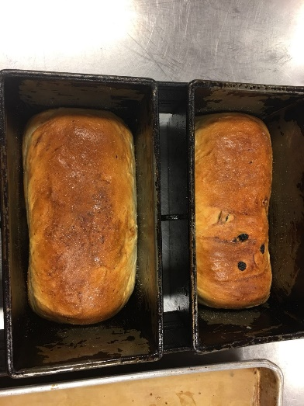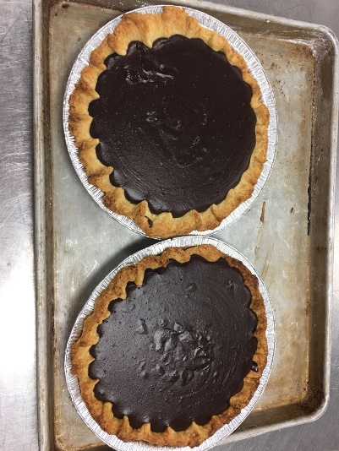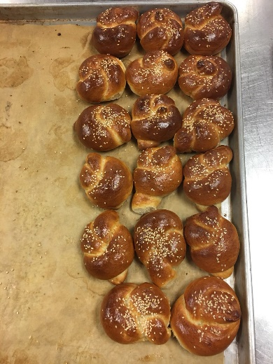
Raisin and Cheese Bread Chocolate Cream Pie Soft Yeast Dinner Rolls
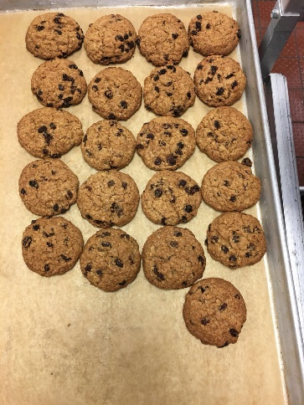 Oatmeal Cookies
c.) Method Mixing, baking
Raisin and Cheese bread: Rolling the dough to round ball before ferment, portion the dough into two pieces equally and shape the dough to loaves
Chocolate Cream Pie: Fold the pie dough, and baking until golden; evenly portion the fillings and distribute evenly to the dough
Soft Yeast Dinner Rolls: Knead all ingredients allow to ferments; punch down the dough before fold to desired shape; put into proof until double and bake
Oatmeal Cookies: Sift all dry ingredients, using creamy methods and fold in the raisins; portion the dough equally drop to the paper-lined sheet pans bake right way.

d.) Outcomes:
The raisin and cheese bread colour looks nice but the cooking time did not long enough, chocolate pie fillings were formed and the shapes were fold and present better than previous week. Soft yeast dinner rolls baked well and the folded to the desired shapes. The cookies turned out a little bit brown, but overall were good and taste good.

2. Timeline for my products:
6:35 – 7:00 Lectures and prepare/weight all ingredients
7:05 – 7:15 Demo for soft yeast dinner roll dough
7: 20- 7:30 Started to make dinner roll dough
7: 45 Demo for raisin and cheese bread
8: 15 – 8: 25 Demo for cookies
9: 00 Demo for fold dinner put into proofer and started to make cookies
9:15 Demo for fold the raisin and cheese bread
9:30 Baked cookies
9:45 Baked dinner roll and chocolate pie filling demo
10:15 – 10:35 Started to make pie filling and put into fridge
11: 00 – 11: 25 Baked raisin and cheese bread
11: 10 Clean up the kitchen and chef critique

3. List my temperature chart
1) Baked raisin and cheese bread and dinner rolls in 400F
2) Oats Cookies baked at 375F
3.) Chocolate pie need to put into the fridge to cool

4. My personal thoughts about my production
I thought we were doing a better job to make pie dough and learned some new skills on tie the dough for dinner roll. This week we did four products which I found time management and work effectiveness and efficiency were really important. Most of our products outcomes were good, but there were many skills I still need to keep practicing and learned from the mistakes that I made such as the time control for the cookies to avoid brown colour or making sure double checked the bread baked long enough before removed from oven.

5. Describe the chef's critique and recommendations for improvement.
1) Chef's critique:
Raisin and cheese breads were undercooked
Chocolate pie did not have the topping
Soft yeast dinner rolls the shapes were good and color were nice golden
Oatmeal cookies were over baked a little bit

2) Recommendation:
Raisin and cheese breads should cook longer
Cookies must have the golden color without brown them
Chocolate pie should have a topping on them

6. Write any questions that you need clarified. If you have no questions about the content we are covering, please feel free to pick my brain about other things pertaining to the industry. No personal questions, please. This section is NOT optional.
1) How to make sure the bread was fully cooked because sometime I found out the surface already golden I though it was ready but still undercooked. How to check the doneness and without brown it?

Week 7

Menus

Pound Cake

Multigrain Sourdough Bread

Cranberry White Chocolate Orange Scones

Morning Glory Muffins

Recipes and Methods:

Pound cake
Ingredients
flour, cake | 397g
baking powder | 7 g
butter, unsalted (room temperature) | 284g
sugar, granulated | 435g
corn syrup, light (or use additional granulated sugar) | 19g
salt | 7 g
eggs (room temperature) | 302g
vanilla extract | 5mL
almond extract (optional) | 5mL
Lemon Zest | 1g
Orange Zest | 1g
buttermilk (room temperature) | 158mL

Directions:
- Sift the flour and baking powder together. Set aside.

- Cream the butter until light and lump-free. Add the sugar, corn syrup and salt. Cream on medium speed until light and fluffy. Add the eggs a few at a time, allowing them to be completely incorporated before adding more eggs. Scrape down the bowl after each addition.

- Add the vanilla and almond extract (if using) and the lemon and orange zest.

- Fold in the dry ingredients alternately with the buttermilk in three additions each.

- Divide the batter evenly into three 9-inch × 5-inch (22-centimeter × 12-centimeter) greased loaf pans. Bake at 400°F (200°C) for 15 minutes, then reduce the oven temperature to 350°F (180°C). Bake until the centers of the cakes bounce back when lightly pressed, approximately 45 to 55 minutes. If the cakes begin to darken, cover them loosely with aluminum foil.

- Cool the cakes in their pans on a wire rack for 10 minutes. Unmold and cool completely.

Multigrain Sourdough Bread

Ingredients:
cracked wheat | 128g
water (warm) | 237 mL
butter (melted) | 57g
molasses | 43g
honey | 43g
salt | 6g
milk, nonfat dry | 57g
flax seeds | 57g
sunflower seeds (roasted) | 57g
Simple Sourdough Starter | 624g
yeast, dry active | 4g
flour, whole wheat | 284g
flour, bread | 284g
Egg Wash | as needed
Directions:
- Combine the cracked wheat and hot water in the bowl of an electric mixer. Add the butter, molasses, honey, salt and milk powder. Set aside to cool.
- When the mixture has cooled to lukewarm, stir in the flax seeds, sunflower seeds, starter and yeast. Stir in the whole-wheat flour, then gradually add the bread flour. When the dough begins to stiffen, attach the bowl to a 6 quart (6.5 liter) or larger mixer fitted with a dough hook and continue adding the bread flour. Knead until the dough is smooth and elastic, approximately 5 minutes.

- Place the dough in a lightly oiled bowl, cover and ferment until doubled.

- Punch down the risen dough, cover and ferment again.

- After the second rise, punch down the dough and divide into two equal portions. Place the dough into two well-greased loaf pans, cover and proof the dough until doubled again.

- Brush the surface of each loaf with egg wash and make two or three cuts across the top of each loaf. Bake at 375°F (190°C) until done, approximately 30 minutes.

Cranberry White Chocolate Orange Scones (Yield: 8 scones)

Ingredients:

All Purpose Flour 200 g
Sugar 25 g
Salt 1g
Baking Powder 10 g
Cold unsalted Butter 80 g
Orange Zest 5g
Dried Cranberries 50 g
Eggs 30 g
Milk 45 g
Cream 45 g
White Cho chips 150 g

Method: Biscuit

Directions:

- Sift together dry ingredients.

- Add cold, cubed butter and blend to pea-sized pieces.

- Add dried cranberries and orange zest.

- Combine eggs, milk and cream and add to dry ingredients.

- Mix until dough just comes together.

- Add Cho chips

- Roll or part into a ½“ thick circle and cut 8 wedges.

- Bake at 400°F for 15-20 minutes or until golden and puffed.

Morning Glory Muffins

Ingredients:

200 g All Purpose Flour
40gr whole wheat flour
170 g Granulated Sugar
100gr Brown Sugar
10 g Baking Soda
Pinch Salt
2 g Cinnamon, ground
210 g Carrots, grated
90 g Raisins
60 g Pecan pieces
60 g Coconut, shredded
90 g Apple, grated
150 g Eggs
160 g Canola Oil
10 ml Vanilla Extract

Method: Muffin Method

Directions:

- Sift the dry ingredients together and set aside.

- Combine the carrots, raisins, pecans, coconut and apple. Mix in with the dry ingredients until
each piece is coated with flour evenly.

- Whisk together the eggs, oil and vanilla. Add to the dry ingredients.

- Mix batter until just combined.

- Portion into greased muffin tins and bake at 350°F until done.

Reflection

1. Describe the key points of the lesson:

a.) Menu list of your products:

Multigrain Sourdough Bread: Used warm water dissolved the dry yeast incorporate with equal amount of whole wheat and bread flour, butter, salt and milk powder. Put the seeds in the ends to avoid gluten break.

Cranberry White Chocolate Orange Scones: Sift all dry ingredients and combine with cold butter, cranberries, and orange peeled skin(zest); incorporate with eggs, milk and cream mix well; roll and cut into desired shape bake immediately to avid butter melting.

Morning Glory Muffins: Sift flours(all purpose and whole wheat), granulated sugar, brown sugar, baking soda, salt and ground cinnamon; combine all dry ingredients and incorporated with eggs, oil and vanilla. Mix every thing together and portion equally to the muffin pan.

Pound Cake: Creamy butter, sugar, corn syrup and salt; add eggs a few at a time and allow them to be completely incorporated before adding more eggs. Mix the vanilla, lemon and orange peeled skin(zest). Sift the flour and baking powder fold with buttermilk. Pull into the baking pan and bake until begin to darken.

b.) Picture of my products:
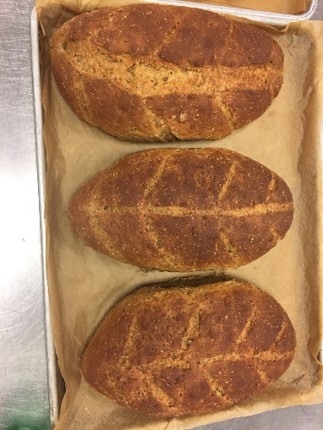 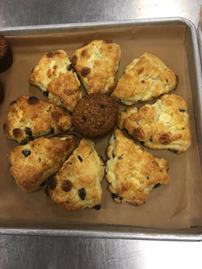 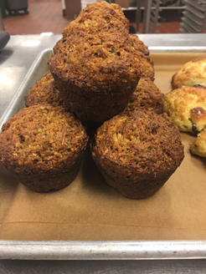Multigrain Sourdough Cranberry White Chocolate Morning Glory Muffins
Bread Orange Scones
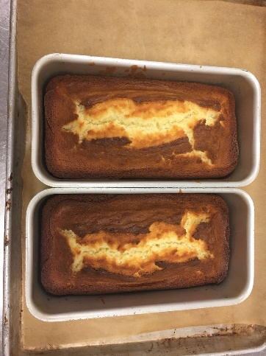 Pound Cake

c.) Method Mixing, baking:
Multigrain Sourdough Bread: Kneaded and punched down the dough; Mixed with seeds without breaking gluten; Rolled the dough into the desired shapes (round or demoed shape)
Cranberry White Chocolate Orange Scones: Biscuit methods
Morning Glory Muffins: Muffin Methods
Pound Cake: Creamy methods

d.) Outcomes:
The shape of the breads was good and colour were nice golden brown. The scones looked nice and equally cut into desired shape. The muffins looked a little burnt and dry, but the shapes looked same. The pound well baked.

2. Timeline for my products:
12:00-12:30 Instruction for the day and went through the recipes.
12: 45 Started to measure all ingredients
13:16 Sourdough Bread Demo
13:30 Started to made bread and waited dough to be doubled
14: 32 Morning Glory Muffins Demo
15:00 Started to make baked muffins
15: 20 Started to make Cranberry White Chocolate Orange Scones and baked right way
15: 30 Demo about how to roll and made bread into desired shapes
15: 45 – 16: 35 Proofed and baked bread
16:30 -17: 00 Clean up kitchen and chef critiques

3. List my temperature chart:
Multigrain Sourdough Bread: 375F
Cranberry White Chocolate Orange Scones: 400F
Morning Glory Muffins: 350F
Pound Cakes: 400F

4. My personal thoughts about my production
This week I though my bread baked well, even though the shape broke a little bit, the colour and surface looked nice. The scones were equally distributed and present with nice golden color. The muffins did not look nice because they were too small and dry. The baked time a little bit too long with some dark colour. Pound cakes overall were very nice.

5. Describe the chef's critique and recommendations for improvement.
1.) Chef's critiques:
Multigrain Sourdough Bread: Nice color and well baked, but the bread surface spilt and surface did not cut well for one bread
Cranberry White Chocolate Orange Scones: Well baked but maybe prepared too long, but few slices the shape did not puffed. Overall, everything was prefect.
Morning Glory Muffins: Baked a little bit too long, so dark colour appeared. Muffins were too dry.
Pound Cakes: Nicely done, good dark brown colour and equally distributed into different baking pan. The cakes were soft and well done.

2.) Recommendations:
When cut a bread, we could use a small knife and should not allow too many airs incorporated with the dough because it could cause the bread spilt. We could cut the bread by using the oblique line.

6. Write any questions that you need clarified. If you have no questions about the content we are covering, please feel free to pick my brain about other things pertaining to the industry. No personal questions, please. This section is NOT optional.
1.) If the muffin batter too dry, which liquid we could add to increase the moisture？
2.) When we cut the bread, we thought it looked nice but why the outcomes did not turn well?
3.) How to make sure the scone puffed every time? We made same mistake and tried to avoid or improved this time but some scone still not good enough.

Week 8

Menus

Soft Yeast Dinner Rolls

Sour Cream Coffeecake

Cinnamon Buns and caramel Glaze

Butter Cookies

Recipes and Methods:

Soft Yeast Dinner Rolls

Ingredients:
yeast, dry active | 20g
water (temperature controlled) | 243 g
flour, bread | 446 g
salt | 10g
sugar, granulated | 41 g
milk, nonfat dry | 20 g
shortening, vegetable | 20g
butter, unsalted (softened) | 20 g
eggs | 32g(1 egg)
Egg Wash | as needed

Methods: Straight Dough Method

Directions:

- Dissolve the yeast in the water in a bowl. Combine the flour, salt, sugar, milk powder, shortening, butter and eggs in the bowl of a mixer fitted with a dough hook.

-Add the water-and-yeast mixture to the mixer bowl; stir to combine.

-Knead on medium speed 10 minutes or until the dough reaches 77°F (25°C).

-Transfer the dough to a lightly greased bowl, cover and place in a warm spot. Ferment until doubled, approximately 1 hour.

-Punch down the dough. Let it rest a few minutes to allow the gluten to relax.

-Divide the dough into 1 1/4-ounce (38-gram) portions and round. Shape as desired and arrange on paper-lined sheet pans. Proof until doubled in size.

-Carefully brush the proofed rolls with egg wash. Bake at 400°F (200°C) until medium brown, approximately 12 to 15 minutes.

Sour Cream Coffeecake

Ingredients:
Filling
flour, all purpose | 11g
cinnamon, ground | 6g
sugar, light brown | 170g
pecan halves (chopped) | 113g
butter, unsalted (melted) | 28g
Cake
butter, unsalted | 113.4 g
sugar, granulated | 227g
eggs | 2 eggs
cream, sour | 227g
flour, cake (sifted) | 198g
salt | Pinch
baking powder | 4 tsp
baking soda | 4 tsp
vanilla extract | 4mL

Directions:

- To make the filling, blend all the filling ingredients together in a small bowl. Set aside.

- To make the cake batter, cream the butter and sugar. Add the eggs one at a time, beating well after each addition. Add the sour cream. Stir until smooth.

- Sift the sifted flour, salt, baking powder and baking soda together twice. Stir into the batter. Stir in the vanilla.

- Spoon half of the batter into a greased tube pan. Top with half of the filling. Cover the filling with the remaining batter and top with the remaining filling. Bake at 350°F (180°C) for approximately 35 minutes.

Cinnamon Buns

Ingredients:

Brown Sugar 25g
Salt 4g
Shortening 37g
Milk Powder 18g
Egg 15g
Water 175 g
Fresh Yeast 16 g
Bread Flour 282 g
Pastry Flour 33 g
Raisins or Chopped Pecans 60 g
Egg Wash as needed
Cinnamon Sugar as needed

Method: Enriched straight dough

Directions:

- Place first four ingredients in a bowl and mix with a dough hook until combined.

- Add egg and mix.

- Dissolve yeast in water and add to mix.

- Add flours and mix for 2 minutes or until combined.

- Knead on bench until gluten is fully developed.

- Bench for 20 – 30 minutes @ 29°C dough temperature.

- After benching, roll dough to about a 12” x 10” rectangle. About 1/8” thick.

- Egg wash, sprinkle with cinnamon sugar and raisins or chopped pecans, leaving one long edge free.

- Egg wash bottom and roll into a cylinder.

- Cut into half, divide into 6 – 7 pieces

- Place into a greased 8” cake ring prepared with caramel glaze.

- Proof and bake at 375°F

Caramel Glaze

Ingredients:

Brown Sugar 100 g
Glucose 10 g
Water 15 g
Butter 25 g
Cinnamon 2 g

Methods:

- Combine ingredients to make a smooth paste.

- Smear onto bottom of pan.

Butter Cookies

Ingredients:

Butter, softened 250g
Icing Sugar 150g
Egg 50g
Vanilla Extract 15ml
Orange Extract 5Drops
Almond Extract 5ml
Salt 6g
Pastry Flour 330 g
Pistachios 1
Dried Cherries 1
Slivered Almonds 1

Method: Creamy Method

Directions:

- Cream butter and sugar. Gradually add the egg, flavourings, and salt.

- Blend in the flour until just combined.

- Using a piping bag and medium star tip, pipe 2” rosettes on parchment-lined sheet pans.

- Place a pistachio, dried cherry and almond on each cookie.

- Bake at 350°F until golden. ~ 10-12 minutes.

Reflection

1. Describe the key points of the lesson:

a.) Menu list of your products:

Soft Yeast Dinner Rolls: Using warm water dissolve the yeast and incorporate into the flour mixture(flour, salt, sugar, milk powder, shortening, butter and eggs), Ferment until double approximate 1 hour, punch down the dough and round(50 g each), proof and baked

Sour Cream Coffeecake:
Fillings: Blend all-purpose flour, ground cinnamon, brown sugar, chopped pecan and melted butter
Cake: Cream the cake batter by incorporate the butter, sugar and eggs together, sift all dry ingredients and stir into the batter;
*Lay the half cake batter to the baking pan bottom and cover the fillings, repeat the process(to with the fillings), Baked about 1 hour

Cinnamon Buns:
Buns: Combine brown sugar, salt, shortening, milk powder and egg. Dissolve the yeast into the warm water, add to egg mixture and combine with flour. knead and bench
Caramel Glaze: Mix brown sugar, glucose, water, butter and cinnamon to make the smooth paste.
* Lay the caramel glaze on the bottom of the baking pan; roll the dough, egg wash the surface, sprinkle with cinnamon sugar and raisins and chopped pecan, fold the dough and cut into 6 to 7 pieces, put in to the caramel glaze pan, proof and bake. After removing from the oven, turn it over and remove the buns from the pan immediately(upside down).

Butter Cookies: Mix the butter and icing sugar, add eggs a little at a time until fully incorporate before add more; blend in the flour until just combined and piping the batter directly to the baking pan. Attach one piece of a pistachio, one dried cherry and one almond on each cookie’s centre; bake until golden.

b.) Picture of my products:
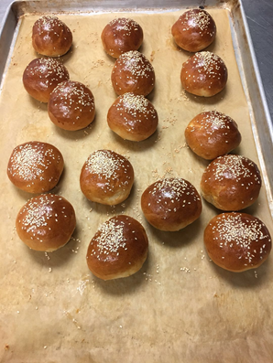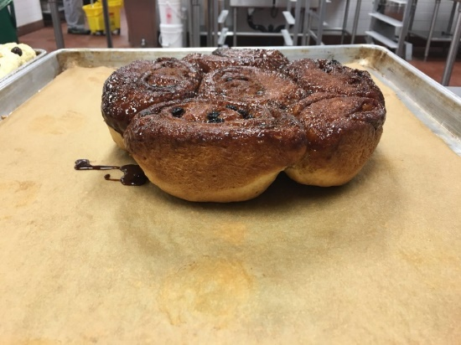
Soft Yeast Dinner Roll Cinnamon Buns
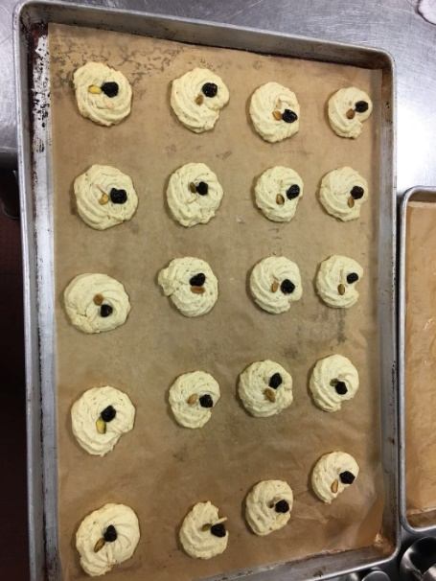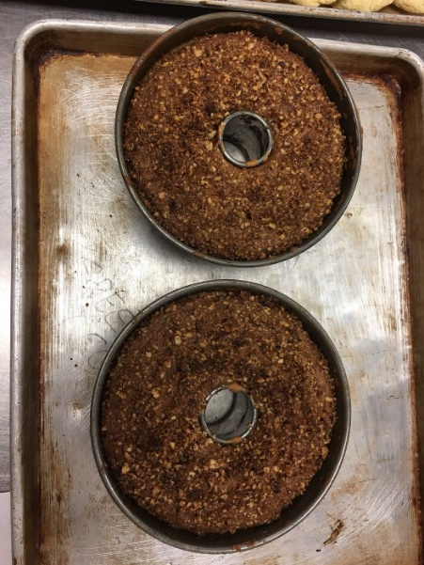
Butter Cookies Sour Cream Coffeecake

c.) Method Mixing, baking:
Dinner Roll: Straight dough method
Sour Cream: Creamy method
Cinnamon Buns: Enriched straight dough method
Butter Cookies: Creamy method

d.) Outcomes:
Today our soft yeast dinner rolls the colour was nice golden brown and proof large enough. The sour cream coffeecakes baked long enough, but compare with chef’s demo, the colour was a little bit dark. Cinnamon buns colour looked nice, but few shapes not similar with others. Butter cookies were golden and shapes were good.

2. Timeline for my products:
12:15 Scale all ingredients
12: 40 Demos of dinner rolls
12: 55 Started to made roll dough and waited doubled
13: 05 Demoed caramel glaze
13: 10 Made caramel glaze and sit aside
13: 30 Made cinnamon buns dough
13: 50 Demo of butter cookies
14: 15 Stared to made cookies
14: 30 – 15:00 Started to punched and made rolls; putted into the proofer
14: 45 Started to bake the cookies
14: 50 Demoed sour cream coffeecake
15: 05 Removed the cookies from the oven and demoed cinnamon buns
15: 25 Made cakes and put the cinnamon buns to proofer
15: 45 Baked cakes
16:00 Egg wash and garnish with white sesames
16: 10 Started to bake dinner rolls
16: 15 Started to bake the cinnamon buns
16: 45 Remove the cinnamon buns upside down
16: 50 – 17: 10 Remove the cake from the oven and chef critiques

3. List my temperature chart:
Soft Yeast Dinner Rolls: 400F
Sour Cream Coffeecake: 350F
Cinnamon Buns: 375F
Butter Cookies: 350F

4. My personal thoughts about my production
Overall, I thought we did a good job on time management because we finished our products on time. Soft dinner roll doubled and proofed into the desire sizes. However, we did not round well before baking, so they did not the same for some rolls. I though our cakes and cookies was good. For cinnamon buns, the shape did not look nice but the outcome was good.

5. Describe the chef's critique and recommendations for improvement.
Soft dinner rolls: We still need work on the round skills because some rolls the shape were not round enough and did not look nice
Sour Cream Coffeecake: The colour looked too dark and the sugar not enough because it tasted not sweet enough.
Cinnamon Buns: Good
Butter Cookies: The piping should practice more, too many bubbles in the cookie’s surface, not sweet, and dry ingredients were falling apart from the centre so we must make sure next time we needed to attached them harder.

6. Write any questions that you need clarified. If you have no questions about the content we are covering, please feel free to pick my brain about other things pertaining to the industry. No personal questions, please. This section is NOT optional.
1.) How to make sure the garnish ingredients can attach to the cookies/bread without breaking the surface and do not fall apart?
2.) How to check whether the butter soften enough before creamy because this week we had a problem with creamy the butter with sugar because the butter was

Week 9

Final Practical Exam

Menus

Soft Yeast Dinner Rolls

Pie dough and pecan pie

Cheddar-Chive Scones

Butter Cookies

Recipes and Methods:

Soft Yeast Dinner Rolls

Ingredients:
yeast, dry active | 20g
water (temperature controlled) | 243 g
flour, bread | 446 g
salt | 10g
sugar, granulated | 41 g
milk, nonfat dry | 20 g
shortening, vegetable | 20g
butter, unsalted (softened) | 20 g
eggs | 32g(1 egg)
Egg Wash | as needed

Methods: Straight Dough Method

Directions:

- Dissolve the yeast in the water in a bowl. Combine the flour, salt, sugar, milk powder, shortening, butter and eggs in the bowl of a mixer fitted with a dough hook.

-Add the water-and-yeast mixture to the mixer bowl; stir to combine.

-Knead on medium speed 10 minutes or until the dough reaches 77°F (25°C).

-Transfer the dough to a lightly greased bowl, cover and place in a warm spot. Ferment until doubled, approximately 1 hour.

-Punch down the dough. Let it rest a few minutes to allow the gluten to relax.

-Divide the dough into 1 1/4-ounce (38-gram) portions and round. Shape as desired and arrange on paper-lined sheet pans. Proof until doubled in size.

-Carefully brush the proofed rolls with egg wash. Bake at 400°F (200°C) until medium brown, approximately 12 to 15 minutes.

Pie Dough

Ingredients:

Pastry Flour 350 g
Salt 5 g
Sugar 12 g
Cold, Unsalted Butter, cut into small cubes 225 g
Ice Water 75 – 100 ml

Directions:

- Sift flour, salt and sugar into bowl.

- Cut or rub butter into flour to desired size.

- Gradually add water to flour mixture. Mix gently, just until water is absorbed and dough comes together. Do not overwork dough.

- Wrap dough in plastic wrap and chill for at least an hour.

- Scale dough at 300 g for bottom crust and 250 g for top crust.

- Roll pastry 1/8” thick.

Pecan Pie
Ingredients:
Pie Dough 225 g
Pecan Halves 150 g
Brown Sugar 170 g
Golden Corn Syrup 170 g
Eggs 150 g
Butter 35 g
Vanilla Extract 2 g

Method:

- Line form with pie dough. Chill in fridge.
- Line with foil and par bake at 300°F.
- Deposit pecans evenly in pastry shell.
- Heat brown sugar, corn syrup vanilla and butter into a pot until melted & combined.
- Whisk eggs and temper with sugar mixture.
- Strain & cool.
- Pour filling over pecans.
- Bake at 300°F until set.

Cheddar–Chive Scones (Yield: 8 Scones)

Ingredients:
All Purpose Flour 200 g
Salt 2g
Baking Powder 12 g
Cold, Unsalted Butter 80 g
Chopped Fresh Chives 10 g
Grated Cheddar Cheese 50 g
Eggs 30 g
Milk 45 g
Cream 45 g

Egg wash and grated cheddar for garnish

Method: Biscuit Method

Directions:
- Combine dry ingredients with paddle attachment.

- Add cold, cubed butter and blend to pea sized pieces.

- Add chives and grated cheddar cheese.

- Add egg, milk and cream and mix just until dough comes together.

- Roll into a ½” thick circle and cut 8 wedges.

- Egg wash and garnish with grated cheddar.

- Bake at 400°F for about 15 – 20 minutes.

Butter Cookies

Ingredients:

Butter, softened 250g
Icing Sugar 150g
Egg 50g
Vanilla Extract 15ml
Orange Extract 5Drops
Almond Extract 5ml
Salt 6g
Pastry Flour 330 g
Pistachios 1
Dried Cherries 1
Slivered Almonds 1

Method: Creamy Method

Directions:

- Cream butter and sugar. Gradually add the egg, flavourings, and salt.

- Blend in the flour until just combined.

- Using a piping bag and medium star tip, pipe 2” rosettes on parchment-lined sheet pans.

- Place a pistachio, dried cherry and almond on each cookie.

- Bake at 350°F until golden. ~ 10-12 minutes.

Reflection

1. Describe the key points of the lesson:

a.) Menu list of your products:
Soft Yeast Dinner Rolls: Using warm water dissolve the yeast and incorporate into the flour mixture(flour, salt, sugar, milk powder, shortening, butter and eggs), Ferment until double approximate 1 hour, punch down the dough and round(50 g each), proof and baked

Butter Cookies: Mix the butter and icing sugar, add eggs a little at a time until fully incorporate before add more; blend in the flour until just combined and piping the batter directly to the baking pan. Attach one piece of a pistachio, one dried cherry and one almond on each cookie’s centre; bake until golden.

Cheddar-Chive Scones: Combine all purpose flour, salt, baking powder, add cold cubed butter and mix leave the butter chunk, put chives and cheddar, combine milk, cream, brush and add some extra cheese on the top, egg brush and put to the oven

Pecan Pie and pie dough
Dough: Pastry flour, salt, sugar, unsalted cold butter, iced water
Fillings: Mixture of pecan halves. brown sugar, golden corn syrups, eggs, butter, vanilla extract

b.) Picture of my products:
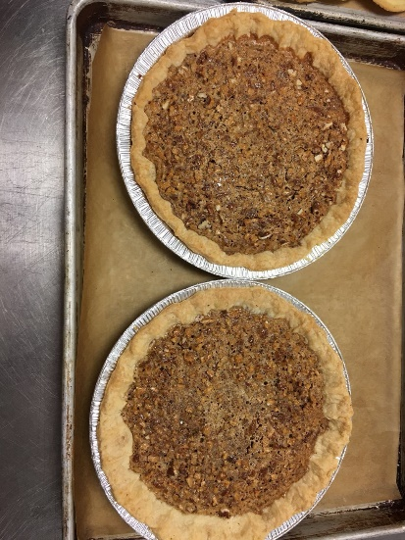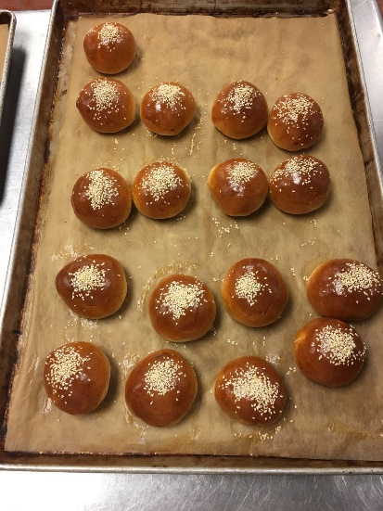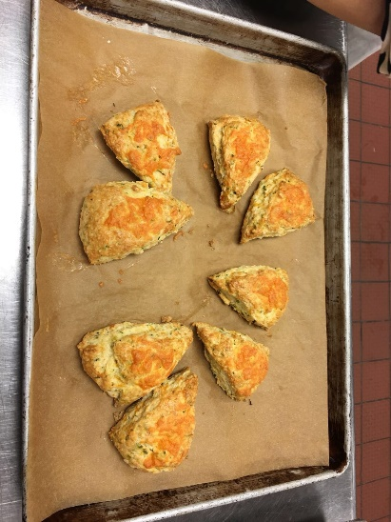
Pecan Pie Soft Yeast Dinner Rolls Cheddar – Chive Scones
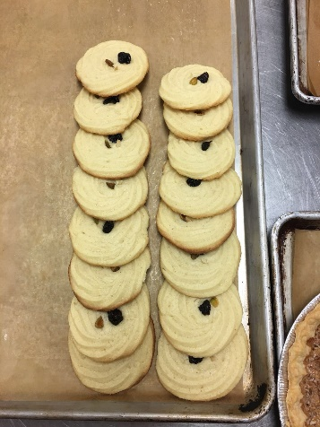 Butter Cookies

c.) Method Mixing, baking:
Dinner Roll: Straight dough method; Knead all ingredients allow to ferments; punch down the dough before fold to the desired shape; put into proof until double and bake
Pie dough and pecan pie: Chilled the pie dough and fold nicely put into the oven baking for few minutes and then adding the filling for pecan pie.
Cheddar-Chive Scones: Egg wash, Butter chunk(Mix cold cube butter with flour), Garnish with grated cheddar
Butter Cookies: Creamy method

d.) Outcomes:
Dinner Rolls looked nice and round this time, but we need more practice because 1- 2 rolls still not round enough. Pie dough we need cook longer because the colour was not golden brown. Cookies were nice, but we need to make them smaller because we add too many batters for cookies made them look too flat. Cheddar – Chive Scones were nicely done. We did not add too much cheese to garnish that our scones were nice and fluffy.

2. Timeline for my products:
12:00 Scales all the ingredients
12:20 – 12:40 Started to knead all ingredients for soft dinner roll and allow to ferments
12: 30 Made pie dough put into the fridge to chill
12:55 – 13: 20 Creamy the butter and sugar, make cookies
13: 35 – 14:00 Punch down the dinner roll dough, folded and round. Put into the proofer
13: 45 Baked cookies
14: 10 Made cheddar – chive scones and baked right way
14: 35 Fold the pie dough and baked until golden
15: 00 Baked soft dinner rolls
15: 15 Made pecan pie fillings
15: 35 Baked pecan pie
16: 00 Clean up the kitchen and chef critiques

3. List my temperature chart:
Soft Yeast Dinner Roll: 400°F (200°C)
Cheddar-Chive Scones: 400°F
Pie dough baked at 325F. After add fillings, baked at 375F until done
Butter Cookies: 350F

4. My personal thoughts about my production
We did very well for our final practical exam. We had many good improvements for our products. We round our soft yeast dinner rolls into uniform shapes, and our scones were nicely done this time. Even though our cookies still had some issues for the shapes, overall we well baked and garnishes were not falling apart this time. Our pie dough undercooked, but the fillings were nice.

5. Describe the chef's critique and recommendations for improvement.
1.) Chef's critiques:
Soft dinner rolls: Good improvement of round skills, well baked
Pie dough and pecan pie: Pie dough a little bit undercook, overall were good
Cheddar-Chive Scones: Nicely done
Butter Cookies: The shapes were a little bit too big, but well baked

2.) Recommendations:
Pie dough baked at 325F, and can bake longer
Do not pip too many batters for one cookie that less batter will split, the shape will not become too flat

6. Write any questions that you need clarified. If you have no questions about the content we are covering, please feel free to pick my brain about other things pertaining to the industry. No personal questions, please. This section is NOT optional.
1.) How many gram we should pip for one cookie?
2.) How to fold the pie dough nicely? I tried different ways, but after baking the shape did not look nice than my expect.

Summary

1. What did I learn during the 11 weeks?
During the 11 weeks studies, I learn many baking methods such as straight method, muffin method, and biscuit methods. Using these different methods, we baked many different types of bread, cookies, muffins and scones. We also learn different kinds of baking techniques such as rolling, rounding, creamy and folding skills. We applied baking techniques for making our product into uniform shapes. We tried to make our bread, muffins, cakes, scones and cookies looked nice and evenly baked. I learned the importance of the baking time management and understood the proper temperature for baking different products. I learn from my mistakes that I made through the 11-week studies.

2. What were some difficulties or challenges?
The most difficulties for these 11 weeks studies have shaped the cookies and evenly distribute the dough for different products. Sometimes we had a hard time to make the dough into similar shapes, even though they were divided equally. There were some challenges for rounding and making nice cookies all the time.

3. What was the highlight or the most memorable event?
This term we worked as a team, so I made many new friends. My partner and I were improving our comprehensive skills together. I felt happy I learned many new pieces of knowledge.

4. What did you take away from the intro to Baking course?
From introduction to baking I learned many useful methods and techniques which I would apply to my future studies. I would use the chef critiques throughout the term to learn from my mistakes. I knew my strengths and weaknesses now, so in the future, I could improve my weakness and have more improvement. I also could apply what I learned in this course to other relative course.

