Bendu’s Stolen Heirloom

**(A mod for the Elder Scrolls V: Skyrim)**

*Level Design Document*

**Nathan Iwasuik**

*Notice: This document and its contents are not to be copied, reproduced, or distributed*

|  |
| --- |
| **TABLE OF CONTENTS** |

|  |  |
| --- | --- |
| LEVEL OVERVIEW |  |
| Gameplay Timeline |  |
| Level Mission Synopsis |  |
| Level Gameplay Objectives |  |
| LEVEL BEATS |  |
| BEAT 1 : The Dungeon |  |
| Experience Overview |  |
| Player States |  |
| Gameplay Elements |  |
| Beat Flow |  |
| BEAT 2 : The Sword and Dragon |  |
| Experience Overview |  |
| Player States |  |
| Gameplay Elements |  |
| Beat Flow |  |
| BEAT 3 : The Dragon |  |
| Experience Overview |  |
| Player States |  |
| Gameplay Elements |  |
| Beat Flow |  |

|  |
| --- |
| LEVEL OVERVIEW |

|  |
| --- |
| Gameplay Timeline |

* This is the only quest in this mod that can be played.
* This level/quest is meant to be completed in about 15 to 20 minutes.

|  |
| --- |
| Level Mission Synopsis |

* Situation: the Player must navigate through an old Nordic dungeon in order to retrieve a stolen sword.
* Setting/World:
  + The first beat takes place in a dungeon, filled with enemies.
  + The second beat takes place in big cave found inside the dungeon.
  + The third beat takes place in an enclosed outdoor environment.

|  |
| --- |
| Level Gameplay Objectives |

* The Player is expected to find a key to which opens a locked door.
* The Player is expected to find a claw shaped key and decipher the code on it.
* The Player is expected to engage with the enemies and kill them with whatever method they choose to (melee, ranged, magic).
* The Player is expected to defeat the dragon near the end of the quest.
* The Player is expected to follow the quest objectives which will insure that they can experience the quest as well as the level itself.

|  |
| --- |
| LEVEL BEATS |

|  |
| --- |
| **BEAT 1 : The Dungeon** |

|  |
| --- |
| **Experience Overview** |

This first beat is made to set the type of dungeon that the Player will experience, in this case a Nordic dungeon. This tells the Player of the types of enemies that will appear within this dungeon, which is going to be draugr, a type of undead enemy. The Player should feel like they are in a very hostile environment.

|  |
| --- |
| **Player States** |

* **Fear:** the overall feeling of being surrounded by enemies in almost every place you travel to in the dungeon.
* **Challenged:** having a challenge to fight all of the enemies inside the dungeon.

|  |
| --- |
| **Gameplay Elements** |

* **Gameplay Objectives Overview**
  + Getting the quest from a man named Bendu in a nearby village Inn.
  + Getting a key surrounded by enemies.
  + Using the key in order to get a special key to open the main chamber door.
  + Using the special key to get into the chamber in order to kill the bandit leader and get the sword.
  + Reading the journal on the table and finding out that the bandit dropped it in a hidden cave.
* **Available Pick Ups**
  + Weapons.
  + Armour.
  + Potions.
* **Hazards / Enemies**
  + Melee enemies.
  + Ranged enemies.
  + Mage enemies.



|  |
| --- |
| **Beat Flow** |

* The Player walks into the dungeon to a couple of dead bandits suggesting that bandits aren’t the main enemy here.
* Once the Player walks through the hallway, they are greeted by a bigger room as well as enemies ready to kill them.
* The Player has a quest marker pointing to the first key that they must acquire as part of the quest. Once the enemies guarding the key are dead, the Player can grab the key in order to get the next quest objective.
* The next quest objective is aimed at a claw shaped key in a different room. The Player must use the key that they found in the previous room in order to get the claw. Inside of that room they are faced with two bandits that managed to get past all the undead. Once the Player has grabbed the claw, the next part of the quest is triggered.
* After the Player fights their way to the next door, they must figure out a puzzle that is on the claw and once they figure it out they can open the door. This requires going into the inventory and finding the claw.
* The next room is where the next quest objective is and this room also has the most enemies in the whole level. The Player must fight their way through the hoard of enemies to be able to defeat the bandit leader.
* Once the bandit leader lies dead, then the Player must read the journal on the table in order to learn what the bandit leader did with the sword, as it was not on them.
* After the journal is read, the Player will make their way to the next room which is triggered by a load door, thus ending this beat.

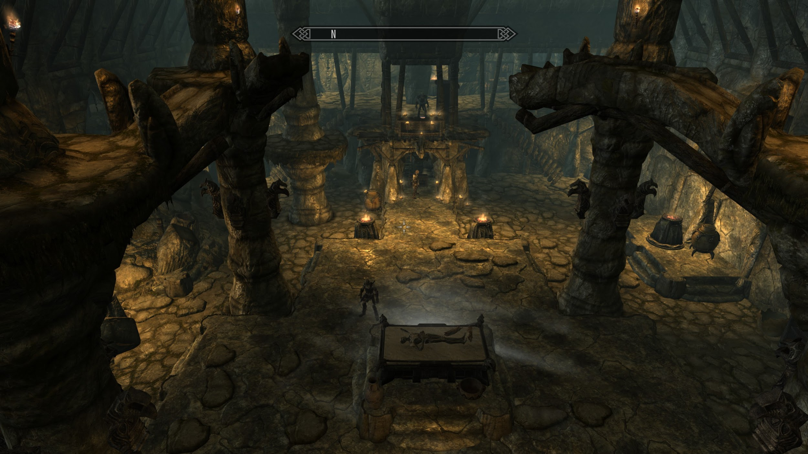

*This image represents one of the main dungeon area.*

|  |
| --- |
| **BEAT 2 : The Sword and Dragon** |

|  |
| --- |
| **Experience Overview** |

In this beat, the Player is expected to pick up the sword and return it to the quest giver, Bendu who is back at the Inn in a small nearby town. But to the Player’s surprise there is a dragon hiding in the back of the room and once the Player picks up the sword, the dragon awakes and the screen fades to black. This beat is immensely smaller and easier than the first beat.

|  |
| --- |
| **Player States** |

* **Cautious:** the Player should feel very cautious in approaching the sword as they read in the book that there was a dragon in the cave and chased the bandit leader away, to which the sword was dropped.
* **Fear:** the Player should feel scared after they pick up the sword as the dragon will awake and start making its way towards them.

|  |
| --- |
| **Gameplay Elements** |

* **Gameplay Objectives Overview**
  + Retrieving the lost sword that was dropped on the cave floor.
  + Watching the dragon walk towards the Player.
  + Player screen fades out and then back in to see no dragon.
* **Available Pick Ups** 
  + Quest sword.
  + Miscellaneous bones and trinkets.
  + Potions that were hidden in the cave.
* **Hazards / Enemies**
  + Fall damage if the Player jumps to far down without looking for a safe way down.
  + Dragon, but no damage is dealt to the Player.



|  |
| --- |
| **Beat Flow** |

* Once the Player loads into the new space of the cave, they must make their way safely down to where the sword has landed.
* The Player grabs the sword and their movements are halted in order for the dragon to make its approach towards the Player.
* The screen shakes in order to simulate the dragon walking heavily across the ground.
* When the dragon gets a certain distance to the Player, the screen fades to black for a couple seconds, then fades back in with the dragon gone.
* The Player is then able to explore the cave or walk outside to the next stage of the quest, thus ending the second beat.

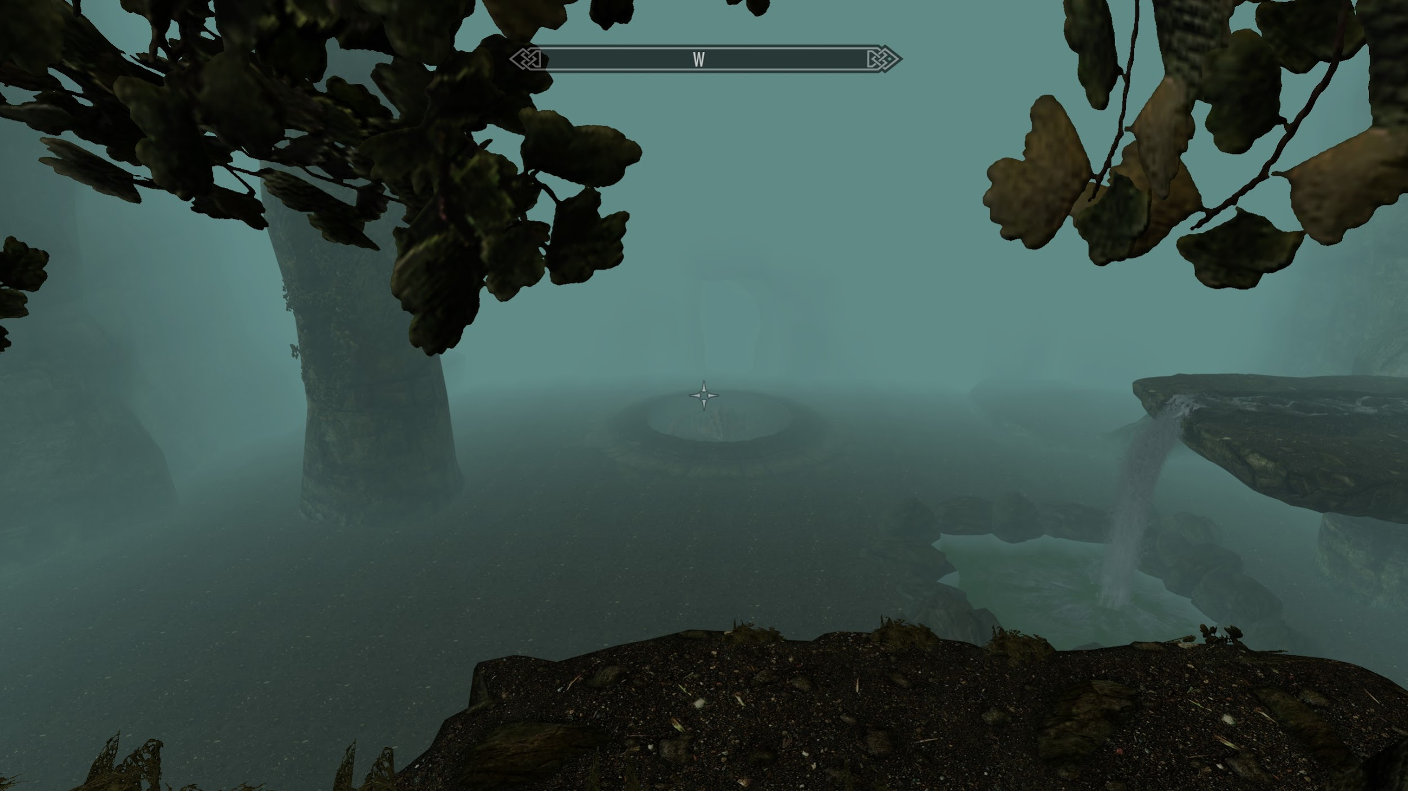

*This image represents the dragon sitting in its hole.*

|  |
| --- |
| **BEAT 3 : The Dragon** |

|  |
| --- |
| **Experience Overview** |

In this beat, the Player is expected to successfully fight and kill the dragon using various ways to attack it and then return to Bendu for a prize for returning his sword.

|  |
| --- |
| **Player States** |

* **Scared:** the Player should feel scared to walk into the outdoor environment as the dragon could attack at any minute.
* **Strategic:** the Player is going to have to be strategic in order to defeat the dragon without it killing the Player first.

|  |
| --- |
| **Gameplay Elements** |

* **Gameplay Objectives Overview** 
  + Fight and kill the dragon.
  + Return to Bendu and receive reward for returning sword.
* **Available Pick Ups**
  + Loot from the dragon.
  + Any miscellaneous items the Player can find scattered throughout the exterior.
  + Gold as reward from Bendu.
* **Hazards / Enemies**
  + The Dragon.



|  |
| --- |
| **Beat Flow** |

* The Player will have left the cave and entered the outdoor part of the level in search of the dragon to kill.
* The Player will be tasked with killing it once they trigger the dragon to attack.
* The dragon will have different sets of attacks to attack the Player with such as shooting a fireball, spraying a breath of fire, and even attacking the Player up close on the ground.
* After the dragon has lost a certain percentage of health, it will change up its attack pattern as to keep the Player on their feet.
* Once the dragon has been slain, the Player is free to explore the outdoor area or return to Bendu and claim their reward for returning the sword to him.

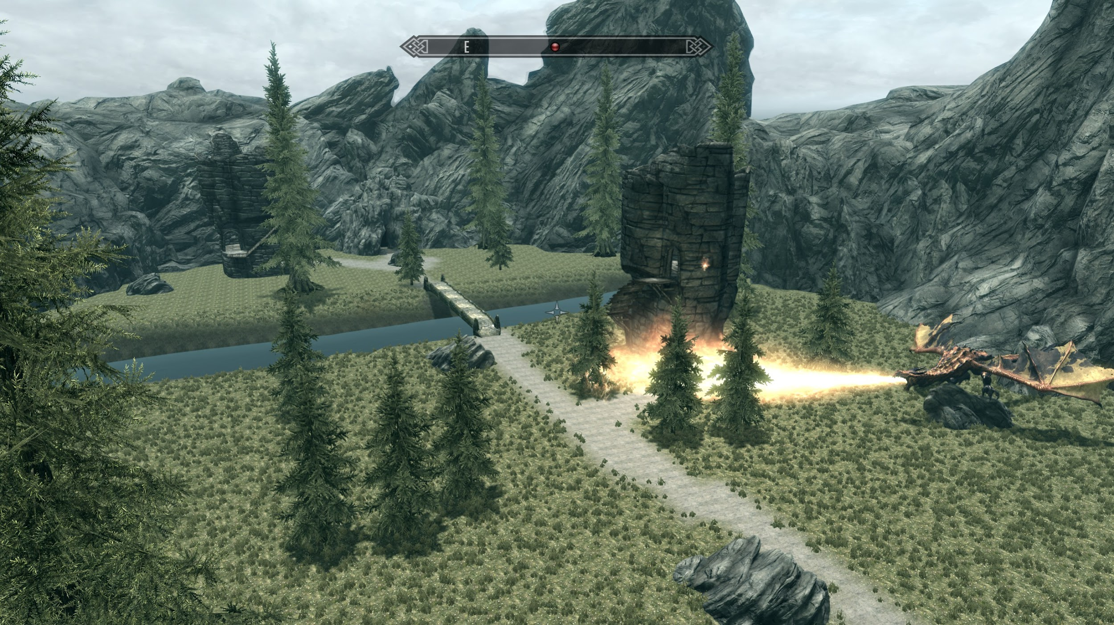

*This image represents the final area where the Player fights the dragon.*