DKNY
SECTION C: Primary research identifying private label brands and product positioning
compared to brand products

The products available in the retailers store are DKNY and Donna Karan. They do not sell any other brand names within this store.

(Layout of the retail store)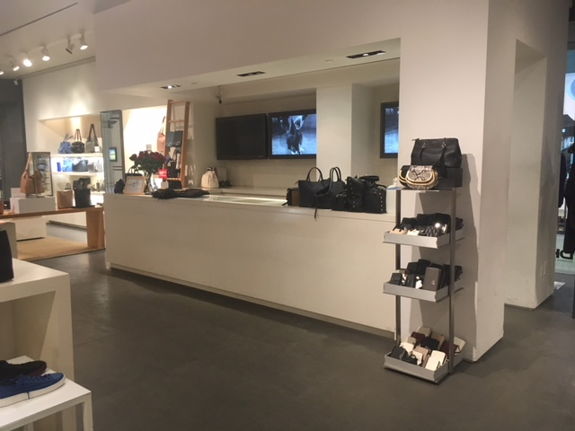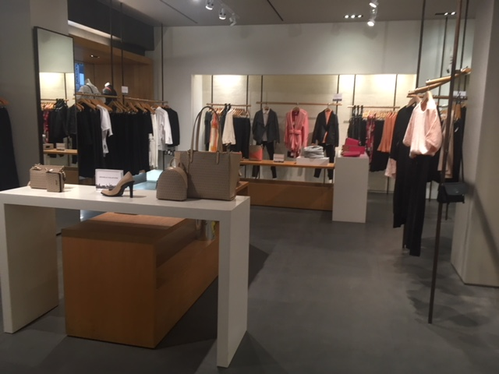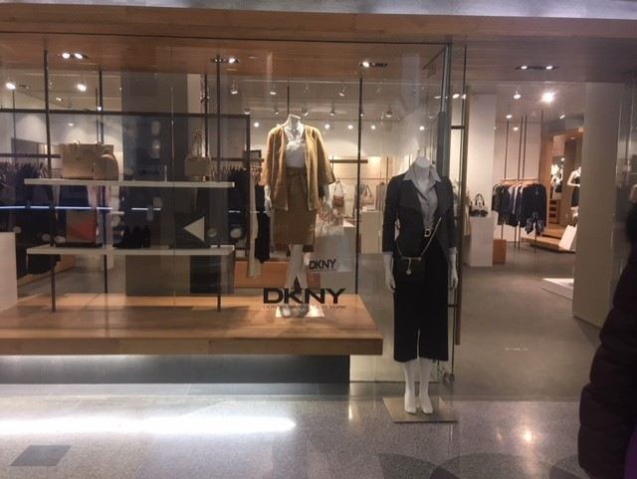

While visiting the store we notice that there aren't any promotion signs or sale products available. This says a lot about the store in various ways. Because of how luxurious and expensive this brand is, it does not want to really target people who are only purchasing for the sale products but they want to target those who have a high income who could afford to buy a shirt for 80$. Already this retail store is placed in an area where not many people are exposed to. Only customers and clients are aware of this store since it is set in a secluded area in the mall. Around this area, there weren’t many people in the space itself since it is located on a “hidden floor”. The clothing and products were further placed in a way that it is clear and not overwhelming for the clients. It was not cluttered or too empty. They were placed in a classy spacious way so that customers were able to view all the products immediately. The lighting was also an aspect in the store that helped make the store look elegant and clear. The flooring was a carpet that looked like it’s cleaned every night attentively. Ultimately, the retail store itself reflected greatly on the brand and company since DKNY is a brand that targets those who expect more than a normal retail store. They expect to receive impeccable customer service, a clean environment and appropriate music.

Now, the difference between DKNY and Donna Karan is not quite similar. Even though Donna Karan is the creator of DKNY this is not her main brand she keeps track of. Donna Karan had in fact created a Donna Karan brand that includes couture garments that have possibly been on the runway. Further, Donna Karan has many products that are of higher quality which does indeed add more value and price to their products. Donna Karan states that the type of Donna Karan woman is the type to be on the move at all hours in the day. That they constantly have to figure out what outfit they have to wear for a specific occasion which is a complicated life. These women are much more fashion forward than the DKNY clientele. However, the DKNY woman is a woman whom is more exposed to society and lives downtown in the city. Donna Karan describes them as bohemian. These clients love her body and is a bit more open minded. These customers are a much larger base than DKNY since it is much more affordable than Donna Karan, the more fashionable exclusive brand. DKNY is a brand that’s more directed to lifestyle and family. This market mostly consists of a younger generation of women who are also constantly on the move either heading to class or typically looking for jobs.

DKNY is known for its excellent branding and advertising. They have a global presence through online and physical stores offering a very wide range of products. (from jeans to baby clothing to shoes to underwear…)
During our visit of the physical DKNY store we noticed that they did not have many advertisements inside, especially ones making the customers aware of the different promotions on the products offered. A company needs to not only advertise itself but advertise its products so that they could possibly attract new customers. DKNY uses a strong social media presence to advertise as well as different influencers on several social media platforms. In the store we noticed that there are only posters of the clothing being worn by models and the visuals and designs that in fact made it very appealing to the audience. They made sure to differentiate themselves from Donna Karan by the use of influencers such as Emily Ratajkowski who does not in fact even work with Donna Karan. The people that follow this influencer and admire her style will learn more about DKNY and then Donna Karan. Emily Ratajkowski is an example of the audience she attracts and directs towards this specific brand. The DKNY company is differentiating themselves, which is a process of distinguishing the brand image from others like Donna Karan, and it clearly gives them a competitive advantage. They are trying to reach out to a specific demographic that are influenced by celebrities like how Emily Ratajkowski interacts with her followers and fans on social media. The use of social media opens doors to a younger, trendier, and more affordable market for DKNY.
(Emily Ratajkowski advertisement for DKNY)

