College students behavior on used textbooks
Marketing Research 410-DB4-AS Section 08322

november 23rd, 2017
lasalle college

By students

Pedro Ivo De Macena
Thi Thanh Thao Nguyen
Sovoitey Sovann
Thi Mai Huong Vo

To Professor

Jacqueline De Stefano

Table of Contents

1 Executive Summary 2
2 Introduction 3
2.1 Business Opportunity 3
2.2 Opportunity Description 3
3 Problems Identification 5
4 Research Plan 6
4.1 Objectives 6
4.2 Methodology 6
4.3 Results 7
5 Project Limitations 9
6 Conclusion 10
References 12
Appendix 13

Executive Summary
This report is about the behavior of college students towards textbooks that have been used. Student life is quite difficult as it comes with a myriad of expenses. One of the major costs that a student has to incur is the purchase of textbooks. Each semester students take different lessons hence forcing them to purchase books quite often. Most of the purchased books are used for a short while and then kept by the student. The study is done to look at the viability of selling second hand books to students. This will cost less and will be favorable to the finances of most students. It is suggested that an online website will be developed where students will buy and sell second-hand books. It will also create a good business opportunity.
The paper speaks about a business focus carried out which identifies that an initial investment will be needed to develop the online application, physical selling space and a phone application. The initial target market is students studying in Montreal before it expands into other markets.
There are a number of challenges that may be faced by the project, the major one being the condition of the textbooks and whether some students may fail to purchase due to this.
To determine project viability, a survey was conducted on LaSalle College students. The research uses a descriptive survey, which involves students answering questionnaires. The study results show that a huge percentage is willing to sell their used textbooks, another large percentage is willing to purchase and many welcome the idea of an online application. The survey analysis concludes that the business idea is a viable one.

Introduction
Student life period is a tough time during everybody lives. During this period, there are a lot of uncertainties such as what to do when graduate or even how to pay your bills for the next month. Most likely, during this period of live, money is a constantly concern and being able to save some and avoid expending it, comes with certain priority.
At the begging of every semester, there is the necessity to buy a few books, some very expensive for a student income, therefore one option that is not well used is to buy second hand books. This purchase option does not cost as much as a brand-new book and it fits well to the issue of money.

Business Opportunity
Buying and/or selling second hand books to students through an online channel is a good business opportunity. There is room for business in this market whereas a company can earn profits on considerable number of books supply. Another positive factor in this type of business is that an organization can earn the profit from both buyers and seller. A student most likely will buy a used book in good conditions for his/her new semester but at the same time will sell the books that are no longer needed. Students who buy the book will wish to sell them on next semester. This cycle will repeat until the person has graduated. In this sense, an organization in this market is a communication channel for buyers and sellers.

Opportunity Description
To conduct a business focusing on that market, we identified that the initial investment is consisted in developing and maintain an online website and a physical space whereas the customer would leave and pick up the books; also with a possibility to develop an app in the future. No, other operational costs are involved. At the initial stage two partners can easily manage the business (Besser and Miller, 2010). As a target market, the business can focus initially into college students in Montreal area at the beginning. Gradually it can explore other levels of education markets, such as universities, masters and doctorates etc.
One important aspect of the business is regarding the delivery of books after the deal is closed. The first idea is for the organization to have a physical space whereas the customers, first the seller would leave the book and later the buyer would pick up the book. This way company will not have to spend much on supply chain and. Eventually with the growth in business, having a delivery system can be incorporated, but for that to take place, the business must have solid volume of exchanges.
Regarding legal aspects on the business of selling and buying used books, there are no implication. However, the organization must have its registration and all legal requirements to be fully functioning, just like any other business. A buyer/seller must have an account valid with the organization whereas it is obliged to agree with the terms and conditions of the business. This makes necessary to guarantee legal contract between organization and costumers (buyer/seller) (Taylor, 2010).
The organization will make a tie-up with online payment system to receive the payment through online channel. There are many online payment platforms are available in the market form which any one can be chosen based on the requirement. The organization can provide many options for payment, such as: online payment, transfers or UPI. Cash on delivery option can be risky and costly at this point of time and is not seeing as a desired option.

Problems Identification
Several problems can be identified regarding the business opportunity. Issues related to creating, managing, financing etc. Some of the problems already identified are listed below:
- Promoting the business idea among college students focusing on gaining students’ confidence. Most of the students like to check the book’s condition before buying it. Therefore, the business will have to ensure it. For the initial phase of the business, the organization can offer to buy few books to guarantee quality.
- The business will have to do some market research to know the probable volume of exchanges on the year.
- Registering the organization will demand time and formalities. At the same time, signing contract with sellers after verifying their books’ quality will also require some efforts.
- The business needs to choose the payment solutions based on the volume of transactions.
- The business needs to understand better its customers and its behaviours.
- The business needs to develop a fair system on the % charged on every transaction to guarantee customer satisfaction.
- Developing website and managing all online needs, such as: confidentiality, access, servers, database management, developing user friendly homepage and others.

Research Plan
To solve and answer some of the problems and issues listed above, it was identified the need to conduct a survey with the potential customers.

Objectives
This survey was developed and created with focus on LaSalle College students and had the objective of answering the questions below:
- Who are the potential customers of the business?
- Where they come from?
- What is their field of studies?
- What volume exchange can be expected at the initial phase of the business?
- Are students willing to buy used books online?
- What is their source of income?
- What is done with the book after the student does not need it anymore?
There were several other questions, but at this initial stage of understanding the customers, the decision made was not to make the survey too long. For that reason, the research was 15 questions long and covered the above items.

Methodology

One of the elements of the research design that was applied for conducting research is qualitative descriptive research. The research method chosen was a survey consisting of a questionnaire with 15 questions about the buying behaviors and the opinions that potential customers have regarding the used textbooks.
The conduction of the research was made through an internet website known as Kwik Surveys since it is free, user friendly and easy to manage and process results. Once the questionnaire was prepared, a link with the survey online address was spread through email to all the students to participate.
The survey was conducted from November 12th to November 18th and was answered by 64 people, which composes the sample size and the sample unit as one person. Since this survey was conducted in a format which the person answering did not have to identified him/herself, it is not possible to determine what is the sample frame.
The sampling was made using random technique since all College LaSalle students could`ve answered it. The probability of being selected is not high, but for this study focusing on identifying the potential viability of the business, it is believed that the sample reflects the population behavior.

Results

The research results present that 78% of the people are 17 to 25 years old, being 98% of the sample composed by people under 35 years old. 44% of them come from Asia, 40% are Americans (thereof: 27% Latin and South America; 13% Canada and US). Most of the people that participate on the survey, 65%, are at Business Management and Accounting programs. The remaining amount, 35%, are spread among Tourism and Hotel Management, Fashion, Insurance, Early Childhood Education and Social Science programs.
The findings show us that 92% of the students had to buy books on their last academic year, in which 56% of them bought up to 3 books and an additional 39% of them bought up to 7 books. The most common way to acquire the books is through a physical store, 79% while online purchase method consists around 16% (Figure 1). Around 52% of the respondents have never bought second hands books, while 66% of them never heard about an application to buy it online. At the same time, 73% are willing to sell their used books (Figure 2), so it will be a favorable result if there is a business application for people to try.
About 59% of the people keep their textbooks after they have no longer used it and 73% of them are willing to sell their books after they are finished with it and 53% of them would be using an online platform to negotiate it. Some people even comment that they burn the books or throw them away to the trash after they are done with it.
The weighted average for people that would be likely to use an app or a specific homepage to sell the used books is 3.62 out of 5. Also, it was identified that 61% of the students work during their studies. The most common source of paying tuition fess is with the help of parents, 48%, the remaining amount of people has its tuition fees funding based either their work, 18%, with a loan 5% or they do not pay tuition fees, around 25%.

Project Limitations

The first limitation identified was a possibility to sample mistake occur as if one person answered more than once the survey; this could characterize bias to the conclusions. The was no tool available to avoid this fact to occur, although this should not affect the conclusions. The sample size is minor compared to the total population and it is not likely that the same student would spend time to answer more than once the survey given the period the survey was taken, from November 12th to November 18th, it is exam period on College LaSalle and time is in shortage.
Second limitation is regarding the sample size. 64 people participated on the survey. College LaSalle has over thousands of students and the amount of 64 people answering it represents a low percentage on the total. Despite it, due to the typical characteristics of student’s behavior tending to repeat, it is believed the answers of those 64 people, do represent the majority.

Conclusion

Subsequently to analyzing the results on the proposed survey, it is concluded that there is a business opportunity to commercialize second-hand books to college students. Correlation between the questions and answers enables us to conclude that.
First important data that shows that the potential market size is almost all students, 92%, since that’s the percentage of respondents that have the need to buy a book during the academic year and 52% would buy a second-hand book. Montreal area has over thousands of students that have the same needs despite of the institution they attend to.
Second key factor is the potential revenue. The result enables us to conclude that overall, the average books bought by students per year is around 5, which valuing it by an average of $30.00 dollars per book, in a conservative view, would be a total of $150.00 dollars per student per year. Simulating a scenario with 1.000 student/customers, the amounts sum up to revenues of around $150.000 dollars per year. Figures based on conservative assumptions.
On the other hand, there will be a need to invest in advertising since most of the people never heard about this type of business. Also, an additional effort must be done to encourage people to negotiate their books online throughout the platform, either home page or app.
Despite of the fact that 92% of the people must buy a book for their studies, 59% of them keep their books after they are finished with it. Those respondents represent the suppliers for the business. A special effort must be done to encourage more people to commercialize their books. Although, it does represent additional effort on convincing people, the fact that most of the respondents need aid to finance their tuition fees is positive. Commercializing your used books would represent a potential additional income as well as expenses avoidance in the moment of purchasing a book.
As a recommendation, it is necessary to mention that before going live with this project a business case that contains finance simulations, investments, potential revenues, potential costs, etc. must be done. It is not advised taking decisions without it. Also, it is extremely necessary to develop the terms and conditions the customers will agree upon their registration with the business. This is extremely important to guarantee the business protection and the sense of fairness to all customers that process exchanges with the business.

References

Besser, T. L., & Miller, N. J. (2010). The significance of customer base in the new economy: Satisfaction and perceptions of success among small suppliers and small nonsuppliers. Journal of Small Business Management, 48(1), 1-15.
Taylor, C. R. (2010). Integrated marketing communications in 2010 and beyond. The International Journal of Advertising, 29 (2),161-164
KwikSurveys. Retrieved from www.kwiksurveys.com

Appendix

Figure 1

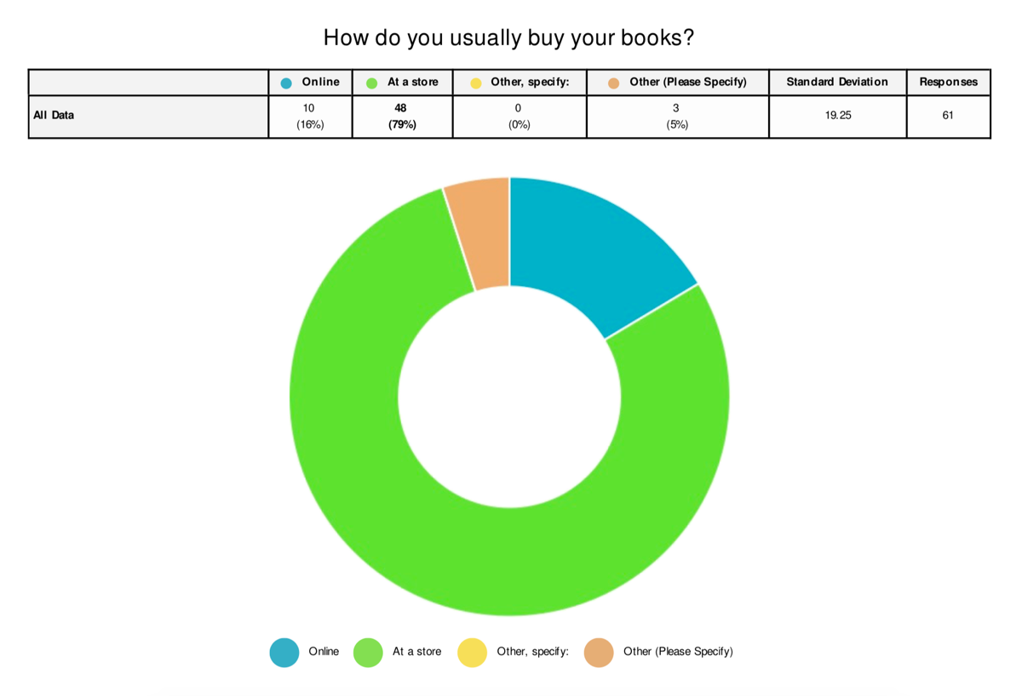

Figure 2

