- Government’s action in fiscal policy and real GDP growth

Fiscal policy is the means by which a government adjusts its spending levels and tax rates to monitor and influence a nation’s economy.

The Canadian government take many actions to improve the GDP by using Fiscal Policy and this are briefs of the actions:

- Support for the Canadian families through new Family Tax Cut and universal Child Care.
- Support for small businesses through the Small Business Job Credit and Employment Insurance (EL)
- Boosting the economy by $5.8 billion in new investment that will continue to build and renew federal infrastructure across the country
- Supporting the Manufacturing Sector and Investing in Advanced Research
- Encouraging Investment in Canada’s Manufacturing Sector by maintaining a low tax burden on businesses to encourage investments in Canada and also by developing a national aerospace supplier development initiative.
- Helping Small Businesses Grow and Fostering Entrepreneurship by reducing taxes, expanding services of Business Development Bank of Canada, and providing $14 million over two years to Futurpreneur Canada in support of young entrepreneurs.
- Supporting Canadian Workers by enhancing labour market information, and providing $35 million over five years to make permanent the Foreign Credential Recognition Loans pilot project.
- Growing Trade and Expanding Markets by ensuring that Canada’s trade remedy system operates in an effective, accessible and transparent manner and by creating an Internal Trade Promotion Office within industry Canada to support efforts to renew the Agreements on Internal Trade.
- Helping Families by increasing the Tax-Free Saving Account annual contribution limit to $10,000and by extending Employment Insurance Compassionate Care Benefits from six weeks to six months.

- Fiscal Policy, tax portion & Fiscal monitor

- A. Main elements of last fiscal year 2014. What tax potion is the most important to you and why?

For the fiscal year ending March 31, 2014, Canada’s federal government spent $276.8 billion. That represents roughly 15 per cent of our country’s $1.9-trillion economy.

Those are the elements of the last fiscal year 2014:

• Canada Health Transfer (11 cents)

• Canada Revenue Agency (3 cents)

• Canada Social Transfer (5 cents)

• Children’s benefits (5 cents)

• Crown corporations (3 cents)

• National Defense (8 cents)

• Employment Insurance benefits (6 cents)

• Other major transfers to other levels of government (6 cents)

• Other operations (12 cents)

• Other transfer payments (13 cents)

• Public debt charges (10 cents)

• Public Safety (3 cents)

• Support to elderly (15 cents)

The most tax potion important for me is public safety because now days we live in a dangers world which safety become more important for me and for sure to the Canadians.
- B. The FISCAL MONITOR compare April-May-June- July 2015 to the same periods of 2014
2015 | April | May | June
Budgetary results | Revenues increased by $5.5 billion, or 12.8 per cent, to $49.1 billion.  - Personal income tax revenues were up $1.9 billion, or 9.2 per cent, reflecting, in part, timing issues which raised the May 2015 results.  - Corporate income tax revenues were up $0.5 billion, or 9.0 per cent.  - Non-resident income tax revenues were down $0.1 billion, or 7.6 per cent.  - Excise taxes and duties were up $0.6 billion, or 8.3 per cent. |  | Revenues increased by $0.6 billion, or 2.6 per cent, to $24.3 billion.  - Personal income tax revenues were down $0.2 billion, or 1.6 per cent, reflecting timing issues which raised May 2015 receipts but lowered June 2015 receipts.  - Corporate income tax revenues were down $6 million.  - Non-resident income tax revenues were up $0.1 billion, or 30.6 per cent.  - Excise taxes and duties were up $0.5 billion, or 11.3 per cent
2014 | April | May | June
Budgetary results | Revenues increased by $1.6 billion, or 3.8 per cent, to $43.5 billion.  - Personal income tax revenues were up $0.8 billion, or 3.9 per cent.  - Corporate income tax revenues were up $0.6 billion, or 12.1 per cent.  - Non-resident income tax revenues were down $0.1 billion, or 13.3 per cent.  - Excise taxes and duties were up $0.4 billion, or 5.5 per cent. |  | Revenues increased by $0.9 billion, or 3.8 per cent, to $23.7 billion.  - Personal income tax revenues were up $0.1 billion, or 0.6 per cent.  - Corporate income tax revenues were down $0.1 billion, or 2.6 per cent.  - Non-resident income tax revenues were up $0.2 billion, or 53.9 per cent.  - Excise taxes and duties were up $0.6 billion, or 16.4 per cent

2015 | July
Budgetary results | Revenues increased by $1.9 billion, or 9.5 per cent, to $21.7 billion.  - Personal income tax revenues were up $0.6 billion, or 6.1 per cent.  - Corporate income tax (CIT) revenues were up $1.6 billion.  - Non-resident income tax revenues were down $31 million, or 6.4 per cent.  - Excise taxes and duties were down $0.4 billion, or 8.0 per cent.
2014 | July
Budgetary results | Revenues increased by $2.1 billion, or 9.8 per cent, to $23.9 billion.  - Personal income tax revenues were up $0.3 billion, or 3.1 per cent.  - Corporate income tax revenues were up $0.8 billion, or 38.7 per cent.  - Non-resident income tax revenues were up $0.1 billion, or 12.1 per cent.  - Excise taxes and duties were up $0.5 billion, or 11.4 per cent.

- Counterfeit prevention

- A. How to detect a counterfeit Canadian note 20$ & 50$
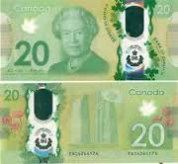
Every time you receive a Canadian polymer note and you think that it might be counterfeit, here are some tips that will help you to verify your doubts.
The 20 $ and 50 $ have the same security features. If the bill is flip to the front, you will feel that the ink is raised in some many spots such as: on the right shoulder of the queen, on the number “20” or “50” colored in green that is situated on the left side of the bill, on the words “Banque du Canada”.
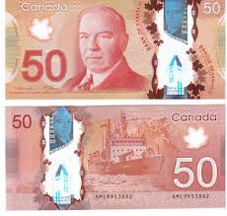
If you look on the through the transparent window, you will notice that the numbers match the note’s value (some are reverse) and look the word Canada. It feels slightly raised. On the metallic portrait you will also notice that it matches the big portrait, if you tilt it you will see that it changes colour. Do the same thing for the metallic building. The maple leaves are supposed to border and cross the large window. On the left side on the note, look at the frosted maple leaf window it should be transparent and look for hidden numbers. Now, if you flip the bill to the back, all the security features should be the same except that there is no raise ink and no hidden numbers.

- B. How to detect a counterfeit American note 50 $ and 100$

Now I will explain to you how to verify an American Bill if it’s counterfeit or not.
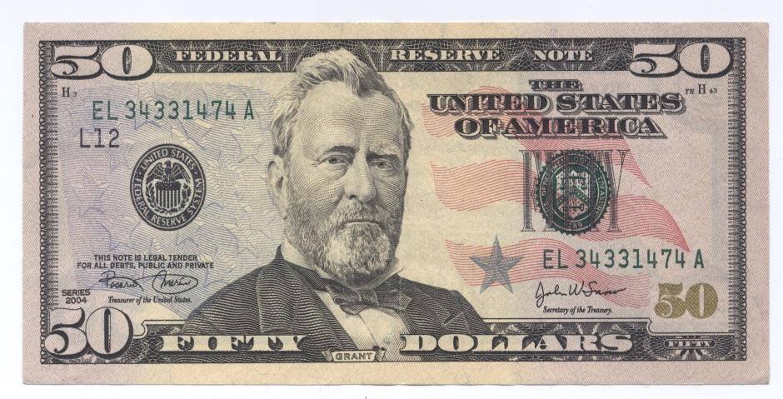
First of all, I will start by explaining the main key security features of a 50$ bill that were issued in 2004 until now. If you hold the note to the light you will notice an fix thread placed vertically to the right of the portrait. You will read USA 50 and a small flag alternates the pattern. This flag is visible on both sides of the bill. The thread glows yellow if it is illuminated by ultraviolet light. Always holding the note to the light, search the image of the President Grant. It is also visible if you flip it to the back. On the lower right corner, the numeral image 50 shift from copper to green.

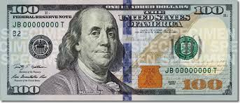
Finally, I will explain the main key security features of a 100$ bill that were issued in 2013 until now. This note has also the same thread but it is situated on the left side and when it is illuminated by an ultraviolet light it glows pink. There is a 3-D security blue ribbon and if you tilt the note back, you will see the bells change to 100s as they move. While you are tilting the note, the bell changes of color from copper to green. In the blank space to the right you will see an image of Benjamin Franklin if you hold the bill to the light. On the lower right corner the numeral “100” shift from copper to green.

- Monetary policy

- A. The central bank’s objective in term of inflation, interest rate & foreign exchange
Interest rate
In order to preserve the value of money, the objective of monetary policy is to keep inflation low, stable and predictable. In that way, Canadians can spend and invest with more confidence, it encourages longer-term investment in Canada's economy, and contributes to sustained job creation and greater productivity. This in turn leads to improvements in our standard of living. Canada’s monetary policy framework consists of two key components that work together and reinforce each other: the inflation-control target and the flexible exchange rate.
The bank is guided be the inflation-control target. If inflation is above target, the Bank may raise the policy rate. In order to fight inflation, financial institutions will increase interest rate on loans and mortgage. It that way people will not borrow money from banks. If inflation is below target, the Bank does the opposite. They may lower the policy rate and financial institutions will decrease their interest rates on their loans and mortgages.

Foreign Exchange
Canada has a flexible exchange rate system. It changes depending on the demand and the supply of Canadian dollars in the foreign exchange market. Normally, the exchange rate is between Canada and US but when it comes to export, Canada competes with many other countries. Movements in the Canadian dollar reflect the interaction of various domestic and external factors such as: the world prices for commodities, relative economic performance, relative inflation and interest rates, Canada’s productivity record, trade and current account balances, short-term capital flows and domestic political turmoil. What influences also the exchange rate is the economic growth, inflation, the productivity and the fiscal position. The Central Bank, before changing the rate they verify the economy’s wealth.

- B. Monetary policy function & different transmission mechanisms to fight inflation.

The “transmission” of monetary policy is the process by which changes in the Bank of Canada’s policy interest rate work their way through the economy and its affects the rate of inflation. The objective of monetary policy is to keep inflation close to the 2%. When there is a change in the policy interest rate, it affects: commercial interest rates, asset prices, the exchange rate of the Canadian dollar, economic growth, and inflation, which in turn also affect asset prices and the exchange rate. There are four transmission channels that influence the overall level of demand for goods and services:
1. The first transmission channel concerns the commercial interest rates. When it declines, it automatically reduces the cost of borrowing and the money paid on interest-bearing deposits, so people borrow more, spend and invest, and it discourage saving. That brings to a boost to overall demand for goods and services. The opposite happens when commercial interest rates rise.
2. The second transmission channel concerns the change on interest rate. It has an effect on the various assets, bonds, house & etc. If it increases, people will tend to save more and the opposite happens when interest rate decreases.
3. The third transmission channel concerns the effect of changes in interest rates on the exchange rate. Normally, when Canadian interest is high, it attracts investors. On the other side, if the Canadian dollar is too strong, people are less tempts to buy Canadian products so they buy imported goods. That brings to less demand.
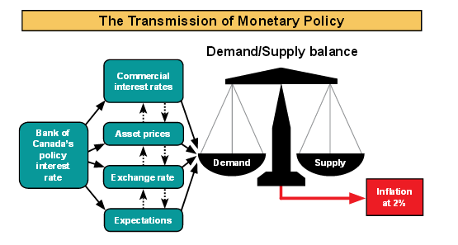
4. Finally, the fourth channel is the effect of changes in interest rates on people’s expectations of future interest rates, growth, and inflation. These expectations have a big impact on the decisions of firms and households regarding current saving and investment choices, and they affect wages, the prices of goods and services, and asset prices. If, for example, inflation were expected to rise in the future, longer-term interest rates would typically rise to reflect this expectation.

- The security features for the new 1$ and 2$ bills

- A. The New $1 Coin
The Canadian one dollar coin, commonly called the loonie, is a gold-coloured one-dollar coin introduced in 1987. It bears images of a common loon, a bird which is common and well known in Canada, on the reverse, and of Queen Elizabeth II on the obverse. It is produced by the Royal Canadian Mint at its facility in Winnipeg.
- Security features:
- A single laser mark: of a maple leaf positioned within a circle on the coin's reverse – i.e. around the Loon design. This laser mark is produced during the striking of the coins using a contrasting pattern micro-engraved on the coin die itself.

- Specifications:
- Diameter: 26.5mm
- Edge Height: 1.95mm
- Weight: 6.27g
- Composition: Multi-ply brass plated steel.
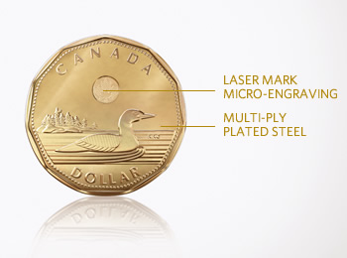

- B. The New $2 Coin

The Canadian two dollar coin, commonly called the toonie, was introduced on February 19, 1996 by Public Works minister Diane Marleau. The toonie is a bi-metallic coin which on the reverse side bears an image of a polar bear by artist Brent Townsend. The obverse, like all other current Canadian circulation coins, has a portrait of Queen Elizabeth II. It has the words "ELIZABETH II / D.G. REGINA" in a different typeface from any other Canadian coin; it is also the only coin to consistently bear its issue date on the obverse.

- Security features
- The addition of two laser marks of maple leaves, each within a circle, at the bottom of the coin's reverse – i.e. on the side with the Polar Bear design.
- A virtual image of two maple leaves will appear at the top of the coin – a different image is produced as the coin is turned from side to side. The virtual image is produced by engraving different patterns on each side of two-sided grooves on the face of the coin.
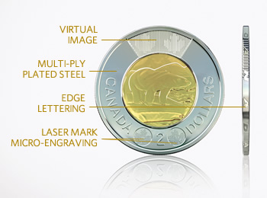
- Edge-lettering of the words "CANADA" and "2 DOLLARS" are engraved along the coin's outer edge.
- Specifications:
-Diameter: 28mm
-Edge Height: 1.75mm
-Weight: 6.92g
- Composition:
Outer Ring –Multi-ply nickel plated steel
Insert –Multi-ply brass plated aluminum bronze

- Statistics Canada

- A. Consumer Price Index for (2014) and the inflation rate.

2002=100
 | 2014
Canada | 125.9
Quebec | 123.5
Ontario | 126.4

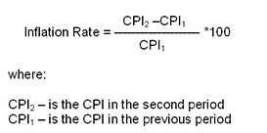

- B. The inflation rate of 2015 for the Canada and the 2 provinces.

- Canada:

Inflation rate = 3.34

- Quebec :

$Inflation Rate=\frac{123.5-121.9}{121.9}*100$= 1.31

- Ontario :
$Inflation Rate=\frac{126.4-123.3}{123.3}$* 100 = 2.51

- C. How would you interpret the CPI? What is the base year?
The consumer price index is obtained by dividing the expenditure on a set of consumer goods in one year (the current year) by the expenditure on that same set of goods in the base year.
The base year is 2002 = 100

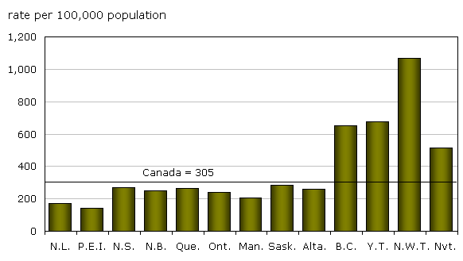
- D. For Canada, Quebec and Ontario, determine the items with biggest PI and biggest PI increase.

- E. Unemployment rate in Canada, Quebec and Ontario for August 2015

- Canada
$Unemployment rate=\frac{1,346.1}{19,312.0}*100= 7.0$ %
- Quebec
$Unemployment rate=\frac{355.9}{4,451.1}*100=$8.0 %
- Ontario
$$Unemployment rate=\frac{508.4}{7,450.1}*100=6.8 \%$$
- F. GDP and last GDP growth in 2014
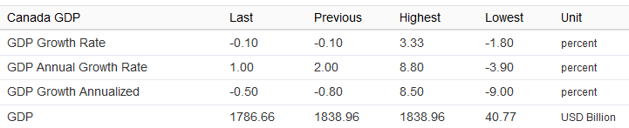

- G. EXPORT and IMPORT with Japan and the US.

- United States:
- Exports = 528,953.8 for 2014
- Imports = 350,436.1 for 2014

- Japan:
- Exports = 11,092.6
- Imports = 9,183.6

- H. The exchange rate with the US $ and CAN $

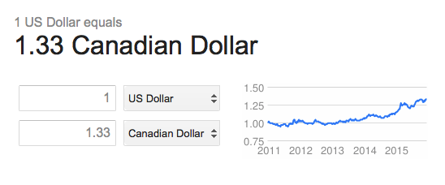

- I. Relation between money supply M1 AND THE TOTAL MONEY SUPPLY

The money supply is commonly defined to be a group of safe assets that households and businesses can use to make payments or to hold as short-term investments. For example, U.S. currency and balances held in checking accounts and savings accounts are included in many measures of the money supply.

There are several standard measures of the money supply, including the monetary base, M1, and M2. The monetary base is defined as the sum of currency in circulation and reserve balances (deposits held by banks and other depository institutions in their accounts at the Federal Reserve). M1 is defined as the sum of currency held by the public and transaction deposits at depository institutions (which are financial institutions that obtain their funds mainly through deposits from the public, such as commercial banks, savings and loan associations, savings banks, and credit unions). M2 is defined as M1 plus savings deposits, small-denomination time deposits (those issued in amounts of less than $100,000), and retail money market mutual fund shares. Data on monetary aggregates are reported in the Federal Reserve's H.3 statistical release ("Aggregate Reserves of Depository Institutions and the Monetary Base") and H.6 statistical release ("Money Stock Measures").

- Definitions

- Budget Deficit: Is a situation which an entity expenditure exceed its revenue. It is commonly used by governments; however, it can be applied to other entities.

- Economic growth: Is an increase in the amount of goods and services produced by an economy.

- Purchasing power: Is the value of a currency compared to the amount of goods and services that one unit of this currency can buy.

- Trade deficit: Is a situation which a country’s imports exceeds its exports creating an outflow of domestic currency to foreign markets.

- Flexible exchange rate: is a monetary system that allows the exchange rate to be determined by supply and demand.

- Balance of payments: is the record of all economic transactions between the residents of a country and the rest of the worlds for a particular period of time.

- Dumping and anti-dumping: It occurs when manufacturers export a product to another country at a price either below the price charged in its home market or below its cost of production. Anti-dumping legislation allows countries to charge extra import duty from the particular exporting country in order to bring its price to normal value.

- Economic profile

Turkey and Saudi Arabia are both an emerging markets and members of G20.
Turkey:
Turkey has an economy with $1.515 trillion GDP and it is estimated to grow 2.9% in 2014. Its GDP per capita is $19,700. Services are the biggest driver in the economy by 67.6%, followed by 27.6% in the industry sector. Textiles, food processing, automobiles, electronics, mining (coal, chromate, copper, and boron), steel, petroleum, construction, lumber, and paper are produced in Turkish industries. Agriculture still account for about 25% of the employment and 8.1% of the GDP.

Saudi Arabia:
Saudi Arabia is an oil-based economy with $1.61 trillion GDP and $52,300 per capita. Crude oil production, petroleum refining, petrochemicals, ammonia, industrial gases, sodium hydroxide (caustic soda), cement, fertilizer, plastics, metals, commercial ship repair, commercial aircraft repair, construction industries represent 57% of the economy. Services sector is the second sector in the kingdom with 41.1%. Agriculture is only 1.8% due to the scarcity of water in the Arabian Peninsula.

- Explanation and comments on Supply-side economy

According to The Laffer Center (2015), Supply-side economics emphasizes economic growth achieved by tax and fiscal policy that creates incentives to produce goods and services. This means that government should lower taxes and regulations to attract more investments and businesses. Consumers will then have more businesses and options to choose from, so they benefit from a greater supply of goods and services at lower prices. Furthermore, the growth of the new businesses and investments will increase the demand for employees and therefore create jobs. “Supply-side economics is better known to some as “Reaganomics,” or the "trickle-down" policy espoused by 40th U.S. President Ronald Reagan” (Harper, 2013).

Although the supply side economic suggests that lowering taxes and regulations increases the number of investments and jobs, many studies suggest that the theory of supply side economics did not increase any when applied. The Center of American Progress published a study that investment growth was weaker under supply-side economics. “Proponents argue that lower taxes on the rich will spur more investment, and since investment is a key ingredient to growth, that will boost the overall economy. But investment growth during both supply-side eras lagged far behind that of the 1990s when taxes were higher” (Ettlinger& Linden, 2012). They also suggest that the number of jobs created was slower when taxed were cut. In fact, more jobs were created after the 1993 increases on taxes than both 1980s and 2000s supply-side periods (Ettlinger& Linden, 2012).

I believe that high taxes reduce the amount of money families and individuals are willing to spend on local businesses, which reduce the growth of production and employment; however, high tax cuts also reduces public spending which also reduces many jobs including public services, construction workers, and public health and education workers. It is important to keep a good balance between the two. We need to raise money, so the government could spend more and keep the economy running, but we also need to make sure that we don’t create a repulsive environment for businesses and investments.

References

Ettlinger, M., & Linden, M. (2012, August 1). The Failure of Supply-SideEconomics. Retrieved November 26, 2015, from https://www.americanprogress.org/issues/economy/news/2012/08/01/11998/the-failure-of-supply-side-economics/

Harper, D. (2013, November 29). Understanding Supply-Side Economics. Retrieved November 26, 2015, from http://www.investopedia.com/articles/05/011805.asp

Supply-Side Economics. (2011, March 10). Retrieved November 26, 2015, from http://www.laffercenter.com/supply-side-economics/

