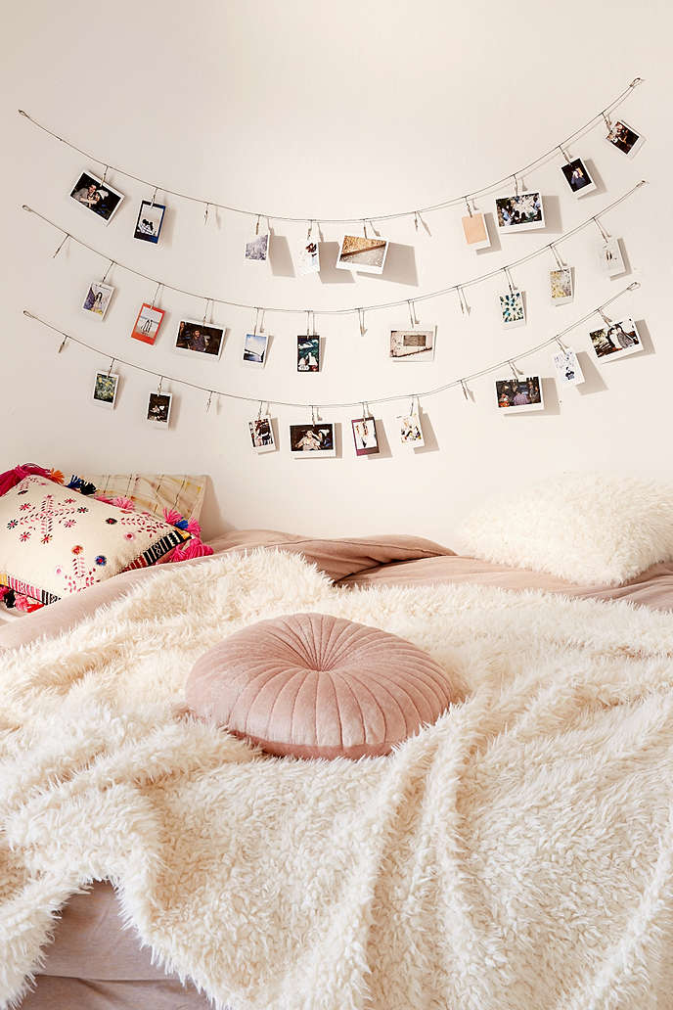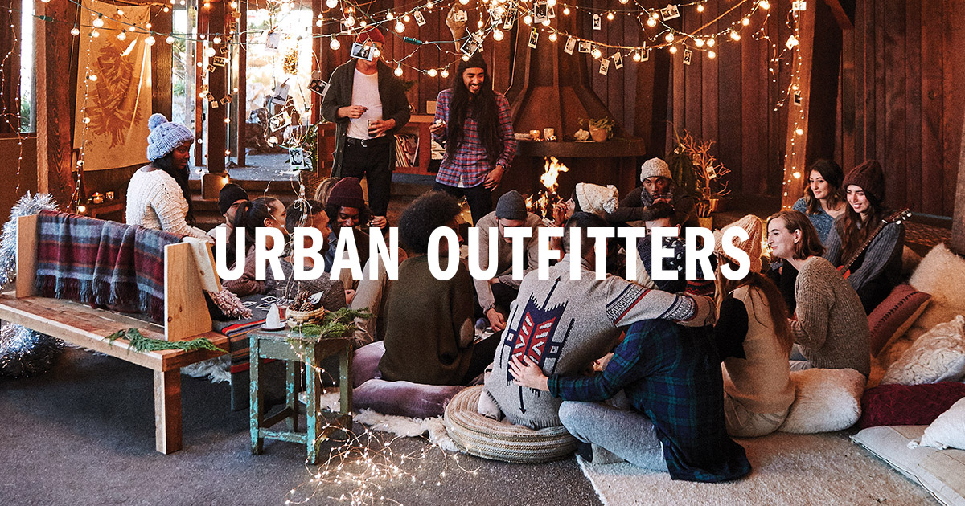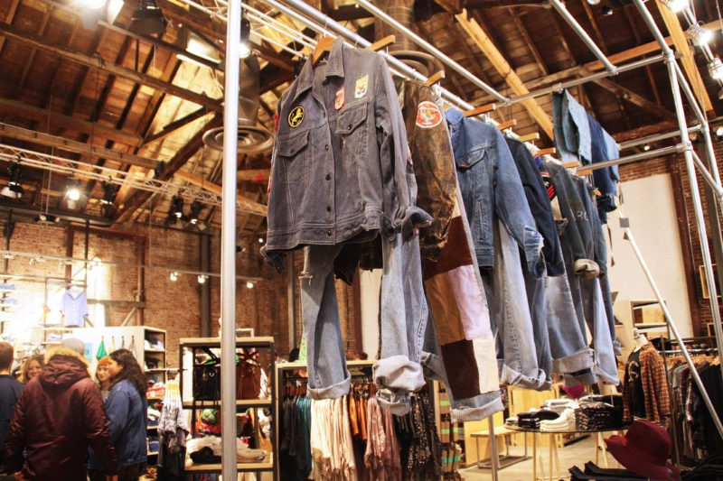

The first thing that is displayed on the Urban Outfitters homepage is a banner with their latest promotions and sales. The store offers clothing items and accessories for men and women, also furniture for apartment and homes. Seeing as it is winter, their homepage also displays a series of sweaters with the entitlement of “Sweater Weather” and a “Winter Essentials Checklist”. Since the holidays are just around the corner, they also promote gift shopping and holiday apartment party prep. Urban Outfitters is often known for their exclusive collection, which is also available on their homepage. Furthermore, the store displays their Polaroid Fujifilm Instax to promote their music and technology section, and displays their favourite facemasks to promote the UO Beauty section. As viewers continue to scroll down, they will also see the intimates section, the UO Blog, the UO Rewards, a lovely entitlement that reads “Follow us on Instagram @UrbanOutfitters in order to promote their social media and lastly, the #UOONYOU which is the UO Community. As for the features, viewers have the ability to shop women’s, men’s, apartment, gifts, music + tech, beauty, intimates, sales and they also have access to the UO blog. While users are shopping, they are able to share a garment or accessory through Facebook, Twitter and Pinterest. At the bottom of the homepage, viewers can find all the company’s social media platforms, which are Instagram, Facebook, Pinterest, Twitter, Snapchat, Tumblr, Youtube, Spotify and Google +.

While analyzing the UO Facebook and Twitter pages, I noticed that the company posts as often as four to five times a day in order to keep customers interested and notified. The content posted consist of party invitations, exclusive clothing, Halloween outfits, their latest clothing trends and upcoming holiday trends for Christmas. They also display their UO beauty collection, which is extremely lovely and satisfying.

As for their Tumblr account; it is extremely different than their Facebook and Twitter pages. The Tumblr account is extremely aesthetically pleasing seeing as they chose to go by different color themes every week for example, week 1 consisted of black and white photos of their models, clothing and brands where as week 2 consisted of pink photos, week 3 consisted of orange photos and week 4 consisted of green jungle themed photos. This definitely keeps viewers interested and satisfied.

While browsing on their Instagram page, viewers are able to see their latest sales, trends and collections. They company posts photos such as their latest footwear collection, Halloween and holiday photos, high end brands such as Tommy Hilfiger, Fila and Calvin Klein, their intimate collection, their UO Beauty collection and many more. The colors and filters that they use to edit and display their photos are definitely attention grabbing and satisfying due to the high quality and contrast used.

Lastly, UO posts up to four times a month on their YouTube channel. They upload educational videos from their brands and collections. For example, they recently posted a video for their UO Beauty collection to show their viewers how to use their metallic beauty collection in 3 different ways where as they also upload videos about different cultures, holiday idea videos such as their “ UO Guide: Friendsgiving” video and their skate guide video which shows viewers where to skate in Brooklyn, New York.

Urban Outfitters