Taranpreet Kaur Sohal
Fashion Phenomena
571-KNA-03 gr.02052

INDIVIDUAL RESEARCH

Presented to Ms. Jennifer Millen

LaSalle College
February 26th , 2019
INTRODUCTION

Fashion is not just a piece of clothing , it is way to express ourselves to the world. An individual's choice of fashion can be influenced by their culture, their religion or their values. Today’s generation is quite unfamiliar with the ancient fashion and garments produced , and lack knowledge of the history behind them. However, There’s a lot of pieces produced in ancient periods belonging from different cultures and places that deserve to be known and talked about. Greece is one of the countries that has evolved their magnificent pieces of fashion and jewellery throughout the period of times. They are known to possess a great variety of jewellery worn exclusively by men, women and children. Ancient Greek jewelry spans a period from 2600 BC to 31 BC, including great civilizations and eras such as Minoan Greece, Mycenaean age, Classical Greece and the Hellenistic period.A very diverse amount of styles and techniques were developed over the centuries until the conquest of Greece by the Roman empire. The Hellenistic era has various types of jewelry such as : necklaces, rings, earrings, bracelets, diadems, etc. This research paper will be focusing on the earrings of Greece’s Hellenistic era.

Source : GUMERO, JUAN. Greek Jewelry History & Facts: Distinct styles over time.The Ancient Home. 12 March 2018.
< https://theancienthome.com/blogs/blog-and-news/greek-jewelry-history-facts >

“In the Hellenistic period, the Greek world was flooded with gold. Greece itself had few sources of gold, and those had been depleted by the late Classical period. Alexander the Great’s conquest of the Persian Empire, which included Egypt, made vast resources of gold available for the first time. The various royal courts of Alexander’s successors, including the Ptolemies in Egypt, comprised a wealthy clientele with a taste for luxury, which, in combination with this new abundance of gold, led to an immense outpouring of gold jewelry”(Getty Villa). During that era jewellery was also starting to become more accessible to people due birth of various new styles, such as earrings. It is known those who wore these earrings made with precious elements , such as gold , were the people that had a higher social status than the others. Wearing jewelery had become a way of showing the wealth that one possessed. Woman were usually the ones that mostly wore earrings, however there were only few man who were also attracted to this type of adornment.

Most of the earrings were made out of gold since it had become a very popular resource during the Hellenistic era. There were different styles of earrings: drop earrings, hoop earrings and other various shapes. Artists would often integrate different animal or human shapes into the earrings. They usually included a bust of an human figure or an animal, however it was very rare that they included the whole body. To add , “elaborate subsidiary ornamentation drew plant and animal motifs, or the relation between adornment and the goddess, Aphrodite, and her son Eros. Airborne winged figures, such as Eros, Nike, and the eagle of Zeus carrying Ganymede up to Mount Olympus, were popular designs for earrings”(Colette Hemingway and Seán Hemingway, 2007). Egepttyan motifs were also very popular.

What was most of these pieces used for ? “In Hellenistic times , jewelry often passed from generation to generation as family heirlooms. And occasionally it was dedicated at sanctuaries as an offering to the gods. There are records of headdresses, necklaces, bracelets, rings, brooches, and pins in temple and treasury inventories, as, for example, at Delos. Hoards of Hellenistic jewelry that were buried for safekeeping in antiquity have also come to light. Some of the best-preserved examples, however, come from tombs where jewelry was usually placed on the body of the deceased. Some of these pieces were made specifically for interment; most, however, were worn during life. In the early Hellenistic period, wealthy Macedonians buried their dead with elaborate gold jewelry” (Colette Hemingway and Seán Hemingway, 2007).

Hemingway, Colette, and Seán Hemingway. “Hellenistic Jewelry.” In Heilbrunn Timeline of Art History. New York: The Metropolitan Museum of Art, 2000–.
https://www.metmuseum.org/toah/hd/hjew/hd_hjew.htm (April 2007)

https://roadrunnersguidetotheancientworld.com/hellenistic-jewelry/

https://theancienthome.com/blogs/blog-and-news/greek-jewelry-history-facts

IMAGES
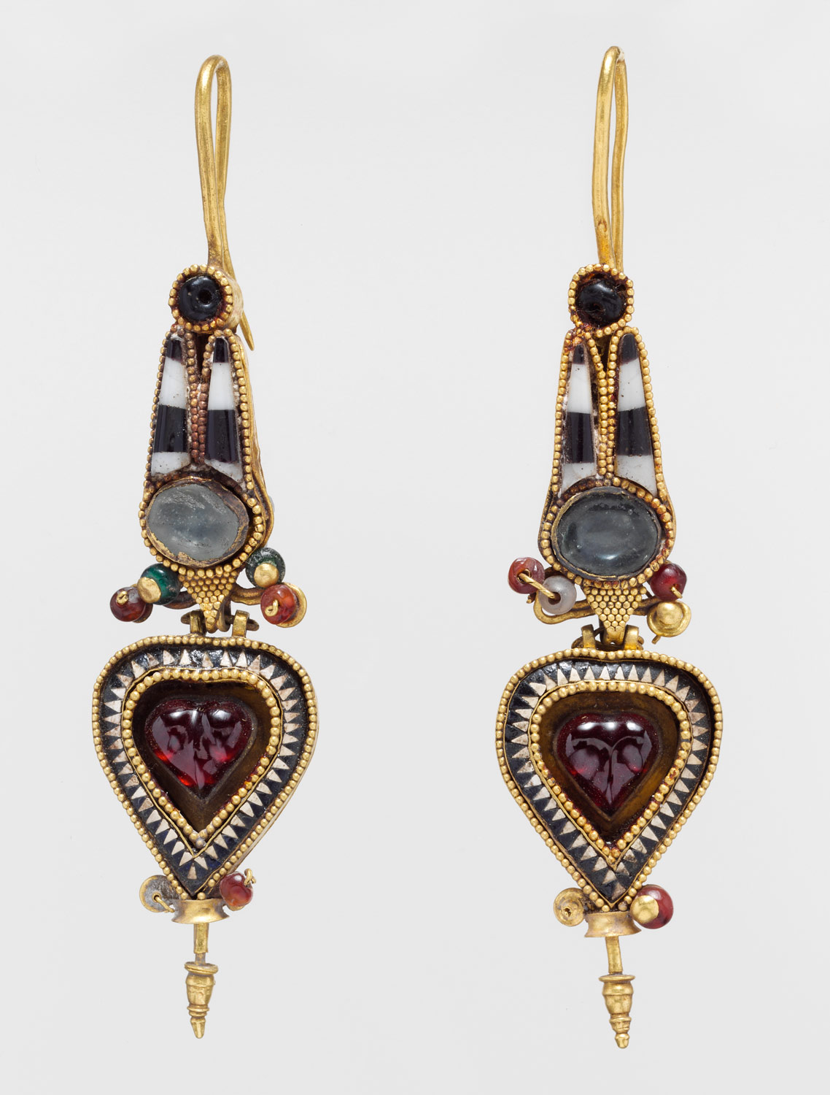

Gold earrings with an Egyptian Atef crown set with stones and glass
3rd–2nd century B.C.
Gold with stones and glass
Egyptian Atef crown
By Christos G. Bastis
Hellenistic period, Greece
https://www.metmuseum.org/toah/works-of-art/1995.539.11a,b/

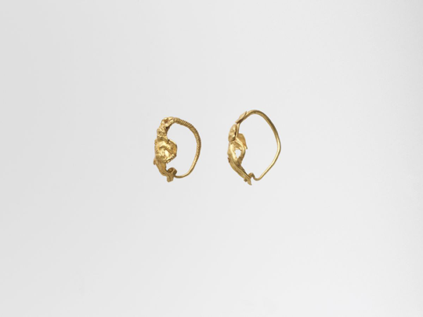

Gold earrings with winged figure
3rd-2nd century B,C.
Circlet of twisted gold wire
The Cesnola Collection
Hellenistic Period , Greece

https://www.metmuseum.org/art/collection/search/242937

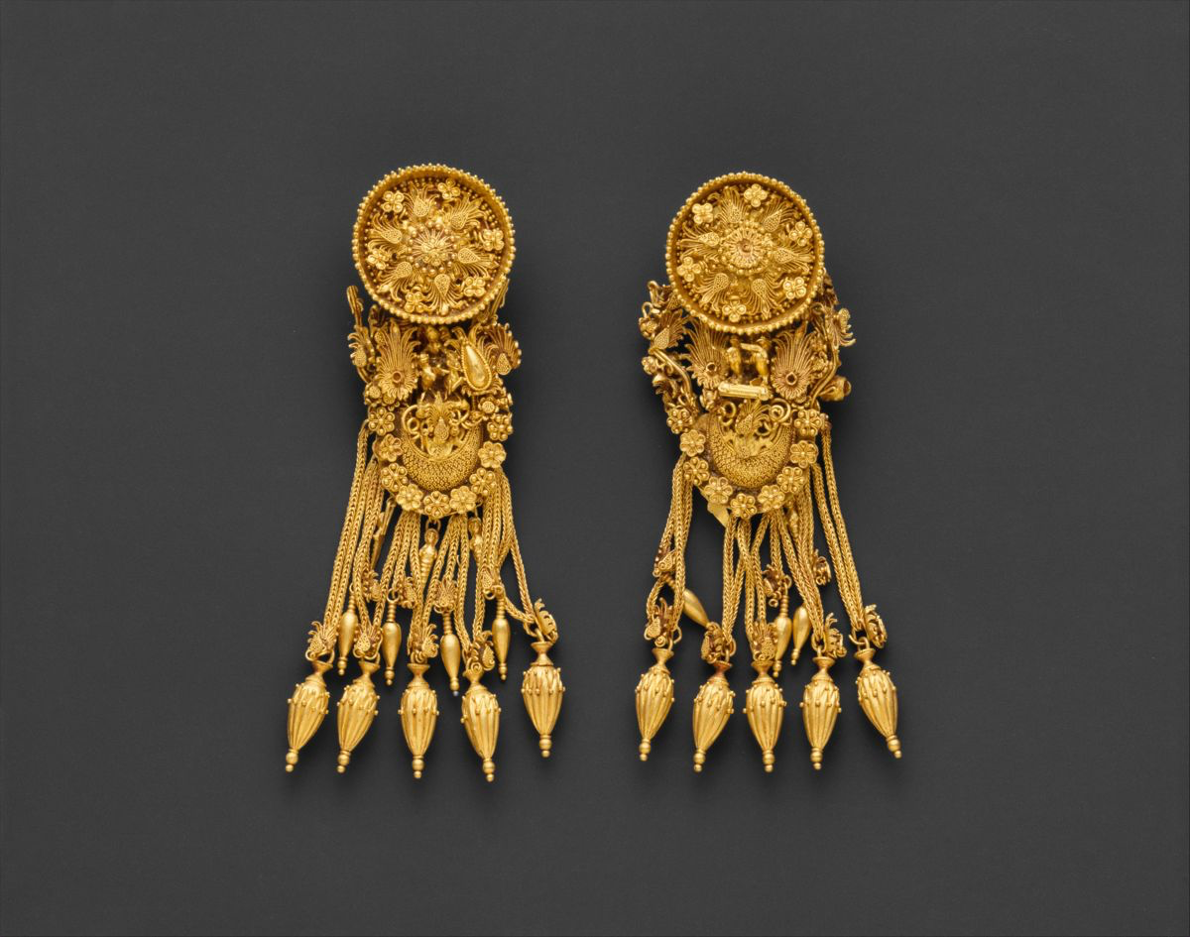

Gold earrings with disk and boat-shaped pendants
300 B,C.
Figurine of Nike , the personification of victory , driving two horses Amit the floral design above the boat-shaped forms
The Met Fifth Avenue in Gallery 158
https://www.metmuseum.org/art/collection/search/254595

CONCLUSION

To conclude, we have learnt that the Greeks were goldsmiths of the Hellenistic era. They had managed to create such beautiful motifs and decorations for earrings which became so popular. This iconic period helped popularize and start the evolution for the Greek culture. These antique pieces of jewellery has been passed down generation by generation by the families and they’re still shown at museums as cultural and historical garments to be remembered.

