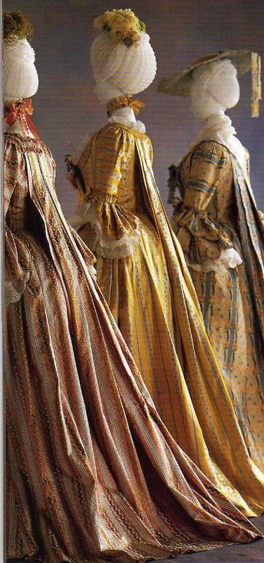
Stefanie Becker
Sack-back gown
Robe à la française
Fashion Phenomena
571-KNA-03 section 02052

INDIVIDUAL RESEARCH ON ROBE À LA FRANÇAISE

Presented to Ms. Jennifer Millen

La Salle College
March 2nd, 2017

INTRODUCTION

The 18th century was marked by the French Revolution that had its beginning in 1787 and finished in 1799, having as its result the end of the monarchy in France. During Louis XVI mandate the country was going through a terrible crisis, therefore the Estates General decided to try to come up with ideas to hold back the economical crisis. However, in one of their meetings, the Third State declared itself the “National Assembly” that represented the people, inspired by liberal ideas from the Enlightenment movement, which had new political ideas trying to spread radicalism, liberalism, socialism, feminism and secularism.
The king tried to dissolute the new assembly but he failed, they were demanding a new constitution while a shortage of food was happening and the mob was taking down the streets. The situation in the country was getting worse until one of the groups of the Assembly; the Jacobins broke down the king’s house and arrested him. The biggest even of the French Revolution was the execution of the king Louis XVI in the guillotine under the accusation of "conspiracy against the public liberty and the general safety" and his wife, the queen Marie Antoinette, also executed for committing depletion of the national treasury, conspiracy against the internal and external security of the State and intelligence with the enemy. At the end of the Revolution, the Republic was established in France and in 1795 Napoleon Bonaparte takes the power of the country.
I chose the robe à la française because it shows femininity and also power, wealth. The gown is gorgeous and you can see the amount of work that was invested to make it and also the quality of the materials used in the garment. I want to learn what are the materials used in a sack-back gown, who exactly were the people that wore this garment and the historical background of the robe à la française.

FACT FILE INFORMATION

Student name: Stefanie Becker

Object researched: Robe à la française

WHO? | The robe à la française was worn by exclusively by the wealthiest woman. The European royalty, such as the French dutchess Èlisabeth Charlotte d’Orleans, often wore this piece of garment, for example.
WHAT? | The most noticeable characteristic of this gown is its back that has a panel of fabric that falls all the way to the floor loosely, which is sewn in in the center of the back of the neckline, contrasting to the rest of the garment that is very form-fitting. The robe à la française was worn over a petticoat(underskirt) usually made with the same material used in the garment. The dress was also known for the pleats on its back, which later in the century they turned into arrangements of single, double or triple box pleats connected to the folds of the skirt. Also, the gown was worn with sidehoops or panniers, known as romps back then, to build the wide formats of the skirts, showing their inspiration in the Spanish designers. With a very form-fitting structure, the sack-back gown has a funnel-shaped silhouette by the V shaped stomacher and the wide structured skirts. The garment was opened in the front, disclosing the petticoat and the stomacher. The folds of fabric that falls down the shoulders on the sides of the dress are known as robings. To give them volume, they were stuffed with sheep’s wool.  The dress was easily adjusted to two or three dress sizes.  The robe à la française was made of silk, sometimes wool broadcloth, cotton, linen, metallic thread and satin.  The colours this piece of garment is found in is light colours that represent the Rococo era. A specific characteristic of this artistical movement is the curves and the flowers, elements that were seen a lot in the robes à la française. Most gowns were made in light blue, crème, light rose, yellow and blue colours with a flower pattern and decorated with ruffles, lace, bows and ornamental touches.
WHERE?  WHEN? | This specific type of dress was worn in Europe, most precisely in France and England. There was no particular season for the robe à la française once it was usually worn indoors, at most of the occasions, for the court events, where woman wore this gown in a large variety of shapes, sizes, colours and decorations. In the middle of the 18th century, it was also worn in weddings and soirées. Nevertheless, in the article George Smith's Laboratory or School of Arts the author suggests that the flower patterns of the gowns were inspired by the seasons.  The sack-back gown was found in the era of the French Revolution(1789-1790), the Rococo art movement(1720-1770) and the era of the embracement of the Enlightenment ideals through the whole European continent. After the French Revolution, in 1795, with a new regime installed in the country, Napoleon Bonaparte takes down the control of France.  The robe à la française had its first appearance in the beginning of the 18th century as an informal gown with a loose fitting. Throughout the years, the garment started to adopt a more form fitting and, later on, it became a formal gown, with wide and very structured skirts. However, the dress had various modifications through the 1800’s and at the end of the century and beginning of the 19th century, the sack-back gown became simpler with skirts less wider and with a loose fitting once again.
WHY? | The purpose of the robe à la française is to show status and wealth, once it is noticeable that there is an exaggerated use of fabric, seen in the strongest characteristic of this piece of garment: the panel of fabric from the back that falls all the way to the floor. This is shown through conspicuous consumption that basically is a display of wealth through the quantity and the quality of the garments or how much fabric the piece of garment has and how good the materials are. The conspicuous leisure is also noticeable in the robes à la française once the movements of whoever is wearing the gown is completely limited, due to the stomacher that tightens the stomach area and the farthingale that gives structure to the dress limiting woman to bend, pass through doors or make any simple movement. This shows that people that wore these gowns had to had someone next to them all the time to realize simple tasks for them once they were not able.
OTHER INFO | The french painter from the rococo era, Jean-Antoine Watteau, was known from admiring the pleats in the back of the gown and representing them in many of his artworks. Due to that fact, the pleats are now known as Watteau Pleats.  One of the notable wearers of the robe à la française was Élisabeth Charlotte d'Orléans, mostly known as Duchess D’Orléans, wore one of the earliest versions of this garment, the robe battante, which was created in 1670 by Louis XIV’s mistress to conceal her pregnancies. Therefore, everytime that the public saw the dutchess in the “maternity gown” they assumed that she was carrying a baby.
SOURCES | Eighteenth-Century Clothing at Williamsburg  https://books.google.ca/books?hl=pt-BR&lr=&id=aIBGKdODsiwC&oi=fnd&pg=PA9&dq=sack+back+gown&ots=5xUlMz-3eQ&sig=ImTdGp6X9hWjtoOgNDDXltGNHCs&redir_esc=y#v=onepage&q=sack%20back%20gown&f=false  How to Make a Contouche - La Couturière Parisienne  http://www.marquise.de/en/1700/howto/frauen/contouche.shtml  Paniers or Panniers, 18th Century Sack Dress and Polonaise  http://www.fashion-era.com/paniers.htm  http://www.metmuseum.org/art/collection/search/159485  http://www.palaisgalliera.paris.fr/en/work/robe-la-francaise-sack-back-gown  http://historyandotherthoughts.blogspot.ca/2014/02/robes-la-francaise.html  http://www.fashionencyclopedia.com/fashion_costume_culture/European-Culture-18th-Century/Robe-la-Fran-aise.htm

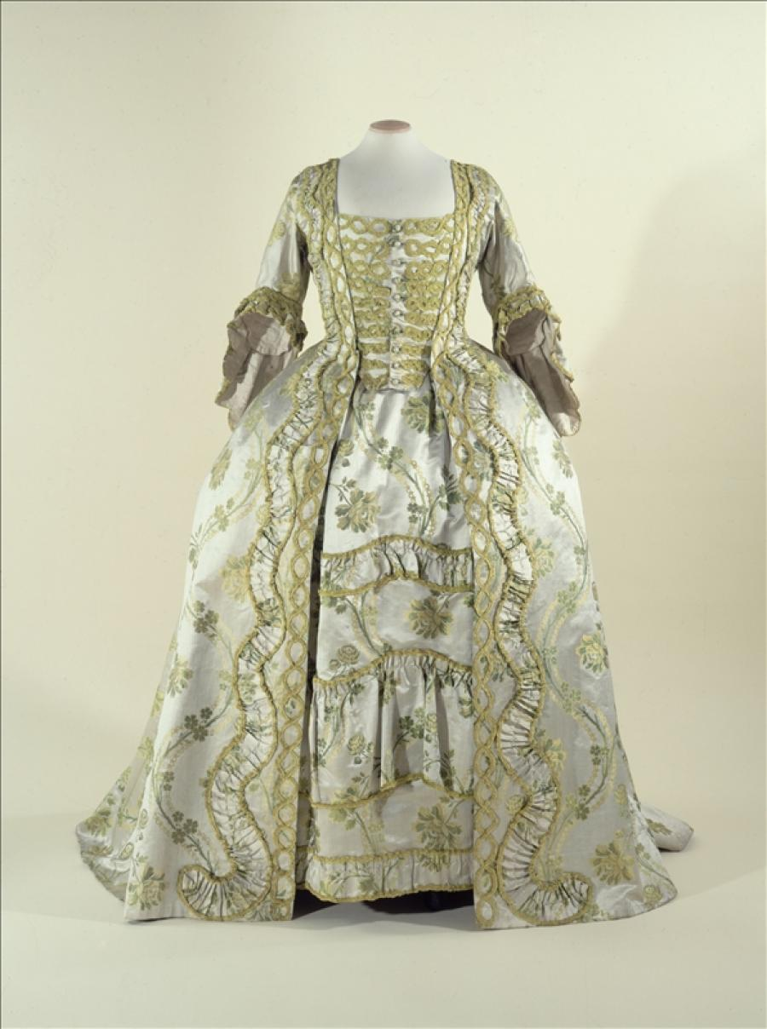
FACT FILE IMAGE 1

FACT FILE IMAGE 2

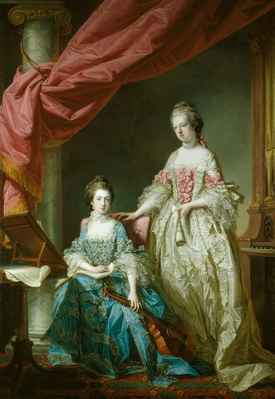
FACT FILE IMAGE 3

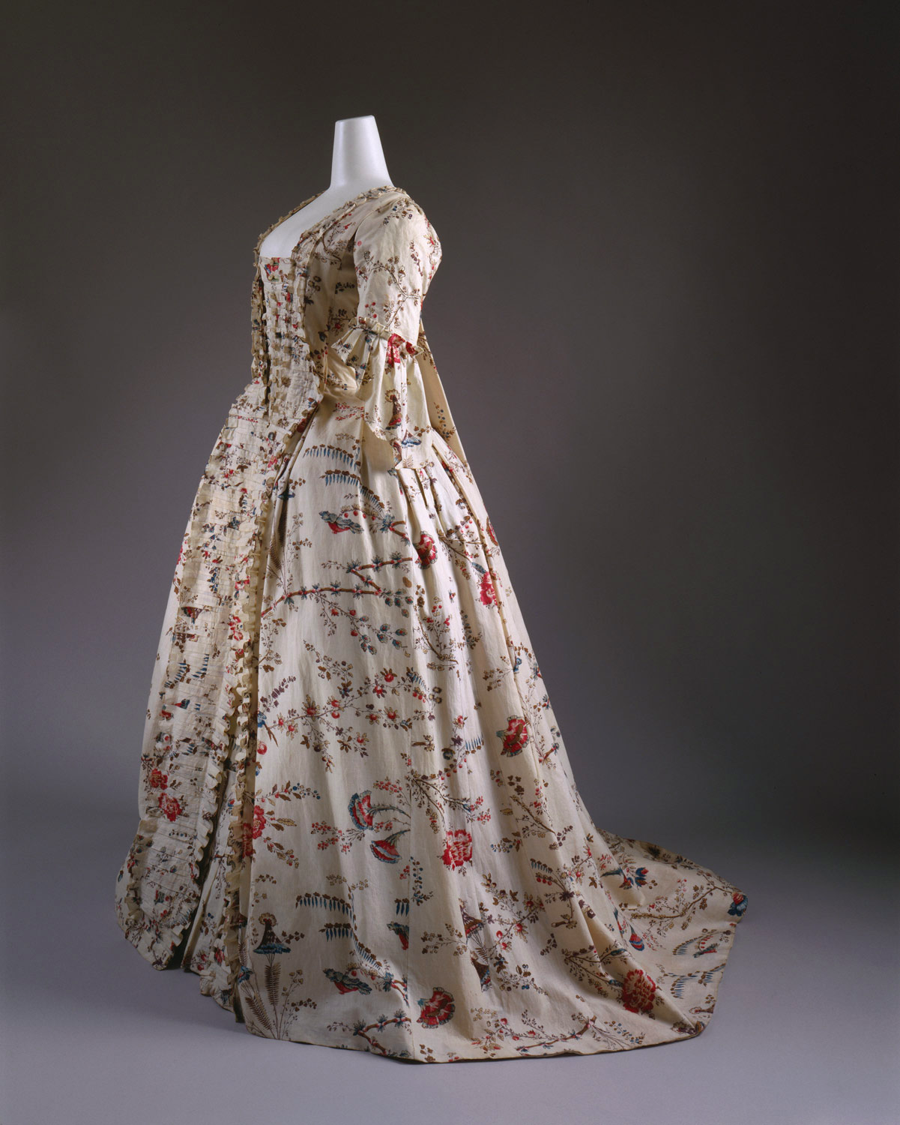

FACT FILE
IMAGE / OBJECT IDENTIFICATION

IMAGE 1
Name | Robe à la française
Year / date | 1750-1760
Materials | Satin, silk and taffeta
Color, decorations, motifs | Gray, green, violet
Label / artist | -
Collection / location | 18th – Century Dress Department, Palais Galliera, France
Source | http://www.palaisgalliera.paris.fr/en/work/robe-la-francaise-sack-back-gown

IMAGE 2
Name | Princess Louisa and Princess Caroline
Year / date | 1767
Materials | Oil on canvas
Color, decorations, motifs | -
Label / artist | Francis Cotes
Collection / location | Green Drawing Room, Buckingham Palace, England
Source | https://www.royalcollection.org.uk/collection/search#/12/collection/404334/princess-louisa-and-princess-caroline

IMAGE 3
Name | Robe à la française
Year / date | 1760’s
Materials | Cotton
Color, decorations, motifs | Exotic floral pattern, copy of a Chinese pattern.
Label / artist | -
Collection / location | 18th – Century Dress Department, Palais Galliera, France
Source | http://www.metmuseum.org/toah/works-of-art/C.I.64.32.3a,b/

CONTEMPORARY CONNECTION IMAGE

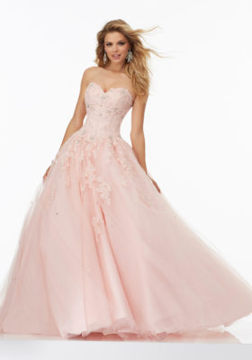

INFORMATION

Name of object | Prom Ballgown with Beaded Lace Sweetheart Bodice and Tulle Skirt
Year / collection | -
Label / designer | Morilee Madeline Gardner
Materials, color, decorations, motifs | Lace, tulle, Blush colour, beading/crystals and lace
Reason chosen  (min. one paragraph) | This gown reminds me of the robe à la française because it has a light colour, is composed by a flower pattern and has a circular movement exactly like what the rococo art movement transmits. The quinceanera dresses are used for a celebration, where formal dressing is required. That assimilates to the fact that the sack-back gown was also used for formal events such as courts, weddings and soirées.
Source of image | https://www.morilee.com/product/prom-dresses/prom-ballgown-with-beaded-lace-sweetheart-bodice-and-tulle-skirt-2/

CONCLUSION

In conclusion, with this research about the robe à la française I realized that the cultural, political, artistical, architectural and economical factors impacted the fashion in an enourmous way throughout the centuries. The piece of garment that I chose was first made in the beginning of the18th century and was strongly influenced by the Rococo movement and also the aristocracy that was very spendthrift and wore extravagant garments with luxourious jewelry. However, the French people could not accept the fact that they were spending money on artificial things while the country was going through a terrible economic crisis and that led the country to a Revolution and took down the monarchy. That shows that culture, art and politics go through history with fashion aside, one has an impact on the other.

