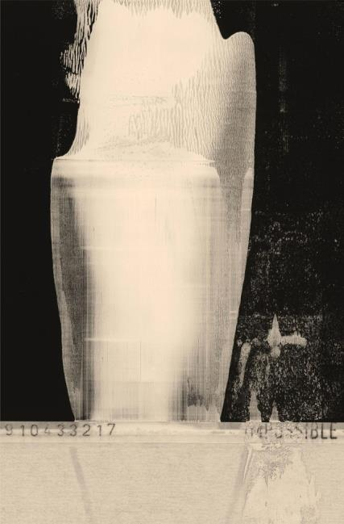

MENGYANG LYU (Tyler)
+1 (514)-963-2182(Montreal)
naoyang123@gmail.com

Languages
Fluent Chinese,
English
Basic French and keep learning.

Skills
Microsoft Office **********
Adobe Illustrator and Adobe Photoshop ****************
Painting and sketch ********************
Photography (cartridge and electronic) **********************

Education
Winter 2016-Present Fashion Design, LaSalle College---DEC fashion design
Fall 2014 Sep-Nov Parsons the new school of design (New York city)
---fashion design [Partial Scholarship]

Work Experience
2013-2014 Bartender in “School” bar (Beijing)
2014 Co-Curator in Gallery------MoCA Beijing

Volunteer Work
2018 Assistant for RELUXE boutique of Le Chaînon Foundation
2014 Translator for exploratory mission from Norway Government
2008 Tour Guide for Beijing Olympic Games
Summer 2008 Tour Guide of Beijing Museum of Natural History

Interest and Activities
Been to anarchic war-torn Somalia,
Pass through Grand Canyon on foot,
Experiencing the living of people from every social class
Photography and graffiti work invited to 3 group exhibitions

Reference and portfolio:
available upon request

