  - == December 10, 2017

O

OPERATING SYSTEM : LINUX
420-235-AS

Project: CentOS 6

Presented by Nguyen Quoc Dang Khoa

Patrick Paul
LaSalle College
I. INTRODUCTION:
1. CentOS 6.9 DVD
- Host Name: centos6-dvd-minimal
- User Name: dvduser
- IP address : 10.0.2.15
2. CentOS 6.9 Minimal
- Host Name: centos6-minimal
- User Name: minimaluser
- IP address : 10.0.2.4

II. ERROR & ANSWER FOR PROJECT QUESTION:
- Log in as root & create a new user

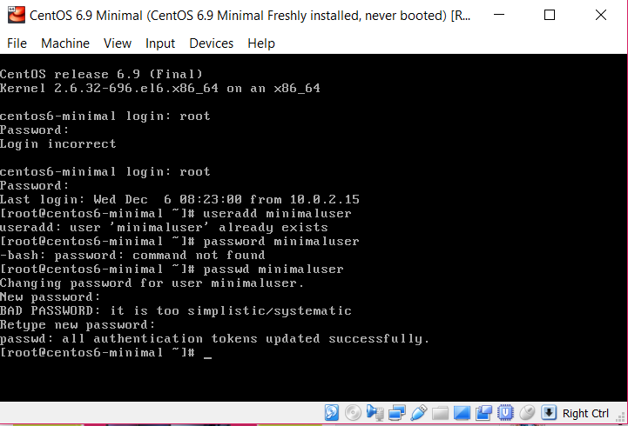

- FIRST ERROR : Wrong command “password” for minimaluser
- FIXING ERROR: “passwd minimaluser “

- Give sudo permission for new user & test sudo work

- At root , type “visudo” to go inside the script and add the user below root
- Testing sudo work on minimaluser
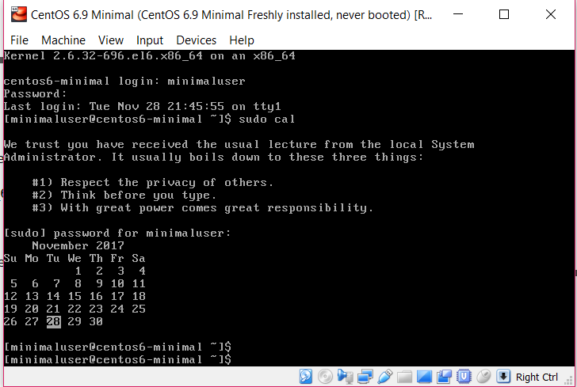

- Networking setup

- ERROR 1: When I try to set up network, I can’t find the right command to go into script (/etc/sysconfig/network-scripts/ifcfg-eth0)

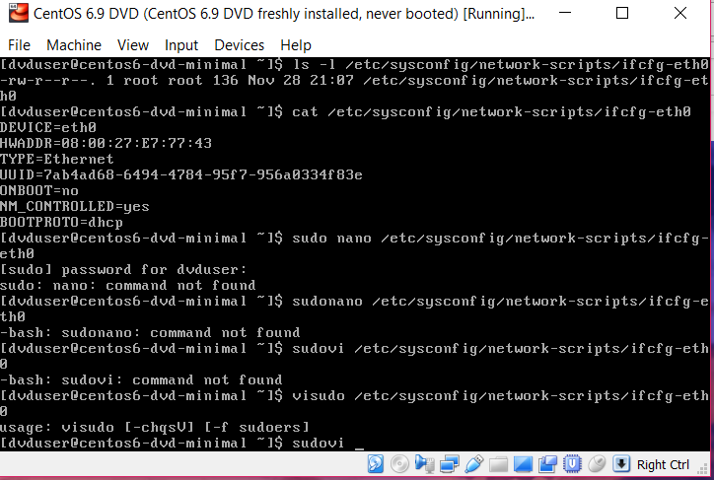

- FIXING ERROR: sudo vi /etc/sysconfig/network-scripts/ifcfg-eth0 I should have a space between “sudo” and “vi”.

- ERROR 2: When I set network to “NAT” for both VMs and change ONBOOT=yes, I got the same IP address for both VMs .
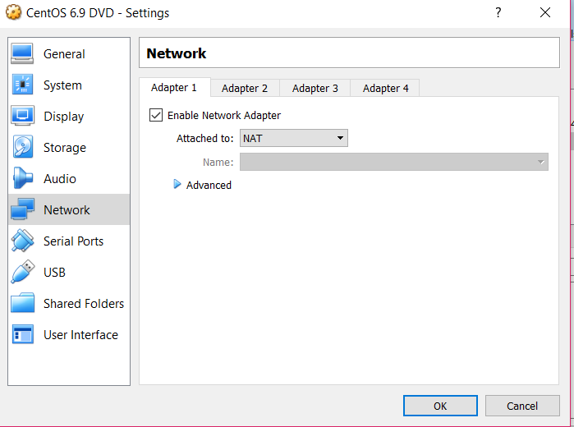
- FIXING ERROR 1 (but it doesn’t success) ERROR 2: I try to change MAC address in the “Advanced” but I got the second error when I restart the network.
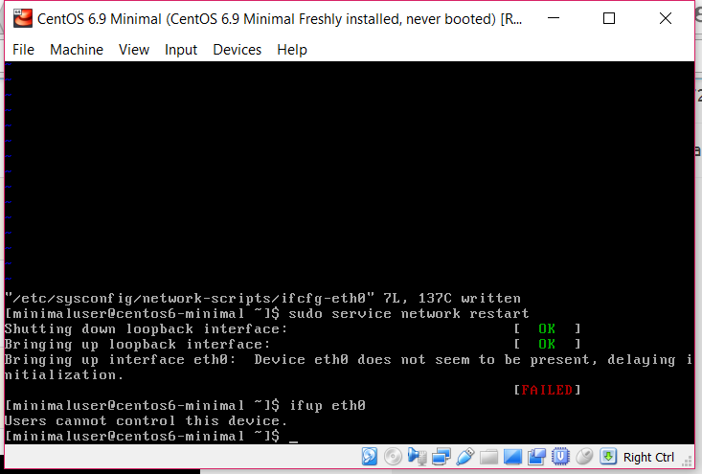
- FIXING ERROR 2: I have to use snapshot and setup the network again (Nat NatNetwork). Redo the above command:
+ sudo vi /etc/sysconfig/network-scripts/ifcfg-eth0
+ Change ONBOOT = yes
+ sudo service network restart
+ ifconfig
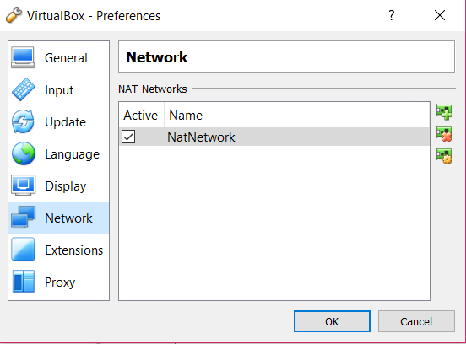
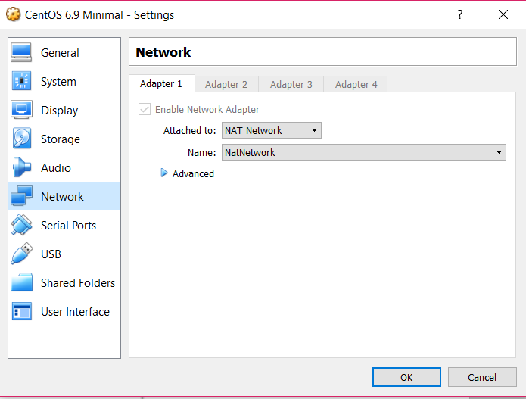
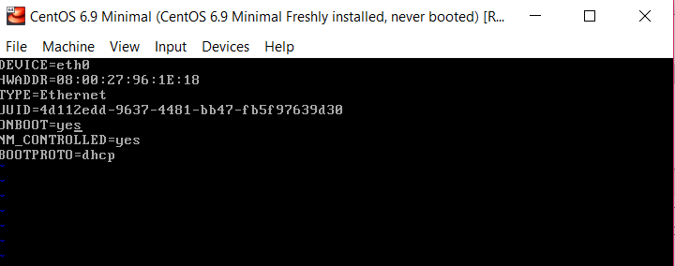
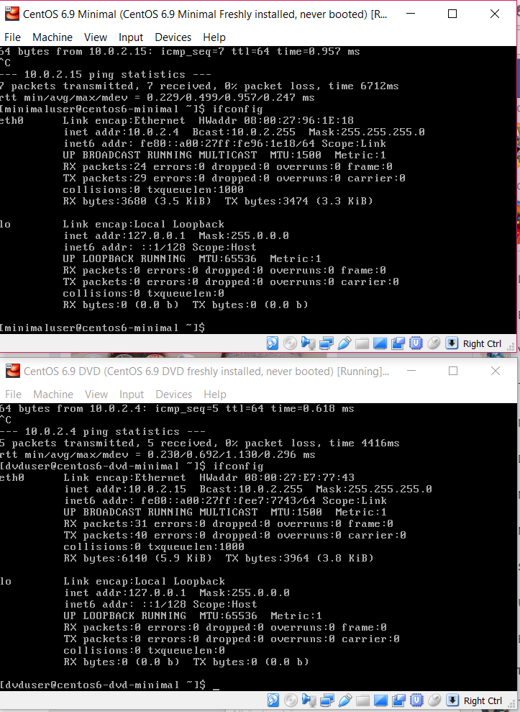
- Generate SSH connection between both VMs
- ERROR 1: When I installed ssh & key package for both VMs by using:
+ sudo yum install openssh-clients
+ ssh-keygen create a private key for each VM
+ ssh-copy-id generate a public key between 2 VMs but this error appears

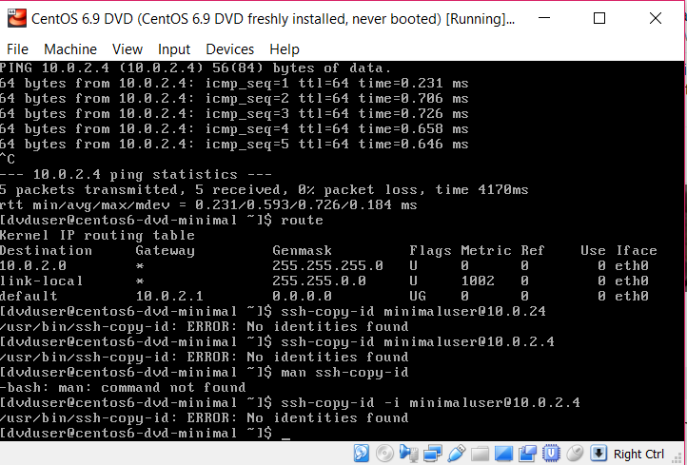
- FIXING ERROR 1: I realize that the problem is “ssh-keygen” because I give the wrong path when the system ask me to enter the file’s name I shouldn’t type any name or password and let it set by default private key can be created.

- Comparing installed packages (DO IN MINIMAL VM)
- List all installed packages in local host:
- rpm –qa | sort > centos6-minimal-installed-rpms-sorted.txt
- Remotely list and sort all installed package by using ssh :
- touch centos6-dvd-minimal -installed-rpms-sorted.txt
- ssh dvduser@10.0.2.15 “rpm –qa” | sort > centos6-dvd-minimal-installed-rpms-sorted.txt

- Compare packages between 2 files :
- comm -3 centos6-minimal-installed-rpms-sorted.txt centos6-dvd-packet.txt | nl

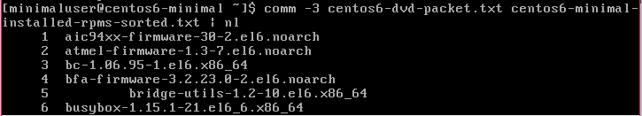

- comm : the command uses for comparing 2 files
- -3 : eliminate the identical packages between 2 files only show different packages
- nl : count how many different packages between 2 files
- OR I CAN USE:
- comm centos6-minimal-installed-rpms-sorted.txt centos6-dvd-packet.txt
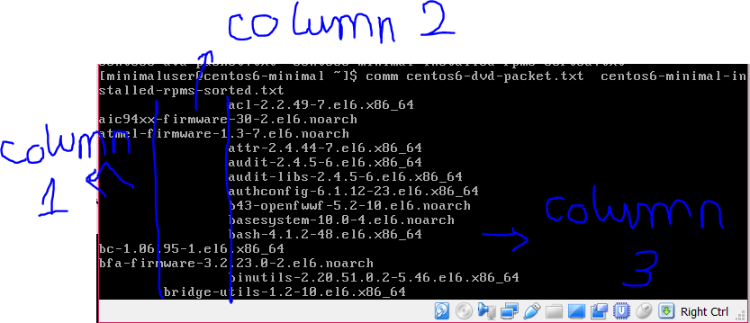

- Column 1 : List of packages in file 1 that are different from file 2
- Column 2 : List of packages in file 2 that are different from file 1
- Column 3 : All of the packages are identical between 2 files

