College LaSalle
410-BE3-AS International Trade
Project

Team members:
Xiaoyu Wen, Hengzhi Li, Ka Wai Chik, Chun Hin Chan

Presented to: Uma Kaplan
Semester: Winter 2018

Introuduction
1. Company
Jamieson Laboratories, as Canada's Nov.1 vitamin brand and one of the world's top three nutritional health products companies, was established by Claire Edwin Jamieson in 1922. In the 90 years, it has grown into a world leader in vitamins and nutrients and recognized as the leading manufacturer and distributor of natural health products in Canada. Nowadays, Jamieson products are exported to more than 50 countries and regions in the world including the United States, Japan, Singapore and South Korea, and consumers love it.

2. Products
As a company with long history and large manufacturing scale, Jamieson has more than 1,000 product categories. It is proud to offer a variety of natural health products for entire family, including:
- Vitamins and minerals
- Health supplements including omega-3s
- Digestive health products and natural sleep aids
- Prenatal vitamins and vitamins for growing children
- Herbal extracts and botanical solutions
- Natural beauty and skin care products
Jamieson company has a 360 Pure promise to guarantee their products are of the highest quality available.From the seed to the raw material until the finished product, each product has at least 360 inspection procedures, so they are known worldwide because of the high quality, high purity and high safety.

International opportunity analysis
China is currently experiencing an aging problem, in the graph above, it demonstrates that the portion of 50-54 years old and 30-34 years old males and females are occupied the majority of China population in 2020. This is an opportunity to introduce Jamieson’s product to Chinese. Based on Maslow’s hierarchy of needs, security of health is the second layer of the needs’ pyramid. Along with the aging problem that China has, health security would be a big part in the future.
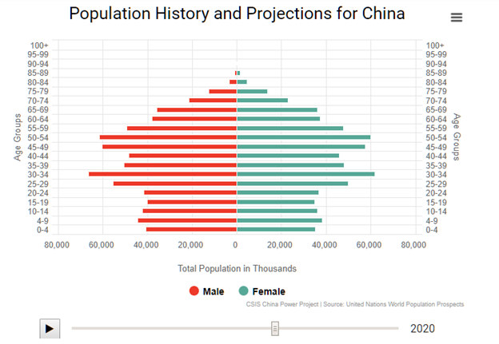
(chinapower, n.d.)

1.Political environment
The government of China had issued an outline of the Program for Food and Nutrition Development in China (2014-2020). (china, Lawinfochina) It indicates the agricultural product has a stable increase, however, the health care’s product does not match the nutrition of the residents. Therefore, they have a high attention on nutrition product such as Jameson’s health care product.

2. Legal environment
The government of China had issued a Measures for the Administration of the Registration and Recordation of Dietary Supplements (china). It states that the health care products’ regulation and the standardize format of the presentation of nutrition fact and ingredient. Including the manufacturing process, it has to be supervised to maintain the quality.

3. Economic environment
China, it is a country that experiencing rapid economic growth, many opportunities
have appeared. First of all, according to World bank, the GDP per capita of China
have growth from $4560.51 USD in 2010 to $8069.21USD in 2015. China has the potential on using their disposable income on goods..
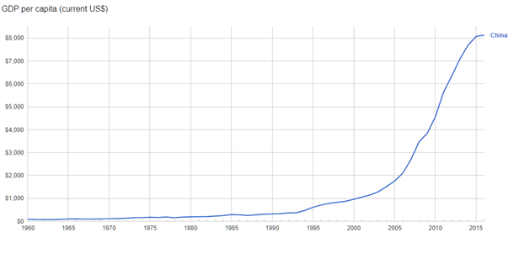(bank, n.d.)

4. Cultural environment
China is a country with the traditional cultural that has a great respect on the senior people. During the festival such as Lunar New Year, Mid-Autumn festival, the junior of a family will often buy gifts for the elder. In such environment, Jamieson’s product will be a great choice for them. The reason being that health is the main concern for Chinese in the future, the junior portion of the population, 30-34 years old, they are mostly in the position of workforce which mean they have the disposable income to afford our product. Furthermore, the large portion of China population, 50-54 years old, they are the clientele that we targeted.

5. Government regulation
China has tariffs on most of the imported goods, the percentage of tariff was 15.3% in 2000 and it has decreased to 9.8% in 2016. (canada). In additional, the government of China had introduced a policy that reduce the income tax on foreign company to decrease the chance where company transfer funds out of China. (NYTimes) It is a policy to fight against the US policy on reducing the corporate tax rates.

Entery Strategy
Entry Strategy
There are lots of ways for our company to enter to the foreign market. Different markets have different strategies to deal with. Our company planned to use Direct Exporting to open online and offline markets. Direct exporting is selling our product directly into the market. First, we have to own our own brand and resources. Our company once we have established a sales program turn to agents or distributors to represent us further in that market. International dealers have direct purchase of enterprise products and ownership of products, while foreign agents sell products on behalf of enterprises in the international market and do not possess products, but take commission.
The benefits of direct export to enterprises are: Firstly, it can quickly grasp the trend of foreign market, so that it is beneficial for enterprises to improve products and improve their adaptability and competitiveness to the international market. Also it helps to accumulate experience of transnational marketing and set up a reputation of enterprises in the international market, so as to open up international market. However, It aggravated the burden of capital turnover and increased the risk.We planned to open our store on TaoBao and selling our own product on separate pages which more eye-catching and easy to promote.
By using the sales network and sales means of the exporting to enter the market or the international market in a specific area, we can develop or expand the foreign market. By cooperation with the largest Chinese B2B platform Alibaba to helps to ease the differences between the national consciousness of the host country and the corporate culture. It is generally considered to be a method that simultaneously spans the boundaries of ethnic groups, cultures, and companies.

Marketing stategy
- Pricing strategy
Having a good pricing strategy for pricing can bring our company largest benefits and profits. By setting a price we have to consider production and distribution costs, competitor offerings, positioning strategies and the audiences we target on. We prefer to adopt both Psychology Pricing and Pricing at a Premium. By setting a Premium price to make consumers have a good impression of product quality. Premium pricing is most effectively when our product is first introduced to the new market. By showing how unique our product are and distinguish with other companies. When a product has been detrusion highlight those unique elements in marketing and told consumers why these product are costly. And set up a good brand of enterprise image. About psychology pricing is mainly used for the consumption psychology of Chinese people. The main sales market for health care products is the elderly group of people. Elder people in China would love to covetous of small gains so setting a health products price at amount 199 China Yuan(CNY) is proven to attract more consumers than setting it at 200. Moreover, we have to consider about the exchange rate between Canadian dollar and China Yuan. The direct exchange rate between Canadian dollar and China Yuan is probably 1:5.

2. Distribution strategy
Our company planned to use online marketing and offline marketing to guide its entry into its intended market. Distribution channels in marketing are one of the classic “4 Ps” (product, promotion, price, place) They are key element in our entire marketing strategy. First we need to focus on the development of functions, requires products to have a unique selling point, put the product's functional appeal. Price need to be affordable for customers and profitable for organizations. The enterprise does not face the consumer directly, but pays attention to the establishment of the dealer's cultivation and sales network, and the relationship between the enterprise and the consumer is carried out by the distributor. Focus on the change of sales behavior to stimulate consumers, and promote consumption growth with short-term behavior (such as buying one get one, etc.). The online operation mode is to cooperation with Alibaba and selling with B2B platform. The offline operation is to open sprite, independent direct-sale store to selling our product in different variation of the country.

3. Sales and Promotion Strategy
As a company that enters into a new country, we customize some sales and promotion strategies for attracting Chinese customers and counteracting the competitors. We have both short-term and long-term promotion strategies.

Short-term strategy
- Opening promotion
Once we enter into Chinese market , Jamieson will have a opening promotions to both the online and offline distributions in order to let all the customers to know our brand and build a high affection for our products. Therefore, we decide in the first 15 days we open our business in China, everything will be 30% off.
- Big event promotion
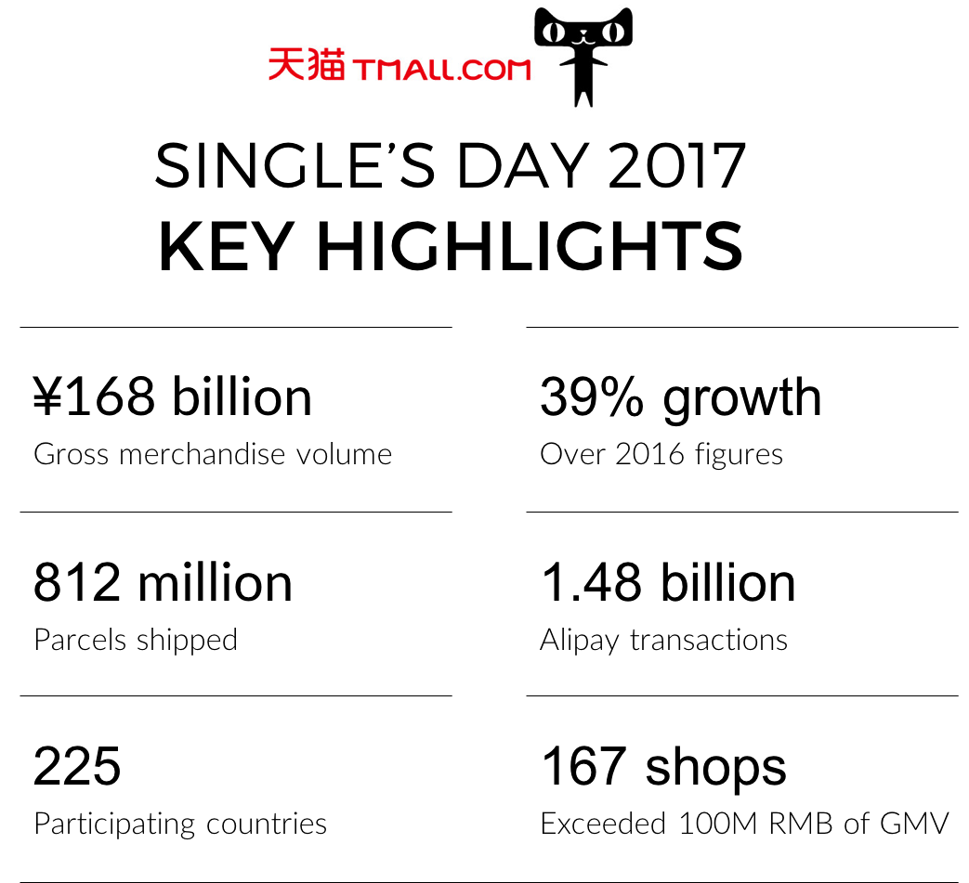
In China, there is a big shopping event which is double 11. In that day, the stores will give a big discounts and almost 80% of Chinese online shoppers will join this party and enjoy the shopping spree. Most of the stores will increase more than 45%. To adapt the Chinese culture, we would like to join this online shopping big event and give around 40% off for our customers. Not only online market distribution, the offline channels will also have a big event every year. Lunar New Year is the biggest festival for Chinese. One month from the festival, they start preparing to celebrating and buying a lot of gifts for friends and family members. As we said in culture environment, they think healthy products are good choices to be a gift. Therefore, we would like to follow the Chinese tradition and launch the corresponding New Year promotion.

Long-term strategy
- Membership level discount
Membership is a useful and profitable promotion strategy which can help us build a stable relationship with customers. By providing the membership, we can understand the customers’ demands and improve their loyalty. In addition , it can provide a stable income for our business. Membership qualifies offer our customers a discount on purchases. Members of our membership grade level discount is dynamic system, according to how many members of the integral level higher grades, enjoy the goods discount.
- Product bundling
For improve the sales, we have a promotion strategy which is bundle sales. It means we will combine two or more products together, create differentiation and greater value for customers, therefore enhancing the offer to the customer for a basic rate. First we will create different categories of packaged products for targeting different people’s needs. The children , the old, the women and the men, even people who has unhealthy lifestyle will be customized by their specialized packages. More than that, we will also have the family bundles that can suit all the family members very well.
- Sales promotion gifts
Promotional gifts are a wonderful way to keep our brand at the forefront of clients' minds and improve the loyalty of customers. We will produce some gift products for customers who purchase above 150 ¥, then they will have the right to choose one or two gift products. We have this promotion strategy because first the gift products can arouse people's desire to buy more and once a person tries another product he has never used, he becomes a potential customers for that products. Thus, we can attract much more people.
- Delivery free
On the Alibaba’s official flagship store, we would like to launch the delivery free promotional activity. As long as the customers who purchases above 200¥, he doesn't need to pay the delivery fee. By doing this, the customers would like to spend more for attaching the amount for delivery free.

References
Sherry: Jamieson Wikipedia: https://en.m.wikipedia.org/wiki/Jamieson
Jamieson官网:https://www.jamiesonvitamins.com/
公司2017年度总结，包括https://www.leedejonesgable.com/wp-content/uploads/2017/07/Jamieson-Wellness-Inc.-Final-Prospectus-EN.pdf
http://wiki.mbalib.com/wiki/%E4%BF%9D%E5%81%A5%E5%93%81%E8%90%A5%E9%94%80
Kenny:
bankworld. . google. world bank: https://www.google.ca/publicdata/explore?ds=d5bncppjof8f9_&met_y=ny_gdp_mktp_cd&hl=en&dl=en#!ctype=l&strail=false&bcs=d&nselm=h&met_y=ny_gdp_pcap_cd&scale_y=lin&ind_y=false&rdim=country&idim=country:CHN&ifdim=country&tstart=-306446400000&tend=146077920000
canadagoc.. The Canadian Trade Commissioner Service. Government of Canada: http://tradecommissioner.gc.ca/china-chine/market-facts-faits-sur-le-marche/125684.aspx?lang=eng
chinagoc. lawinfochina. lawinfochina: http://www.lawinfochina.com/display.aspx?id=22448&lib=law
chinagoc.. Lawinfochina. lawinfochina: http://www.lawinfochina.com/display.aspx?lib=law&id=16251
chinapower. . Chinapower. aging problem: https://chinapower.csis.org/aging-problem/
Measures for the Administration of the Registration and Recordation of Dietary Supplements http://www.cirs-group.com/Uploads/soft/150915/1.pdf (Chinese)
The Program for Food and Nutrition Development in China (2014-2020) https://extranet.who.int/nutrition/gina/sites/default/files/CHN%202014%20%20National%20Program%20for%20Food%20and%20Nutrition.pdf
Ken: http://www.tradestart.ca/market-entry-strategies

